**Task_1**

The V-model is a type of SDLC model where process executes in a sequential manner in V-shape. It is also known as Verification and Validation model. It is based on the association of a testing phase for each corresponding development stage. Development of each step directly associated with the testing phase. The next phase starts only after completion of the previous phase

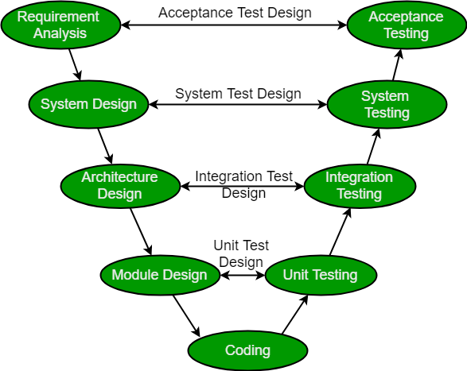

**Verification:** It involves static analysis technique (review) done without executing code. It is the process of evaluation of the product development phase to find whether specified requirements meet.

**Validation:** It involves dynamic analysis technique (functional, non-functional), testing done by executing code. Validation is the process to evaluate the software after the completion of the development phase to determine whether software meets the customer expectations and requirements.

So V-Model contains Verification phases on one side of the Validation phases on the other side. Verification and Validation phases are joined by coding phase in V-shape. Thus it is called V-Model

* **Requirement Analysis:** This phase contains detailed communication with the customer to understand their requirements and expectations. This stage is known as Requirement Gathering.
* **System Design:** This phase contains the system design and the complete hardware and communication setup for developing product.
* **Architectural Design:** System design is broken down further into modules taking up different functionalities. The data transfer and communication between the internal modules and with the outside world (other systems) is clearly understood.
* **Module Design:** In this phase the system breaks down into small modules. The detailed design of modules is specified, also known as Low-Level Design (LLD).
* **Unit Testing:** Unit Test Plans are developed during module design phase. These Unit Test Plans are executed to eliminate bugs at code or unit level.
* **Integration testing:** After completion of unit testing Integration testing is performed. In integration testing, the modules are integrated and the system is tested. Integration testing is performed on the Architecture design phase. This test verifies the communication of modules among themselves.
* **System Testing:** System testing test the complete application with its functionality, inter dependency, and communication.It tests the functional and non-functional requirements of the developed application.
* **User Acceptance Testing (UAT):** UAT is performed in a user environment that resembles the production environment. UAT verifies that the delivered system meets user’s requirement and system is ready for use in real world.

**Task_2**

**It is clean code and attached with this word file**

**Task_3**

All DevOps operations and tools ::

* 1. **Plan operation :**
     + Jira software
     + Confluence
     + Slack
  2. **Build operation::**
     + Kubernetes
     + Docker
  3. **Continuous Integration ::**
     + Jenkins
     + AWS
     + Bitbucket
  4. **Operate::**
     + New Relic
     + Nagios
     + Slack
  5. **Continuous Feedback::**
     + Pendo
     + GetFeedback

**Task_4**

DataOps Cycle :

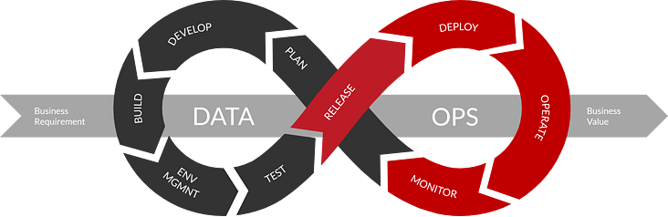

**Task_5**

MLOps Cycle:

