file_name='125.wav';
rate=1;
filter_type=2;
g_1=1;
g_2=2;
g_3=3;
g_4=4;
g_5=5;
g_6=6;
g_7=7;
g_8=8;
g_9=9;
band_num=1;
%input file from the user and read it
[x,Fs]=audioread(file_name);
%choosing the rate
if rate == 1
rate = Fs;
end
if rate==2
rate = Fs * 0.5;
end
if rate==3
rate = Fs * 2;
end
%the original sound
sound(x, rate);
%plotting the original signal in time domain
t=linspace(0, length(x)/Fs,length(x));
plot(t, x);
%plotting in frequency domain
Nfft = length(x);
f=linspace(0, Fs, Nfft);
G=abs(fft(x, Nfft));
figure;
plot(f(1:Nfft/2), G(1:Nfft/2));
%choosing filter type (FIR rectanguar window or IIR)
if filter_type == 1
H_1=rectangular1(Fs);
H_2=rectangular2(Fs);
H_3=rectangular3(Fs);
H_4=rectangular4(Fs);
H_5=rectangular5(Fs);
H_6=rectangular6(Fs);
H_7=rectangular7(Fs);
H_8=rectangular8(Fs);
H_9=rectangular9(Fs);
end
if filter_type == 2
H_1=IIR_1(Fs);
H_2=IIR_2(Fs);
H_3=IIR_3(Fs);
H_4=IIR_4(Fs);
H_5=IIR_5(Fs);
H_6=IIR_6(Fs);
H_7=IIR_7(Fs);
H_8=IIR_8(Fs);
H_9=IIR_9(Fs);
end
%plotting the virtualization of the chosen band filter
switch band_num
case 1
grpdelay(H_1);
case 2
grpdelay(H_2);
case 3
grpdelay(H_3);
case 4
grpdelay(H_4);
case 5
grpdelay(H_5);
case 6
grpdelay(H_6);
case 7
grpdelay(H_7);
case 8
grpdelay(H_8);
case 9
grpdelay(H_9);
end
%output of each band filter
y_1=filter(H_1, x);
y_2=filter(H_2, x);
y_3=filter(H_3, x);
y_4=filter(H_4, x);
y_5=filter(H_5, x);
y_6=filter(H_6, x);
y_7=filter(H_7, x);
y_8=filter(H_8, x);
y_9=filter(H_9, x);
%plotting the time and frequency domain of the chosen band filter
switch band_num
case 1
t=linspace(0, length(y_1)/Fs,length(y_1));
plot(t, y_1);
Nfft = length(y_1);
f=linspace(0, Fs, Nfft);
G=abs(fft(y_1, Nfft));
figure;
plot(f(1:Nfft/2), G(1:Nfft/2));
case 2
t=linspace(0, length(y_2)/Fs,length(y_2));
plot(t, y_2);
Nfft = length(y_2);
f=linspace(0, Fs, Nfft);
G=abs(fft(y_2, Nfft));
figure;
plot(f(1:Nfft/2), G(1:Nfft/2));
case 3
t=linspace(0, length(y_3)/Fs,length(y_3));
plot(t, y_3);
Nfft = length(y_3);
f=linspace(0, Fs, Nfft);
G=abs(fft(y_3, Nfft));
figure;
plot(f(1:Nfft/2), G(1:Nfft/2));
case 4
t=linspace(0, length(y_4)/Fs,length(y_4));
plot(t, y_4);
Nfft = length(y_4);
f=linspace(0, Fs, Nfft);
G=abs(fft(y_4, Nfft));
figure;
plot(f(1:Nfft/2), G(1:Nfft/2));
case 5
t=linspace(0, length(y_5)/Fs,length(y_5));
plot(t, y_5);
Nfft = length(y_5);
f=linspace(0, Fs, Nfft);
G=abs(fft(y_5, Nfft));
figure;
plot(f(1:Nfft/2), G(1:Nfft/2));
case 6
t=linspace(0, length(y_6)/Fs,length(y_6));
plot(t, y_6);
Nfft = length(y_6);
f=linspace(0, Fs, Nfft);
G=abs(fft(y_6, Nfft));
figure;
plot(f(1:Nfft/2), G(1:Nfft/2));
case 7
t=linspace(0, length(y_7)/Fs,length(y_7));
plot(t, y_7);
Nfft = length(y_7);
f=linspace(0, Fs, Nfft);
G=abs(fft(y_7, Nfft));
figure;
plot(f(1:Nfft/2), G(1:Nfft/2));
case 8
t=linspace(0, length(y_8)/Fs,length(y_8));
plot(t, y_8);
Nfft = length(y_8);
f=linspace(0, Fs, Nfft);
G=abs(fft(y_8, Nfft));
figure;
plot(f(1:Nfft/2), G(1:Nfft/2));
case 9
t=linspace(0, length(y_9)/Fs,length(y_9));
plot(t, y_9);
Nfft = length(y_9);
f=linspace(0, Fs, Nfft);
G=abs(fft(y_9, Nfft));
figure;
plot(f(1:Nfft/2), G(1:Nfft/2));
end
%multiply each band by the gain
y_1=y_1*(10^(g_1/20));
y_2=y_2*(10^(g_2/20));
y_3=y_3*(10^(g_3/20));
y_4=y_4*(10^(g_4/20));
y_5=y_5*(10^(g_5/20));
y_6=y_6*(10^(g_6/20));
y_7=y_7*(10^(g_7/20));
y_8=y_8*(10^(g_8/20));
y_9=y_9*(10^(g_9/20));
%adding bands to produce the composite signal
Y = y_1+y_2+y_3+y_4+y_5+y_6+y_7+y_8+y_9;
%the output sound
sound(Y, rate);
%plotting the time domain and frequency domain of composite signal
t=linspace(0, length(Y)/Fs,length(Y));
plot(t, Y);
Nfft = length(Y);
f=linspace(0, Fs, Nfft);
G=abs(fft(Y, Nfft));
figure;
plot(f(1:Nfft/2), G(1:Nfft/2));
%save the output sound file
audiowrite('outputcomposite.wav',Y,Fs);

Sample Run:
IIR Filter: rate = 1 gains = (1,2,3,4,5,6,7,8,9) dB
Plot of the original signal in time domain
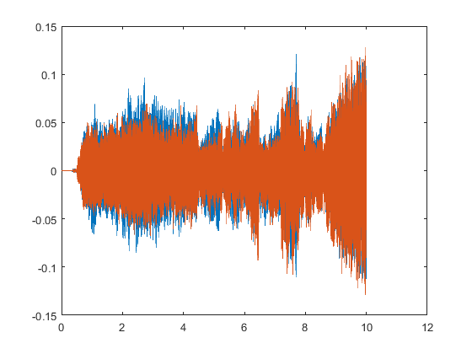

The Original in frequency domain:
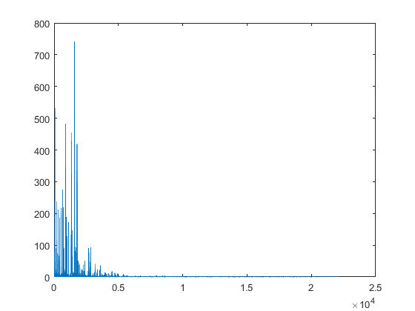
Group delay of Band 5:
It’s – the derivation of the phase.
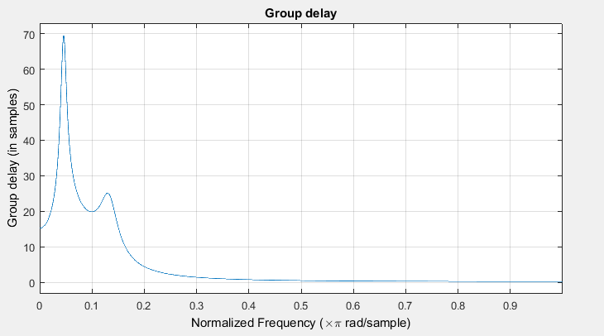
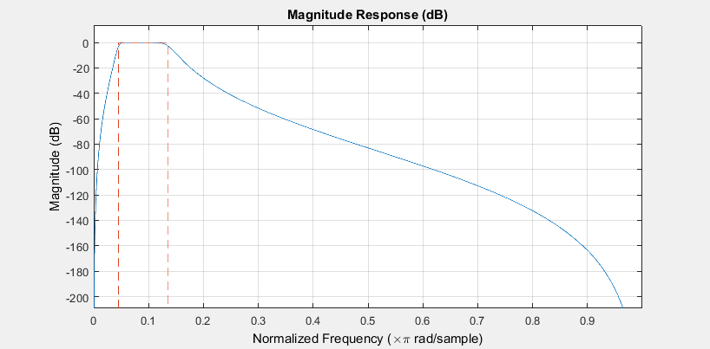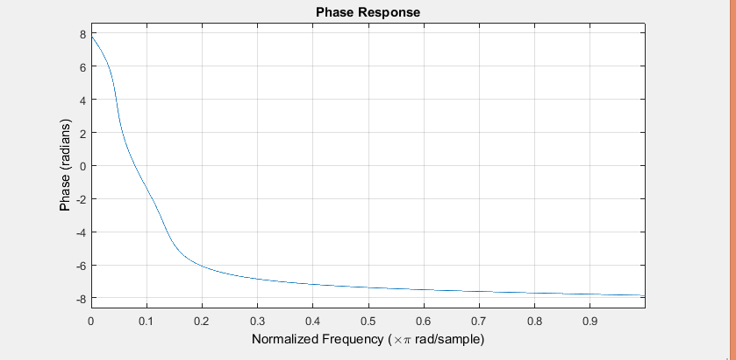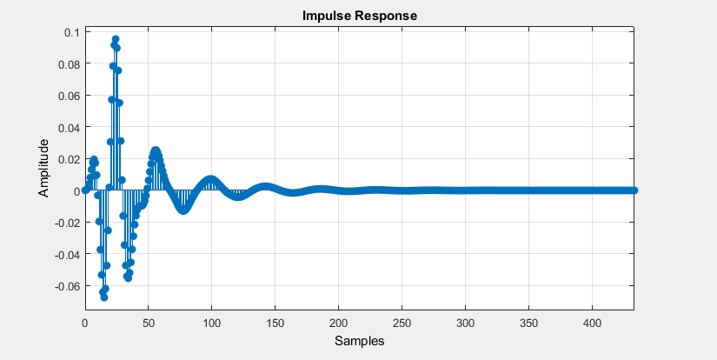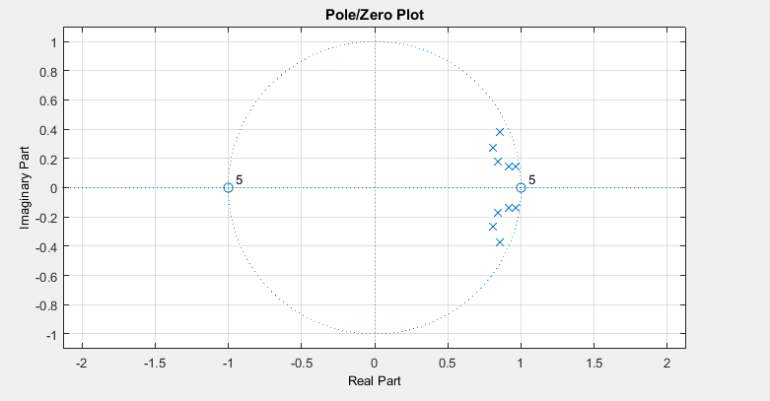
Plot of a filter band 5 in time domain and frequency domain.
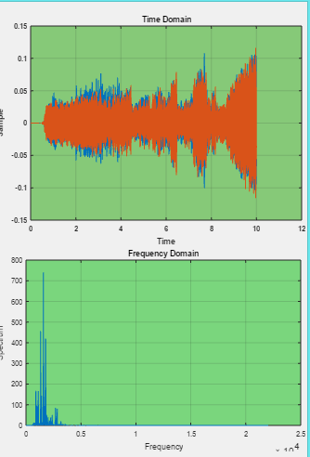

Plot of the comosite signal in the time and frequency domain
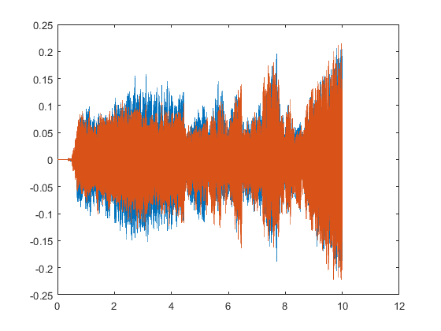
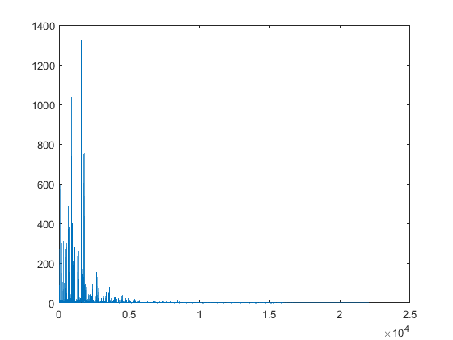
FIR Window Rectangular: rate = 2, all gains = 2dB
Group delay of Band 3:
It’s – the derivation of the phase.
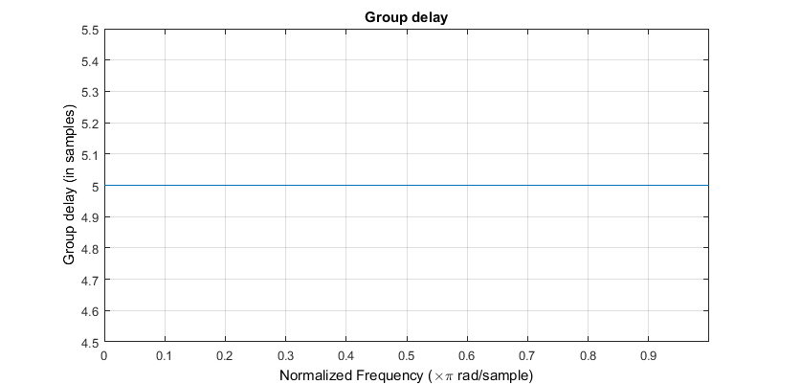
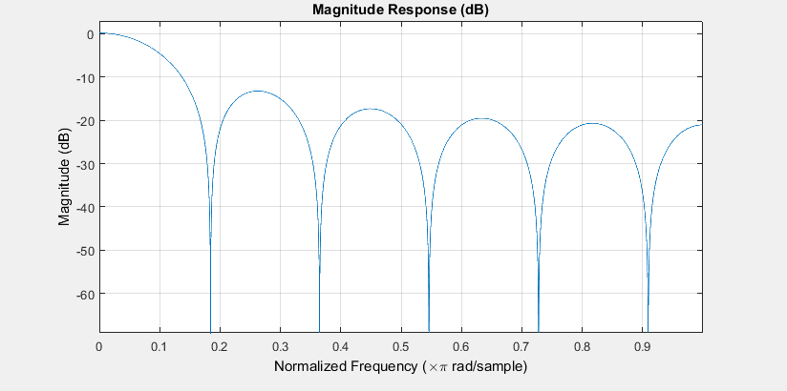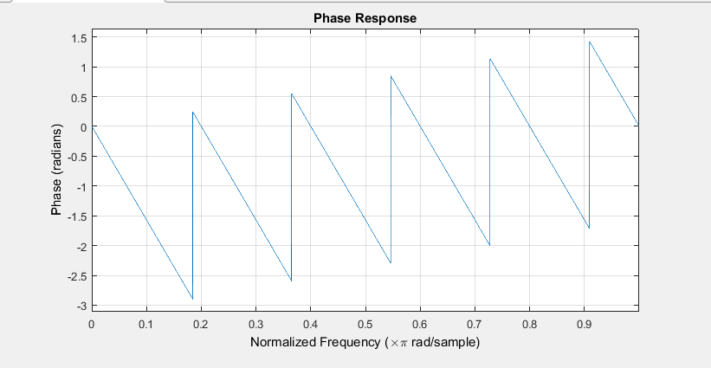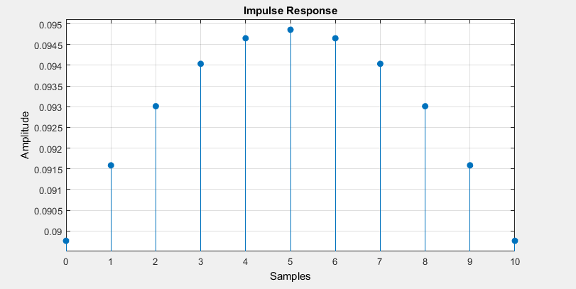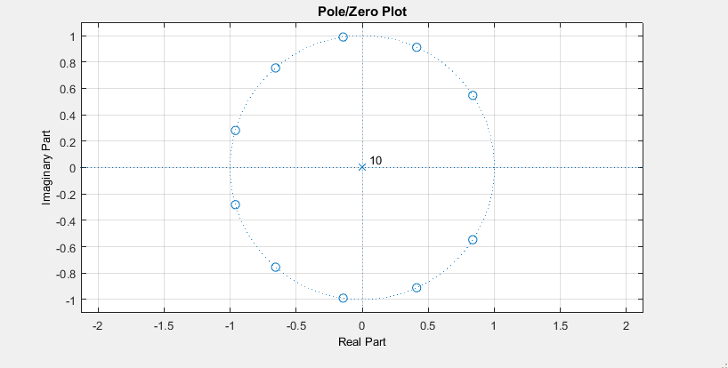
Plot of a filter band 3 in time domain and frequency domain.
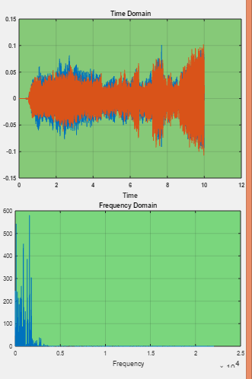

Plot of the comosite signal in the time and frequency domain

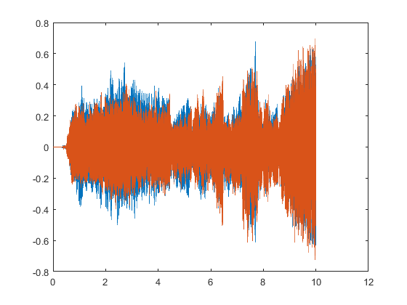
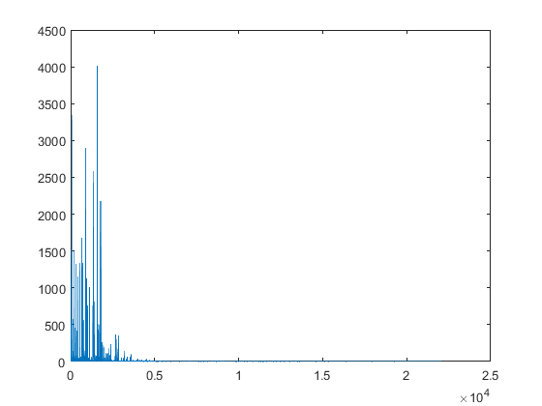
Sample run when base is dominant:
Chosen filter is FIR Rectangular, gains used : 12dB(max) for the first band and zero for all others.
Output in Time and Frequency
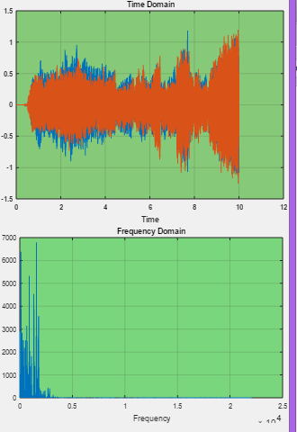
Sample run 4: Filter = FIR Rectangular, rate = 0.5 gains = 4 for the first band and -8dB for the rest of bands.
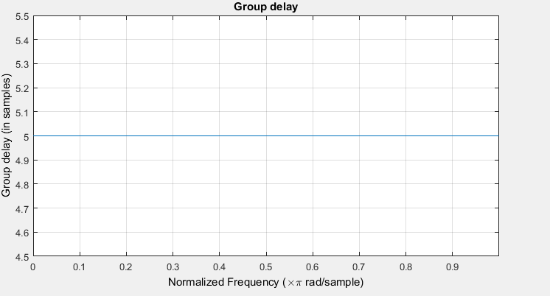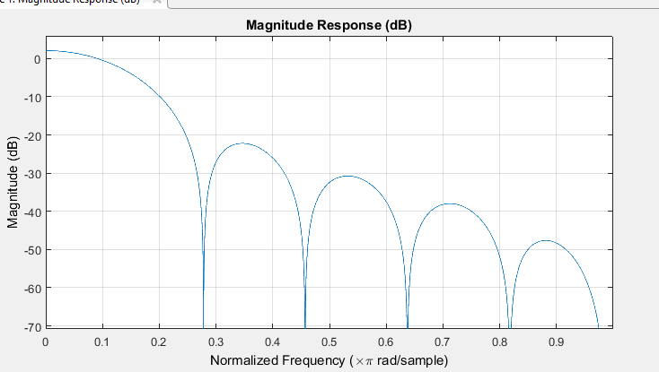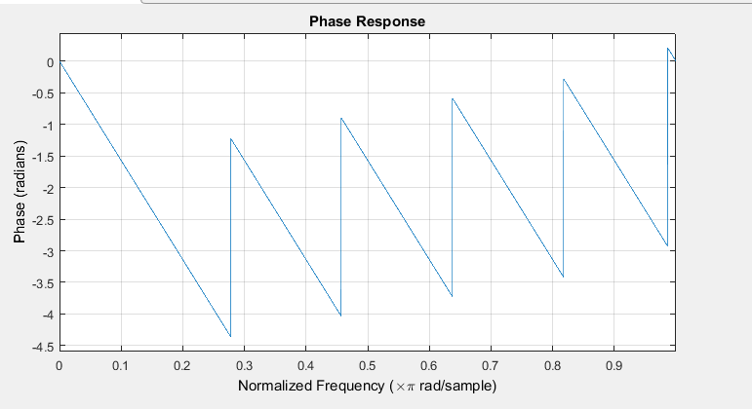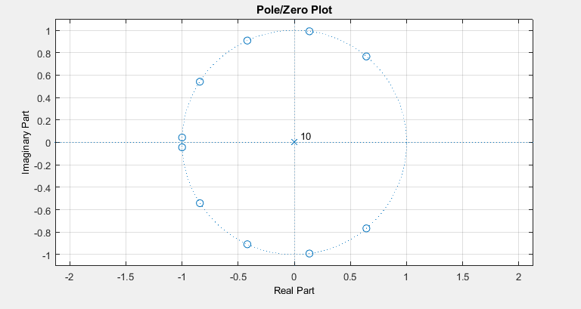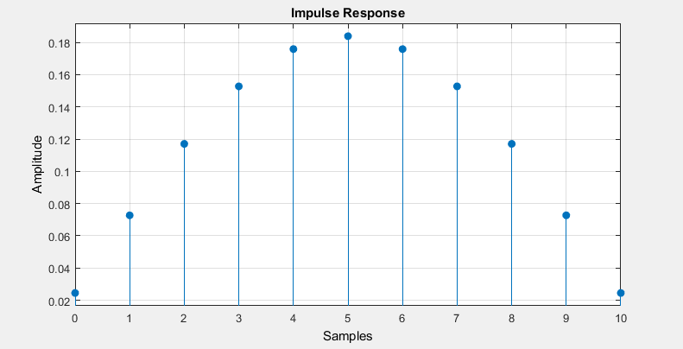
Output
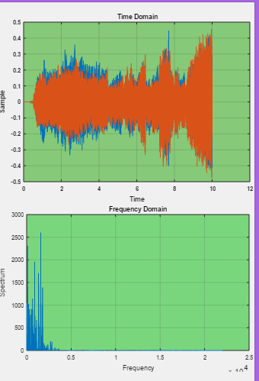

Filter Specification:
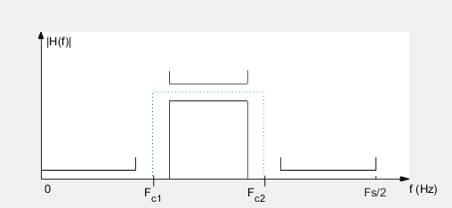
FIR Window Rectangular:
The order of the filter = 10 (max between number of poles or zeroes of the filter transfer function).
Fc1 define the starting frequency of the band.
Fc2: define the end frequency of the band.
The bandpass filters pass the frequencies in the specific defined range and attenuate the rest. The band pass is used for the eight bands starting from the second band.
There is a delay in the filter it can be shown in the picture which is the difference between the 2 solid line before and after the dotted. It is from the 2 sides before and after the band.
The first band (0-170) is done by a low pass filter:
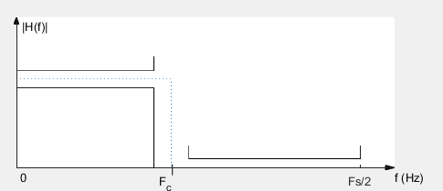
It passes the frequencies starting from 0 till the value defined by Fc.
The delay is on one side only and the order is the same as in the bandwidth.
In IIR: The Butterworth is used choosing also the low pass for the first band and bandwidth for the 8 other bands. The specifications are the same as above.

Maximum error And Average Error:
The ideal filter multiplies the desired frequencies by 1 and the rest by zero but this can not be designed in real so, we will find ripples around the 1 and zero values so the frequency is not actualy multiplied by 1 and 0 but there will be error in the output.
There is also a transition band so there are other unwanted frequencies multiplied by unknown values that will appear in the output.

