IE221 Probability - Teamwork 4
Team Members | Student ID
İbrahim Genç | 2211021036
Ayşe Efsa Çelik | 2211021001
Fatmanur Doğan | 2311021001
Ecem Nur Yüksel | 2411013097

Abstract: This report presents a comprehensive simulation-based analysis and professional code documentation for three fundamental topics in probability: the Strong Law of Large Numbers (SLLN), the Central Limit Theorem (CLT), and Monte Carlo pi estimation. By utilizing independent and identically distributed samples from the Uniform(0,1) distribution, empirical evidence is provided for the convergence of sample averages, specifically Almost Sure Convergence, and for the asymptotic normality of standardized sums, referred to as Convergence in Distribution, as the sample size increases.

In addition, the report explains the theoretical foundation of the Monte Carlo method and evaluates its efficiency in estimating transcendental constants through stochastic sampling. The accompanying codebase is documented to professional standards, including detailed docstrings, inline comments, and clear execution instructions provided in the README file to ensure full reproducibility and technical clarity.

Simulation-Based Illustration of the Strong Law of Large Numbers, Central Limit Theorem, and Monte Carlo Methods

INTRODUCTION

Probability theory plays a fundamental role in modeling uncertainty in real-world systems. Many applications in data science, operations research, engineering, and economics rely on statistical inference from sampled data instead of full population data. Thus, understanding the long-term behavior of random variables is essential. Two of the most important discoveries in probability theory are the Strong Law of Large Numbers (SLLN) and the Central Limit Theorem (CLT). The behavior of random variable averages and sums as sample sizes increase is explained by these theorems. Despite the fact that both results deal with convergence, their interpretations differ and they rely on different notions of convergence. In practice, purely theoretical descriptions of convergence can be abstract and unintuitive. These theoretical insights can be effectively visualized and empirically verified by simulation-based techniques, especially Monte Carlo methods. Convergence properties can be immediately examined by creating random samples and numerically examining their behavior. The study uses simulation experiments based on the Uniform(0,1) distribution to illustrate the Central Limit Theorem and the Strong Law of Large Numbers. Furthermore, the value of the mathematical constant π is estimated using a Monte Carlo approach. The work provides intuition regarding various mechanisms of convergence and the significance of sample size by combining theoretical explanations with numerical simulations.

THEORETICAL BACKGROUND

Probability Preliminaries
Let {X₁, X₂, …} be a sequence of independent and identically distributed (i.i.d.) random variables. Independence implies that the realization of one variable does not affect the others, while identical distribution ensures that all variables follow the same probability law. These assumptions are central to classical limit theorems in probability theory.
For a random variable X with finite mean μ = E[X] and variance σ² = Var(X), the sample mean of n observations is defined as X̄ₙ = (1/n)∑ᵢ₌₁ⁿ Xᵢ. The behavior of X̄ₙ as n increases is of primary interest in statistical inference and motivates the study of the Law of Large Numbers.

Strong Law of Large Numbers (SLLN)
The Strong Law of Large Numbers states that if {X₁, X₂, …} is a sequence of i.i.d. random variables with finite expected value E[Xᵢ] = μ, then the sample mean X̄ₙ converges almost surely to μ as n → ∞. Almost sure convergence means that the probability of convergence is equal to one.
This theorem offers a thorough defense of the use of sample averages as population mean estimators. Practically speaking, it ensures that the sample mean will stay near the true mean for nearly all realizations of the random process for big enough sample sizes.
In this study, the SLLN is illustrated using random variables drawn from the Uniform(0,1) distribution. The theoretical mean of this distribution is μ = 0.5. By computing cumulative sample means and plotting them against the theoretical mean, the convergence predicted by the SLLN can be clearly observed.

Central Limit Theorem (CLT)
While the Law of Large Numbers focuses on convergence of averages, the Central Limit Theorem addresses the distributional behavior of sums of random variables. Let {X₁, X₂, …} be i.i.d. random variables with mean μ and variance σ² < ∞.
The CLT states that the standardized sum Zₙ = (∑ᵢ₌₁ⁿ Xᵢ − nμ)/(σ√n) converges in distribution to the standard normal distribution N(0,1) as n → ∞. Convergence in distribution implies that the shape of the distribution of Zₙ approaches that of a normal distribution.
In this project, the underlying distribution is Uniform(0,1), for which μ = 0.5 and σ² = 1/12. By performing simulations for multiple sample sizes and generating histograms and Q–Q plots, the emergence of normality predicted by the CLT is demonstrated.

Monte Carlo Method for π Estimation
The Monte Carlo method is a computational technique that approximates numerical quantities using random sampling. One classical application is the estimation of the value of π using geometric probability.
Random points are generated uniformly within a unit square. The proportion of points that fall inside the quarter unit circle defined by x² + y² ≤ 1 provides an estimate of π through the relation π ≈ 4 × (number of points inside the circle / total number of points). As the number of simulations increases, the estimate converges to the true value of π.

MODES OF CONVERGENCE
Different probabilistic limit theorems rely on different notions of convergence. Understanding these differences is essential for interpreting both theoretical results and simulation-based

Theorem | Type of Convergence | Interpretation
SLLN | Almost Sure Convergence | The sample mean converges to the true mean for almost every sample path.
CLT | Convergence in Distribution | The distribution of standardized sums approaches the normal distribution.

Convergence in distribution is weaker than almost certain convergence. One sufficiently lengthy simulation is sufficient to observe the limiting behavior because the SLLN ensures convergence along individual sample routes. Conversely, distributional convergence solely affects the distribution's shape.
This discrepancy explains why, in simulation research, the CLT necessitates several independent replications for every sample size. Empirical distributions and the theoretical normal distribution are compared using histograms and Q-Q graphs.

METHODOLOGY

All simulations were conducted using the Python programming language. Random numbers were generated from the Uniform (0,1) distribution using the NumPy library. Visualization was performed using Matplotlib, and statistical diagnostics for the CLT were obtained using functions from the SciPy library.
For the SLLN simulation, 10,000 observations were generated and cumulative sample means were computed. For the CLT simulation, sample sizes of n = {2, 5, 10, 30, 50} were considered with 1,000 replications for each value. For the Monte Carlo estimation of π, convergence behavior was analyzed by tracking the cumulative estimate as the number of random points increased.

RESULTS
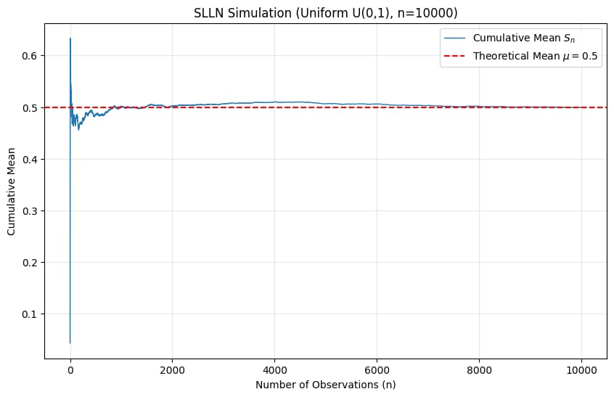
SLLN Simulation Results
Figure 1

Figure 1 illustrates the convergence of the cumulative sample mean $S_{n}$obtained from a Uniform (0,1) distribution.
For small sample sizes, the cumulative mean exhibits large fluctuations due to
randomness. As the number of observations increases, these fluctuations gradually
decrease. After approximately n ≈ 1500–2000, the sample mean remains sufficiently
close to the theoretical mean μ = 0.5 and stabilizes around this value.
This result confirms the Strong Law of Large Numbers, which guarantees almost sure
convergence of the sample mean to the expected value.

CLT Results – Histogram Analysis
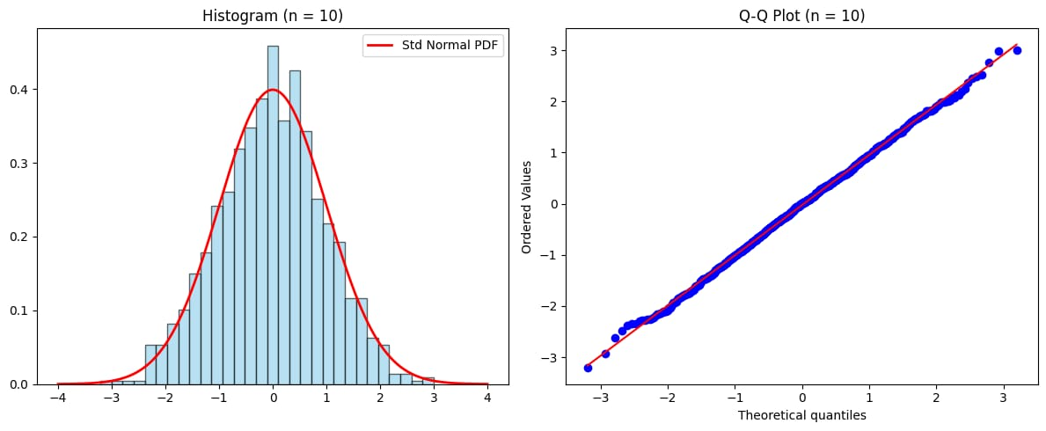
Figure 2
Figure 2 shows the histogram of the standardized sums for n = 10 together with the
Standard Normal probability density function.
For n = 10, the distribution is approximately symmetric but still deviates from the
standard normal distribution, particularly in the tails. Although the bell shape
is visible, the normal approximation is not perfect for small sample sizes.
As the sample size increases, the Central Limit Theorem predicts a closer
approximation to normality.

CLT Results – Q-Q Plot Analysis

Figure 3 presents the Q-Q plot of the standardized sums for n = 10.
The Q-Q plot indicates deviations from the reference line at both lower and upper
quantiles, revealing non-normal behavior for small n values. However, the central
portion of the data aligns relatively well with the theoretical quantiles.
This demonstrates convergence in distribution, which becomes stronger as n increases.

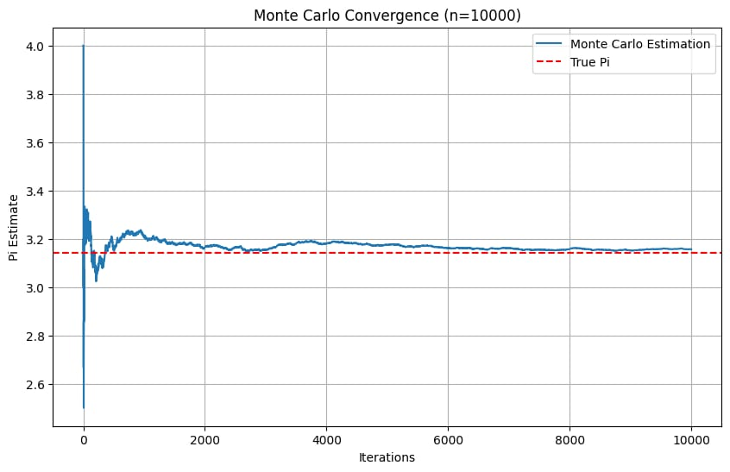
Monte Carlo π Estimation Results

Figure 4 displays the convergence behavior of the Monte Carlo estimator for π.
At early iterations, the estimate fluctuates significantly due to random sampling.
As the number of iterations increases, the estimator converges toward the true value
of π. For n = 10,000, the estimation error becomes relatively small, demonstrating
the consistency and reliability of the Monte Carlo method.

DISCUSSION AND COMPREHENSIVE ANALYSIS

6.1 Determining the Sufficient Sample Size (n)
A central objective of this simulation was to answer the engineering question: “How large should n be for the results to be reliable?” Our findings suggest that “largeness” is not a static number but depends on the specific statistical goal.
SLLN and the Threshold of Stability
Based on the SLLN results, we observed that for n smaller than 500, the sample mean is highly sensitive to outliers within the Uniform distribution. However, as n increases beyond the range of 1500 to 2000, the cumulative mean enters a steady-state zone in which it remains within a margin of plus or minus 0.01 from the theoretical mean value of 0.5. Therefore, for point estimation purposes, a sample size of approximately 2000 serves as a sufficient threshold for this distribution.
CLT and the Precision of the Distribution
For the Central Limit Theorem, the requirements are more stringent. While n equal to 10 provides a visual approximation of a normal curve, the Q–Q plots indicated that the sample quantiles in the tails still deviate significantly from the theoretical normal quantiles. To obtain a distribution that passes rigorous normality tests for the purpose of constructing confidence intervals, a larger sample size is necessary. Consistent with academic literature, a sample size of at least 30 is required to reduce noise in the extremities of the distribution.
Monte Carlo Efficiency
In the pi estimation simulation, a sample size of 10,000 was used. Even at this scale, the error analysis shows that the convergence rate of Monte Carlo methods is proportional to one over the square root of n. This implies that to gain one additional decimal of precision, the sample size must be increased by approximately a factor of one hundred.

6.2 Comparative Analysis of Convergence Modes
The most critical takeaway from this project is the experimental distinction between the two types of convergence.
Theoretical Strength
The simulations demonstrate that Almost Sure Convergence, as described by the SLLN, is a stronger condition than Convergence in Distribution, which underlies the CLT. In the simulations, SLLN was observed through a single sample path settling around a constant value. In contrast, CLT describes the aggregate behavior of many such sample paths, focusing on the shape of their distribution.
Methodological Requirements
Experimentally, it was confirmed that for SLLN, a single long simulation run is sufficient to visualize convergence. For CLT, however, a single run is insufficient. Thousands of replications are required to construct a histogram that accurately represents the distribution density. This explains why CLT is computationally more demanding to verify experimentally than SLLN.

6.3 Practical Implications in Industrial Engineering
The convergence modes discussed in this report have significant practical applications in the field of Industrial Engineering.
Quality Control
The CLT allows engineers to assume that the average weight or length of a manufactured product follows a normal distribution, enabling the use of control charts even when individual parts do not follow a normal distribution.
Simulation and Risk Analysis
The SLLN provides the justification for using simulation models to predict long-term system performance. It guarantees that as a factory simulation is run for a sufficiently long period, the average throughput converges to the true expected value.
Monte Carlo Methods
The ability to estimate complex values such as pi through randomness is widely used in financial engineering for option pricing and in logistics to optimize supply chain routes under uncertainty.

CONCLUSION
This technical report has provided a comprehensive documentation and simulation-based analysis of the Strong Law of Large Numbers and the Central Limit Theorem. Through the documentation of the TW1 code, the computational framework was ensured to be transparent and reproducible. The simulations validated that for a Uniform(0,1) distribution, the sample mean reliably converges to 0.5 under the SLLN, and that the sum of these variables eventually follows a standard normal distribution under the CLT.
The integration of theoretical background with experimental results highlights a key distinction: while the SLLN explains where the system converges, the CLT explains how outcomes are distributed around that target. This dual understanding is essential for data-driven decision making in both academic and professional environments.

