CSE3033 PROJECT 2 REPORT
(Fatmanur ÖZDEMİR – 150116046, Kevser İLDEŞ – 150116048)

In this project, we implement basic shell in c. There are some built-in commands, process executions and redirection in this shell.

A) In this part of project according to given arguments the code is supposed to create a new process and execute that command. To achieve this we basically used fork() to create new child process and then execv() to make it execute the command. Besides according to background property it either waits that process to terminate or not.

First of all, we get the path environment variable by getenv() function then split it into different paths and keep them in an array.
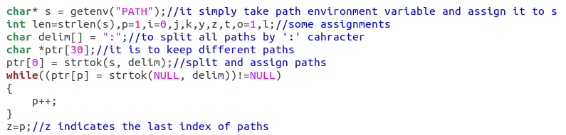
Then, we used dirent library, open directory for each path and search for the match between file name and command given.
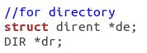
This is the directory checking part.
Below the if statement there are necessary actions like fork and
exec.
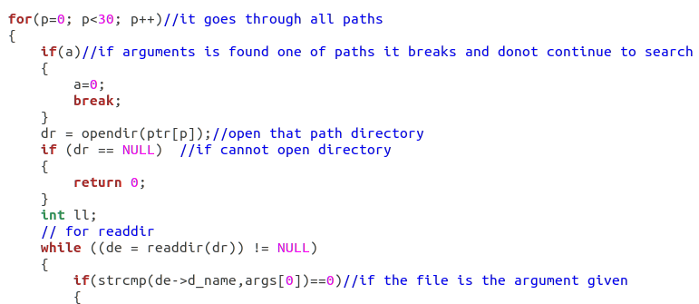

After that, we called fork and execv with matching command and execute it with background checking.
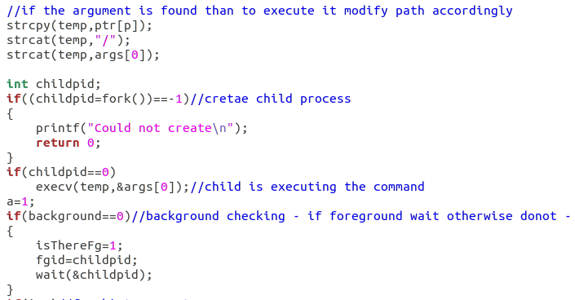

B) In this part, we implemented some built-in functions.

Firstly, the history command is implemented. An array is declared for this purpose and before the execution of each command, it is added to this array – if it is full, then shift and out the last one - .
Then at the beginning, it checks if the command is history and then if it exists -i property as well (to execute specific command in history). After that, if argument is just history then it prints last 10 commands. If it is like “history -i num” then it finds the command at that index and assigns args array accordingly then goes to a part to execute it.

To add a command to history:
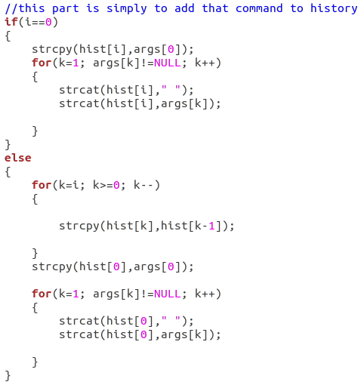

For history command:
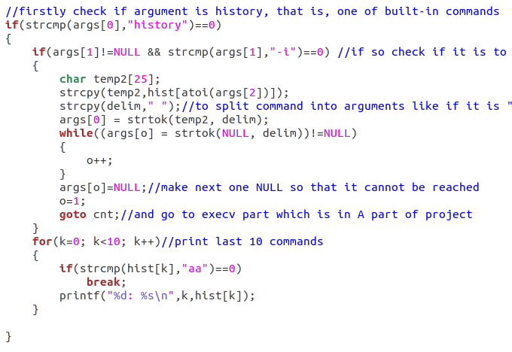
The next command is path. Again if it is with no other arguments it simply prints the path variable separated by ‘:’. If there is ‘+’ or ‘-’ it either add a path to variable or it deletes path with all of its duplicates from variable.
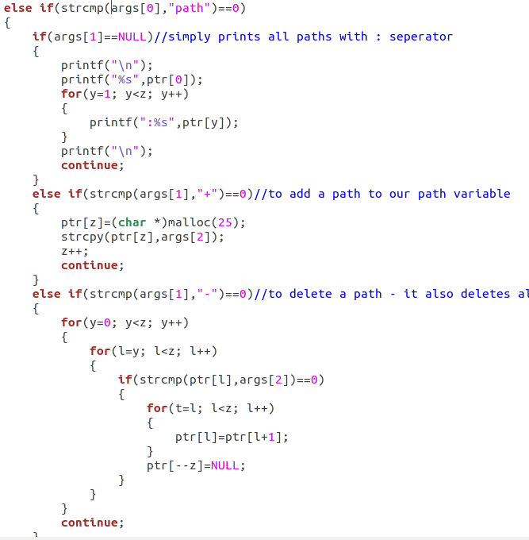

Next, we have ctrl-z signal handling in this part. For this the sigaction is used:

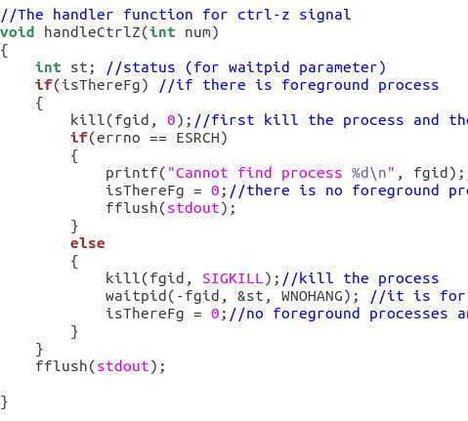

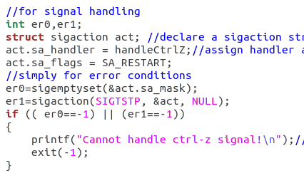

Then,we have fg %num command to move background process to foreground with given id:
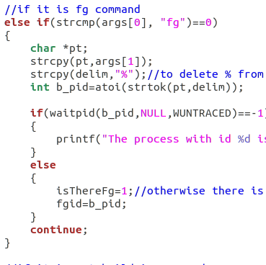

Finally, for this part, we have exit command (if there are background processes donot exit):
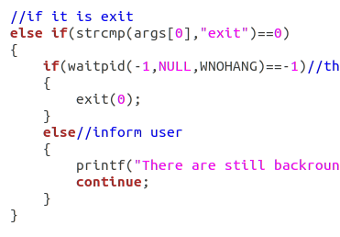

Here are sample executions of A and B parts:

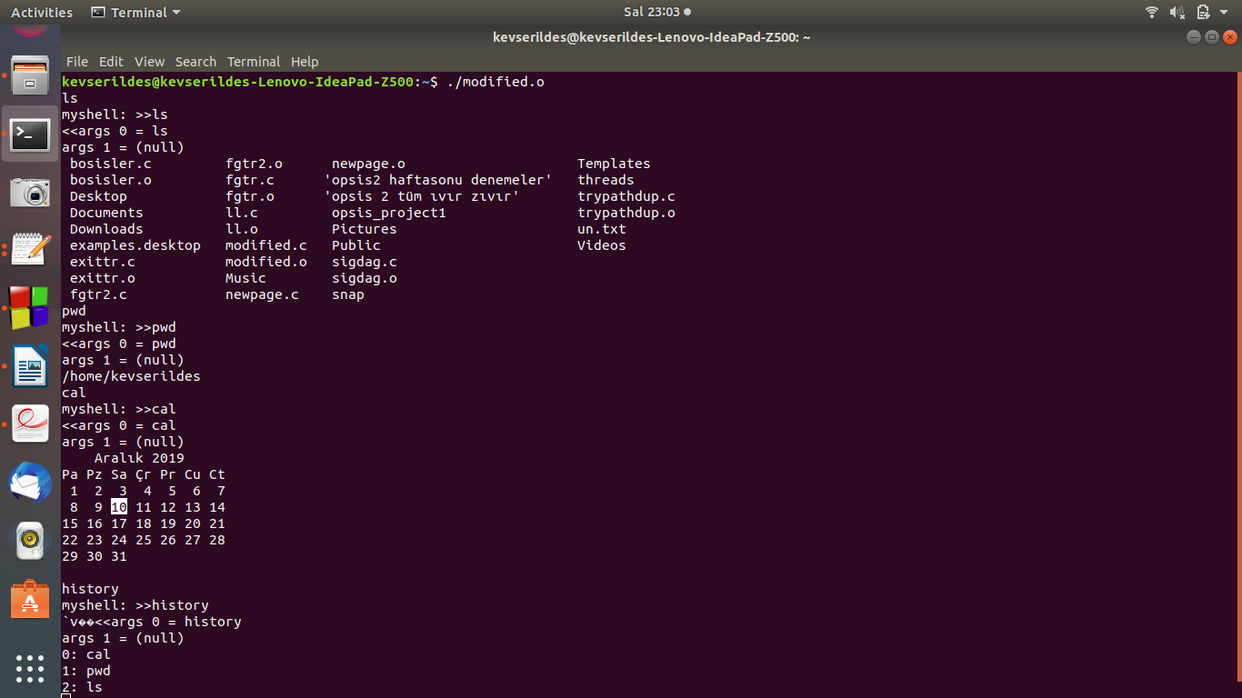

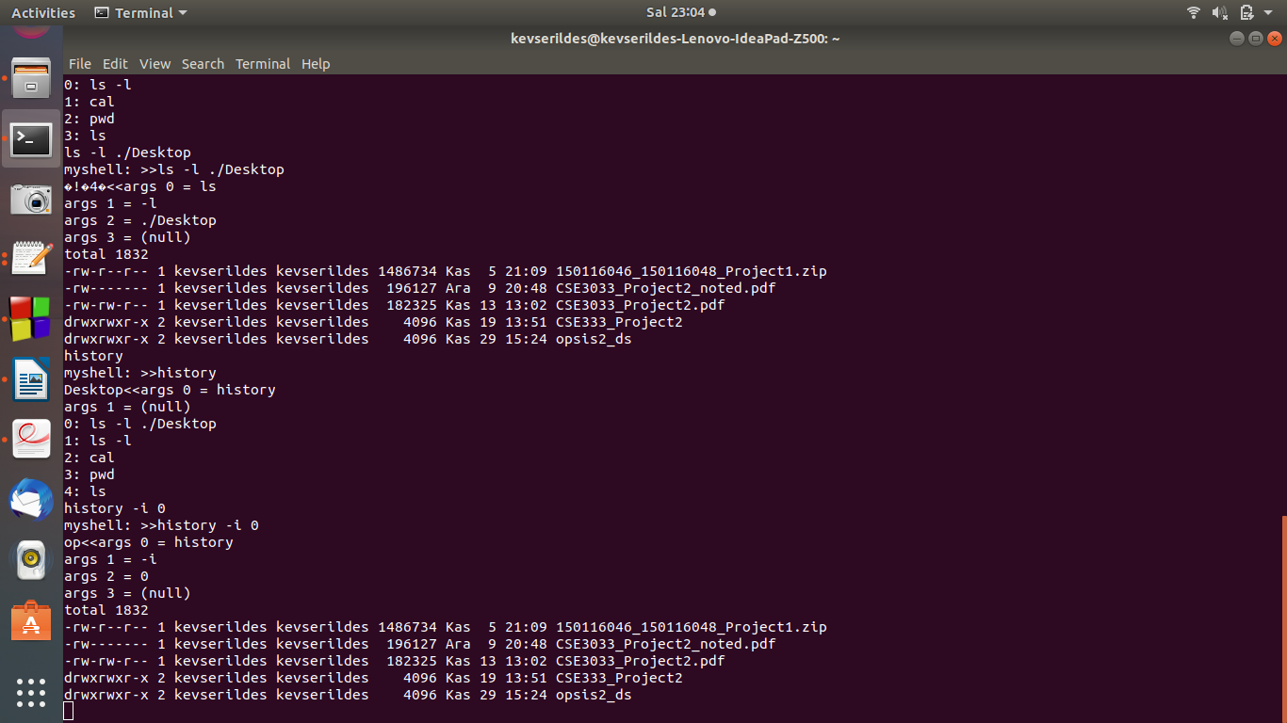
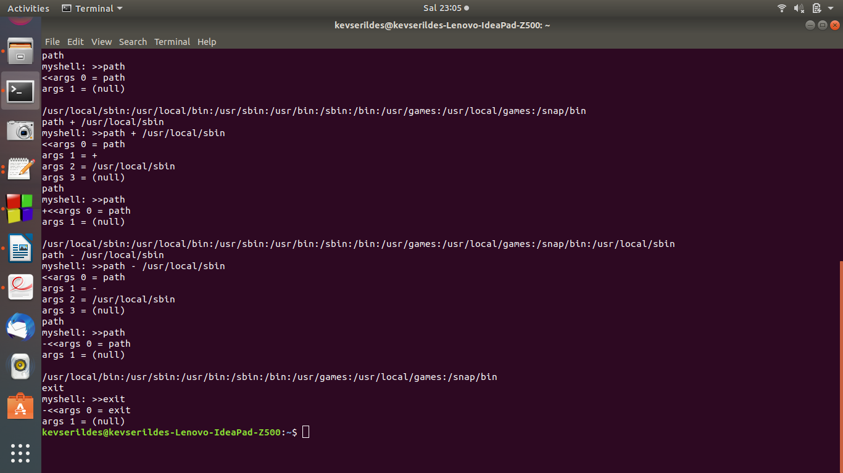

C) In this part, we did redirection.
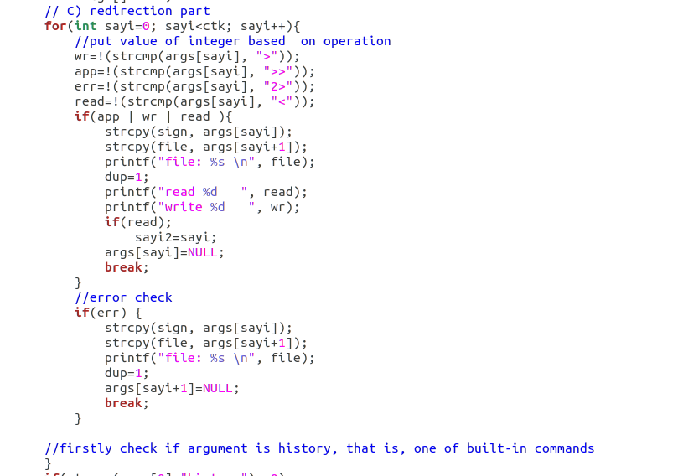

If there is a redirection; after redirection sign, other elements of args array become null to make execv function terminate succesfully. The file name is written into ‘file’ char array.

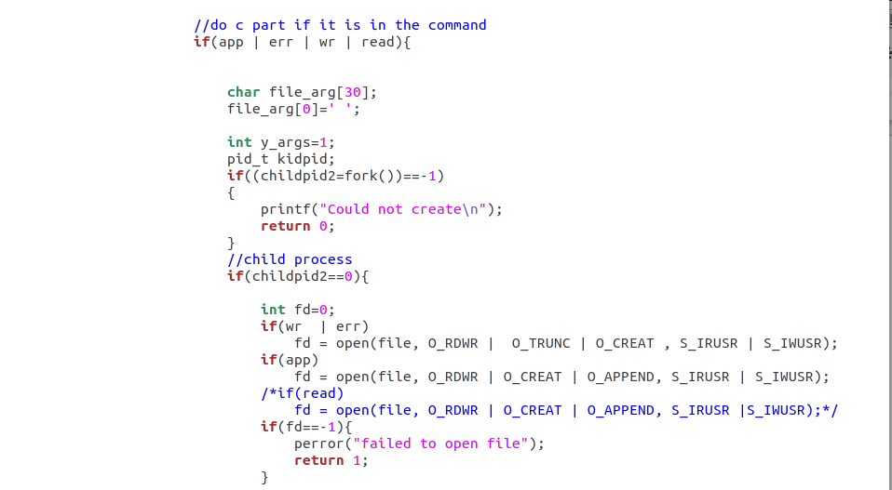
In the if part, check if there is any redirection operation(in this case, one of the integers would be 1). We created file based on operation(except read argumants forcommand operation)

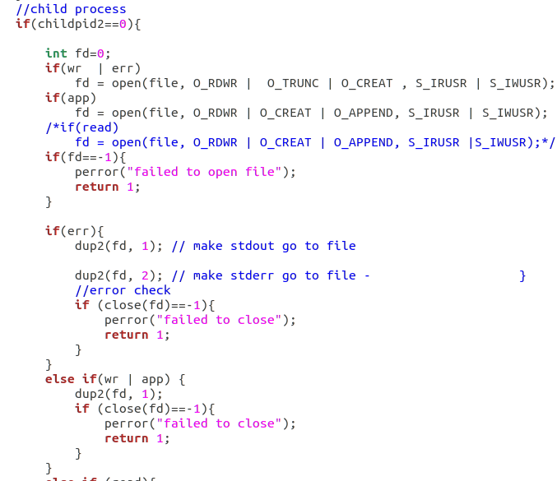
We used dup to write or append output of program into file.

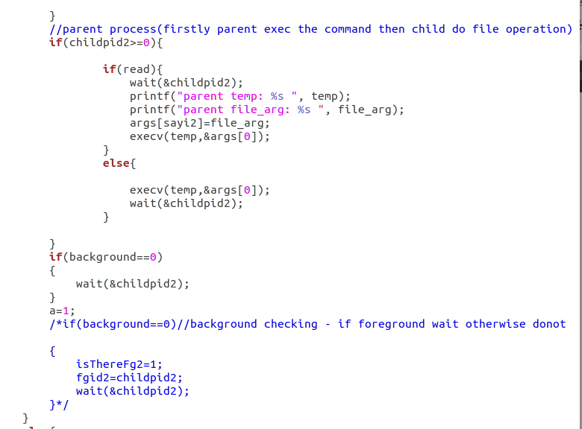
For redirection part parent do exec operation while child do file operation. Parent waits for the child before terminate. That is how we could write the output of command into file.
However in redirection part, unfortunately, program runs for only one time abd it exits.

