"OUR Antiquity Land" Web Application

Software Test Plan (STP)

Version 1.0

25/02/2023

Prepared by: Fatmeh Foqara

Content Table

(Click to go to the wanted section)

1. Software Test Plan data

2. Introduction

3. STP purpose

4. Support documents

5. Tree Testing

6. Entry and Exit criteria

6.1 Entry criteria

6.2 Exit criteria

7. Test strategy

7.1 Test approach

7.2 Test automation

8. Test methodology

8.1 Validation & defect management

8.2 Defect tracking / reporting

8.3 Status of the bug

8.4 Test management process

8.5 Assumptions / risks

9. Environment

10. Milestones

11. Roles & Responsibility

STP-Software Test Plan Document

**1. Software Test Plan**

*Version*: 1.0

*Created:* 25/02/2023

*Last update*:

*Test Plan Template*:

Web site project – "Our Antiquity Land"

*Prepared by:*

Fatmeh Foqara

*Document History*:

|  |  |  |  |
| --- | --- | --- | --- |
| Version | Date | Author | Changes |
| 1.0 | 25/02/2023 | Fatmeh Foqara | Draft |
| 2.0 | 14/03/2023 | Fatmeh Foqara | Add section 8.4 & 8.5 |

**2. Introduction**

"Our Antiquity Land" is a website that collect the must suggested archaeological site to visit in Israel, where the user can view the site he wants, add his review about it, and delete or update the specific site he wants. He can also add new site to the web.

**3. STP document purpose**

This document is describing the scope, approach, resources, and schedule of intended test activities.It helps as a point of reference for testing**.**

**4. Support Documents**

SRS document (attached to the project files).

STD document (attached to the project files).

**5.Tree Testing**

In this project we have four types of testing: smoke, functional, acceptance, and security.

First, we check the functionality of the system, like the ability of the user to add, remove, update a site or adding review, we check also if the logo button really led us to the main page, after that we check the security testing, because functional testing is a perroquet for the functional testing.

Before security testing we make sure that the acceptance testing are all passed, because those tests are about the end user experience in the web, and his ability to do different activities like clicking on a button or filling a form. Last tests we check are the smoke tests.

Smoke tests

Functional tests

Acceptance tests

Security tests

**6. Entry and Exit Criteria**

*6.1**Entry Criteria*

* Microsoft Windows 10+

*6.2 Exit Criteria*

* + 0 critical bugs
  + 0 Regression bugs
  + MAXIMUM 1 Medium bugs
  + Maximum 3 low bugs**.**

**7. Test Strategy**

*7.1. Test Approach*

The tests are mainly focus on the functionality of the web, and on the user's experience in the web. The project is using the agile approach, which mean every step in the project is taken after referring to the SRS document and the user's (developer in this case) requirements.

*7.2. Test Automation*

Four basic types of testing are performed for the web, functional testing, smoke testing, security, and acceptance testing.

**8.** **Testing Methodology**

*8.1. Validation and Defect Management*

Bug are categorized according to the following table:

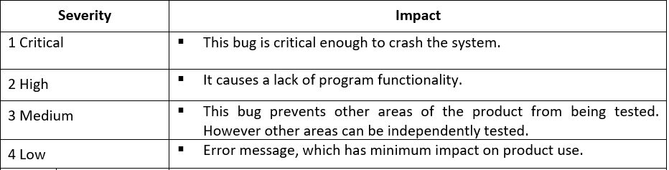

*8.2. Defect tracking and Reporting:*

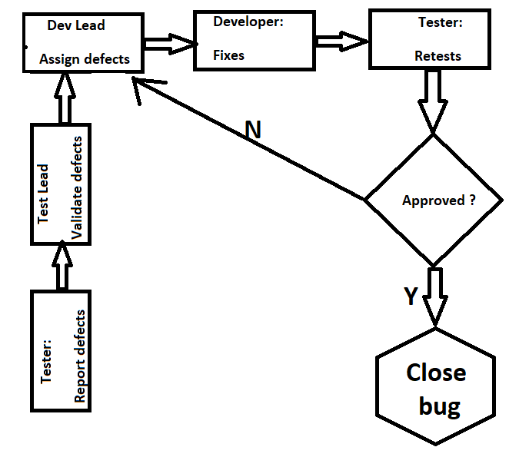

*8.3. Status of the Bug:*

* New: Just created bug
* Open: Opened bug and still not solved
* Rejected: Dev Lead rejected it (it's not bug)
* Fixed: SOLVED bug
* Closed: After bug is fixed, need close this bug
* Re-Open: Bug has been fixed and closed but appear again with time

*8.4. Test Management Process*

*8.4.1. Test strategy:*

four types of testing are made in this project, functional, security, smoke, and acceptance testing. Those tests will be done with "pytest" testing framework, according to the testing methodology.

*8.4.2. Test Planning:*

The different tests will be checked and reported in STD document that will include detailed data about the testing process for each test case. (See below)



*8.4.3. Test executing:*

The test will be run with pytest in the command line in PyCharm integrated development environment, and a logger will handle the detailed information about passed/failed tests, and will report them in html file.

*8.4.4. Test reporting*:

The tests will be reported in html file that will be reported in a html file using the command [pytest - -html="report".html]. They also will be reporting in STD document (see above).

*8.5. Assumptions / Risks*

Assumptions: main assumption is that the system is meeting all the requirements that has been made before coding it.

Risks: risks can be technical like appearing new bugs in the system, or uncompleted testing activities doe to the limited time. Another risk is completing the work without updating the stakeholders about each change, to make sure everything is meeting the requirements.

**9. Test Environment**

*9.1. Hardware Requirements*

* Computer with 8 GB RAM, Windows 10+ and Chrome (Firefox/Edge).

**10. Milestones**

|  |  |  |  |
| --- | --- | --- | --- |
| **Task** | **Start Date** | **End Date** | **Comments** |
| STD document | 25/02/2023 | 25/02/2023 | **…** |
| SRS document | 23/02/2023 | 25/02/2023 |  |
| STP document | 25/02/2023 | 25/02/2023 |  |
| Bug report | 23/02/2025 | 25/02/2023 |  |
| Selenium code | 17/02/2023 | 25/02/2023 |  |

**11. Roles & Responsibilities**

***QA testers:* Fatmeh Foqara**

* Develop test cases and combine them in test suites – STD

* Report BUGS

* Regression testing

***Test manager*: Lecturer**

* Manage the Testing and provide technical support to the Testing team.

* Make Review of Software Test Plan and test cases for the STD document.

***Test Lead*: Fatmeh Foqara**

* Prepare the Software Test Plan

* Analyze requirements during the requirements analysis phase.

* Evaluating exit criteria

* Preparing Test Summary Report