25.10.2018-01.11.2018



**MIDDLE EAST TECHNICAL UNIVERSITY**

DEPARTMENT OF ELECTRICAL AND ELECTRONICS ENGINEERING

EE493 – Weekly Progress Report #3

POTATO INTEGRATED TECHNOLOGIES

A close up of a clock

Description generated with high confidence

**Design Studio Coordinator:** Arzu KOÇ

**Partners and Contact Information:**

Fatma Nur ARABACI 2030047 0533 602 75 27 arabaci.fn@gmail.com

İrem COŞKUN 2030419 0539 414 59 69 iremcoskun0@gmail.com

Aycan BEYENİR 2030328 0539 330 05 70 abeyenir@gmail.com

Berkay GÖKSU 2030757 0505 635 81 45 berkaygoksu1@gmail.com

Furkan Bahadır ELİK 2030518 0554 963 94 10 elik.bahadir@metu.edu.tr

**Project 2 - Devices trying to score in each other’s goal**

**Goal:** Design and construct a teleoperated robot (controlled from a distance up to at least 30 meters) which can compete with a similar robot in shooting and scoring to opponent’s goal.

**Functional requirements:**

* Detect the start signal
* Monitor the surrounding
* Process the monitored data
* Encode the processed data for communication
* Transfer the encoded data to the teleoperator

If the ball is at players half-field and far away from the robot;

* Transfer the movement direction command given by the teleoperator, to move toward the ball
* Perform the move operation respect to the command transferred from teleoperator
* Move robot to the ball until ball is in the shooting range
* Transfer the hit the ball command given by the teleoperator
* Perform the hit the ball operation given by teleoperator

If the ball is at opponent’s half-field

* Transfer the movement direction command given by the teleoperator, to cover the goal, given by the teleoperator
* Perform the move operation respect to the command transferred from teleoperator
* Move robot to the own goal to protect it from the incoming shoot
* Protect the goal respect to the commands from teleoperator

**Constraints:**

* The robot is not allowed to cross the center-line
* The ball must be transferred to the opponents half field no more than 20 seconds
* The communication between robot and teleoperator must happen from a distance at least 30 meters
* Carrying, grasping and scooping the ball is not allowed. Robot can only hit or push the ball.

**Project 3 - Vehicles chasing each other around a closed course with varying properties:**

**Goal:** Follow the elevated path without falling-off, try to catch & tag the opponent robot.

**Functional Requirements:**

* Detect start signal
* Detect elevated path robot is placed on
* Start moving with the suitable speed with respect to the start point on the path
* Follow the path without falling off
* Adjust speed according to the instantaneous location on the path
* Faster robot senses the opponent
* Handshake protocol is achieved (Tagging)
* Tagged robot loses the round
* End of the round

**Constraints:**

* All instrumentation has to be onboarded the robot.
* Robot performance should not be affected from the disturbances.
* Collision of the robots must be avoided.
* One full turn of the robot should not exceed 20 sec.
* Tagging will be achieved when the opponent is 5 cm ahead.

# Project 4 - Devices trying to extract the plan of their surroundings

# Goal: To design a self-contained robot which extracts plan of its surrounding.

**Functional requirements:**

* Detect start signal
* Scan the surroundings
* Change position for different scan angles
* Distinguish different objects in terms of their shape
* Create a data containing information of individual shapes and their positions
* Send created data to a remote location in one-way communication for display purposes

**Constraints:**

* The robot should not disrupt the playfield.
* The robot is fully autonomous.
* All operation sensors must be included within the robot.
* Max height of the robot should not exceed the height of objects in field and the robot should fit in a cylinder of 25 cm diameter.

In our previous report we made weighted the objectives incorrectly. In order to learn from our previous mistakes, we used a different methodology to weight our objectives. Our newly defined objectives can be found in Figure 1 below as an objective tree. After some discussions we have reached consensus that these six objectives have far more importance for us.

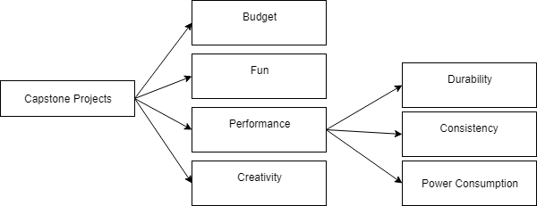

Figure 1: Objective tree for capstone projects

We used pairwise comparison to rank our objectives. In order to weight the objectives, we compared objectives with each other. If we believed an objective is more important than other for our team, we wrote 1 in the row of the important one corresponding to compared one and 0 to the other. If they have equal importance for our team, we wrote ½ to the corresponding column and row. First four objectives (budget, fun, performance and creativity) weighted together. Table 1 shows the pairwise comparison chart for top four objectives.

Table 1: Pairwise comparison chart top objectives

|  |  |  |  |  |  |  |
| --- | --- | --- | --- | --- | --- | --- |
|  | **Budget** | **Performance** | **Fun** | **Creativity** | **Total** | **Weighted** |
| **Budget** | - | 0 | 0 | 1/2 | 0,5 | 0,08 |
| **Performance** | 1 | - | 1/2 | 1 | 2,5 | 0,42 |
| **Fun** | 1 | 1/2 | - | 1 | 2,5 | 0,42 |
| **Creativity** | 1/2 | 0 | 0 | - | 0,5 | 0,08 |

Performance objectives (durability, consistency and power consumption), are weighted together and then multiplied with performance weight which found as 0.42 previously.

Table 2: Pairwise comparison for performance objectives

|  |  |  |  |  |  |  |
| --- | --- | --- | --- | --- | --- | --- |
|  | **Durability** | **Consistency** | **Power Consumption** | **Total** | **Add 1** | **Weighted** |
| **Durability** | - | 1/2 | 1 | 1,5 | 2,5 | 0,42 |
| **Consistency** | 1/2 | - | 1 | 1,5 | 2,5 | 0,42 |
| **Power Consumption** | 0 | 0 | - | 0 | 1 | 0,16 |

Our weighted objectives are used to draw our weighted objective tree which can be found in Figure 2.

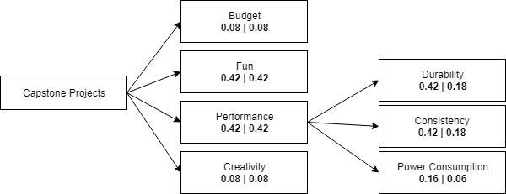

Figure 2: Weighted objective tree for capstone projects

**Next week’s plan:**

* Weekly official meeting will be held in the company headquarter.
* We will decide on which of the four projects to choose, by brainstorming and evaluating from all perspectives.
* The project selection will be finalized with the feedback of the project coordinator.
* We will organize meetings on possible solutions of the chosen project.
* Final version of the proposal report will be put together.
* First month celebration of the company will be held in a location which will be decided later.
* Standard committee representative will be chosen.