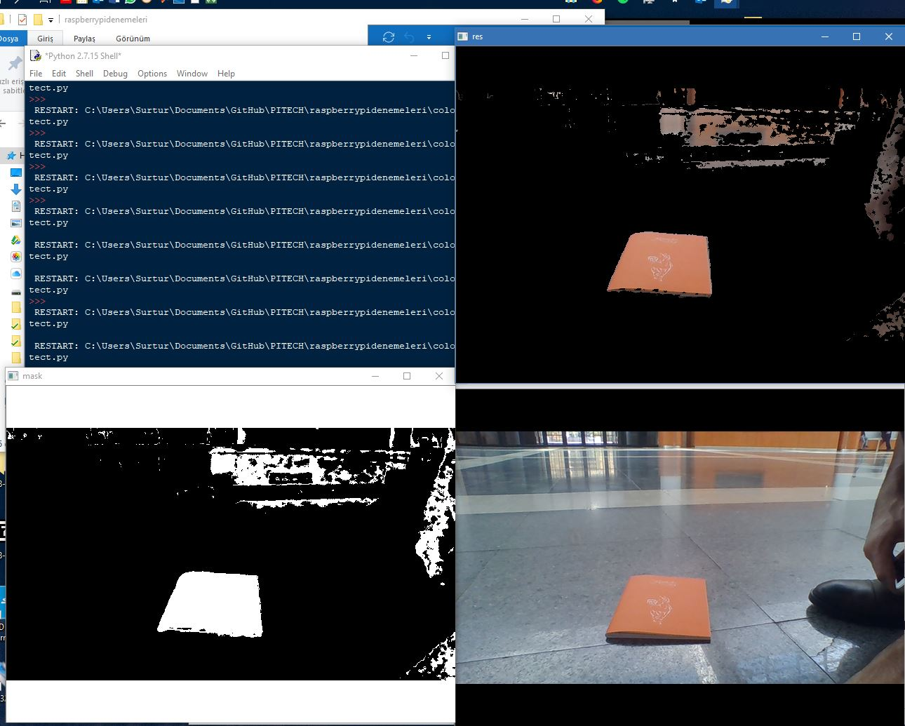

Figure 1 Orange color test

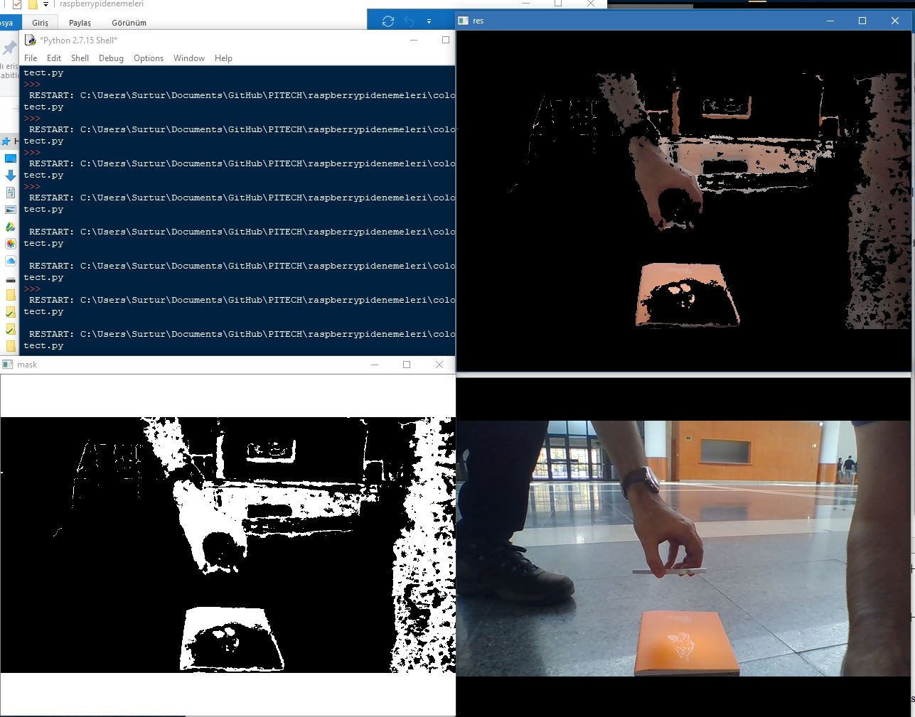

Figure 2 Orange color test with light applied

First, we tried orange color. The detection was quite reasonable as seen in the figure XX, except the wooden parts of the decoration for the walls. They managed to pass through the filter, in addition, their reflection from the floor was also detected by the camera. After first test, we directed a camera flash onto the orange notebook to check whether it affects or not, and as we thought before, the brightness of the object absolutely affects the filtering as seen in figure XX. This situation made us worry because in KKM, the sunlight directly comes through inside and it will cause drastic reflections and bright points as seen in figure XX. Therefore, we concluded that the color of the objects should be matt regardless of the color.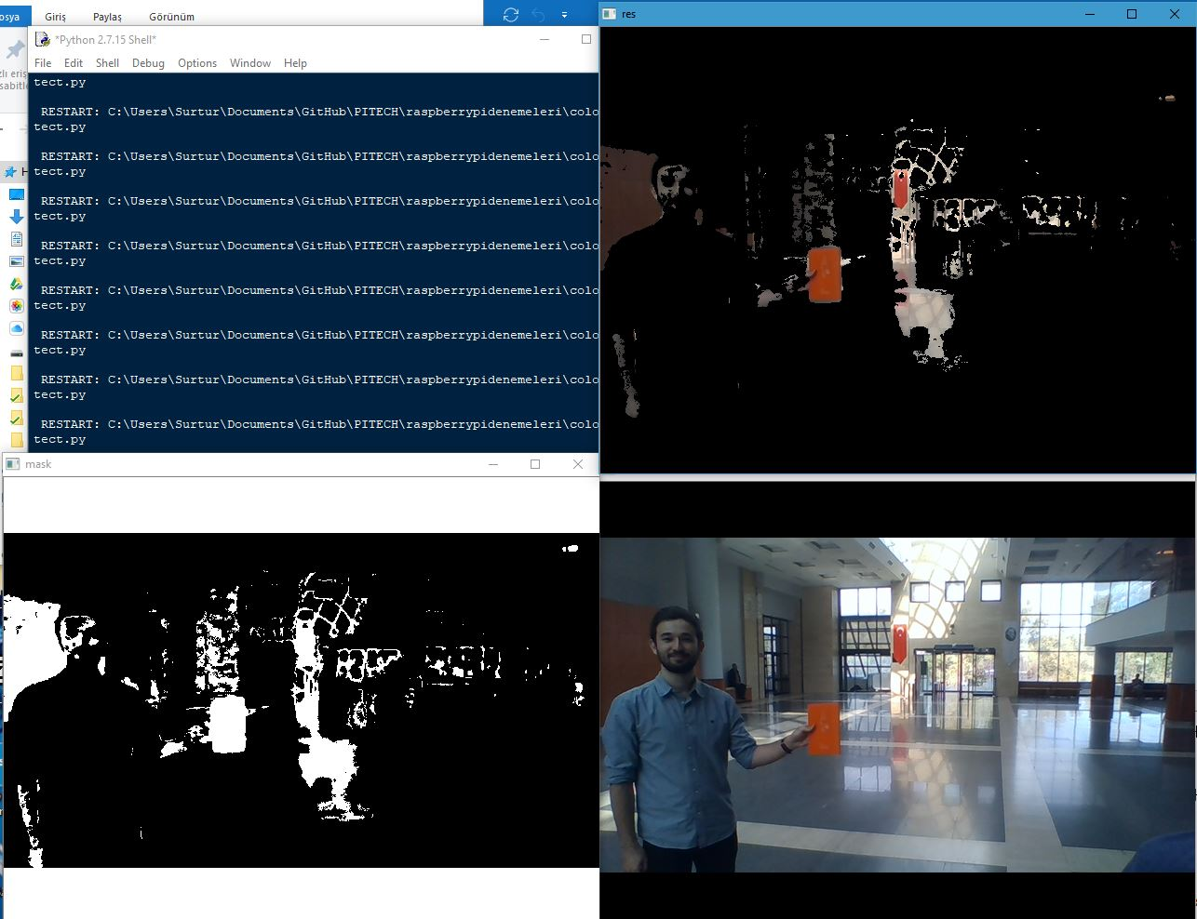

Figure 3 Orange color with some reflections

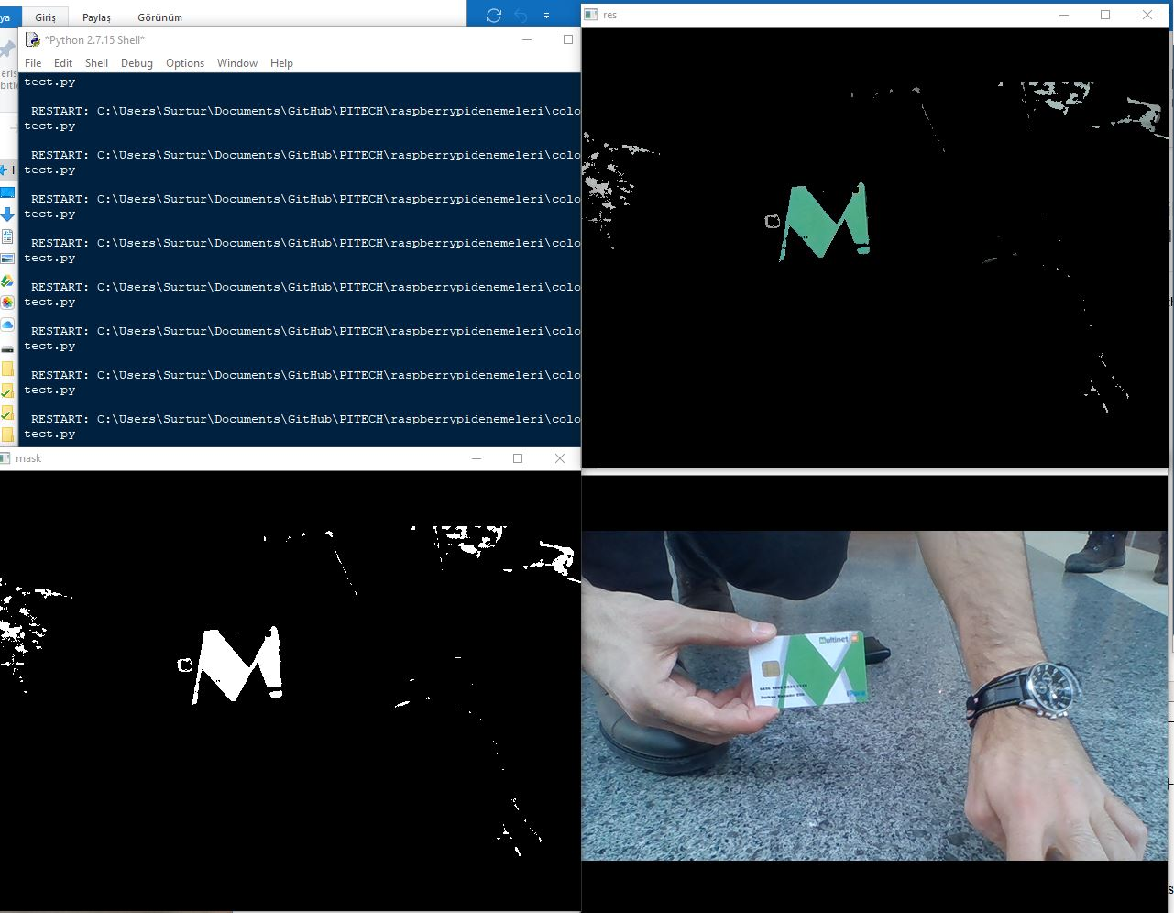

Figure 4 Green color test

For green color, our basic filter performed relatively better. As you can see from figure XX, even little detail were filtered out from the green object. Therefore, we decided to suggest green color for the ball.

For final test, we tried blue color. As we expected, the floor of the KKM got through the blue filter as it contains a lot of blue tones. As seen from figure XX, in the test, the filter completely failed.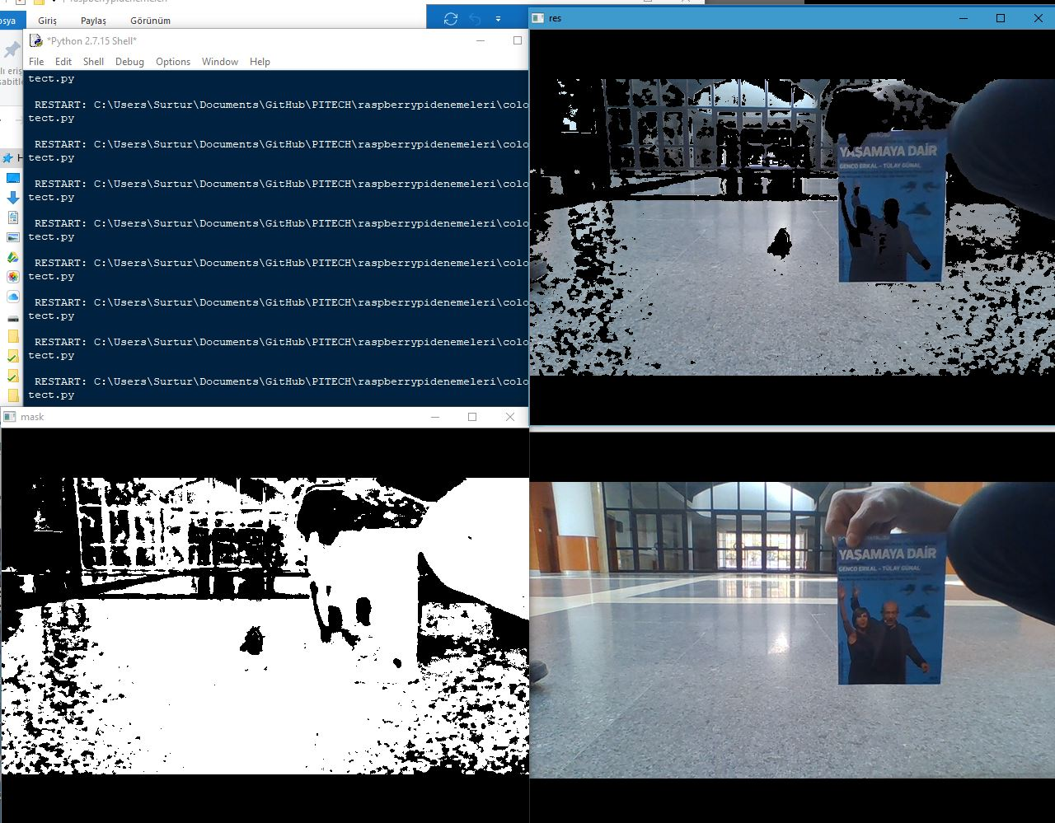

Figure 5 Blue color test

After blue color test, we were sure about which color the ball shouldn’t be, blue. So, in the standards committee meeting, the representative Mr. Elik will point out these test results.