22.11.2018-29.11.2018



**MIDDLE EAST TECHNICAL UNIVERSITY**

DEPARTMENT OF ELECTRICAL AND ELECTRONICS ENGINEERING

EE493 – Weekly Progress Report #7

POTATO INTEGRATED TECHNOLOGIES

A close up of a clock

Description generated with high confidence

**Design Studio Coordinator:** Arzu KOÇ

**Partners and Contact Information:**

Fatma Nur ARABACI 2030047 0533 602 75 27 arabaci.fn@gmail.com

İrem COŞKUN 2030419 0539 414 59 69 iremcoskun0@gmail.com

Aycan BEYENİR 2030328 0539 330 05 70 abeyenir@gmail.com

Berkay GÖKSU 2030757 0505 635 81 45 berkaygoksu1@gmail.com

Furkan Bahadır ELİK 2030518 0554 963 94 10 elik.bahadir@metu.edu.tr

This week we preferred sharing different topics. Each team member’s weekly work is as follows.

**Furkan Bahadır Elik:**

Regarding communication channel progress, Mr. Elik constructed a filter bank which will be used at the FM radio output. This filter bank will be used as channel selector. Each band (channel) will be mapped into a certain command. The designed filters in LTSPice can be shown in Figure 1. The filter bank is contructed to have 10 bands. However, for the demo, only two of them will be used.

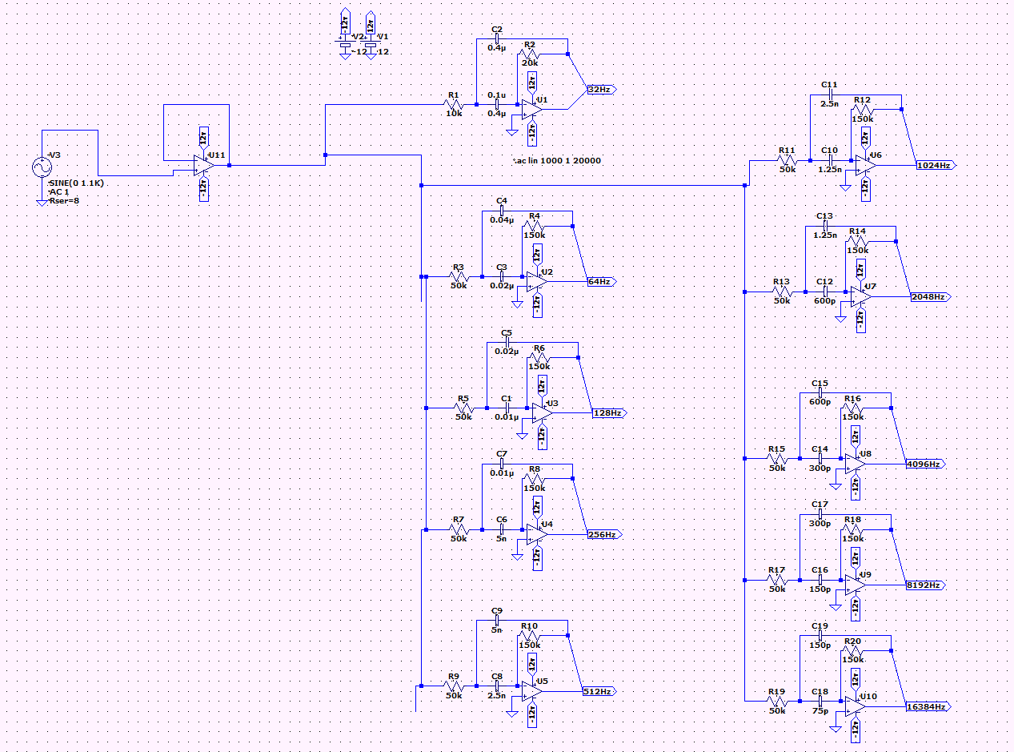

Figure 1 : Circuit schematic of the filter bank

The frequency response of the filter can be seen in Figure 2.

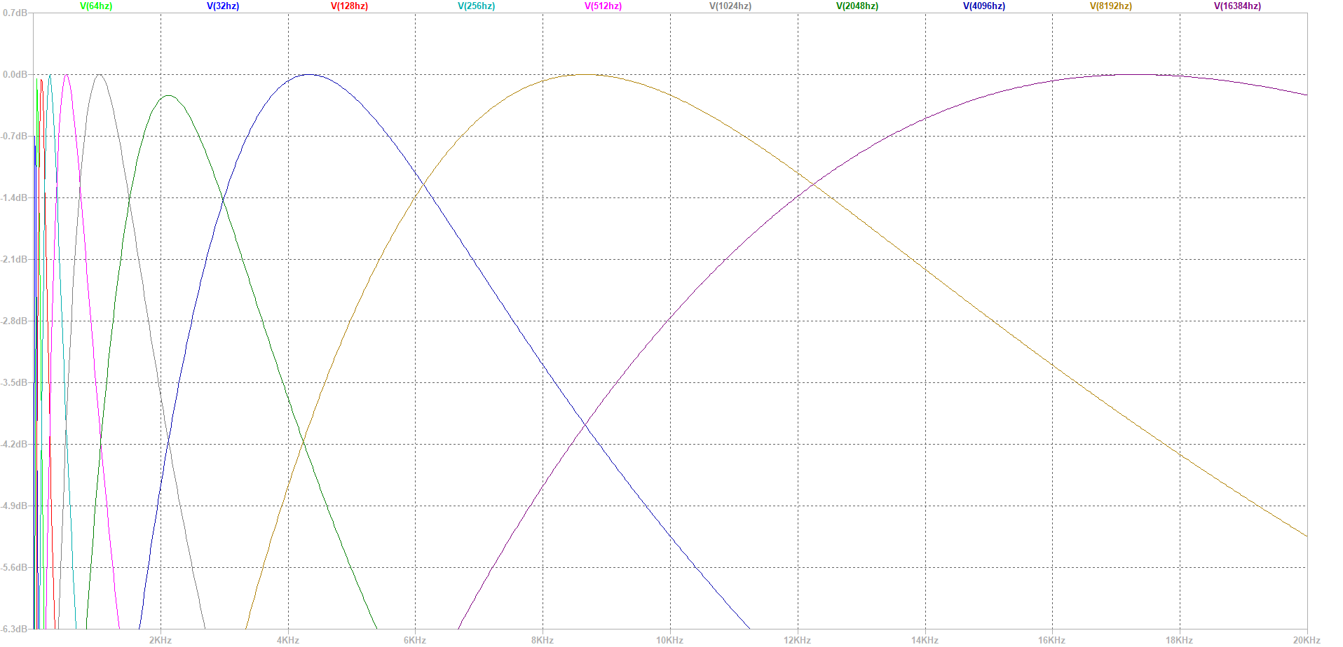

Figure 2 : Frequency Response of the filters

**İrem Coşkun:**

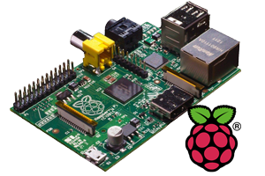 My responsibility for this week was to make some research about main processor subsystem. This week I mainly focused on processor system on the motor rather than the receiver. For input & output operation we decided it is best to use Raspberry Pi before. This week I investigated the operation that we can accomplish with Raspberry Pi. This week my main purpose to understand the GPIO operations of the device. We are planning to use Pi as a decision unit and output the signal accordingly to the motion subsystem. C++ is used for coding the Raspberry Pi because integration with the codes of the other subsystems will be easier. My teammate Fatma Nur Arabacı helped me through this challenging task. We constructed a simple experiment with LEDs in order to use GPIO ports. We accomplished this task so, we can say that we have control over main processor system. The connections between other systems will be covered next week. Also, we did not construct our algorithm fully. But, to sum up it is going to take the signal from its input ports and gives output according to the input ports that have signal. Main challenge we faced was to connect Pi with Ethernet port. We are planning to use Raspberry Pi 3 with Wi-Fi connection but since we do not have it right now, we used one of our member Aycan Beyenir’s Raspberry Pi 2 which does not have a Wi-Fi connection. Figure 3below shows a picture of Raspberry that we are planning to use and continue our trials.

Figure 3 : Raspberry Pi

**Aycan Beyenir:**

In this week I worked on my main responsibility, the development of the detection subsystem. The main responsibility of this subsystem is the detection of the surrounding objects and quantization of this data. Since the main challenge of this project is data transfer between robot and telecontroller, we need to reduce the amount of the transferred data. By processing the image, we can effectively shrink the data. To reach out this objective this week;

* I wrote an RGB to HSV color transformation with only the basic functions of MATLAB. This transformation makes our image processing more reliable and adaptable for environmental color change.
* After then, I started to write a color detection algorithm which separate specific color object from the overall system. With this method we can separate the important objects from the environment noise. This helps our shape detection algorithm to detect objects in shorter process time. The result of this function can be observed in Figure 4.

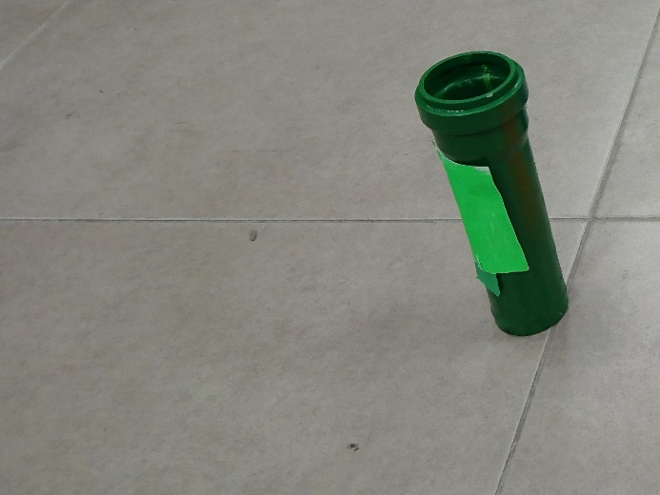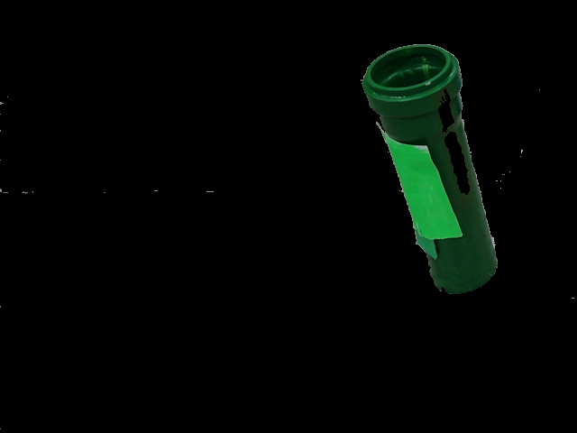

*Figure 4 : Raw image (left) and its Hue filtered version (right)*

**Berkay Göksu:**

This week, my main responsibility was to determine what we should consider when choosing the robot's power supply, and our criteria for this selection.

The robots need power to provide the voltage signals that make the motors turn, the sensors operate and the robot brain. The simplest way of doing so is to use batteries.

As shown in Figure 5, the main types of batteries that can be used in robots are;

* NiMh (Nickel – metal hydride battery)
* LiPo (Lithium Polymer Battery )
* Single Cell Batteries

I've done some research about these types of batteries and decided on some of the criteria that we can use when we decide which one to choose.

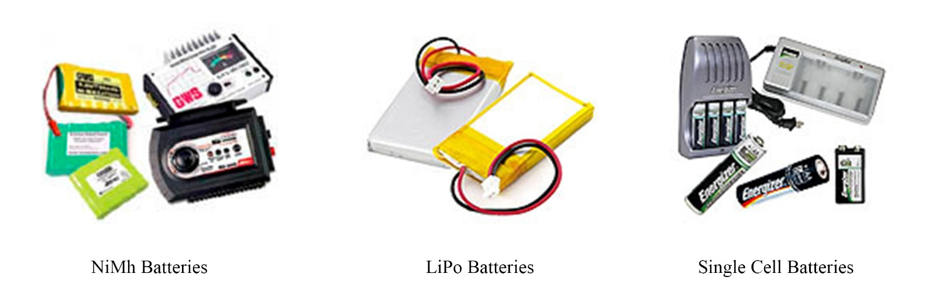

*Figure 5: Battery types*

**Fatma Nur Arabacı:**

This week I tried to integrate a sample encoder with an Arduino to read data from encoder which will be used in the motion subsystem. After some research on encoder types there are two possible types of encoders in the field which are:

* Incremental Encoders
* Absolute Encoders

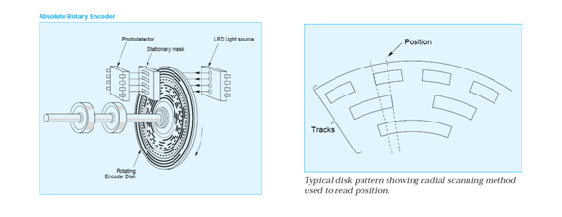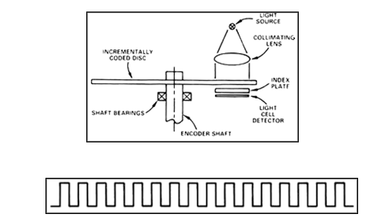 Both type of encoder components and a pulse train produced by Incremental Encoder is as in Figure 6.

*Figure 6 : Incremental (Right) & Absolute Encoder (Left) Components*

First type is used for speed and position tracking. In this type turn count is measured easily but position accuracy is not available.

Second type of encoders are used for accurate position tracking since each position have specific ID so that we can simply know the exact position of the shaft attached to the encoder.

Incremental encoder seems to be more useful for our purpose. Since in motion subsystem we will command the motors to turn specific number of turns to reach the desired position or achieve the desired turn to the left or right. However, we are still searching the areas where Absolute encoders are used. Maybe we will used them both since in the shooting subsystem we may use another motor working in a different way than the ones in the motion subsystem.

After this research I wrote a code in Arduino IDLE and after building the code I managed to observe the count number on the screen. For our specific type of encoder and gearbox ratio every 2640 count means one full turn. Both CW and CCW is available. This module will be used in motor driving part. It will also prevent the turn mismatches between the right and the left wheel for example. We will use this encoder count as a feedback between tires to make our robot move more accurate and straight.

Other than Arduino work, İrem Coşkun and I worked on connecting Raspberry Pi to our PC via Ethernet cable. After following some tutorials, we managed to connect through ethernet cable using Putty Interface. We identified an IP address for our Pi and connection was successful. Now we will solve the issue with the space inadequacy which was also occurring when we are connecting Pi to PC via a router.

**Next Week’s Plan:**

* At least two band pass filters will be implemented and tested.
* Space inadequacy of Pi SD Card will be figured out.
* We will investigate ready kits for transmission and receival of the signal such as drone kits.