This week, we focused on LiPo batteries for battery selection. The reason of focusing on the LiPO battery is that it is lighter and its efficiency was high. The main work of this week about power supply was the use of the battery rather than the choice of battery. We've researched the chargers to charge the battery.

In addition, we understand that we may be able to change the input and output voltages when using the battery. That's why we decided to use the switching converter.

Switching converters (such as buck converters) provide much greater [power efficiency](https://en.wikipedia.org/wiki/Power_efficiency) as DC-to-DC converters than [linear regulators](https://en.wikipedia.org/wiki/Linear_regulator), which are simpler circuits that lower voltages by dissipating power as heat, but do not step up output current. For this reason, more detailed research has been done on buck converter usage. A buck converter (step-down converter) can be seen in Figure x, is a [DC-to-DC power converter](https://en.wikipedia.org/wiki/DC-to-DC_converter) which steps down voltage (while stepping up current) from its input (supply) to its output (load).

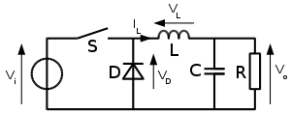

Figure : Buck Converter Schematic

NEXT WEEK:

Batteries research will continue without being highest priority.

In the demo, we will try to determine the voltage and current that the battery should provide.