What has been done:

This week, We were supposed to implement the band bass filters that were designed previous week, however, as a company, we decided to go with Tiva (Texas instrument microprocessor evaluation board) or an Arduino to count the frequencies of the input signal due to the fact that the analog filters will be too sensitive to environmental effects and implementing them correctly will be quite challenging. Therefore, this week, we worked on sending different pulses with different inputs over FM channel that I was implementing. First, we have managed to use Raspberry Pi’ GPIO pins as a input buttons using WiringPi library and depending on the states, I have managed to send specific sine waves with different frequencies. In other words, we did manage to send commands to wireless location. Further optimization will be done in the transmitter program in the following week. On the other hand, Bahadır made a better antenna (it was a simple jumper wire before) using a think satellite receiver coaxial cable to achieve even better range and noise performance. The new antenna can be seen in Figure 1. Testing on the new antenna, we as a team observed that the signal power is way above the level it was before. We believe that with this antenna design, we won’t need an amplifier to boost the signal. However, the antenna can be further improved in the following weeks.

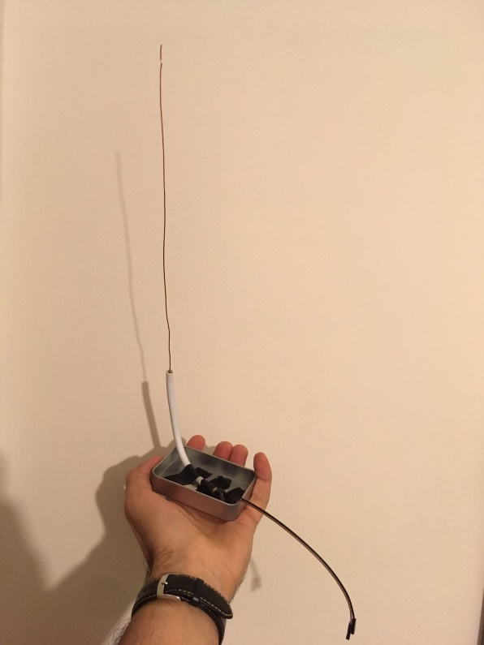

Figure 1: The antenna

For the receiver part of the telecommunication system, frequency measuring code implemented on Assembly. We do not believe Assembly is the most efficient language for this task but since most of our members have a better control on this language we decided to give this a chance. During our tests TIVA TM4C123GH6PM microcontroller used. This option is actually cheaper because TIVA board is $12.99 while a Raspberry Pi3 is more than $30.00. During the tests we worked with two different frequency signal which are 10kHz and 20kHz. These frequencies represent different commands like left and right. Transmission of this signals was already has been made so, we worked with signal generator. We managed to give different outputs for different frequency levels. This means that we have a fully functional system to identify the different commands and give different outputs respectively. These outputs are going to be connected to Motors later. We are waiting for our shipments to arrive in order to try the whole communication system. Figure 2 below shows the Assembly implementation of commands for different frequencies.

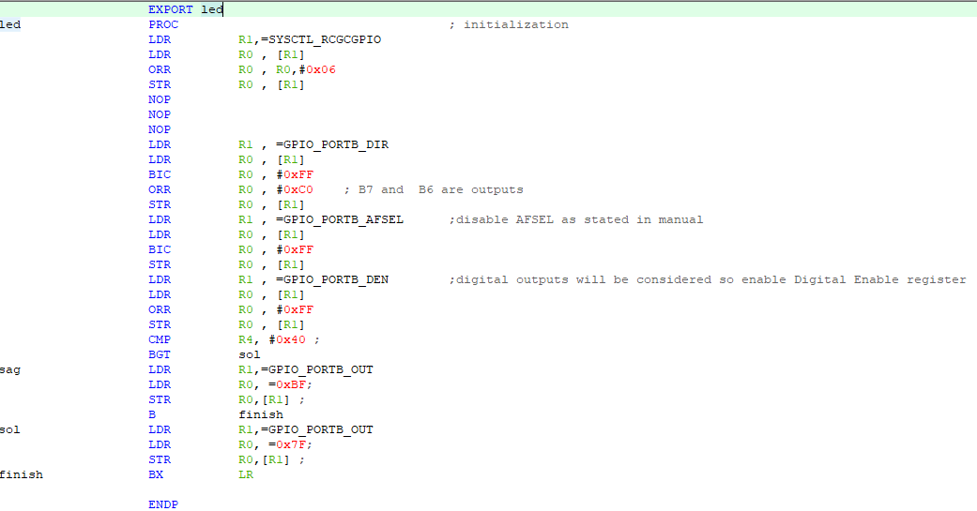

Figure 2: Assembly implementation for identifying different inputs and give outputs respectively

NEXT WEEK:

* Next week, we will try to blink a LED at a remote location using complete communication link that is Raspberry pi, FM radio and Tiva or Arduino.
* Arduino for frequency measuring also going to be tested for plan B.
* Complete command test on actual DEMO place (E and D buildings) will be tested.
* Mora command options will be added to both transmitter and receiver systems for having better control over our robot.
* Optimization on already working systems will be made.
* Also, for the image transfer task, we will try a new drone kit that we had ordered as a plan B that we are waiting it to be shipped.