In this week we started to learn required drawing programs for the design of shooting subsystem. The program which is called “Rhinoceros” is used for 3d modeling of the shooting subsystem and “Keyshot” is used to get the end product image of the system.

According to our experiences, there should be two angular sticks that are parallel to ground for holding the ball closer to rotational shooting part.

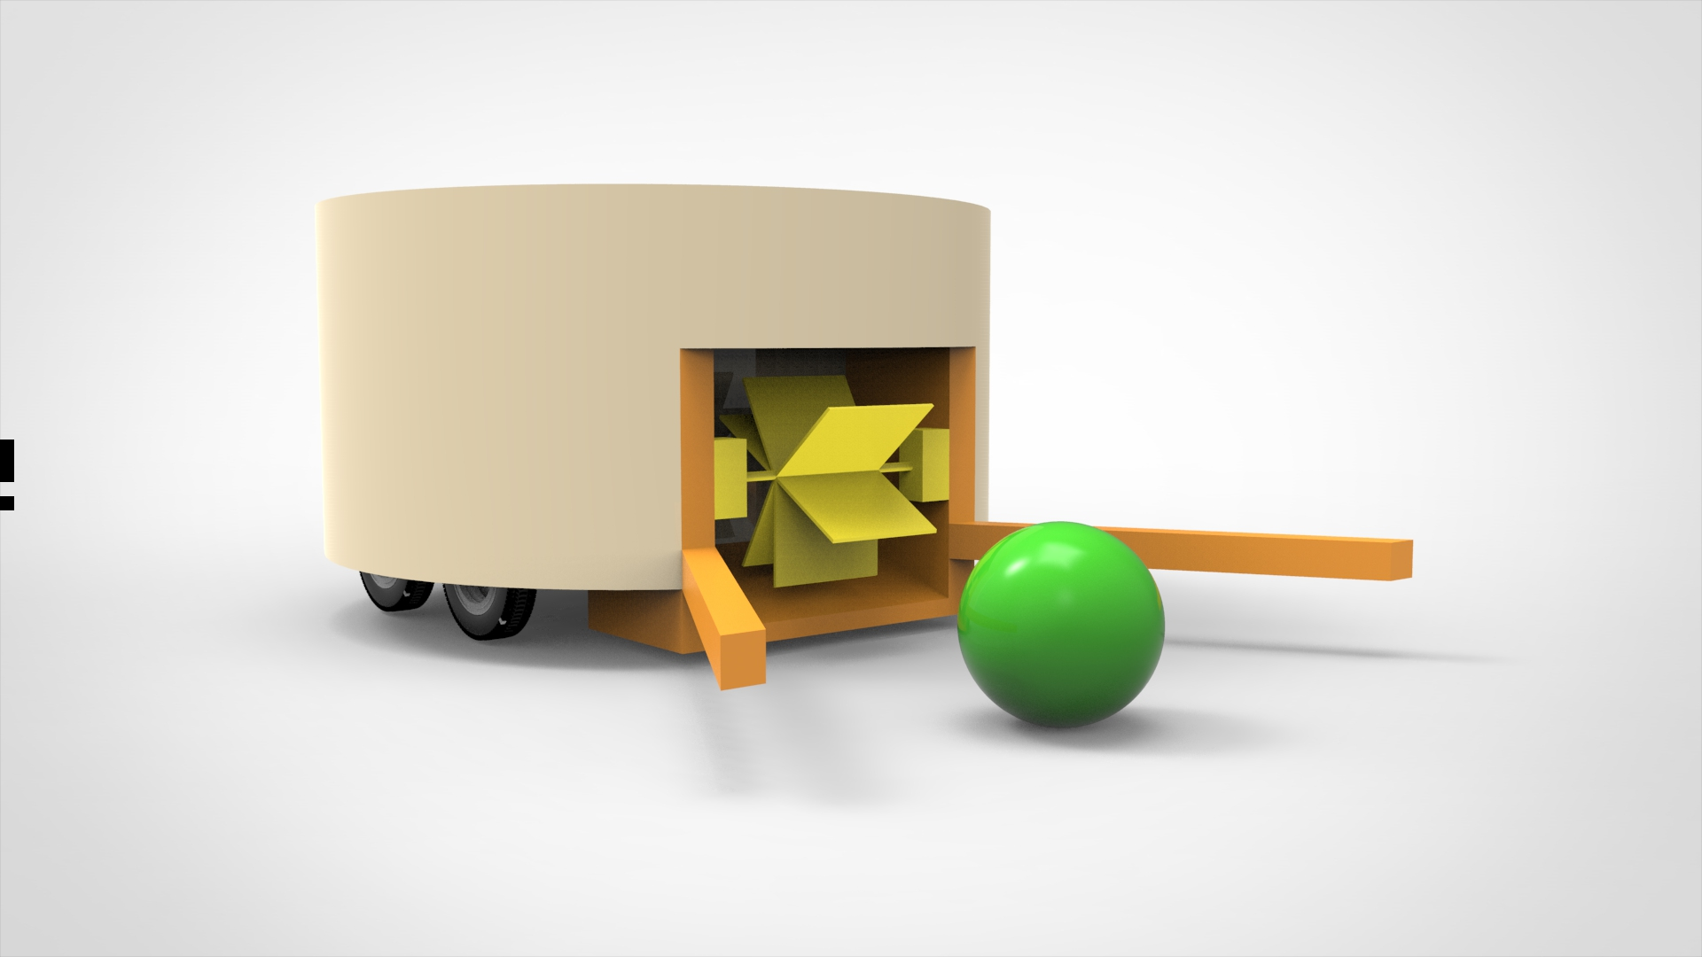

Figure 1: Shooting Subsytem Design

In the figure 1, the orange ones are represent these sticks. The radius of the ball is 4 cm and it gives reference for the rest of the model. The length of the sticks are 25 cm and the radius of larger cylindrical part is around 20 cm. The yellow parts represent the rotational shooting system.

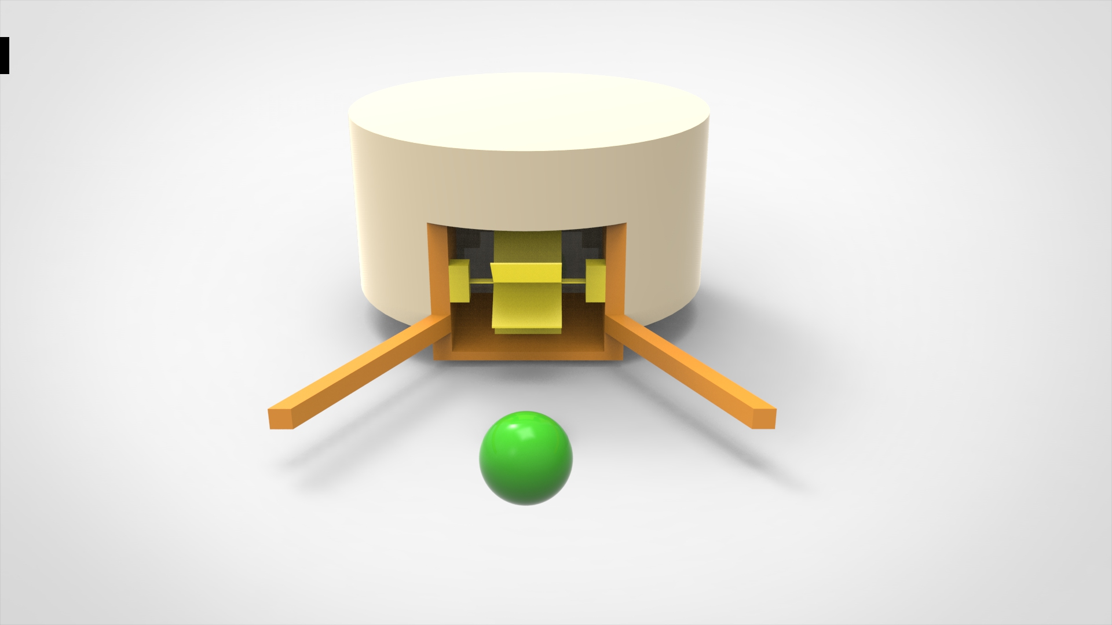

Figure 2: Shooting Subsytem Design (front view)

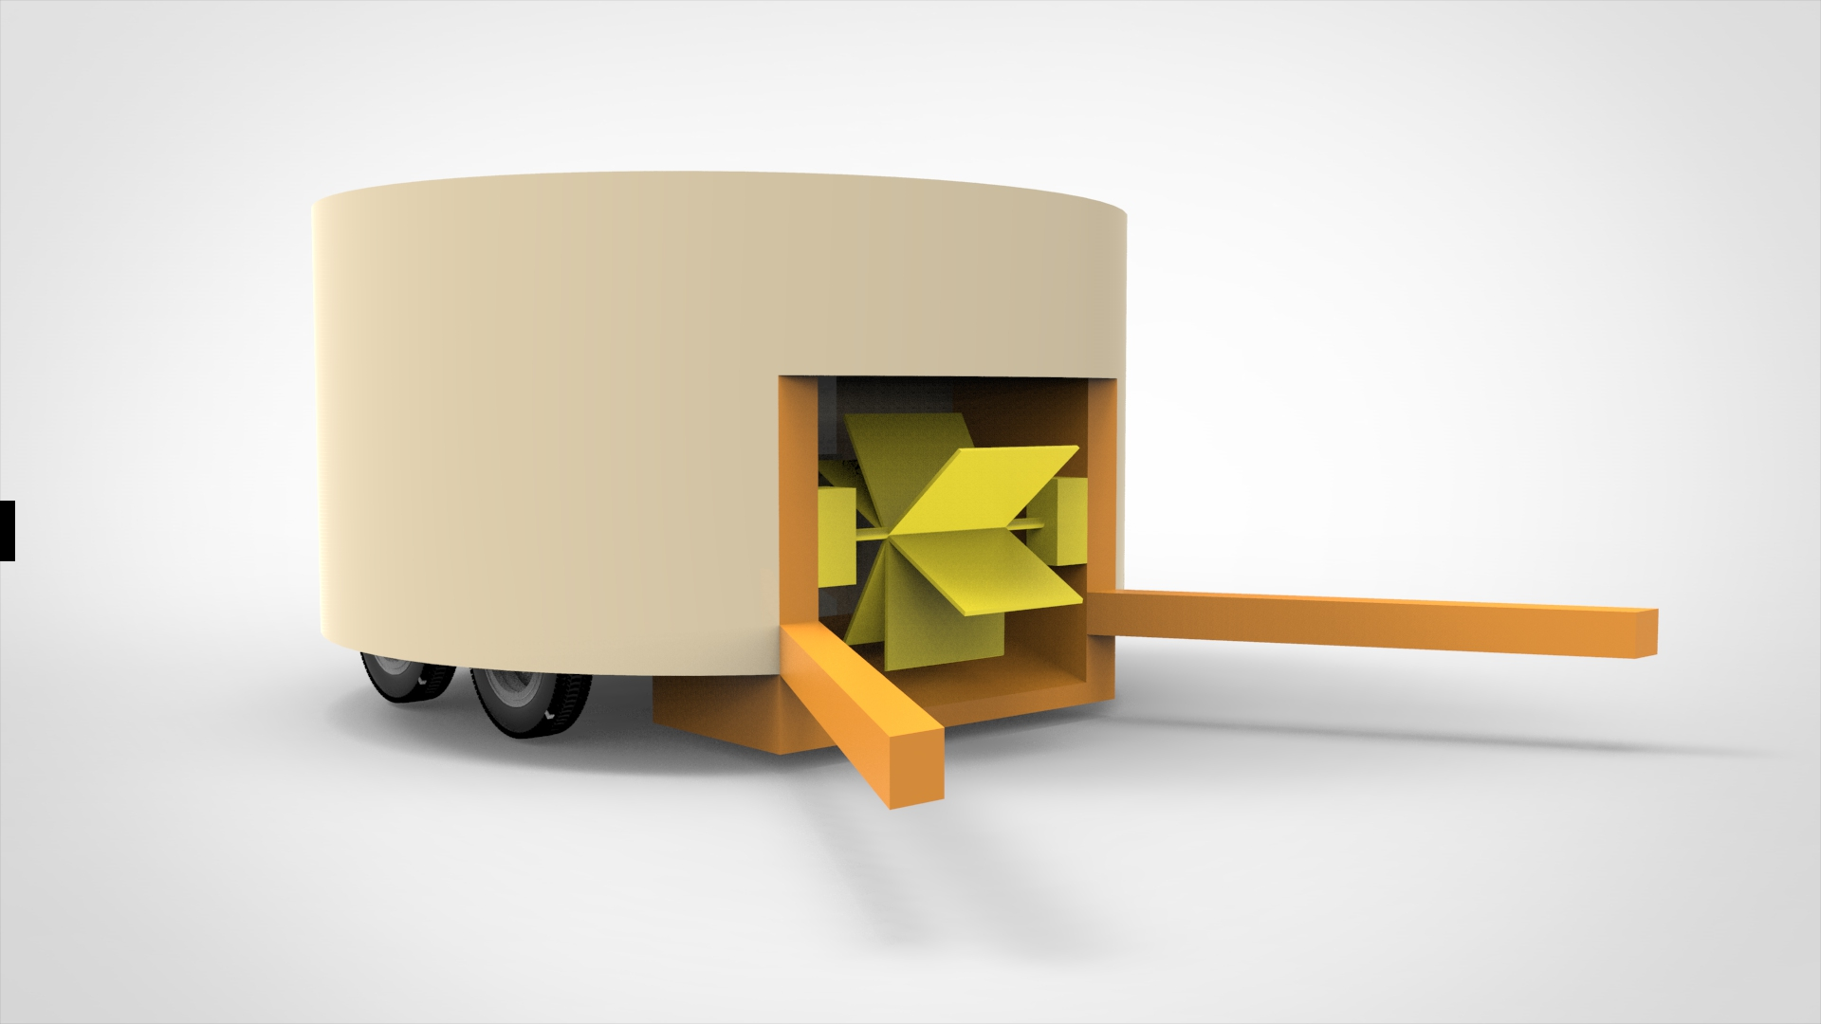

Figure 3: Shooting Subsytem Design (Alternative 1)

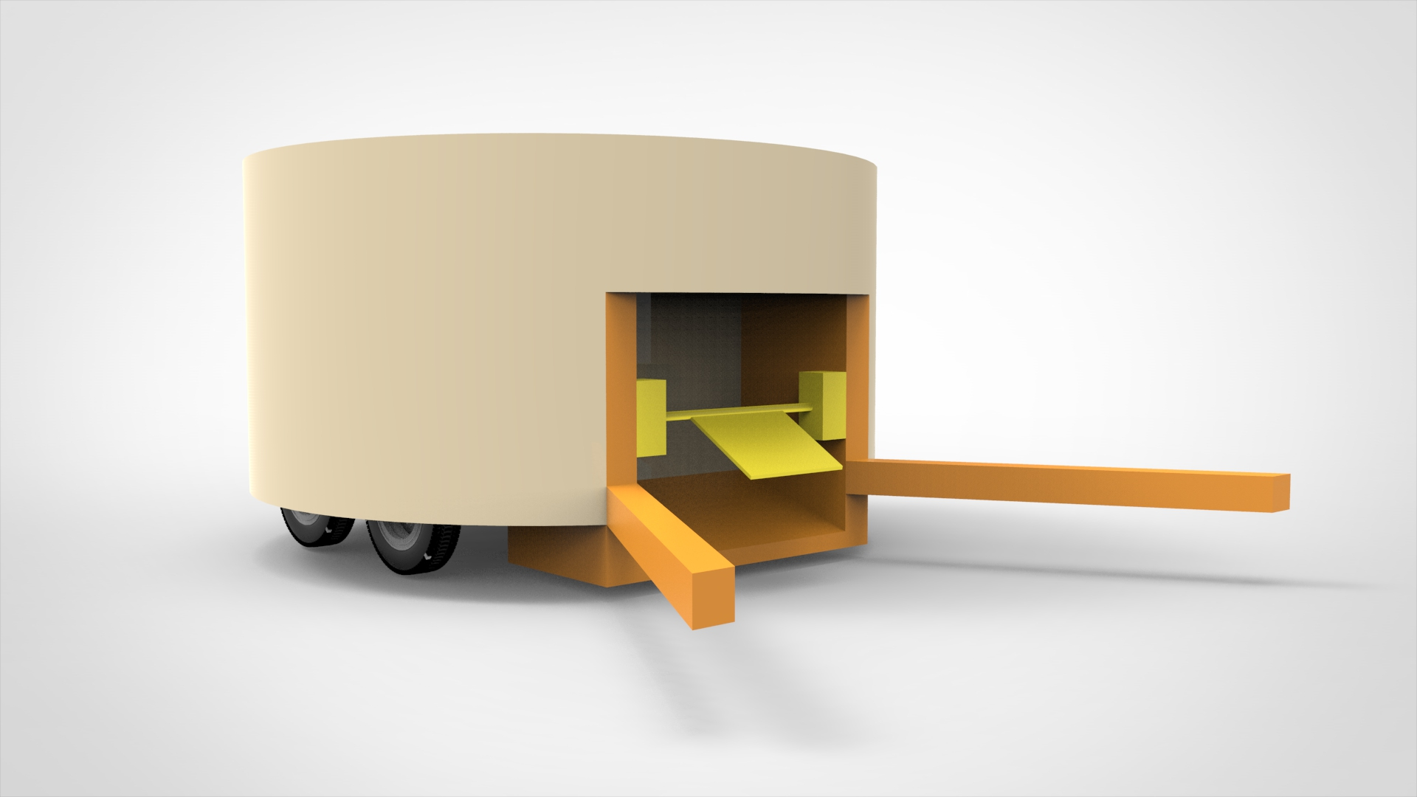

Figure 4: Shooting Subsytem Design (Alternative 2 )

As a first alternative of rotational shooting system, there can be one piece and it shoots the ball by rotating around itself, or the second alternative is multiple pieces connected to a single part. One of them can be chosen in later stages.