20.02.2019-27.02.2019



**MIDDLE EAST TECHNICAL UNIVERSITY**

DEPARTMENT OF ELECTRICAL AND ELECTRONICS ENGINEERING

EE493 – Weekly Progress Report #12

POTATO INTEGRATED TECHNOLOGIES

A close up of a clock

Description generated with high confidence

**Design Studio Coordinator:** Arzu KOÇ

**Partners and Contact Information:**

Fatma Nur ARABACI 2030047 0533 602 75 27 arabaci.fn@gmail.com

İrem COŞKUN 2030419 0539 414 59 69 iremcoskun0@gmail.com

Aycan BEYENİR 2030328 0539 330 05 70 abeyenir@gmail.com

Berkay GÖKSU 2030757 0505 635 81 45 berkaygoksu1@gmail.com

Furkan Bahadır ELİK 2030518 0554 963 94 10 elik.bahadir@metu.edu.tr

**What has been done:**

We started working on our shooting system. After some arguments between team members we still have not decided which type of motor we should use. However, servo motor implementation on Arduino and its shooting mechanism drawings have been made. Figure 1 below shows the shooting system with a servo motor.

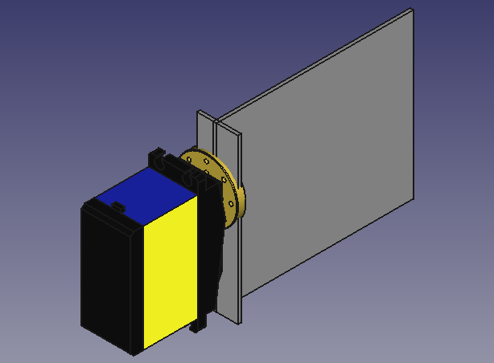

Figure 1: Shooting system drawing

In Figure 1 motor turns the plate which is going to shoot the ball. This is only a proposed design. However, our final design will have a plate like this. After some tests with servo motor, we are not sure if the speed will be enough to shoot the ball as strong as we desire. We are also considering changing the servo motor with a DC motor. The design will be kept same for DC motor but DC motor option also needs a driver so first next week we are going to try servo motor option with its shooting mount.

This week we started the tests of transceiver module. It took couple of days until we managed to make it work. Now we have new transmission and communication module working properly. Tests have been done. Also, joystick implementation to the system was made. So, now we are able to send comments of right, left, forward, slow down and shoot.

Insert picture here baho.

Also, we started the design of our robot’s body.

Insert picture here fato.

**Next week’s plan**:

* Range tests will be implemented for communication module at the demonstration area.
* The final body design will be bought, and motor and body will be connected with the other modules.
* The system tests will be made with body and load conditions.