21.01.2019-20.02.2019



**MIDDLE EAST TECHNICAL UNIVERSITY**

DEPARTMENT OF ELECTRICAL AND ELECTRONICS ENGINEERING

EE493 – Weekly Progress Report #11

POTATO INTEGRATED TECHNOLOGIES

A close up of a clock

Description generated with high confidence

**Design Studio Coordinator:** Arzu KOÇ

**Partners and Contact Information:**

Fatma Nur ARABACI 2030047 0533 602 75 27 arabaci.fn@gmail.com

İrem COŞKUN 2030419 0539 414 59 69 iremcoskun0@gmail.com

Aycan BEYENİR 2030328 0539 330 05 70 abeyenir@gmail.com

Berkay GÖKSU 2030757 0505 635 81 45 berkaygoksu1@gmail.com

Furkan Bahadır ELİK 2030518 0554 963 94 10 elik.bahadir@metu.edu.tr

**What has been done:**

As PITECH, we held our first official meeting after the presentation when final’s week is over. We gathered in company headquarters to discuss the following period for the project. Since most of the members were planning to leave Ankara for semester break, we scheduled our next meeting on February 11th. That day we formed test procedures / scenario for the motor driving procedure we were planning to do. Moreover, we did market search since we needed a module for command transmission towards the robot from the controller side. This was our alternative solution for data transmission as mentioned in Conceptual Report. We found an Arduino compatible Transceiver module (NRF24L01) which will enable us to eliminate Raspberry PI, save money on our budget , and reduce the complexity of the system. Therefore, we ordered this module and as soon as it arrives, we will implement initial tests on it. In the next meeting on February 16th , we drove our DC motors for the first time. At first, we used our power supply in the Design Laboratory and a simple Arduino code that generates PWM with respect to the adjustable voltage level (via a pot) from one of the analog input pins. That PWM signal is sent to the motor driver (L298N) module which can drive up to two DC motors. With this setup as in Figure 1, we implemented a speed control of the DC motor and examined the maximum speed and current it draws with no load.

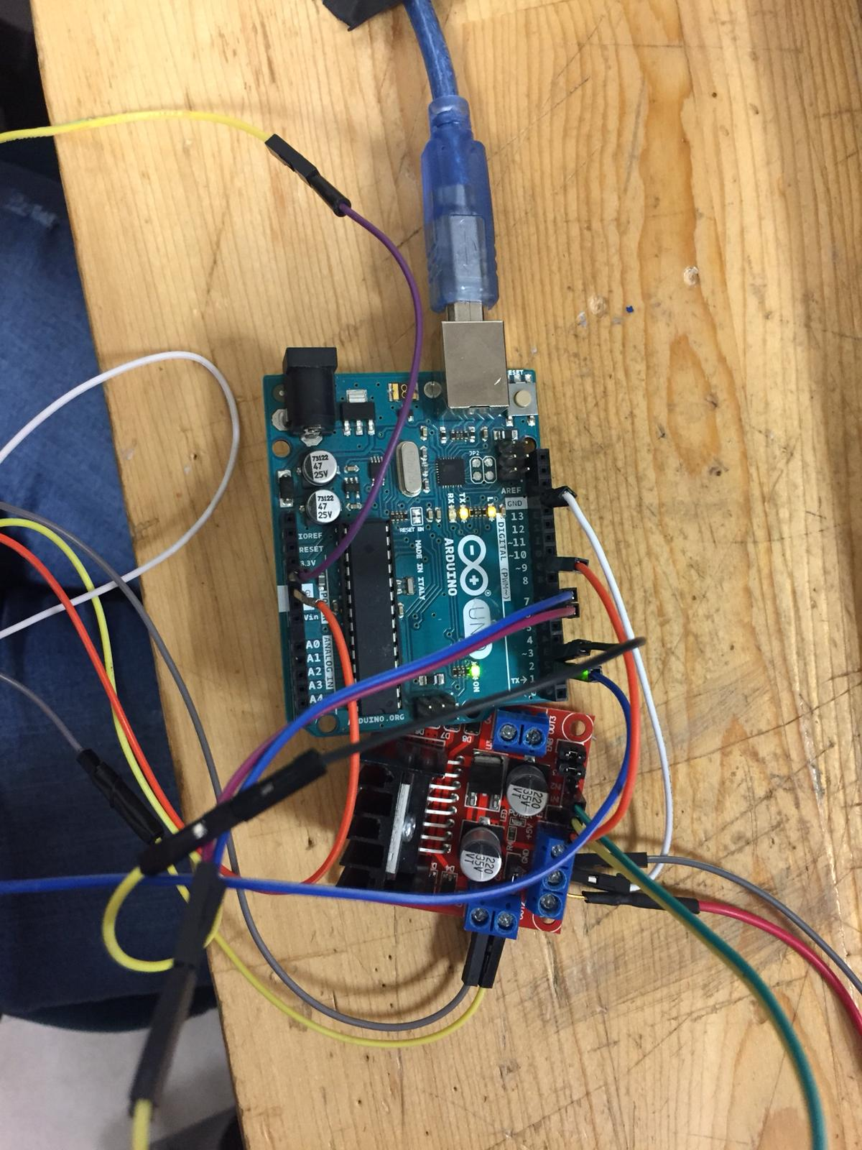

Figure 1: Motor drive setup with a L298N and Arduino UNO

Figure 2 below shows our motor connected to motor driver. We experimented no load conditions with this setup.

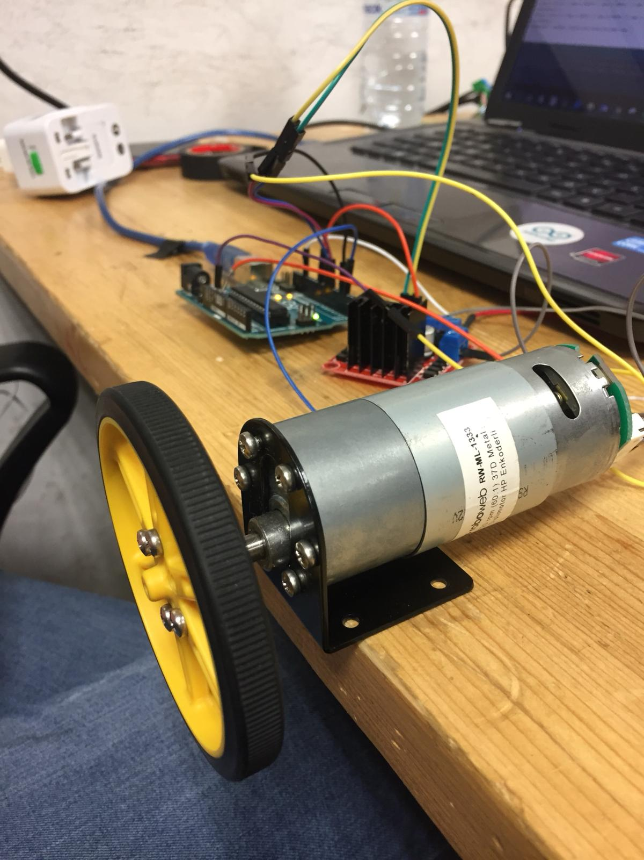

Figure 2: Motor driving circuit with motor

Figure 3 below shows the DC supply when we experimented under no load conditions while using 12V as supply voltage.

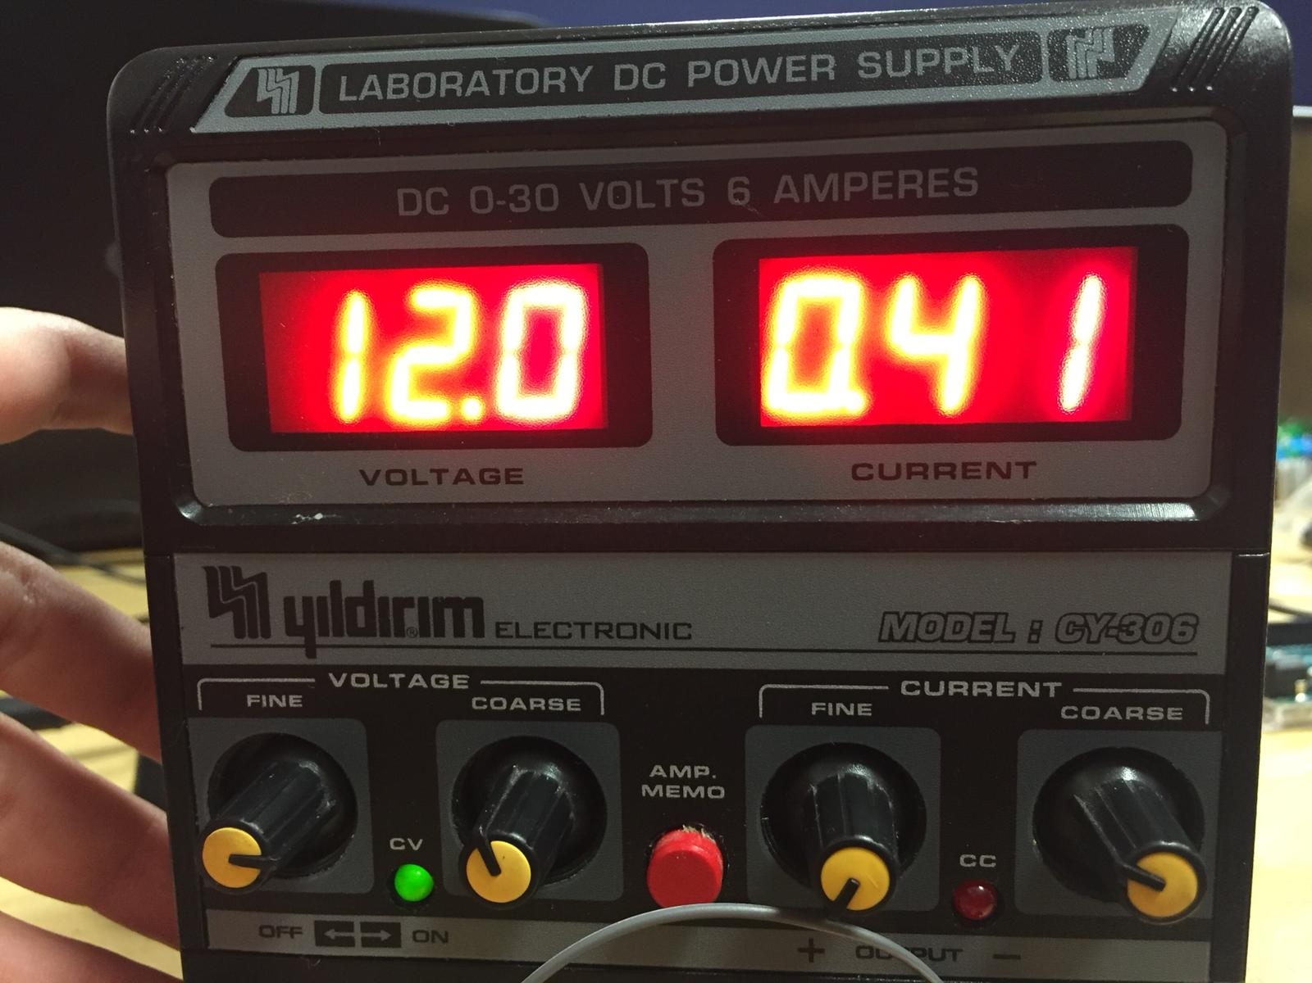

Figure 3: DC voltage reading under no load condition

The results can be seen in Figure 3. Under no load condition our motor draws 0.41A when 12V used as supply voltage. We need to repeat the same tests under load and then we may consider changing the gear ratio in order to increase torque, lower speed or vice versa. We couldn’t run two motors together because the other motor’s shaft and wheel integration needs to be fixed. Then we integrated the encoder reading code with motor driving code and observed correct readings from the serial monitor of Arduino IDE. The accuracy of the encoder reading is highly crucial since this will be used for calibration and optimization of the two DC motors.

Another topic is the control buttons for the tele-controller. At first, we considered to use regular direction buttons but for the sake of simplicity and feasibility we ordered a joystick.

**Next week’s plan**:

* Motor tests under load will be implemented.
* Transceiver module will be tested if it arrives within this week.
* Other motor’s shaft and wheel integration will be fixed.
* Two motors will be driven together.