Cycle Route 1:

A to B:

X miles

Route:

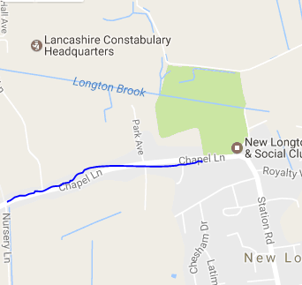Turn left then right then left then left then right then left then right then left then right then left then right then left then right then left then right then left then right then left then right then left then right then left then right then left then right then left then right then left then right then left then right then left then right then left then right then left then right then left then right then left then right then left then right then left then right then left then right then left then right then left then right then left then right then left then right then left then right then left then right then left then right then left then right then left then right then left then right then left then right then left then right then left then right then left then right then left then right then left then right then left then right then left then right then left then right then left then right then left then right then left then right then left then right then left then right then left then right then left then right then left then right then left then right then left then right then left then right then left then right then left then right then left then right then left then right then left then right then left then right then left then right then left then right then left then right then left then right then left then right then left then right then left then right then left then right then left then right then left then right then left then right then left then right then left then right then left then right then left then right then left then right then left then right