Java Ray Casting
by Brian Pratt

An overview and explanation of ray casting algorithms and Java code samples to further illustrate these techniques.

Introduction

Ray Casting was made famous in the early 90’s with the classic shareware video game Wolfenstein 3D. ID Software’s guru programmer, John Carmack, who incidentally made Bill Gates’ short list of geniuses, came up with a way to deliver simple 3D, first-person adventures even on the unsophisticated personal computers of the day.

Ray Casting Defined

Ray Casting is a pseudo-3D rendering technique that transforms a simple aerial map into a 3D projection. The effect is achieved by sending out one ray for each column on the screen and checking if it intersects a wall and drawing the wall if intersection occurs. Though the results are crude renderings characterized by long hallways with block shaped rooms, this technique allows live, real-time renderings suitable for first-person interactivity.

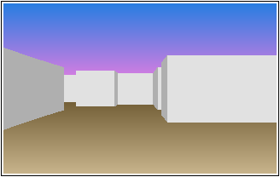

Ray Casting is NOT Ray Tracing

Ray casting should not be confused with ray tracing. Ray tracing is the complex task of evaluating the path taken by a ray of light through a complex scene, calculating reflection, refraction, and absorption of the ray as it bounces around in the scene. One can appreciate the complexity of this technique upon realizing that casting a single ray of light is not enough. An entire stream of photons must run through this simulated process in order to render one single frame from the scene.

To render one frame on a 320x200 display, ray casting would require tracing only 320 rays—one for each column. Ray tracing, however, would require tracing a minimum of 64,000 (320x200) rays in a much more complex manner. As a result, ray casting is blocky but renders rather quickly. Ray tracing is realistic, but renders slowly.

Ray Casting Tricks and Techniques

Ray casting relies heavily on trigonometry and because trigonometric functions are computationally expensive and time consuming, all relevant sine, cosine and tangent functions are loaded up as tables in memory as the program is invoked. During rendering, all needed trigonometric functions can be performed as simple memory look-ups rather than computations, thus saving significant compute time.

The virtual world can be thought of as nothing more than a series of blocks where the sides of the blocks are the walls seen by the player. The blocks are aligned to form rooms and hallways as desired and often resemble a lab rat maze. From an aerial view, the blocks would appear as a series of tiles aligned on a grid consisting of horizontal and vertical lines. All walls are at 90 degree angles from the floor and all walls and floors are conveniently flat.

In our computations, nearly all numbers are powers of two, making multiplication and division operations instantaneous through register shifts. The width of the virtual world (the maze) must be a power of two. Each wall must be 64x64 and the spacing between the horizontal and vertical grid lines is always 64.

In determining where a ray hits a wall, a table in memory holds the distances between all horizontal lines for every angle (or ray) perceived by the player. A similar table of distances between all vertical lines at a given angle is retained in memory as well. Both are built as the program loads, and both ease the burden of real-time rendering computations.

Using these techniques, computation for each ray cast is narrowed to a few register shifts and a few memory lookups as the ray iterates, running from one grid line to the next looking for a wall hit. The culmination of these constraints and techniques allows for adequate real-time rendering.

With sufficient memory present, images can be loaded and held in memory allowing for individual access of image pixels as a two dimensional array. The transfer from this context to the actual screen is fast and flicker free. This technique will help accommodate transparent pixels, such as those found in image .GIF files or .PNG files, making them suitable for props or wall images in the game

Rendering A Single Frame

At the heart of the ray casting algorithm are two vital methods. The first method traces a ray, and as it crosses each horizontal line on the grid, it checks to see if a wall is present. If so, it marks the distance and position of the intersection and returns. If not, it continues on to the next horizontal line and then the next until the edge of the maze is reached.

The second method does the exact same thing as the first, but now with vertical lines. At the completion of these two methods, a comparison is made between the closest horizontal wall hit and the closest vertical wall hit. A slice of the appropriate wall is then drawn, scaled by the distance between the player and the wall.

In order to render one frame in our sample code, this must be done 320 times—one for each screen column. Most ideally, 30 frames must be drawn every second for a smooth animation.

This process might initially sound tedious and slow, but because everything is set up in advance, the process can be unexpectedly quick. That is what makes these algorithms so fascinating. Distances between the grid lines are in powers of two facilitating fast math through register shifts. Positions and distances at various angles are easily calculated using our sine, cosine and tangent look up tables in memory. Distances are set up in the first iteration so moving from one line to the next is the same for every iteration of our ray casting loop.

Code Explanation and Details

Here we seek to outline the details of ray casting and clarify the algorithms and code provided.

General Orientation

In our sample, we will preserve the default “mapping mode” of the display context as a “text orientation” with the origin being at the upper left-hand corner of the screen. The player’s position is therefore always a positive x and y offset from this origin. This has interesting side effects that we must concede. For example, the player starts off with an angle of 0 degrees heading due east as you might expect. However, the orientation is flipped so that 90 degrees is due south rather than due north which may be counter-intuitive but workable. The figure below illustrates this unique arrangement along with the player’s initial position and field of view.

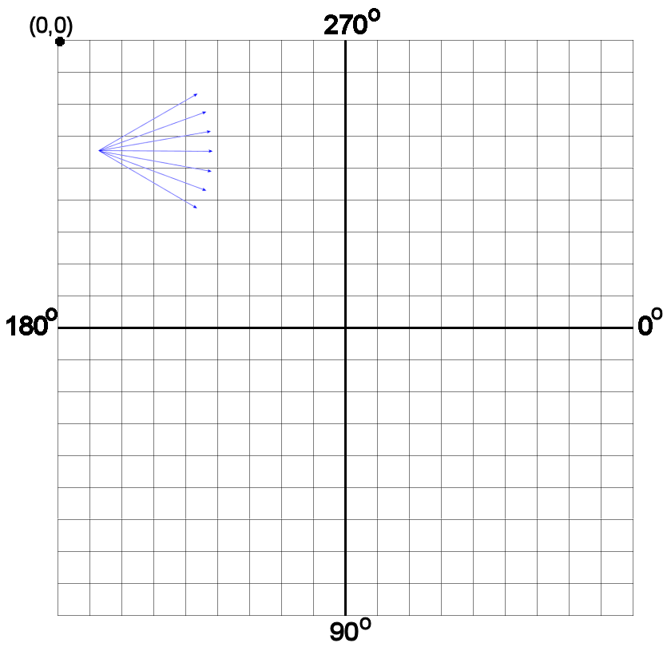

The player can be thought of as walking across square tiles that are a fixed 64 pixels wide. To make things easier, the player’s height is 32 pixels high, or half the height of the walls. The player’s height never changes. The player’s field of view is always 60 degrees—much less than a real human’s field of view (approx. 90 degrees).

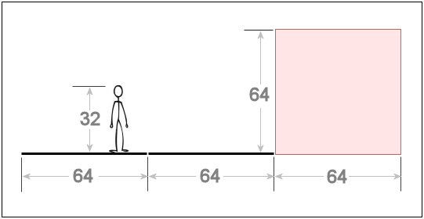

The projection plane is what the user sees and is a 320x200 representation of user’s field of view, mentioned above. Here is an aerial view of the player’s field of view and the projection plane:

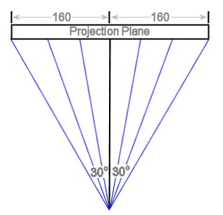

The player’s distance to the projection plane is at a fixed 277 pixels and is computed using the formula below:

(320 / 2) / tan(60 / 2) = 277

Here the 320 represents the width of the projection plane and 60 represents the field of view angle. In the formula, we are finding the distance based upon a known angle and a known opposite site.

The blue rays shown in the drawing above start from the player, pass through the projection plane, then continue on to hit a wall in the virtual world. The projection plane serves as a means to draw what the player sees.

Player Movement

The program provided creates a worker thread that remains in a continuous loop of drawing one complete frame and then sleeping for a fraction of a second, then starting over again. The frame is drawn as a snapshot from the perspective of the player at the moment when the worker thread awakens. The program acknowledges keyboard events in the traditional way with keyUp and keyDown events. If a relevant key (up arrow, down arrow, left arrow or right arrow) happens to be down when the worker thread is awakened, the program will then take action.

Before each frame is drawn, variables retaining the player’s position in the Maze object are adjusted accordingly. Five variables are most critical in our implementation. fPlayerX and fPlayerY retain the current x and y coordinates of the player. fPlayerArc retains the current angle of the player. Lastly, fPlayerXDir and fPlayerYDir are directional vectors (and directly relate to fPlayerArc) describing the magnitude of the x and y directions at any given time.

For forward and backward movements, the player’s position is adjusted by a quarter of a tile length (16 units) in the current direction. The player’s coordinates (fPlayerX, fPlayerY) are proportioned according to the directional vectors fPlayerXDir and fPlayerYDir.

Any forward or backward movements could potentially position the player inside a wall. To guard against this, we scale the player’s newly proposed position down to the smaller aerial map (mostly done by shifting) defined in the fMapData object. The fMapData object will report whether or not the proposed new position is valid based upon its internal map (represented internally as a single dimensional array of on and off switches). If the proposed position is wall-free and valid, the movement is solidified by making adjustments to the variables. If not, two compromise positions are evaluated by throwing away the x and then the y adjustments and trying the fMapData each way. This would be a case in which the player is skimming alongside a wall. If all proposed attempts disallow a suitable movement, this means the player is in a corner and both x and y adjustments are ignored. Only right and left movements (or backing up) will help the player in a corner.

Each right or left movement adjusts the player’s current angle, fPlayerArc, by a positive or negative 10 degrees. Of course, directional vectors (fPlayerXDir, fPlayerYDir) are adjusted accordingly as shown below so that subsequent forward and backward calculations go smoothly:

fPlayerXDir = fCosTable[fPlayerArc];
fPlayerYDir = fSinTable[fPlayerArc];

Now that we have established the player’s orientation and how the player moves in the virtual world, it is time to describe what the player sees in the virtual world.

Casting the Ray

To illustrate the concept of ray casting in detail, we will walk through the very first ray cast from our program. We assume the initial player position is at location (80, 244) and the initial player angle is at zero degrees which means the player is facing due east. We start ray casting 30 degrees left from the player’s angle to begin drawing each of the vertical lines in the projection plane covering the 60 degrees in the field of view. Therefore, the first ray cast is at 330 degrees.

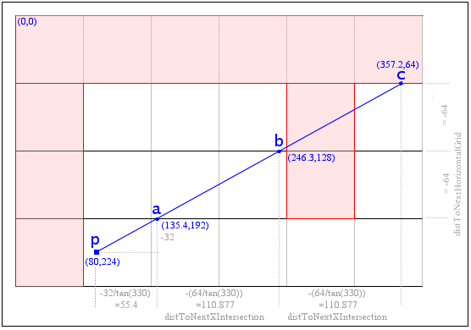

Every angle will require both a horizontal and a vertical cast, but we start with the horizontal cast first so all vertical grid lines can be initially ignored. We accomplish the first cast in four steps.

Step One
Step one is to calculate the initial point a where the ray crosses the first horizontal line. Here is how we compute ay:

ay = (py / 64) * (64)
ay = (224 / 64) * 64
ay = 192

This simply finds the first horizontal line just prior to the player since we intentionally choose to do integer division here. This calculation can be done quickly with register shifts.

The value for ax is computed as follows:

ax = px + (ay - py) / tan(alpha)
ax = 80 + ((192 – 224) / tan(330))
ax = 135.4

Again this calculation is performed rather quickly because tan(330) is already calculated and present in our memory lookup table.

As a side note, we will decrement the ay value by one in our sample code leaving it the value 191. This is a convention adopted to alleviate the confusion that might occur over the ambiguity of the wall presence on the actual horizontal line itself. Is the grid line a wall item for the tile above it, or below it? We only decrement by one on wall hits from rays moving upward (or westward for vertical casting) and thus our dilemma is resolved quite eloquently. Thus, horizontal lines will represent walls below the line, as per our convention.

Step Two
Now that we have our first horizontal line intersection, point a, we need to calculate the distance between it and all subsequent intersections: point b, point c and so forth.

The x distance, or distToNextHorizontalGrid, is -64 since it is just the distance between grid lines moving upwards. The y distance, or distToNextXIntersection is computed as follows:

= -(64 / tan(330))
= 110.877

Lucky for us this entire calculation is pre-calculated at load time as another useful lookup table in memory, so there are no delays in this step either.

Step Three
Now that we have identified a point of intersection a, we will now examine the exit criteria. We will exit the routine if we have run off the edge of the map, or if we have encountered a wall. This is accomplished by scaling (through division/shifting) the coordinates of the intersection (135.4, 191) to the smaller coordinates of the map data. Helpful methods from the MapData class report that equivalent location on the smaller map is not a wall, so we move on to the next step.

Step Four
The final step is to increment and iterate. We move on to the next horizontal intersection or point b by using our established offsets, distToNextXIntersection and distToNextHorizontalGrid. We examine the exit criteria back in step three, this time with point b (246.3, 127) (we use 127 instead of 128, as per our convention). Again, no wall is found at the corresponding location on the smaller map data, so we continue on.

It isn’t until the next iteration of the loop, or at point c (357.2, 63), that we finally meet the exit criteria by hitting a wall. Going from a to b and b to c is simply a matter of adding our established offsets, so no matter how far the ray extends, this step works quickly.

Upon exiting, we record the distance from the player to point c. Doing so will prove helpful in the future. The distance is easily calculated—don’t bother with the Pythagorean Theorem and the expensive square and square root computations. We have a triangle with one side and one angle, we can therefore calculate the hypotenuse (or distance) with the help of our inverse cosine table. Here is the code:

(horizItemHit.getIntersection() - fPlayerX) * fICosTable[castArc]

Most steps outlined above are performed rather quickly through the tricks we have outlined. Good thing because after completing these four steps (and some are iterative steps), we are only half way there in finding a suitable wall to draw. Notice that point c is not truly the desired wall we wish to draw for this angle. Point c represents the wall behind the wall we wish to draw. We missed the obvious hit to the vertical wall near point b since we were only examining horizontal walls. We must cast the exact same angle again, this time looking at vertical lines rather horizontal.

The routine for casting vertical lines is very similar to the routine outlined above and is therefore omitted here. Since distances are recorded every time for both horizontal and vertical casts, we can compare the two to determine which wall to draw. This time, the vertical wall is much closer than its horizontal counterpart. Therefore, the horizontal ray casting described in great detail above was all done in vein, since the vertical cast would prove to be closer.

Drawing the Wall Slice

Once we have determined which ray type is closest for the given angle, we then draw a slice of the wall based upon the distance from the player to the wall. Each wall slice is scaled by a ratio set by the distance from the player to the projection plane compared with the distance from the player to the wall. Using the formula below we can solve for projectedWallHit and draw the wall slice accordingly:

distFromPlayerToProjPlane projectedWallHit
distFromPlayerToWall = wallHeight

Before we draw a wall slice, there is one issue we must resolve first. If we don’t make a slight correction to the distance above, our walls will have a “fish-eye” distortion. Walls will appear rounded because rays that are not directly in front of the player will have an incorrect longer distance as illustrated below:

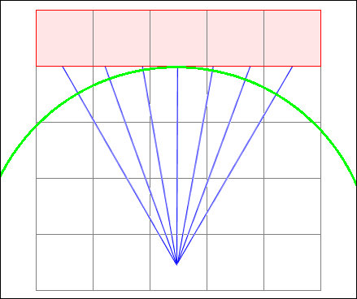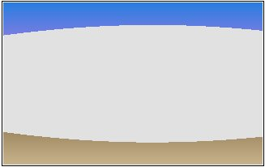

A suitable correction to this problem involves the following formula:

cos(angle) = correct distance / distorted distance

We simply solve for the corrected distance above. Again, tables built in memory will help expedite this calculation. These tables were pre-built at load time since they are required for every slice or column on the projection plane for each frame drawn. Now we are finally ready to draw our wall slice.

For all 320 columns on the projection plane, we will repeat this process of casting horizontally, casting vertically, calculating distances, fixing the distortion, and finally, drawing the wall slice.

Conclusion

The ray casting algorithms described here were developed by some of the most gifted game programmers in the industry who were challenged by the limitations of the common personal computer of the day. The algorithms are most fascinating because they employ simple high-school trigonometry to render first-person adventures in virtual 3D worlds and deliver them on low-end platforms.

Works Cited

I make no claims to original authorship of ray casting concepts and techniques. All algorithms, explanations were gleaned from other sources and are hereby acknowledged. My only contributions in this work are in the words I have chosen to express my understanding of the subject, and secondly, my organization of the code and algorithms to accommodate the understanding of the reader.

- Kushner, David. Masters of Doom. New York, NY: Random House Publishing 2003.
- Permadi, F. Ray-Casting Tutorial. http://www.bol.ucla.edu/~permadi/raycast/rayc1.html
- Lampton, Christopher. Garden of Imaginations. Corte Madera, CA: Waite Group Press, 1995.
- LaMothe, Andre. Tricks of the Game Programming Gurus. Indianapolis, Sams Publishing, 1994.
- Trujillo, Stan. Windows 95 Games Programming. New York, NY: M & T Books 1996.
- Wayne, Holder. Java Game Programming for Dummies. Foster City, CA: IDG Books Worldwide, Inc.1998.

