**NAMA : Maulana Abdul Fattah**

**NIM : 22.01.53.0005**

________________________________________________________________________________

**DATA WEB**

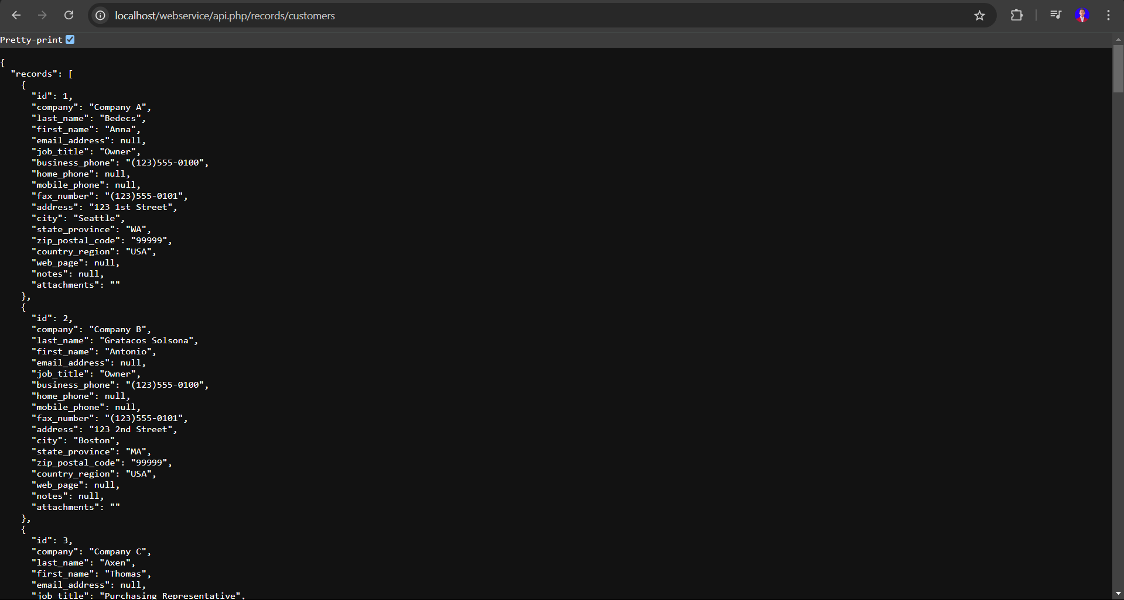

**GET**

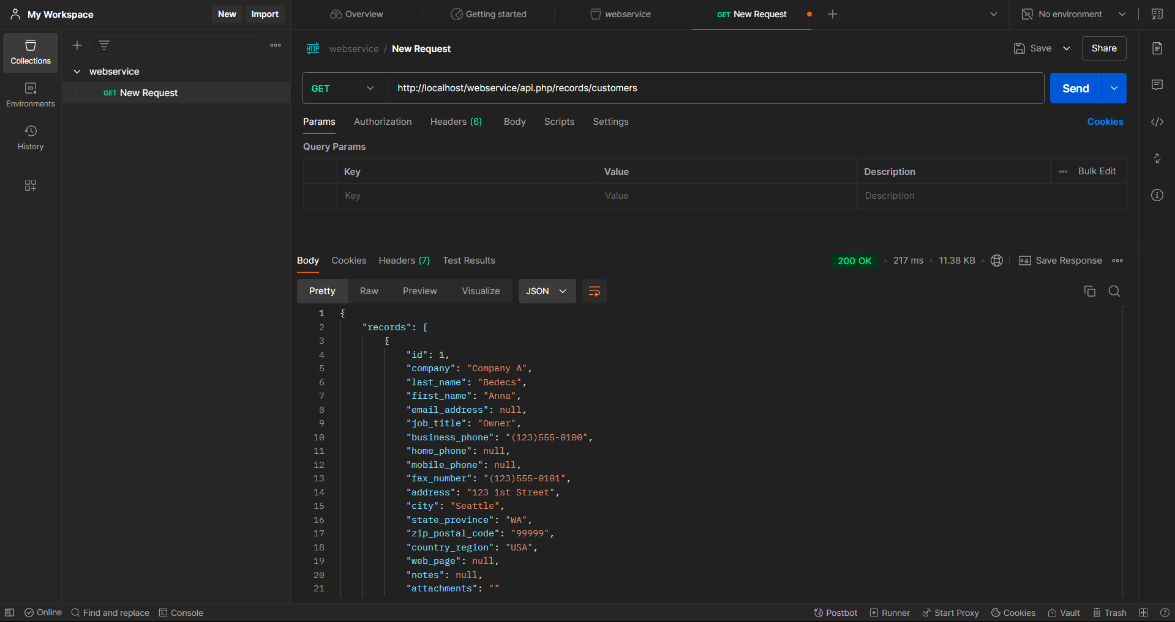

**POST**

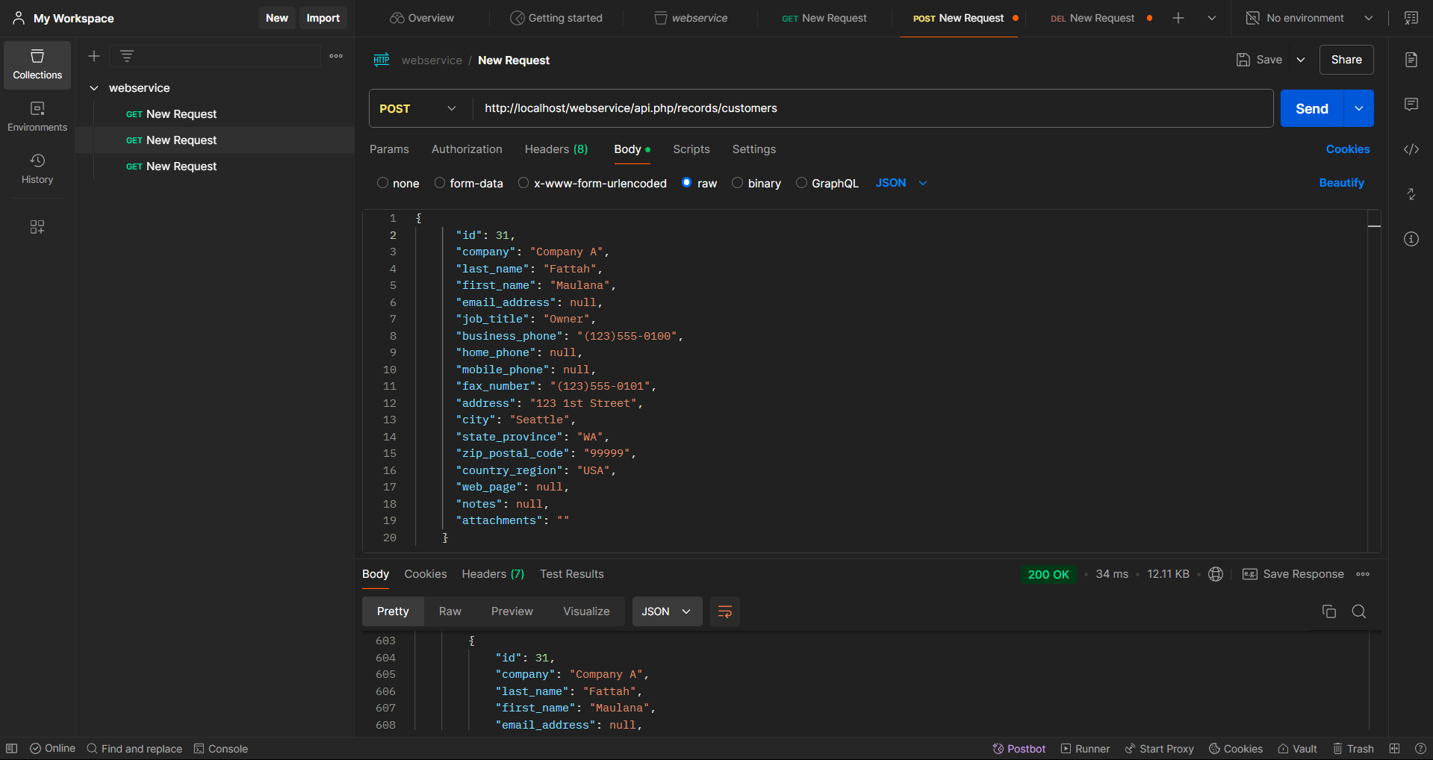

**PUT**

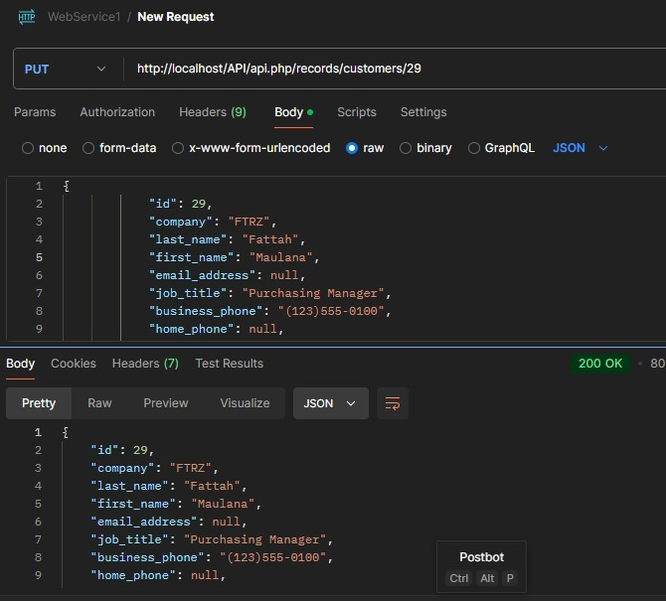

**DELETE**

