# Online clothes shopping website demand analysis

# 线上服装销售网站需求分析

# **Background背景**

In the Internet increasingly popular today, people no longer meet the purpose of information browsing and publishing, but eager to fully enjoy the network brought more convenience. Shopping online is adapted to the fast-paced life of today's society, so that customers can not go out of the door can be convenient and easy to choose their favorite goods.  
 在互联网日益普及的今天，人们已经不再满足用途信息的浏览和发布，而是渴望着能够充分享受网络所带来的更加多的便利。网上购物正适应了当今社会快节奏地生活，使顾客足不出户便可以方便快捷轻松地选购自己喜欢的商品。

# Target目标

We use JSP and Servlet technology to build the website, strive to make the website into a friendly interface, shopping user convenience, administrator management convenient shopping system.

In addition, we use hive and Hbase integration technology to analyze and evaluate the click and purchase of products, and focus on making each product available to the majority of customers.

我们使用JSP以及Servlet技术构建网站，争取将本网站做成一个界面友好、用户购物方便、管理员管理方便的购物系统。

此外，我们还使用hive和hbase的集成技术，对用户的商品点击和购买情况进行分析和评价，着力让每一个上架的商品都能满足大部分客户的需求。

# Software support软件支持

Operating system: Windows

Database: HBase

Servlet: Tomcat

Data warehouse tools: Hive

Database.Connection.driver: Java web integrated development environment.  
 操作系统：Windows

数据库：HBase  
 服务器：Tomcat

数据仓库工具：Hive

数据库连接驱动：Java web 集成开发环境

# Project demand analysis需求分析

## 4.1Functional requirement功能需求

### 4.1.1Functional partitioning 功能块划分

The online mall is divided into two parts. One part is user-oriented, including online registration, shopping, order submission, payment and other operations. The other part is the mall management part, which includes: product addition, deletion, inquiry, order management, operator management, registered user management, etc.

The back-end analysis USES Hive and HBase integration technologies to analyze user requirements. The content includes click-through rate, purchase rate and analysis of the combined purchase.  
 网上商城共分两个部分，一部分是面向用户的部分，包括:顾客在线注册、购物、提交订单、付款等操作;另外一部分是商城管理部分，这部分的内容包括:产品的添加、删除、查询、订单的管理、操作员的管理、注册用户的管理等。

后端分析采用Hive和HBase集成技术对用户的需求进行分析。内容包括用户对商品的点击率、对商品的购买率、以及组合购买的商品的分析。

### 4.1.2Function block description功能块描述

#### 4.1.2.1 User-oriented functions面向用户部分功能

(1) Registration function. Customers first have to register as online mall users. When registering, you only need to fill in the login user name, password and E-mail address. After registration, the user can continue to truthfully fill in the detailed personal information and consignee information, and can change the password, query and modify the order.

注册功能。顾客首先要注册为网上商城的用户。注册时只要填写登录用户名、密码、联系电子信箱3项信息即可。注册后，用户可继续如实填写详细个人信息及收货人信息，同时可修改密码、查询及修改订单。

(2) Select product features. Customers browse online shopping malls, their own needs of products into the shopping cart, can continue to add goods.

选择产品功能。顾客浏览网上商城，将自己需求的产品放入到购物车中,可连续添加商品。

1. Manage the shopping cart. After selecting the goods, the customer can go to the shopping cart page, view the goods he wants to buy, modify the quantity of a certain item, cancel the purchase of a certain item and empty the whole shopping cart.

管理购物车。顾客选择完商品后可进入购物车页面，查看自己要购买的商品，可修改某一商品数量、取消购买某商品和清空整个购物车。

(4) Order function. The customer submits the order after identifying the items in the shopping cart. If the customer has filled in the consignee information, the page displays the information and the customer confirms it. If it is not filled in, the corresponding form will be displayed for it to fill in. The system will record the consignee information submitted by the customer for use in the next shopping. After submitting the order, customers can check the order in the online mall and cancel or modify the order that has not been processed.

订单功能。顾客确定购物车中的商品后提交订单，如顾客已填写收货人信息，则页面显示该信息并由顾客确认。如尚未填写则显示相应表单请其填写，系统记录顾客提交的收货人信息以便其下次购物时使用。顾客提交订单后可在网上商城查询该订单，并可对尚未处理的订单进行取消、修改等操作。

(5) Payment function. After the order is confirmed by the seller, the customer should choose the payment method and pay the seller before receiving the goods.

付款功能。顾客在订单被销售方确认后，要选择付款方式，并付款给销售方，然后才可以收到货。

#### 4.1.2.2 Backend analysis functionality 后端分析功能

(1) Using HBase database to store data, columns can be dynamically increased, and empty columns will not store data, saving storage space; Can provide high concurrent read and write operation support; Associated with Hive, data can be processed more easily.

使用HBase数据库存储数据，列可以动态增加，并且列为空就不存储数据,节省存储空间；可以提供高并发读写操作的支持；和Hive关联，数据的处理会更加方便。

1. The use of Hive and HBase integration technology for data analysis makes it easier and more efficient to process data using command line and function statements.

使用hive和HBase集成技术对数据进行分析，能更加便捷和高效地运用命令行和function语句对数据进行处理。

## 4.2 Performance requirement性能需求

### 4.2.1 Data precision数据精确度

Price units are retained to the point. 价格单位保留到分。

### 4.2.2 Adaptation适应性

Shopping process should be simple and clear, product pictures should be clear, and product information description should be accurate.

购物流程要简单明了，产品图片要清楚，产品信息描述准确。

## 4.3The data analysis 数据分析

### 4.3.1sales volume 销售量

The sales volume of a commodity can reflect the best selling degree of a commodity, count all the goods that have been purchased, calculate the number of purchases of all goods, count the Top5, with the most times of purchase output to the result file, and use the ECharts to visualize the display.

商品的销售量可以反映一个商品的畅销程度，统计出所有被购买过的商品,计算所有商品的购买次数，统计出购买次数最多的Top5，输出到结果文件，并用ECharts进行可视化展示。

### 4.3.2 Click rate 点击量

The click volume of a commodity can reflect the popularity of a commodity. The most popular commodity is defined as Top5, which has the most clicks among all commodities. All clicked commodities are counted and the click times of all commodities are calculated.

商品的点击量可以反映一个商品的受欢迎程度，最受欢迎的商品的定义是在所有商品中点击量最多的商品Top5，统计出所有被点击过的商品，计算出所有商品的点击次数，最后统计出Top5，输出到结果文件, 并用ECharts进行可视化展示。

### 4.3.3 The rate of purchase 购买率

Commodity purchase rate can reflect the loyalty of the users of goods and the acceptance of goods description, for all the goods, the statistics for each number of clicks and buy goods by formula purchase rate = buy number/(clicks + purchase number) for record, the statistics Top3 results output to a file, and the visual display ECharts.

商品的购买率可以反映用户群体对商品的忠诚度和对商品描述的接受程度，对于所有的商品，统计出每种商品的点击数和购买数，通过公式购买率=购买数/(点击数+购买数)来进行记录，统计出Top3输出到结果文件, 并用ECharts进行可视化展示。

### 4.3.4 Purchase combination购买组合

Through the analysis of the purchase combination, we can increase the sales volume by means of bundled sale or special promotion of the goods, count the purchase situation of all users, make all the goods combination, finally count the purchase times of various combinations of goods and output Top5 to the result file, and use the ECharts to visualize the display.

通过对购买组合的分析可以对商品进行捆绑销售或者特殊促销的手段来提高销量，统计所有用户的购买商品情况，将所有商品组合，最后统计各种组合商品的购买次数并输出Top5到结果文件, 并用ECharts进行可视化展示。

# Flowchart流程图

## 5.1Customer flowchart顾客流程图

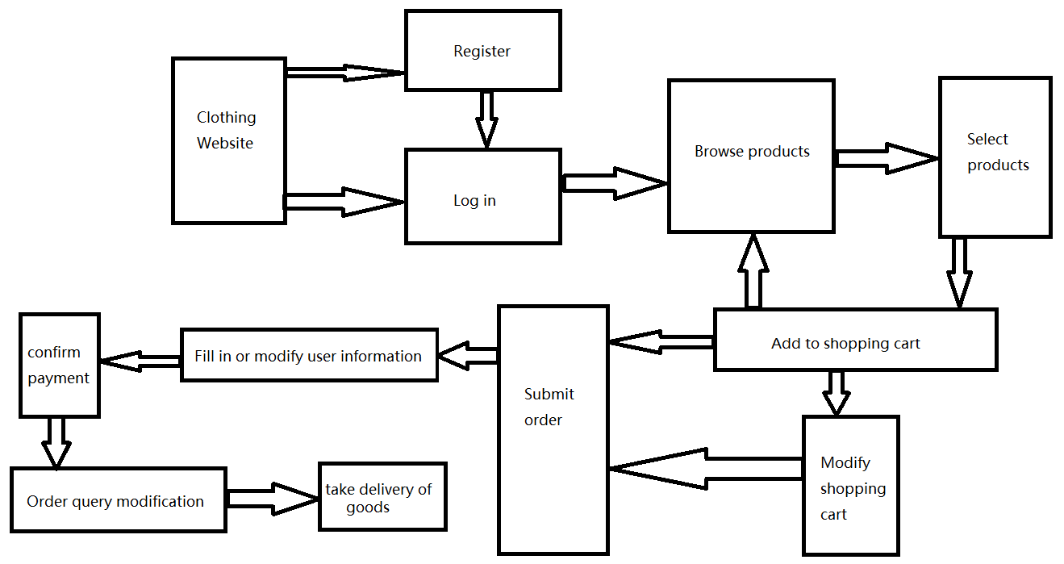

## 5.2 Data flowchart数据流程图

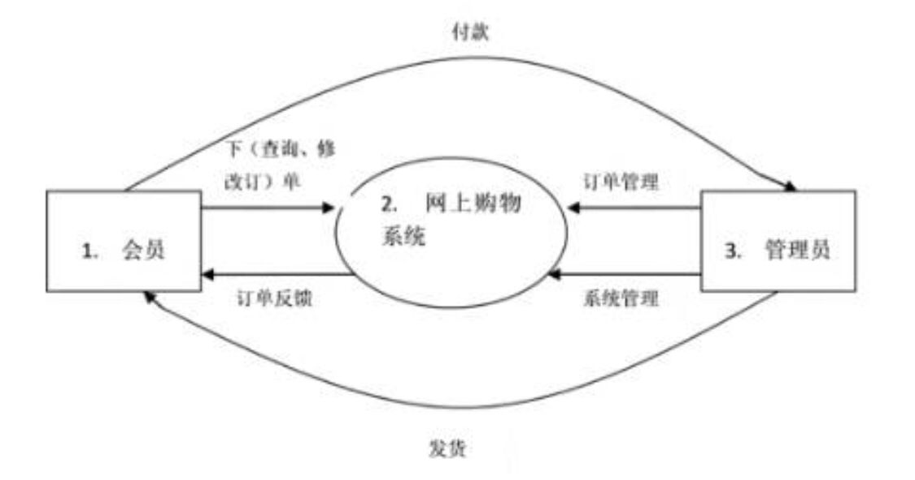

## 5.3 ER flowchart

