**Environmental Control System**

**Reactions**

**Temperature/ Humidity (Temperature/ Humidity sensor)**

Temperature and Humidity sensor are attached to a wall of each zone.

The Sensors are placed further from the actuators; ensure that the whole Zone will reach the desired temperature.

Temperature/ Humidity depends on **two** factors

* Current Temperature/ Humidity of the room
* Presence of Humans: Will determine on/off

Actuator: **Heater**, **Electric** **fan, Window** and **AC** **device**

**Lighting (Light Intensity)**

Light sensors are attached to a wall of each zone.

Sensors are place close to eye level to ensure that current room brightness is not too dark or bright for the workers.

Lighting depends on **two** factors

* Time of Day: Which will change the Luminous Limit
* Presence of Humans: Will determine on/off

Actuator: **Light** **Bulb, Blinds**

**Smoke Alarm**

Some Alarms are attached to the ceiling of each zone.

There is more than one in each zone to ensure that all smoke can be detected.

The Sensors are place close the ceiling to ensure that humidity due to weather is ignored.

When the smoke Alarm is detected, two actuators and activated sirensand sprinklers.

**Sirens** are activated in all zones ensure safety of all the workers, and fast evacuation of the building.

**Sprinklers** will only be activated the large zones in which the smoke was detected.

**Mode (1): Energy Saver Priorities/ From ECOS**

In the case of low energy, smoke alarms and zone2+ zone3 (Temperature) would be the last to lose energy.

In the interest of safety and benefit of the company, these had to be first priority.

Zone1+zone7, the first to lose energy would be temperature/humidity sensor actuators.

Then it all lights in these zones would be sent to minimal, in which it would be still capable of working.

Zone1+Zone7 had to come first as more accuracy / safety is needed to work around an automated robot.

Next would be the zone4+zone5+zone6 temperature sensor and actuators and then zone2+zone3 lighting sensor and actuators.

Only after the machine is stopped, zone4 + zone5+ zone6 lighting would lose power.

**CLOCK DOMAINS**

Environmental Control System is split up into 3 Domains

1: Zone1 + Zone7

2: Zone2 + Zone3

3: Zone4 + Zone5 + Zone6

**Block Diagram of Zone1 and Zone 7 systems**

**zoneNBlind:** has 5 states indicating openness of the Blind.

**ZoneNRLL:** reached light intensity level

**Zone1Lights:** has 5 states indicating brightness of light

**ZoneNTR:** temperature reach

**GUI inputs**

**zoneNULL:** Under light intensity level

**zoneNOLL:** Over light intensity level

**zoneNRLL:** reached light intensity level

**zoneNLTemp:** lower than Temperature

**zoneNHTemp:** Higher than temperature

**zoneNRTemp:**Reached temperature

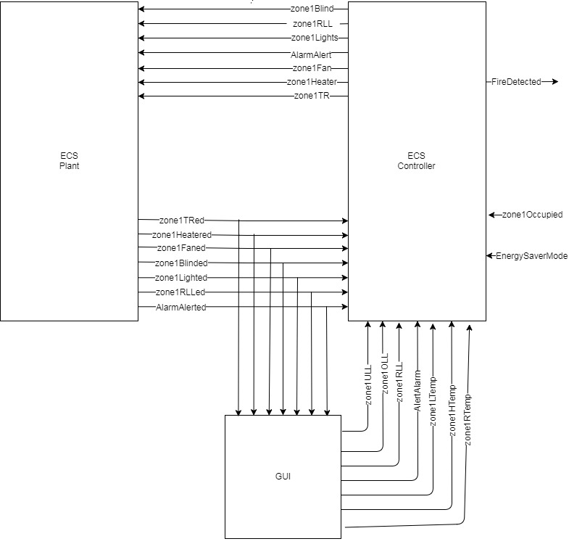

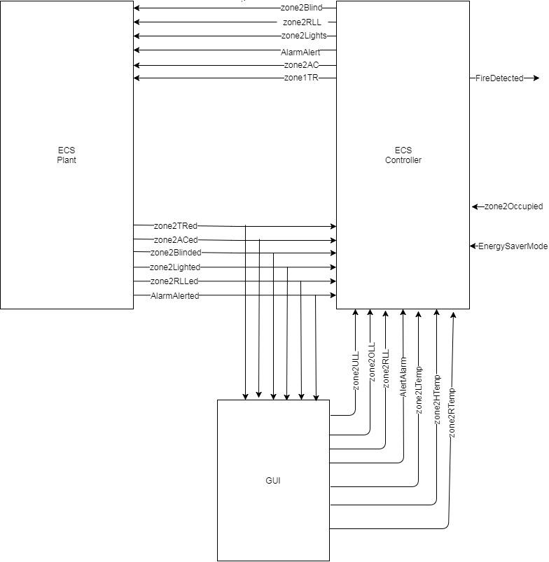**Block Diagram of Zone2 to Zone 6 systems**