**Protein expression optimization of *Campylobacter* non-*jejuni* (CNJ) GT-42 enzymes**

**Introduction**

The glycosyltransferase family 42 (GT-42) is currently comprised of sialyltransferases in its entirety. These enzymes catalyze the transfer of sialic acid residues to non-reducing oligosaccharides, forming sialylated glycoconjugates. Sialylated glycoconjugates are involved in cell-cell recognition, cell differentiation, and play some functions in virulence (Louwen R et al. 2008). The first characterized GT-42 enzyme was from *Campylobacter jejuni* (Chiu et al. 2007). Due to their important role on physiological and pathological processes, the structures and kinetics of *C. jejuni* GT-42 have been elucidated. These sialyltransferases adopt a modified GT-A type fold and use CMP-N-acetylneuraminic acid (CMP-Neu5Ac) as donor and different kinds of carbohydrates as acceptor (Chiu et al. 2004). However, the biochemical activity of GT-42 enzymes from *Campylobacter non-jejuni* (CNJ) species remains unknown. Therefore, the objectives of this project are: to optimize expression of recombinant CNJ GT-42 enzymes and to test recombinant CNJ GT-42 enzymes for sialyltransferase activity.

**Material and Methods**

pCw-MalET plasmids containing CNJ GT-42 genes were transferred into three hosts: *E.coli* Shuffle express, *E.coli* AD202, and *E.coli* BL21 (Table 1).To overexpress proteins, these hosts were incubated in media (2YT or SOB) at 25 °C for 4 hours or overnight. After that, the proteome was extracted from the bacterial culture either by sonication or grinding method (Table 2). Protein expression levels and the solubility of CNJ GT-42 protein were assessed on SDS-PAGE gel. *In vitro* activity of CNJ GT-42 protein was tested by thin-layer chromatography (TLC).

**Bacterial strains, plasmids, and growth conditions.**

*E.coli* AD202, BL21, and Shuffle express were grown on LB at 37 °C for overnight. Strains containing plasmids were routinely grown in LB supplemented with 150 μg mL-1 ampicillin, unless specified otherwise. Plasmids used in this study are listed on Table 1.

Table 1. Plasmids used in this study

|  |  |  |  |  |
| --- | --- | --- | --- | --- |
| Plasmid code | Gene | *E. coli* AD202 | *E. coli* Shuffle Express | *E. coli* BL21 |
| 24_16 | *C.subantarticus cst* | A24_16 | S24_16 | B24_16 |
| 25_2 | *C.coli* IPSID *cstII* | \ | S25_2 | \ |
| 27_2 | *C.coli* 76339 *cstV* | A27_2 | S27_2 | B27_2 |
| 28_4 | *C.coli* 73 *cstIV* | \ | S28_4 | \ |
| 36_2 | *C.insuniligrae cst* | \ | S36_2 | \ |
| 37_4 | *C.coli* 76339 *cstI* | \ | S37_4 | \ |

***E. coli* AD202 and BL21 transformation**

To transform *E. coli* AD202 and BL21, S24_16, S27_2, and S28_4 were grown at 37 °C. Plasmid purification was proceeded by Thermo Scientific GeneJet plasmid miniprep kit (including neutralization solution, elution buffer, wash solution and lysis solution) following suppliers recommendations. 2 mL of *E.coli* AD202 and *E.coli* BL21 overnight cultures were inoculated to 200 mL LB broth. Then, cultures were incubated at 37 °C with shaking (250 rpm) until an OD600 of 0.4-0.6 was reached to improve transformation efficiency (Szostková M, 1999). Cultures were centrifuged at 7000 g for 7 min at 2 °C. Cells were washed in ice-cold 10% glycerol and centrifuged as before. This step was repeated for three times to wash away salts. Then, cells were resuspended in 2 mL of ice cold 10% glycerol. 3 μL of purified plasmid were added to 100 μL of electrocompetent cells and electroporated at 2 kV, 200 Ω, and 25 μFD. Then, 100 μL of pre-warmed SOC media and cells were left to recover 37 °C for 45 min. Lastly, transformants were plated on LB with 150 μg mL-1 ampicillin.

**Protein overexpression**

To overexpress proteins, 200 ml of 2YT or SOB broth supplemented with 0.2% glucose were inoculated with 2 mL of overnight cultures, and incubated at 37 °C until an OD600 of 0.4-0.6 was reached. Protein expression was induced with 0.5 mM IPTG at 25 °C for 4 h or overnight. Cells were harvested (6000 g, 4 °C for 5 min) and stored at -70 °C until further use. Cells were lysed by either sonication or grinding. For sonication, 5 mL 1× PBS (pH 7.3) buffer and 500 μL 10× Protease inhibitor (diluted by ddH2O) were added to resuspend cells and inhibit protease respectively. Cell suspension was kept in icebox for sonication. The sonication cycle was 10 second ON/ 30 second Off for 4 times. Following this step, sonication-lysed cells were first centrifuged at 6000 g to remove cell debris, and then at 14000 g to separate soluble (supernatant) and insoluble (sediment) proteins. For grinding method, pestle, mortar and diatomaceous silica (Sigma- Aldrich) were used to crush the cells. The following reagents were added: 10 μL DNase (1mg/ml), 10 μL RNase (10 mg/ml), 20 μL lysosome (50mg/ml), 400 μL 10× protease inhibitor and 1 mL 100 mM Tris buffer. Protein expression and solubility was assessed by comparing proteins profile on 12% SDS-PAGE gels. Gels were stained with 0.5 % Commassie G250 (supplemented with 50 % methonal and 10% acetic acid). To estimate proteins size, the Prestained Protein molecular Weight Markers (20 kDa to 120 kDa) was used as a marker.

Table 2. Methods of cell lysis

|  |  |  |  |
| --- | --- | --- | --- |
| Sonication | | Grinding | |
| SOB | 2YT | SOB | 2YT |
| S25_2 | S25_2 | S25_2 | S25_2 |
| \ | \ | \ | S27_2 |
| \ | \ | \ | S28_4 |
| \ | \ | S36_2 | S36_2 |
| \ | \ | \ | S37_4 |
| \ | \ | A24_16 | \ |
| \ | \ | A27_2 | A27_2 |
| \ | \ | B24_16 | \ |
| \ | \ | B27_2 | \ |

**Sialyltransferase activity assay**

*In vitro* activity of CNJ GT-42 proteins was tested on BDP-Lac and BDP-LacNAc using CMP-Neu5Ac as donor. Sialyltransferase activity assays were performed at 37 °C in 10 µl volumes containing 50 mM NaHEPES pH 7.5, 10 mM MgCl2, 1 mM CMP-NeuAc, and 0.5 mM of BODIPY labelled acceptor; Lac or LacNAc. Reactions were stopped in an equal volume of 80% acetonitrile. Enzymatic activity was assessed by thin-layer chromatography on silica using a solvent system of ethyl acetate/methanol/water/acetic acid 3:2:1:0.1.

**Results**

1. **In vitro activity of CNJ GT-42 proteins**

Figure 1 to Figure 9 shows the results of TLC. The first three figures illustrate the protein activity of strain S25_2. For Figure 1 and Figure 2, proteins were extracted by sonication and there was no sialyltransferase activity of these proteins because no spot was separated from sample spot. However, for Figure 3, since cells were lysed by grinding. A spot appears below 5 min sample and it disappears overtime, which indicates sialyltransferases use BDP-LacNac as substrate and there are also some proteins that can degrade BDP-Lac-Nana in strain S25_2. Strain S36_2 and strain B24_16 did not produce sialyltransferase while proteins extracted from strain A24_16 shows activity (Figure 4 and 5). Figure 6 shows the results of strain A27_2 and B27_2. There is no doubt that proteins originated from A27_2 dose not show sialyltransferase activity while proteins from B27_2 has positive result when BDP-Lac was used as substrate. But, when substrate was BDP-LacNac, sample spots are lower than product spots. It may indicate there are enzymes in strain B27_2, which degrade BDP-LacNac (Figure 6). Similar result can be seen in strain S28_4. It produces enzymes to degrade BDP-Lac (Figure 7). There is no positive result in Figure 8.

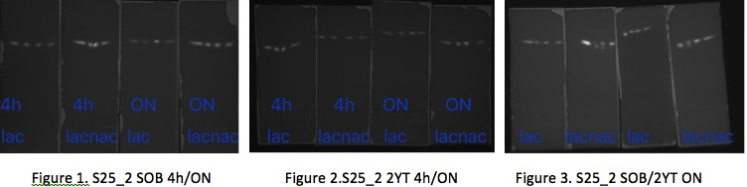

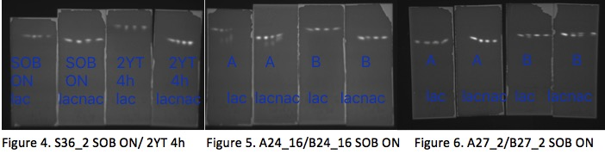

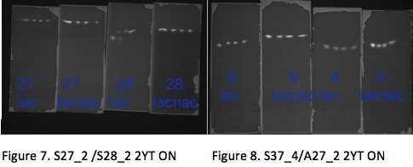

1. **The solubility and concentration of CNJ GT-42 protein**

The following figures show the results of SDS-PAGE (Figure 9,10). The size of the proteins could not be determined for B24_16 and A24_16 due to uneven running of the protein marker. According to Figure 9, Strain A27_2 produces more expected protein (expected size is between 77.1 and 81.2 kDa) after induction and the concentration of this protein increases over time. Thinker bands of 2YT mean that protein expression is efficient when strains growing in 2YT broth (Figure 9). It can be seen from Figure 10 that strain S25_2 produce more soluble proteins than insoluble proteins and the concentration of proteins increases over time. The solubility of CNJ GT-42 protein is high because the concentration of soluble protein is higher than that of insoluble protein. In addition, strain S25_2 prefers SOB broth to 2YT broth for protein expression.

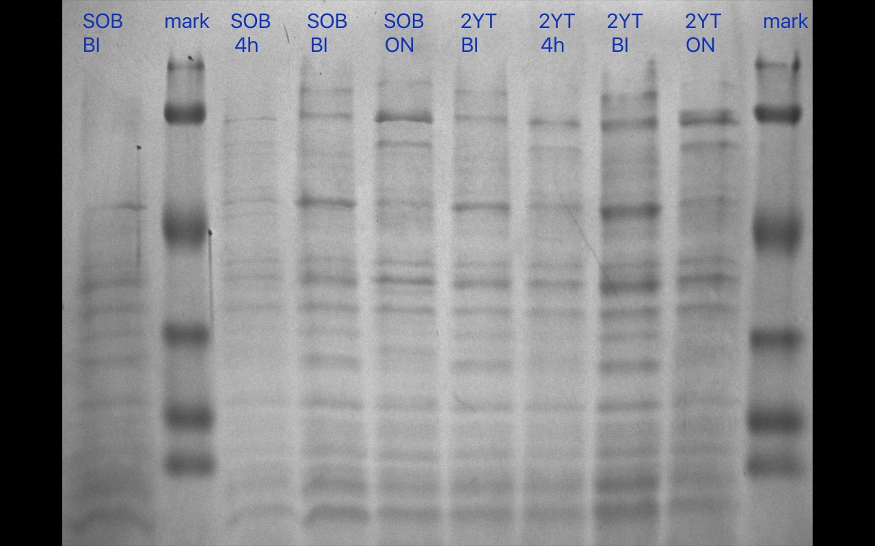

Expected bands

(77.1-81.2 kDa)

Figure 9. A27_2 2YT/SOB 4h/ON

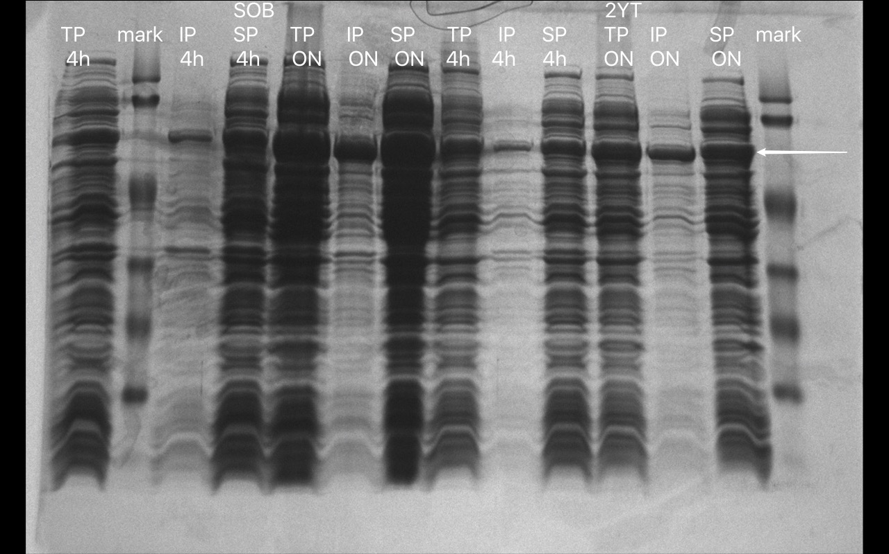

Expected band

(77.1-81.2 kDa)

Figure 10. S25_2 2YT/SOB 4h/ON

Total/soluble/insoluble protein

**Discussion and Conclusions**

According to our previous research, the cells grow faster at 37 °C and the incorrect folding of protein will lead to the loss of sialyltransferase activity. Therefore, in this experiment, incubation temperature was 25 °C to decrease protein misfolding. There are two strains that show sialyltransferase activity: S25_2 and A24_16. However, they have different activities. Enzyme from S25_2 (Alpha-2, 3-/2,8-sialyltransferase) is more active because the majority of expected enzyme was in soluble form and the sialylation was done in less than 5 min while enzyme from A24_16 (encoded by *C.subantarticus cst*) need more than 30 min to finish the reaction. In addition, the high adaptability of *E.coli* shuffle express (expresses active sialyltransferase in both 2YT and SOB broth) makes it a better host than *E.coli* BL21. However, there are several questions need to be considered. First of all, protein extraction methods should be optimized to efficiently lyse cells and avoid protein damage or loss. Both sonication and grinding method used in this experiment have their own drawbacks. Misuse of sonicator may denature protein or cause protein aggregation (Brown, 2008) while grinding is inefficient and time-consuming. All these conditions may affect the result of *in vitro* activity test. Secondly, hosts without recombinant plasmids should be tested in order to prove that sialyltransferase is encoded by recombinant plasmids not chromosome of host. Last but not least, although TLC has high sensitivity, it is only suitable for qualitative research. For quantitative enzyme assay, protein separation and purification are necessary. In future research, we should focus on enhancing activity of the enzymes. Solubility and correct folding are the main factors that influence the activity of the enzymes. Therefore, some strategies should be used to make the enzymes soluble and fold in active native state. We can try to optimize the redox environment and add solubility enhancers (such as sucrose, reduced glutathione, ethanol and arginine) to enhance the solubility of the enzymes and apply supercharging-like strategy to remain correct folding (Ortiz-Soto ME, 2016).

**Reference**

1. Louwen R, Heikema A, van Belkum A, Ott A, Gilbert M, Ang W, Endtz HP, Bergman MP, Nieuwenhuis EE. 2008. The sialylated lipooligosaccharide outer core in *Campylobacter jejuni* is an important determinant for epithelial cell invasion. Infect Immun 76(10):4431-8.

2. Chiu CPC, Watts AG, Lairson LL, Gilbert M, Lim D, Wakarchuk WW, Withers SG, Strynadka NCJ. 2004. Structural analysis of the sialyltransferase CstII from *Campylobacter jejuni* in complex with a substrate analog. Nat Struct Mol Biol 11(2):163-70.

3. Szostková M, Horáková D, Nemec M. 1999. The influence of the growth phase of enteric bacteria on electrotransformation with plasmid DNA. Folia Microbiol 44(2):177-80.

4. Brown RB, Audet J. 2008. Current techniques for single-cell lysis. J R Soc Interface (SUPPL.2):S131-8.

5. Ortiz-Soto ME, Seibel J. 2016. Expression of functional human sialyltransferases ST3Gal1 and ST6Gal1 in *Escherichia coli*. PLoS ONE 11(5).