
ASE: how FAUE's styling intelligence works
A reading guide to the whole FAUE system, the ASE layer inside it, its tiers, its cost, and the gates that decide when an output is ready to use.
Status Draft v0.1 for your review before ASE decisions are finalised
Date 15 October 2026
Prepared for Testimony, FAUE
Companion to docs/60-ai/ase-architecture.md

Contents

If the list above is empty, press Ctrl+A then F9 in Word to refresh it. The headings also appear in the Navigation pane.

The parts of this guide
Part | What you will find | Read it when
1. Start here | Ten things to know, and a plain-language glossary | First, always
2. The FAUE system, layer by layer | Landing, web app, gateway, admin, database, workers, notifications and where ASE sits, with a system diagram | You want the whole picture before ASE
3. ASE in plain language | What ASE is for, the high-level diagram, one look step by step, the five tiers, the eight principles | You want the idea without the detail
4. The eleven sections of ASE | One card and one low-level diagram per section | You are about to edit or decide on a section
5. Cost and speed | The $50 per million allocation, what breaks it, limits and speed targets | You are deciding budgets and limits
6. Quality | How an output is graded, the sets, the thresholds, the cultural process | You are deciding what 'ready' means
7. What exists today | An honest inventory and where it conflicts with the targets | You need the true starting point
8. Build order | Eight phases with exit criteria | You are planning work
9. Decisions for you | Seven decisions in one table | Last, then decide
Appendices | Admin console additions; where things live | As needed

1. Start here
This guide is for reading before you make edits. It explains the whole FAUE system in plain language, then the ASE layer in depth: what each part is for, how it works, what it costs, how we will know its output is good, and what is built today versus only planned.
How to read it
Every section follows the same card: what it is, why it exists, how it works, what can go wrong, how we know it is good, what exists today, and what you decide.
Every diagram sits on its own landscape page with a short 'how to read it' note, so you can look at the picture first and the words second.
Numbers marked as estimates are planning figures. They are there to make trade-offs visible, and they must be replaced by measurements once ASE runs.

The ten things to know
- ASE is not built yet. About 750 lines exist and only one module works. The design is strong; the code is a faithful skeleton. That is a good starting point, because nothing needs undoing.
- ASE has three jobs, in this order. Rules decide what is possible. A ranker decides what is best for this person. A small model finds the words, and only when needed.
- Most requests should never reach a model. Five tiers (T0 to T4) put cheap things first: cache, then rules and a learned ranker, then small models, then large models, and only last image generation.
- Culture lives in data, not in prompts. The fashion ontology is a reviewed, versioned knowledge base of African and global fashion. It is the part competitors cannot copy.
- Every output carries provenance. Which facts, rules, model and prompt versions made a look are stored, so 'why did you suggest this?' is answered from records, not from a fresh guess.
- The user teaches ASE with every tap. Wear logs, more-like-this, not-my-style with a reason, saves, notes and regenerates all feed a per-person memory that they can see and edit.
- Cost is designed in. About $50 per million requests is reachable only because reads never touch AI and most looks are served by cache and rules. Photoreal generation is opt-in and counted.
- Nothing ships on opinion. Evaluation sets, calibrated judges and native-speaking reviewers decide. A single hard-constraint violation blocks a release.
- Two earlier decisions need revisiting. ADR 0017 (model assembles looks in the hot path) and ADR 0018 (generative render by default) conflict with the cost and speed targets.
- Your decisions are listed at the end. Section 9 collects them in one table, so you can read everything first and decide once.

Glossary
Term | Plain meaning
ASE | FAUE's styling intelligence, named for the Yoruba word for the power to make things happen. It is internal: only the API gateway talks to it.
Look | A set of pieces that make one outfit, with a title, a picture, and the reason it works.
Vault | The person's own wardrobe: photographed items with name, category and colours.
Style DNA | The result of the six-question quiz: a persona such as the Cultural Minimalist, with a blend and a palette.
Legal pool | The pieces that are allowed for this person and this occasion after hard rules are applied.
Context pack | The small, typed bundle of facts one request is allowed to use. It never contains an email, phone number or measurement.
Ontology | The reviewed knowledge base of garments, fabrics, occasions, dress norms, regions and windows.
Tier (T0 to T4) | A rung of cost and capability. Requests climb only when a cheaper rung is not confident.
Skill | One named, bounded model behaviour with its own input, output schema, prompt version and test set.
Archetype look | A pre-rendered, reviewed look per persona, occasion and gender, shared by everyone, so a new user sees good looks with an empty vault.
Provenance | The permanent record of what produced a look: facts, rules, versions, models and cost.
Gate | A threshold a change must meet before it can ship.
Template path | The non-model form of a feature. It is always available, so the product works with the model plane down.

2. The FAUE system, layer by layer
Before ASE, it helps to see the whole system. FAUE has a public face (the website and the app), a gateway that holds the rules about people and data, a set of background workers, and ASE as the brain behind the gateway.
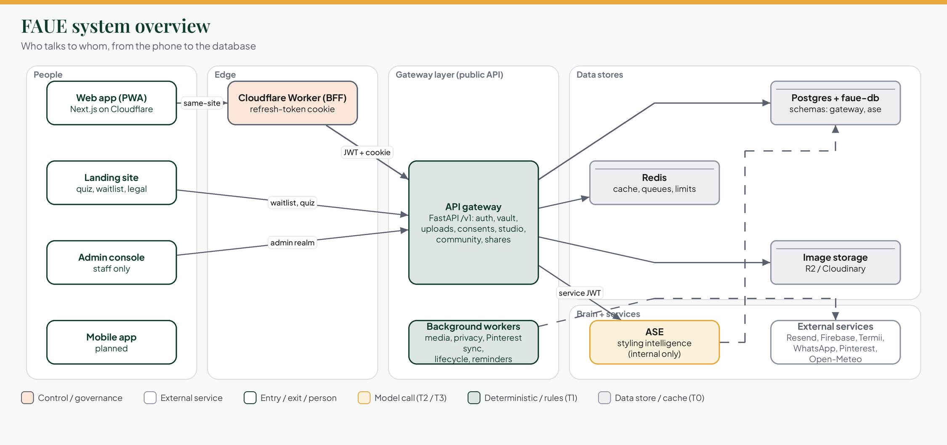
Figure 1. FAUE system overview. The people-facing surfaces on the left, the gateway in the middle, data stores and ASE on the right.
How to read it
- Follow a request from left to right: a person uses the web app, which talks to the gateway through a small Cloudflare Worker that keeps the sign-in cookie safe.
- Only the gateway reaches ASE, with a service token. ASE never faces the internet.
- Dashed lines are things that happen in the background, not while someone waits.
- Green boxes are rules and code, gold is a model, grey is data, and the white outlined box is an outside service.

2.1 Landing site
What it is | The public website for faueofficial.com: the story, the six-question Style DNA quiz preview, the waitlist, and the legal pages (Terms, Privacy).
Why it exists | To explain FAUE, capture a waitlist, and let people discover their Style DNA before the app is open. It is also what the app links to for legal text.
How it works | A Next.js site. The quiz and waitlist call the gateway's public endpoints. It uses faceless cloth imagery and the brand palette: green anchor, gold accent, peach surface.
State today | Built and then paused by your decision. A sign-in verification fallback page is still pending.
Watch out | No photographs of people. The legal pages are drafts until counsel has reviewed them.

2.2 Web app
What it is | The product itself, as a progressive web app on Cloudflare: onboarding, Home, Vault, Studio, Community, saved looks and Profile.
Why it exists | It is the first real surface for everything the gateway and ASE do, and it works on a phone without an app store.
How it works | A static Next.js export. The access token lives in memory only; the refresh token is an httpOnly cookie managed by the Worker. Pages read the gateway's /v1 API directly.
What a person can do | Take the Style DNA quiz, pick a username, see Home recommendations from the community, add pieces to the Vault with colours suggested on the device, log what they wore, plan events with several reminders, add tailors, tell ASE things, adjust display and permissions, and export or delete their data.
State today | All of these screens exist. Look generation is built end to end but switched off by NEXT_PUBLIC_LOOKS_AVAILABLE until ASE answers. When it is off the app says so honestly rather than failing.
Recently added | Edit events, choose several reminder times per event, multi-select feel when making looks, weather degree in the date chip when location is allowed, and a fix for the keyboard closing after one character inside sheets.

2.3 Cloudflare Worker (BFF)
What it is | A thin server in front of the static web app that handles only /session/* paths.
Why it exists | So the long-lived refresh token never touches JavaScript. It sits in an httpOnly cookie that only the Worker reads.
How it works | The browser asks the Worker to refresh or end a session; the Worker talks to the gateway and sets or clears the cookie. Magic-link sign-in is consumed with a POST only.
Watch out | Local development uses a 'direct' mode where the refresh token sits in sessionStorage. Never point that at a production account.

2.4 API gateway
What it is | The public API at /v1, written in FastAPI. It is the single entry point to everything FAUE knows about a person.
Why it exists | To keep identity, consent, privacy and limits in one place that every surface uses, and to keep ASE free of personal data.
How it works | Routers validate and call one service function each. Consent is a dependency on the route, so it cannot be forgotten. Errors are RFC 7807 problem documents. Anything slow becomes a job.
State today | Largely built and tested. The looks, fabric, spree and agent routes exist as contracts but return an error until ASE exists (about 25 routes).

Gateway modules, in plain terms:
Module | What it does
Identity and auth | Magic-link sign-in with a session challenge, Google and Apple sign-in, refresh rotation, usernames.
Profile and consents | The person's details, avatar, body profile, and the consent ledger. Every optional purpose is denied by default and asked for at the moment it is needed.
Quiz and Style DNA | Scores the six answers into a persona and renders share cards.
Vault and uploads | Photos in, protection pipeline, items out. Restorable deletion for 30 days.
Media pipeline | Server-authoritative: faces and text are covered before anything is stored or used. Stored on R2, Railway or S3 with a Cloudinary backup mirror.
Integrations | Pinterest connect, boards, import, disconnect. Read-only; images are copied through the pipeline.
Studio | Events with several reminders, tailors (phone stored encrypted), and the notes the person has told ASE.
Context | Rough location as a 5 km cell and the weather there from Open-Meteo, cached 30 minutes per cell.
Community | Anonymous sharing of looks, likes, copies, reports, and moderation.
Shares | Share a look to FAUE from TikTok, Instagram or Pinterest, as a link or image.
Notifications | Inbox, push, email, SMS and WhatsApp channels with per-category preferences enforced at delivery.
Privacy | Export, deletion with a 14-day waiting period, restriction, and the deletion ledger.
Waitlist and lifecycle | Invites in batches, and lifecycle campaigns with strict frequency rules, off until an operator turns them on.

2.5 Admin console
What it is | A staff-only console on its own realm of the gateway, with role-based access and an audit trail.
Why it exists | So the team can operate FAUE: invite from the waitlist, moderate community posts, handle privacy requests, switch features off, and read the product funnel.
How it works | Every action is permission-checked, reasoned and written to an audit row. Kill switches, thresholds and limits are editable within safe bounds. Secrets are never editable.
State today | Overview and funnel, community moderation, waitlist, privacy ledger and accounts, uploads and storage, sharing, switches and campaigns pages exist.
Gap you flagged | The admin side has not yet been updated for the new Studio inputs (events with several reminders, tailors count, ASE notes, location opt-ins). Proposed admin additions are listed in Appendix A.

2.6 Shared packages and the database
faue-db | The shared database package: SQLAlchemy models and the single Alembic migration history. Two schemas: gateway and ase. Migrations are expand-only first, so a deploy never breaks the running version. Current version 0.5.0 with migration 0023 (event reminders).
faue-core | Shared building blocks: configuration, telemetry and logging, the error taxonomy, consent purposes, and service authentication.
faue-infra | CI workflows used by every service: lint, types, tests.
Why it matters for ASE | ASE's tables already exist in migration 0001, but there are no ORM models for them yet, and ASE pins an older faue-db than the gateway. That is the first piece of ASE plumbing to do.

2.7 Background workers
Worker | What it does | When
outbox_relay | Publishes events written inside a transaction, so nothing is lost between a save and the event. | Continuous
backup_replication | Mirrors uploads to the backup store and removes them on account deletion. | Continuous
dsr_purge | Completes a deletion after the waiting period and emails the confirmation. | Daily
retention_ttl | Enforces every retention period the gateway owns. | Daily
pinterest_sync | Copies pin images and refreshes imported boards; marks a connection needs_reauth on refusal. | Continuous
lifecycle | Day 5 to 60 and Detty December campaigns under strict frequency rules. | Hourly, off by default
event_reminders | Sends each reminder time the person chose, once, between 08:00 and 20:00 Lagos time. | Every 30 minutes (new)
pending_deliveries, contact_purge | Delivery follow-up and contact-form clean-up. | Periodic

2.8 Notifications, privacy and consent
Three ideas hold this layer together. Consent is denied by default and asked for at the moment of need. Messages are one template rendered to many channels, with a person's per-category switches enforced at delivery. And every deletion or export is a request with a record, not a silent action.
- Consent purposes. camera_photos, pinterest_sync, ai_processing, location_weather, agent_proactive, personalization, marketing_comms. Revoking one removes what was derived from it immediately.
- Reminders. Event reminders are something the person asked for when they saved the event, so they go out under the essential purpose, on push and inbox.
- Quiet hours. Campaigns respect Lagos quiet hours and a four-a-week cap; reminders go out only between 08:00 and 20:00.

2.9 Where ASE sits
ASE is the only part that decides what to wear. It receives a user id and vectors, never an email, phone or measurement. It is reached only through the gateway with a service JWT. Everything from here on is about ASE.

3. ASE in plain language

3.1 What it is for
ASE turns four things into looks: who the person is (Style DNA and what they have taught it), what they own (the Vault), what is happening (events, weather, season), and what they ask for. The output has to be culturally right, faithful to what they actually own, explainable, fast, and cheap enough to run for everyone.
An analogy
Think of a small tailoring studio. The pattern-cutter knows what is physically and culturally possible (rules and the ontology). The stylist knows this client and picks the best option (the ranker, learning from every visit). The copywriter writes the card that goes with the outfit (a small model, only when needed). The studio manager watches cost, quality and the door (router, evaluation and governance).
ASE is that studio. The stylist and cutter do most of the work. The copywriter is called in only when the words need it.

3.2 The big picture
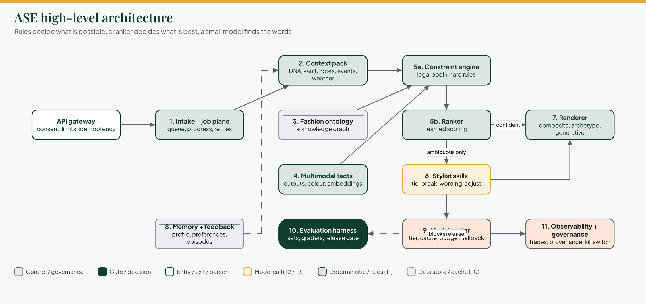
Figure 2. ASE high-level architecture. Eleven sections, grouped into what comes in, what is decided, what is shown, and what keeps it honest.
How to read it
- Numbers match the eleven sections in part 4. Read left to right for the journey of one request.
- Memory (8) feeds the context pack (2): what ASE has learned about a person shapes what it considers next time.
- The model router (9) is the only door to any model. Evaluation (10) and governance (11) sit across everything: no change ships without the gate.
- The ranker either goes straight to the renderer (confident) or asks the stylist skills for help (ambiguous only).

3.3 One look, step by step
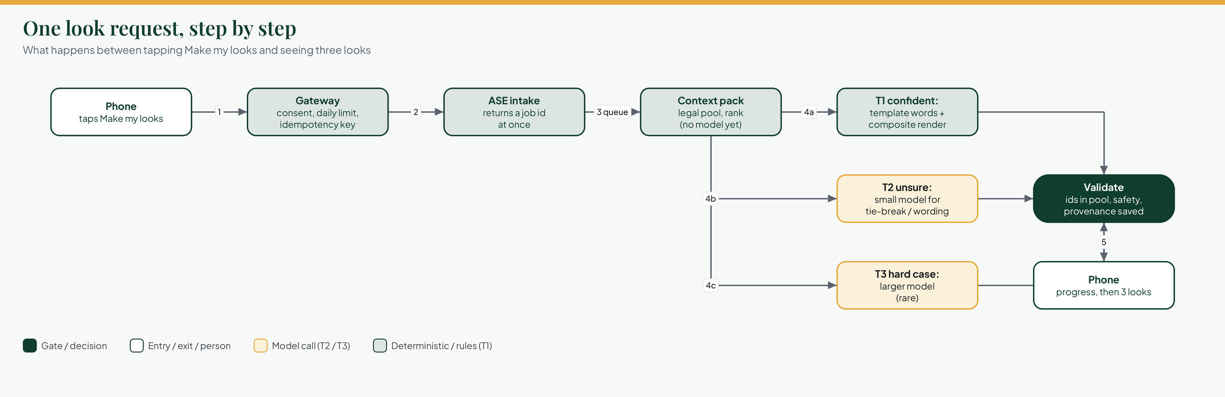
Figure 3. One look request. From the tap to three looks on the phone.
How to read it
- Steps 1 to 3 are quick and cheap: check consent and limits, return a job id, queue the work. The person sees progress within about 400 ms.
- Step 4 is where tiers appear: 4a is the common case and costs almost nothing; 4b and 4c use a model and are the exception.
- Step 5 is the safety net: every id must exist in the legal pool, safety checks run, and a provenance record is saved before the person sees anything.

3.4 The five tiers
A tier is a rung of cost and capability. The rule is simple: use the cheapest rung that passes the gate, and only climb when it is not confident. If a rung is down or over budget, fall back down the ladder rather than failing.
Tier | What runs | Speed | Cost per use (estimate) | Target share
T0 Cache / precompute | Daily edit prepared overnight, archetype looks, cached fabric reads, cached 'why' lines, weather per cell | 5 to 50 ms | about $0 | 30 to 40%
T1 Deterministic + learned | Ontology lookups, constraint engine, colour maths, stored embeddings, ranker, template wording, composite render | 50 to 400 ms | $0.00003 to 0.0001 | 35 to 45%
T2 Small model | Short wording, tie-breaks between near-equal looks, tagging, intent checks | 0.4 to 1.5 s | $0.0002 to 0.0006 | 15 to 25%
T3 Large model | Reading an unseen fabric, fabric-to-style reasoning, culturally ambiguous cases, spree chat | 1.5 to 6 s | $0.002 to 0.01 | 3 to 8%
T4 Generative image | Photoreal render or fabric sketch for a tailor brief | 8 to 30 s | $0.02 to 0.05 per image | 1 to 3%, counted

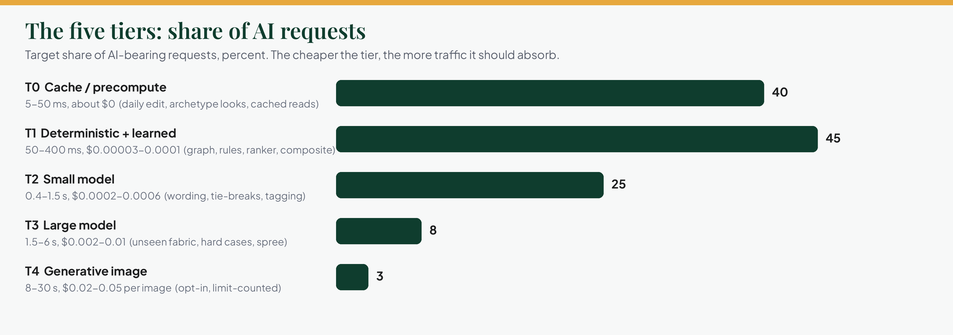
Figure 4. Tier traffic targets. How much of the AI-bearing traffic each tier should absorb.
How to read it
- The aim is a heavy bottom of the ladder: T0 and T1 together should absorb most requests.
- T4 is deliberately tiny and always counted against the person's daily limit.

3.5 The eight principles
# | Principle | What it means in practice
P1 | Rules define the possible, models judge the good, rules verify the result. | Hard constraints and validation are deterministic. A model can never invent a piece the person does not own.
P2 | The cheapest tier that passes the gate wins. | Every task has a ladder, and an escalation needs a reason.
P3 | A model is never the only path. | Every model-backed feature has a template version, so the product works with models switched off.
P4 | Provenance on everything. | Each look can be traced back to its facts, rules and versions.
P5 | Nothing is good until measured. | No prompt, model, rule or ranker change merges without a passing evaluation.
P6 | Culture is data, not prompt text. | African fashion knowledge is reviewed, versioned and sourced.
P7 | Private by construction. | ASE holds ids and vectors only. Measurements never reach a model.
P8 | Budget is a first-class input. | The router can degrade a request; it cannot overspend silently.

4. The eleven sections of ASE
Each section below has the same card, followed by its low-level diagram on its own page.

4.1 Intake and job plane
What it is | The front door of ASE: it accepts work from the gateway, returns a job id at once, and runs the slow part in the background.
Why it exists | A look can take seconds. Holding a request open ties up connections, and a retry could create a duplicate. A job gives progress, retries and idempotency.
How it works | The gateway sends a request with a service token and an idempotency key. ASE checks the key (a repeat returns the same job), checks budget, writes a queued job and hands it to a worker. Progress labels and percentages are written to the job row.
What can go wrong | A worker dies mid-job (it is re-queued, three attempts, then failed and not counted against the person). A budget is exceeded (the request degrades to templates and composites instead of failing).
How we know it is good | Contract tests against the OpenAPI file, a chaos test that kills a worker mid-job, and failure reasons that always name the stage.
Exists today | Routes are declared with documentation and return an error. No queue, job table models or workers yet.
You decide | Per-user limit defaults and what 'failed and not counted' covers.

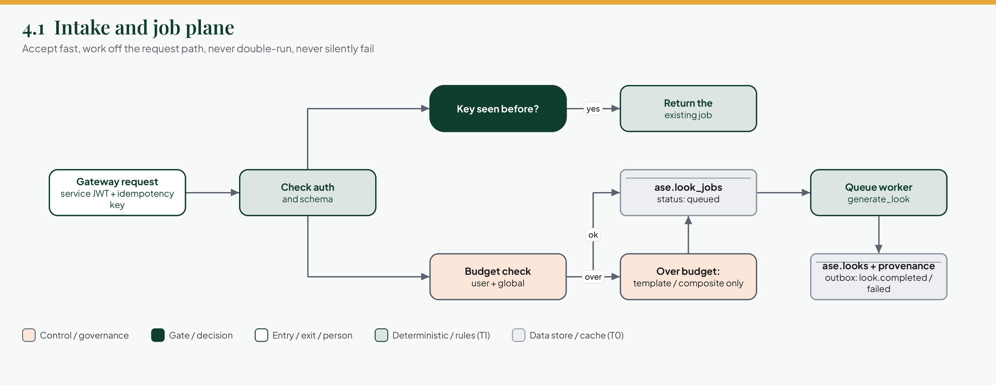
Figure 5. Low-level design: intake and job plane. From a gateway request to a stored result and an outbox event.
How to read it
- The top path is the duplicate guard: a repeated idempotency key returns the existing job.
- The bottom path is the budget guard: when over budget the job still runs, but only on the template and composite path.
- Everything ends in two stores: the looks with their provenance, and an outbox event that the rest of the system reacts to.

4.2 Context engineering
What it is | The step that builds the context pack: the smallest, cleanest, typed set of facts a request is allowed to use.
Why it exists | It is the single place where privacy, relevance and token cost are controlled. Models are expensive per word, and every extra fact is both a cost and a privacy risk.
How it works | Each source (DNA, vault, notes, events, weather, wear history, derived body constraints, calendar windows) passes a consent gate. A relevance step keeps only what this occasion needs. Redaction removes anything personal. The result is hashed so it can be a cache key.
What can go wrong | A missing source. The pack states it explicitly (for example weather: none, reason: no consent) so no later stage guesses.
How we know it is good | Property tests that no personal fields can appear; snapshot tests of the compact text form used in prompts.
Exists today | The sources exist in the gateway and faue-db. The pack type and builder do not exist yet.
You decide | How many vault items, notes and events a single request may carry (the token budget).

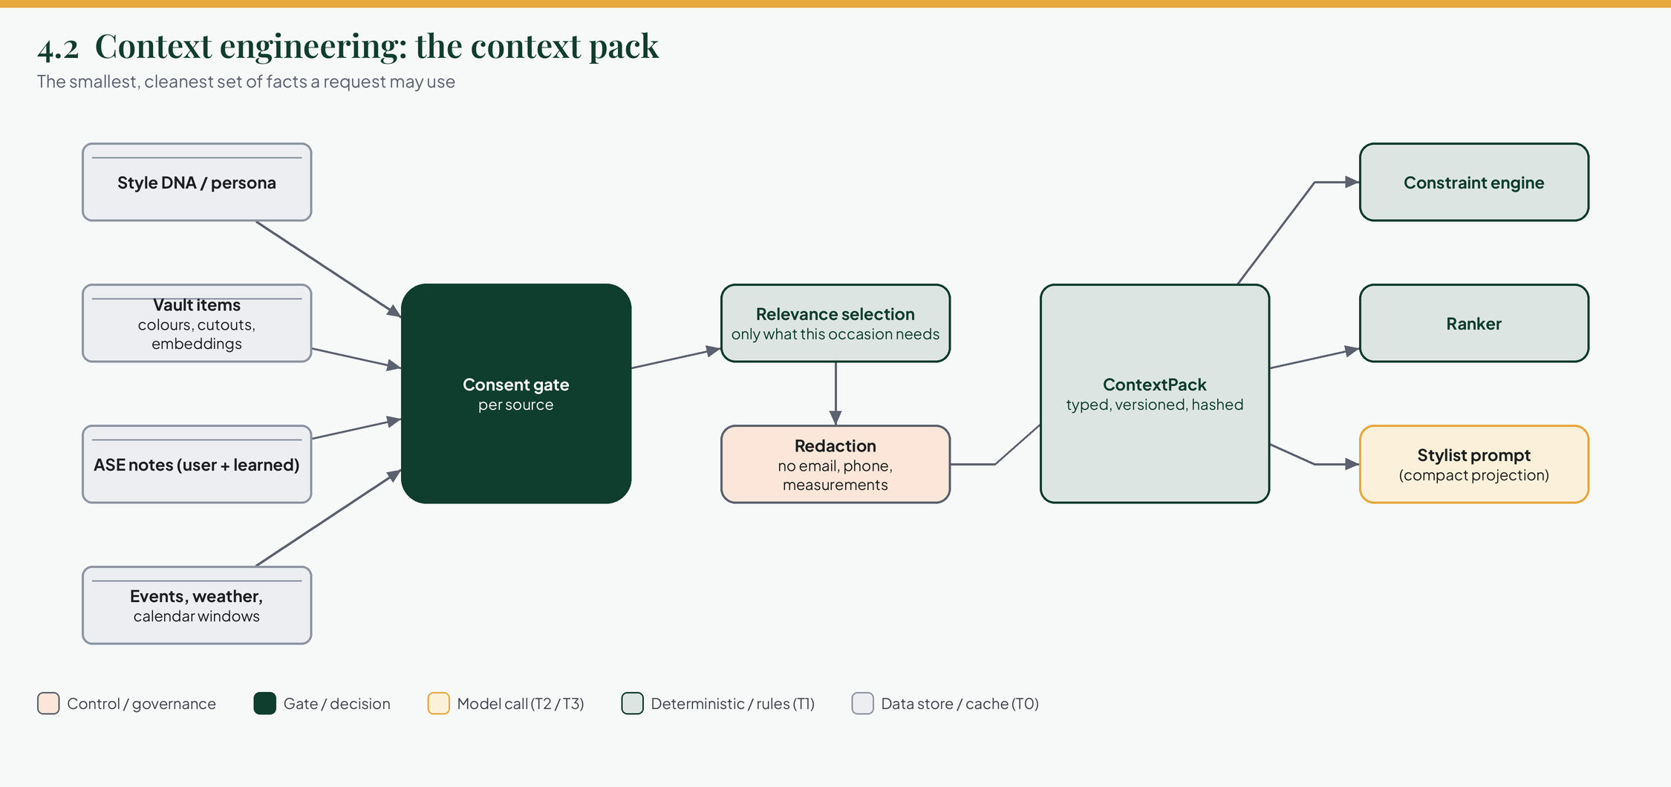
Figure 6. Low-level design: the context pack. Four kinds of source, a consent gate, relevance, redaction, and three consumers.
How to read it
- Read left to right: sources, then the consent gate, then selection and redaction, then the finished pack.
- The pack goes to three places: the constraint engine, the ranker, and (in compact text) the stylist prompt.

4.3 Fashion ontology and knowledge graph
What it is | A reviewed, versioned model of fashion: garments, fabrics, accessories, occasions, formality, dress norms, regions and traditions, and seasonal windows, joined by rules.
Why it exists | This is FAUE's moat. Generic models know fashion in general, not what is right at a Yoruba wedding in December, or why heavy aso-oke will not drape as a boubou. Putting it in data makes it testable, citable and improvable.
How it works | Each rule is a record: subject, relation, object, hard or soft, region, occasion, source, named reviewer, date and version. Hard rules go to the constraint engine; soft rules become ranker features. Disputed or regional norms are never promoted to universal.
What can go wrong | A rule that is wrong or culturally tone-deaf. That is why every rule needs a named reviewer and a source, and why users have a way to report tone-deaf output.
How we know it is good | Consistency checks (no contradictions or cycles), coverage reports per occasion and region, and every rule exercised by at least one evaluation case.
Exists today | The occasion taxonomy and window types are sketched in code; the ASE schema has style_library and compatibility_rules tables. No reviewed data.
You decide | Who the named reviewers are for each tradition, and how they are compensated and credited.

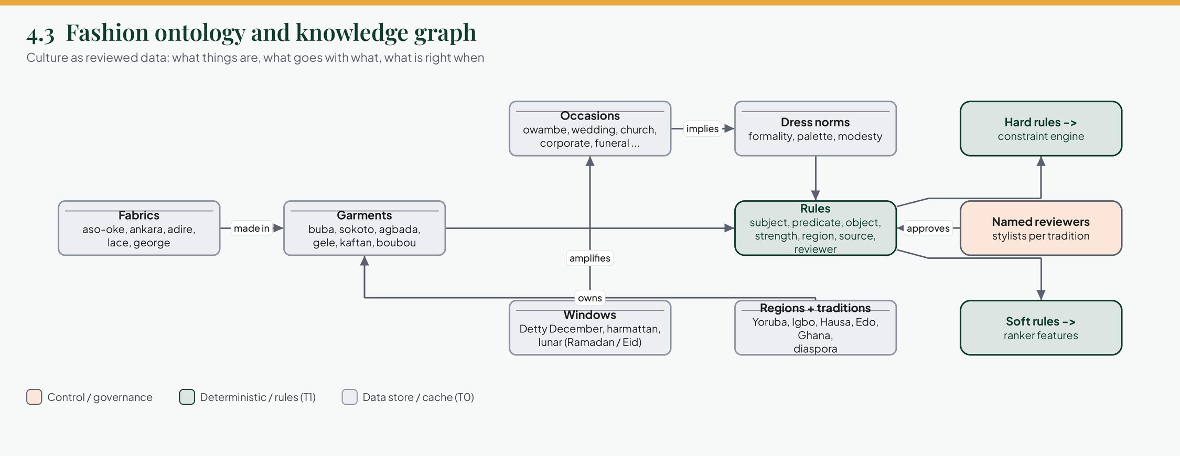
Figure 7. Low-level design: ontology and knowledge graph. How garments, fabrics, occasions, norms, regions and windows connect to rules and their reviewers.
How to read it
- The centre is the rule. Everything on the left and top feeds it; everything on the right consumes it.
- The reviewer node is not decoration: no reviewer, no rule loaded.
- Hard rules decide what is allowed. Soft rules decide what is preferred.

4.4 Multimodal intelligence
What it is | Everything that turns pictures into structured facts: cut-outs, colours, embeddings, category guesses, and fabric reading.
Why it exists | A model should never need to look at a photo twice. Doing this once at upload makes every later request cheap and fast.
How it works | At upload: remove the background, extract dominant colours into the 18 named colours plus LAB, compute an embedding with a self-hosted model, and tag category and pattern. If tags are not confident, one vision model call is made and cached by image hash. Fabrics are matched by nearest neighbour over labelled swatches; the vision model is used only below 0.7 confidence.
What can go wrong | A bad cut-out or a wrong colour. The on-device colour suggestion is only a hint; the server recomputes and the person can always edit.
How we know it is good | A labelled swatch set for fabrics, colour tolerance tests, and an embedding regression test against a fixed corpus.
Exists today | On-device colour suggestion in the web app. Cut-outs, embeddings and fabric reading in ASE do not exist.
You decide | Which embedding model to self-host, after benchmarking on your fabric and garment sets.

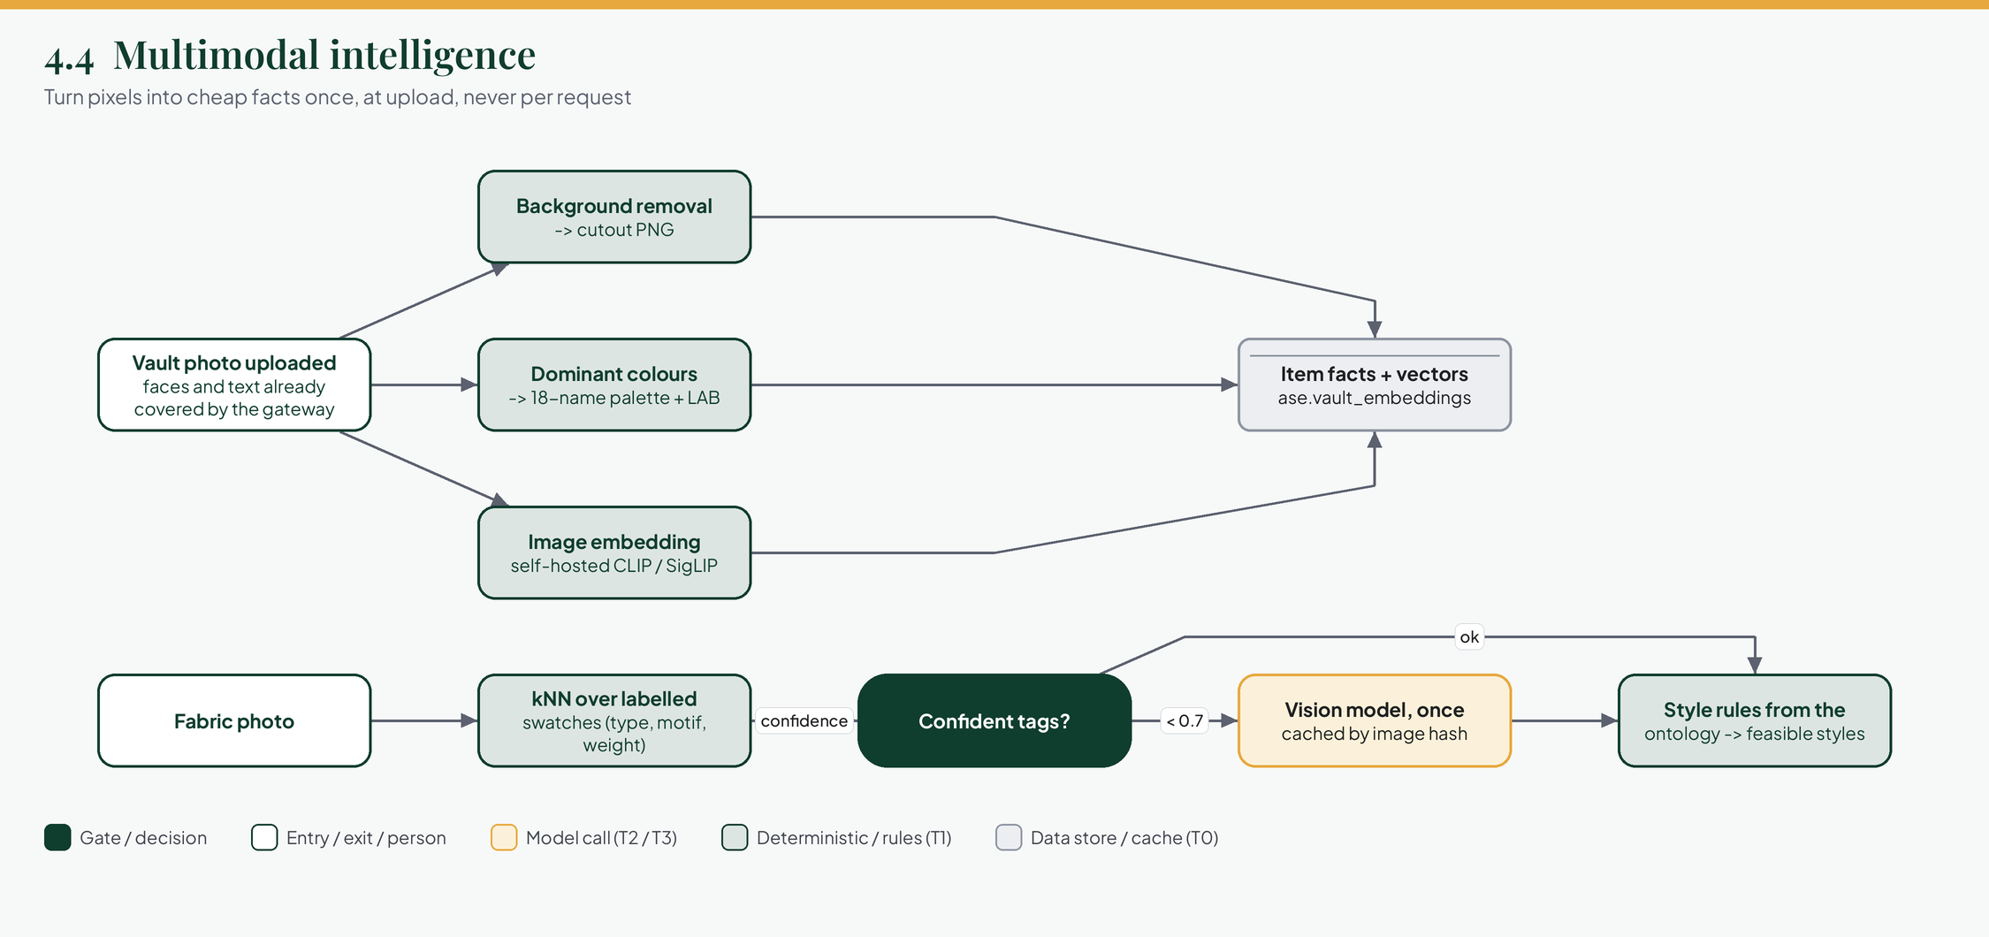
Figure 8. Low-level design: multimodal intelligence. Three things happen to every vault photo; fabric photos take a separate, rules-first route.
How to read it
- The top path is per vault item, once, at upload.
- The bottom path is for fabric photos: nearest-neighbour first, a vision model only when unsure.
- Both end in facts that the rest of ASE reads cheaply.

4.5 Constraint and ranking engine
What it is | The deterministic core. It builds the legal pool, assembles candidate looks into slots, throws out anything that breaks a hard rule, and scores the rest.
Why it exists | The pool is small (one wardrobe), the rules are explicit, and the scorer can learn from this person's own history. That makes it faster, cheaper and more consistent than asking a model each time.
How it works | Hard filters give the legal pool. Slot templates define an outfit shape. A beam search generates about 200 candidates. Hard checks discard those that break formality, dress code, fabric against weather, or palette norms. Features (coherence, colour relations, occasion fit, taste, novelty, weather, reuse value) are scored. A diversity step makes the three looks different. A confidence test decides whether a model is needed.
What can go wrong | An empty or too small pool. The pipeline stops with 'empty pool' and says why, rather than building a poor look from three items. Widening relaxes occasion first, then recency, never size or silhouette.
How we know it is good | Deterministic tests with full branch coverage on pool and hard checks, metamorphic tests (an irrelevant item must not change the top look), and nDCG against human rankings.
Exists today | scoring.py only: cosine similarity, coherence, context score and pairwise matrix, with 8 tests.
You decide | The first scorer (hand-weighted) and the point at which the learned ranker replaces it.

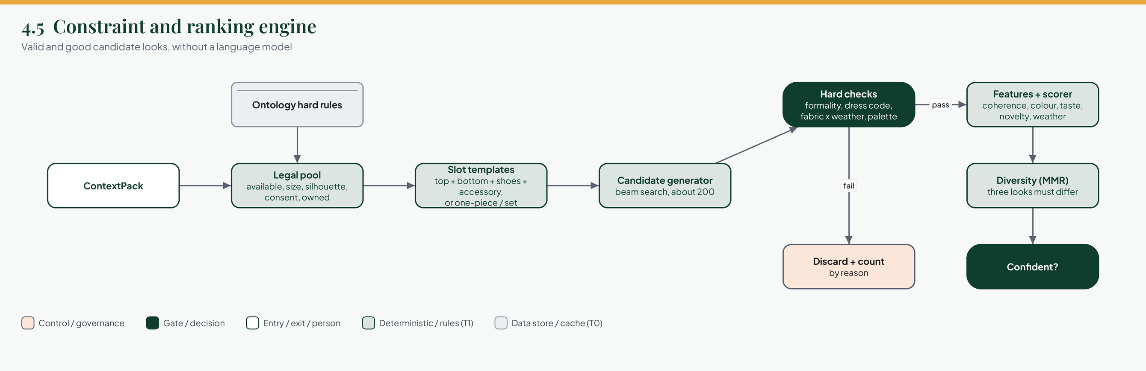
Figure 9. Low-level design: constraint and ranking engine. From the context pack to a short list of valid, ranked, varied looks.
How to read it
- Rules sit on the left (what is allowed). Scoring sits on the right (what is best).
- 'Fail' is counted by reason, so the team can see which rule removes most candidates.
- The final gate is not about quality: it asks whether the ranker is confident enough to skip any model.

4.6 Skills, loops and the stylist
What it is | The only place a language model is used for judgement and wording. Each behaviour is a 'skill' with its own limits.
Why it exists | Some things really do need language: a one-line reason, a tie-break between near-equal looks, understanding 'warmer', or reading a fabric photo. Everything else should not need a model.
How it works | A skill has a typed input, an output schema, a versioned prompt, allowed read-only tools, a token cap, a tier and a template fallback. Output is validated against the schema and the legal pool; one retry, then the template path. 'Adjust' turns language into a change to the constraints and re-runs the engine, so the model never edits an outfit directly.
What can go wrong | A model proposes something not in the pool, or text that makes an unsupported claim. Both are dropped, never repaired.
How we know it is good | Recorded-provider tests (CI never calls a real model), schema fuzzing, the injection suite, and groundedness checks.
Exists today | Guardrail classes and the read-only tool list with caps exist as stubs. No skills, prompts or providers.
How skills are packaged | As a phased pipeline skill with reference files. Each skill is a folder: a short SKILL.md that lists the phases in order, one file per phase, and a references folder (ontology, colour rules, slot templates, schemas, rubrics, examples). A phase names the reference files it needs, and only those are loaded. The next figure shows the layout.
You decide | Which skills ship first (suggested: reason and tie-break), and the loop limits for chat.

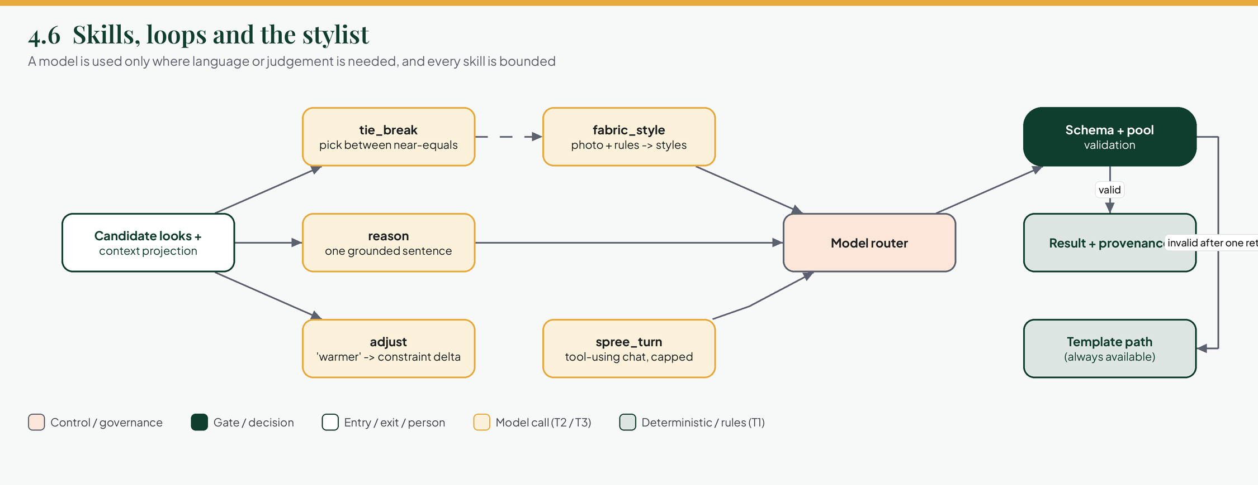
Figure 10. Low-level design: skills and the stylist. Five skills, one door (the router), and a template path behind everything.
How to read it
- Skills never talk to a model directly. They go through the router.
- The only loop allowed is the chat skill, capped at four rounds and eight tool calls.
- If output is invalid after one retry, the template path answers instead.

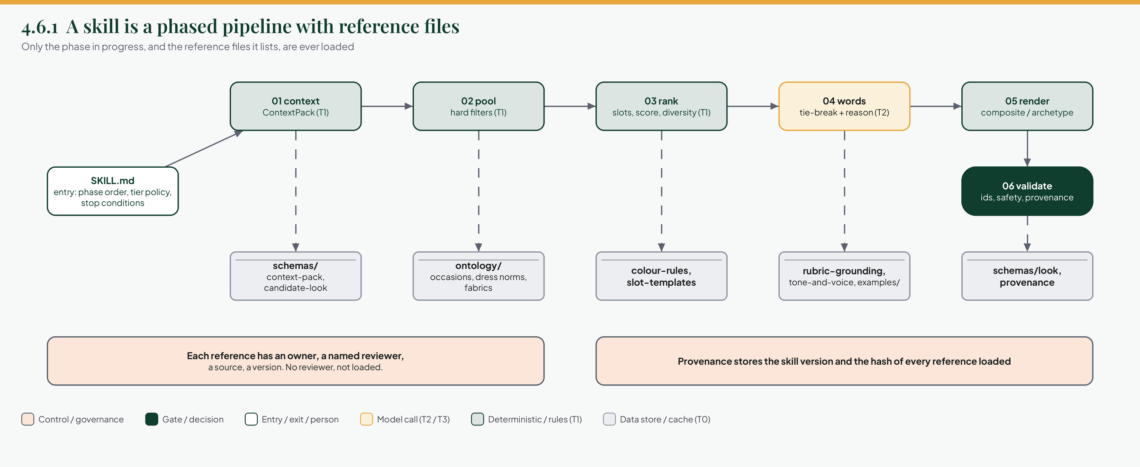
Figure 11. Skill layout: a phased pipeline with reference files. One entry file, six phases, and the reference files each phase loads.
How to read it
- Follow the top row left to right: the phases run in order. Dashed lines go down to the reference files a phase loads, and nothing else is loaded.
- Green phases are code that reads references as data, with no prompt. Only the gold phase (04 words) calls a model.
- The two bars at the bottom are the rules that make it safe: every reference has a named reviewer, and provenance records the exact reference hashes used.
- The same shape is used for every skill: look-pipeline, fabric-style and spree-chat.

4.7 Rendering
What it is | How a look is shown as a picture: composite, archetype, hybrid or generative.
Why it exists | A picture is the most expensive and most emotional part of a look. Choosing the method deliberately is the biggest cost lever and a big trust lever.
How it works | Composite layers the person's own cut-outs on a silhouette (about 100 ms, near zero cost, completely faithful). Archetype looks are pre-rendered once per persona, occasion and gender and shared, which solves the empty-vault first session. Hybrid fills in pieces the person does not own. Generative is opt-in, limit-counted and labelled as AI. Every picture passes a render safety check and is stored with its provenance.
What can go wrong | Composites can look like a collage; generative can drift from the real garment. That is why generative is labelled and why composite is the default for owned pieces.
How we know it is good | Visual regression on composites, the render-safety set, and cost per look tracked per strategy.
See a sample | A code-drawn sample of the composite output is on the review page /dev/composite in the web app (development only). It shows the build steps, the slot template and layer order, the result card, and the provenance record. The garments there are drawings; real composites use each person's own cut-outs in the same slots.
Exists today | The renderer interface exists. The default in configuration is generative, which conflicts with the cost target.
You decide | Whether to supersede ADR 0018: composite plus archetypes by default, generative opt-in.

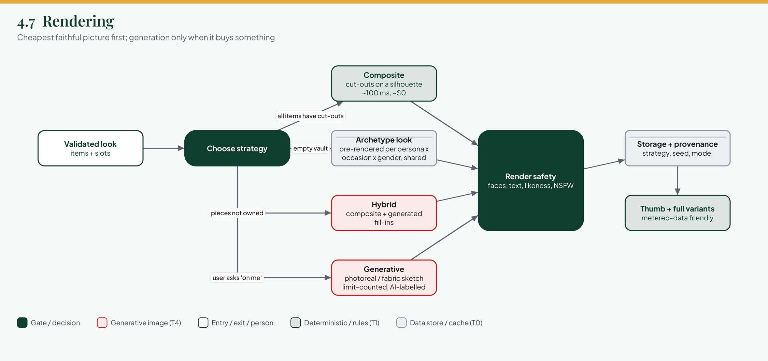
Figure 12. Low-level design: rendering. Four strategies behind one safety check.
How to read it
- The strategy chooser picks one route; the red boxes are the only places image-generation cost can appear.
- Archetype looks are shared, so a new person gets good looks at almost no cost.
- Thumbnails matter: mobile data in Nigeria is metered, so lists load small variants.

4.8 Memory and feedback
What it is | How ASE learns each person, and how it can say why it suggested something.
Why it exists | The product's quality improves with every tap, and a person should see and control what ASE believes about them.
How it works | Signals (more like this, not my style with a reason, wear logs, saves, shares, regenerates, tailor sends, written notes) become typed events with weights and decay. An append-only log updates a behaviour vector, learned preferences, a never-suggest list and durable profile facts. These flow into the context pack. A small exploration rate keeps the profile from narrowing.
What can go wrong | A feedback loop that learns what it showed first. That is why every served look is logged with its position and candidate set, so bias can be corrected later.
How we know it is good | Replay tests (the same stream rebuilds the same state), decay tests, 'forget this' tests, and offline improvement on held-out users.
Exists today | The signals exist in the gateway and the web app (reasons, wear, notes, What ASE knows). The learner does not.
You decide | Decay rates, the exploration rate, and which signals count as strong intent.

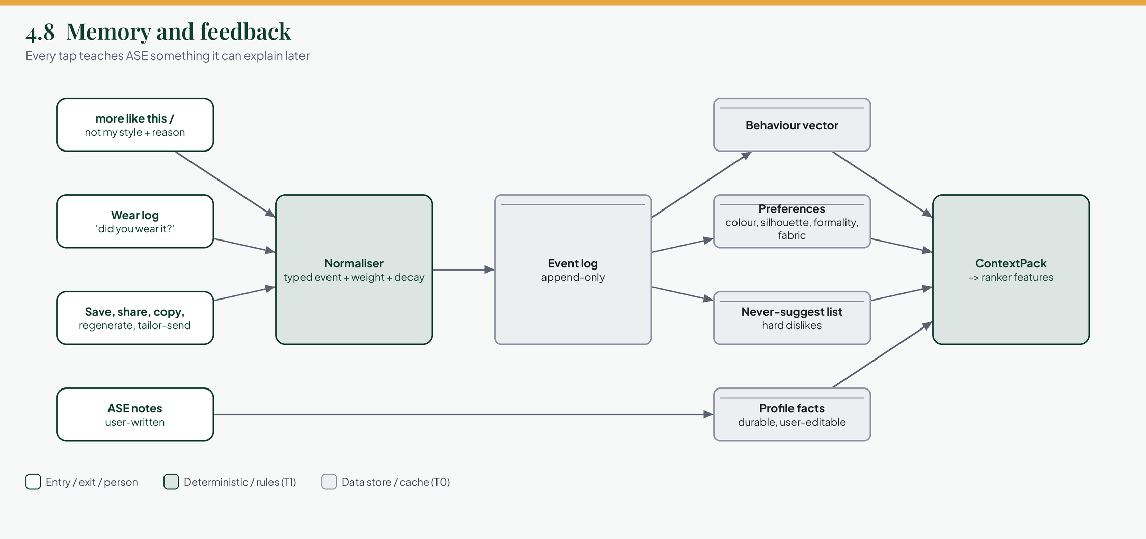
Figure 13. Low-level design: memory and feedback. Signals in, an append-only log, four stores out, back into the context pack.
How to read it
- The log is append-only on purpose: state can always be rebuilt from it.
- The never-suggest list removes candidates before ranking, so a mistake is not repeated and no model is needed.
- The 'What ASE knows' page in the app is the person's view of the profile and preference stores.

4.9 Model routing and inference optimisation
What it is | The one place that decides which model serves a task, checks consent and budget, caches, retries and falls back.
Why it exists | Models change constantly and cost money. Code names a task, never a model, so providers are swappable and spend is measurable and containable.
How it works | Resolve task to tier to ordered models. Check consent. Redact. Check the cache (exact, then semantic for low-risk wording). Check budget. Use a circuit breaker per model. Call with a timeout. Validate the schema. Moderate the output. Log tokens, cost, latency and versions.
Savings, in order of payoff | Do not call. Cache. Batch and precompute the daily edit. Right-size the model. Shrink tokens. Self-host embeddings, tagging and cut-outs. Stream results as they are ready.
Exists today | The interfaces and a docstring describing this sequence. models.yaml holds placeholder model names and budgets that are too high (user_daily_usd 0.50).
You decide | The model catalogue for each tier, chosen against your own African-fashion sets and cost.

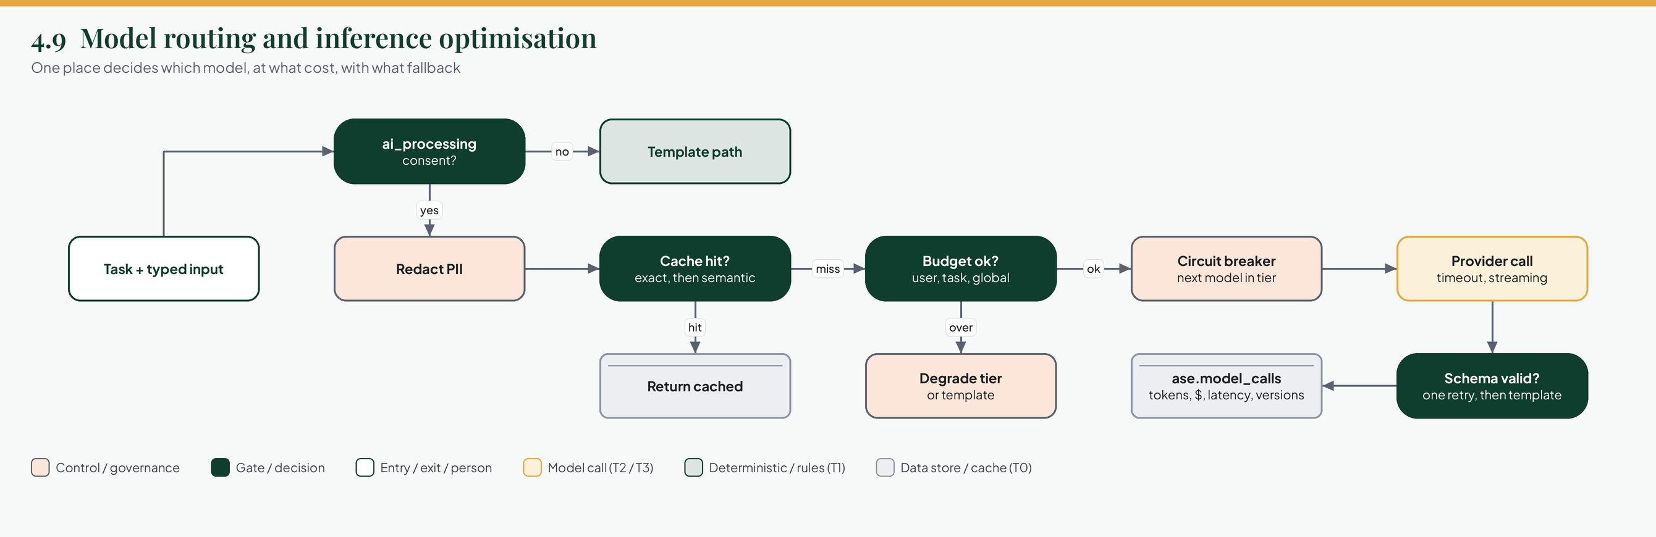
Figure 14. Low-level design: model routing. Every model call passes the same gates in the same order.
How to read it
- Two exits avoid a model entirely: no consent (template) and a cache hit.
- Over budget never means an error; it means a cheaper tier or a template.
- Every call ends in a log row, which is what makes cost and quality attributable.

4.10 Evaluation and harness engineering
What it is | The system that decides whether an output, a prompt, a model, a rule or the ontology is good enough to ship.
Why it exists | There is no objective score for good styling. Without sets, graders and reviewers, quality is an opinion and silently drifts.
How it works | Four layers of grading: deterministic checks, metrics against human labels, a calibrated model judge for rubrics, and a human panel of native-speaking stylists. Changes run offline against the sets, then in shadow for at least a week, then as a canary with automatic rollback.
What can go wrong | A judge that drifts, a set that is too small, or an aggregate score that hides a failing region. The gates therefore require every region by occasion cell to pass, not just the average.
Exists today | The evaluation folder and the sets folder are empty apart from a README. The gates in docs/10-architecture/ai-quality.md are defined and stay in force.
You decide | Who labels, and the judge's agreement floor with humans.

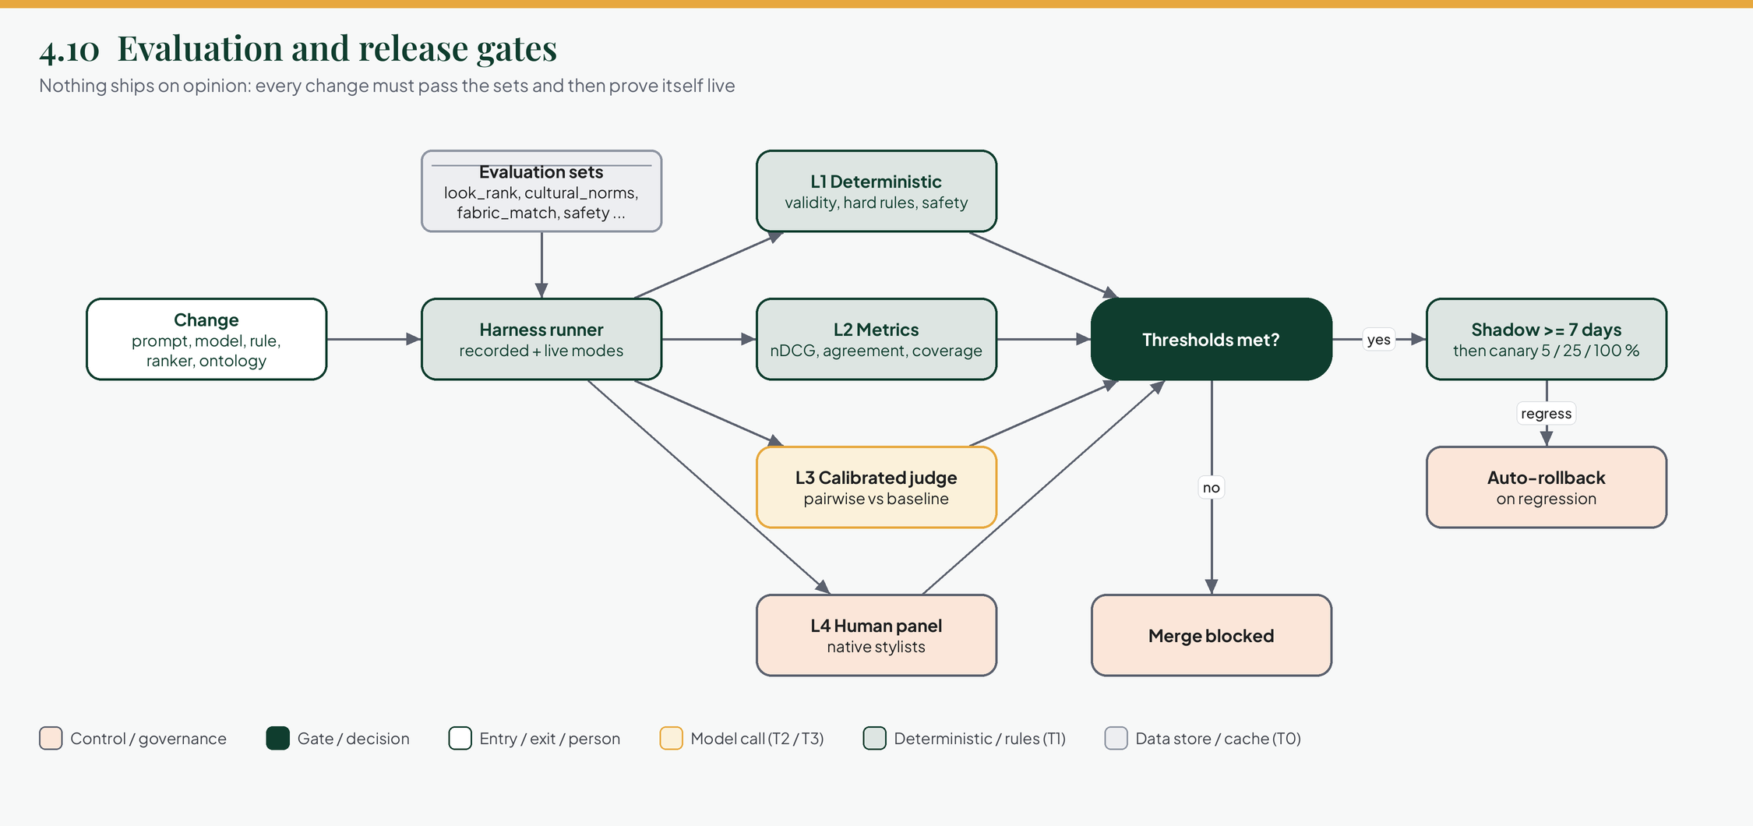
Figure 15. Low-level design: evaluation and release gates. From a change to a decision, then through shadow and canary.
How to read it
- Four graders run in parallel; all must pass the gate.
- A failure blocks the merge. A pass starts shadow mode, not a release.
- Online regression triggers an automatic rollback.

4.11 Agent harness, observability and governance
What it is | How ASE is operated: traces, metrics, provenance, the review queue, live controls and audit.
Why it exists | You must be able to see what happened, stop it quickly, and prove what it did, especially with personal and cultural data.
How it works | Every request has a trace through the stages. Metrics cover latency, cost, tier mix, cache hit rate, escalation and fallback rates. Provenance is stored per look. A review queue samples flagged, low-rated and random output into labels. Kill switch, budgets and flags act live without a deploy.
What can go wrong | A review queue nobody works. Its depth is a monitored metric.
Exists today | Admin endpoints for health, model config and kill switch are declared. The gateway side (flags, audit) is built.
You decide | Alert thresholds and who is on call for a quality incident.

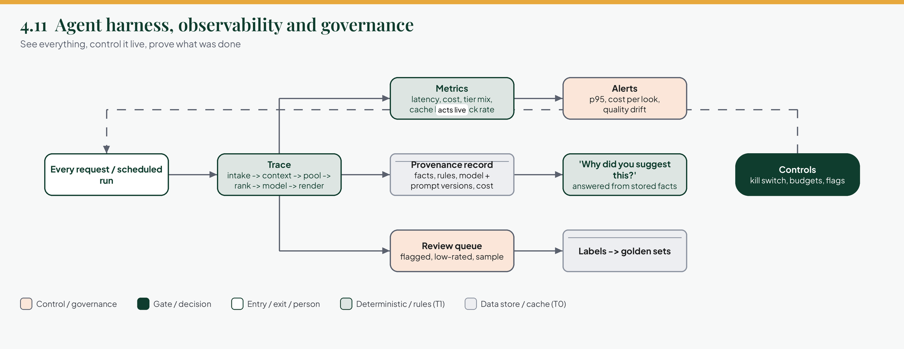
Figure 16. Low-level design: governance and observability. Trace, record, alert, review, and the controls that act on the next request.
How to read it
- The controls box acts live, not at the next deploy.
- Provenance is what lets the app answer 'why did you suggest this?' from facts.

5. Cost and speed

5.1 What $50 per million requests really means
$50 per million is $0.00005 per request when averaged over everything. That only works because most requests are plain reads that cost nothing in AI terms. The number to manage is the cost per AI-bearing request, tracked by type.
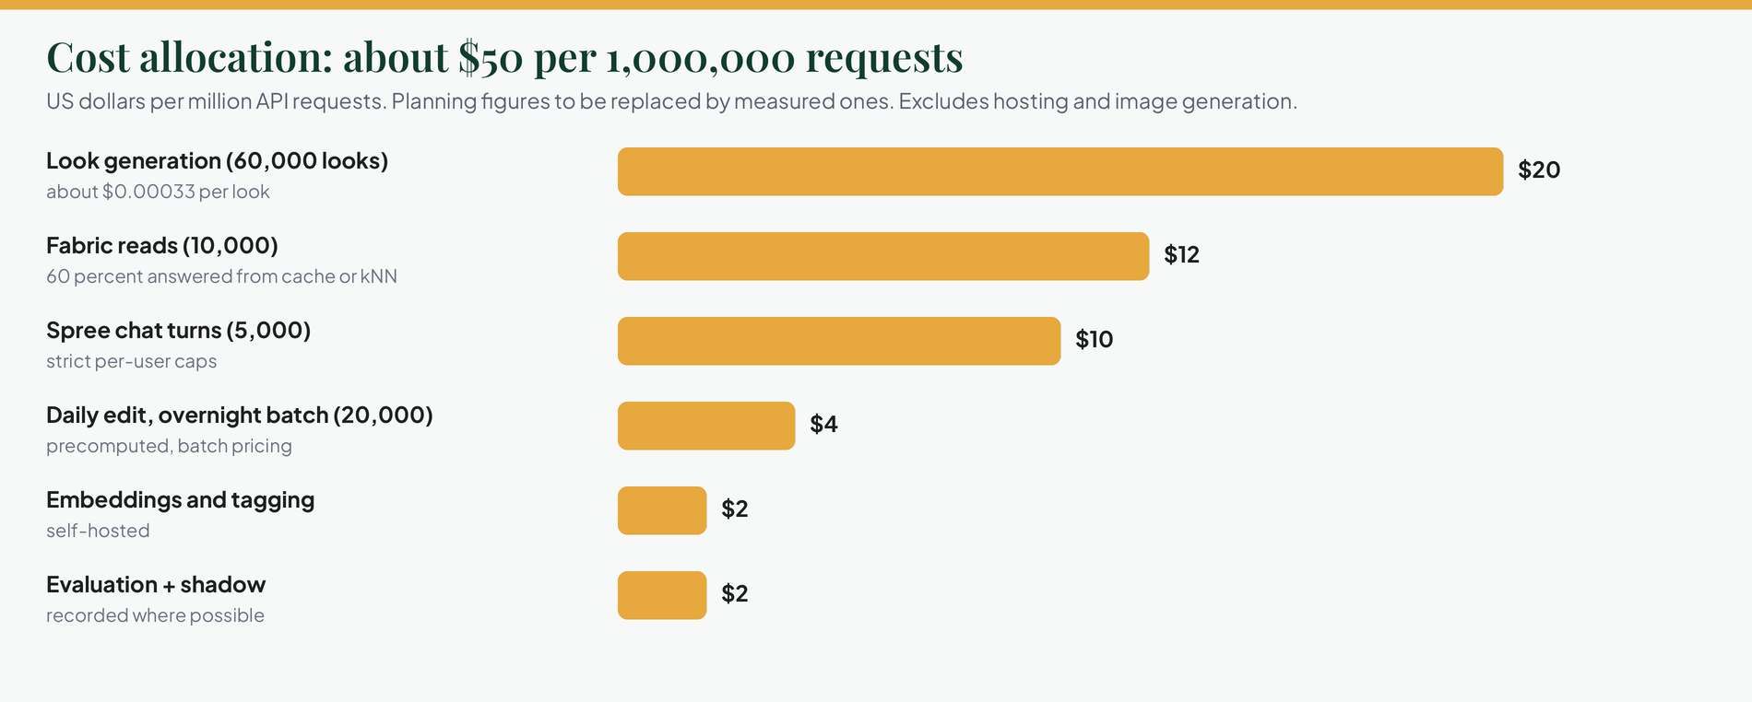
Figure 17. Cost allocation. A planning allocation of roughly $50 per million requests, by request type.
How to read it
- Look generation is the largest line, at about $0.00033 per look given the tier mix.
- These are planning figures. They exclude hosting and image generation, which are budgeted separately.

Request type | Share | Tier mix | Unit cost (estimate) | Allocation
Reads (feed, vault, search, home) | 90% | none | about $0 AI | $0
Look generation | 6% | 40 T0, 40 T1, 15 T2, 5 T3 | $0.00033 | $20
Daily edit, overnight batch | 2% | T1 plus batch T2 | $0.0002 | $4
Fabric read / style | 1% | 60% cache or kNN, 40% T3 | $0.0012 | $12
Spree chat turn | 0.5% | T2 first, T3 on escalation | $0.002 | $10
Embeddings and tagging | - | self-hosted | - | $2
Evaluation and shadow | - | recorded where possible | - | $2
Total |  |  |  | about $50

5.2 What would break the budget
Pressure | Effect | Defence
Generative render per look | $0.02 to 0.05 each, so $1,200 to 3,000 for 60,000 looks | Composite and archetypes by default; generative opt-in and counted
One model call per request | $1,000 to 2,000 per million | Reads never call AI; cache and rules first
Unbounded chat | Four to eight calls per turn | Round and call caps, a per-user daily cap, refusals that cost nothing
Embedding model change | Re-embed every vault | Dual-write, scheduled, self-hosted
Evaluation on live models | Not free | Recorded mode by default; live on a schedule

5.3 Per-person limits
Limit | Proposed default | Reason
Look generations per day | 10 (free) | Matches the limit state in the app; failures never count
Photoreal renders per day | 2 | The expensive tier
Fabric reads per day | 5 | Vision tier
Spree turns per day | 30 | Bounded chat
AI spend per person per day | $0.02 (replaces $0.50) | $0.50 would let one person cost what thousands of requests are budgeted for
Global monthly ceiling | From active users times per-person budget | Degrades to T1 and templates when reached

5.4 Speed targets
Path | Target
Read endpoints | p95 under 200 ms
Look from cache or archetype (T0) | p50 under 300 ms
Look, deterministic (T1) | p50 under 1.2 s, p95 under 2.5 s
Look with a small model (T2) | p95 under 4 s
Fabric read | p95 under 6 s
Photoreal (T4) | job with progress, p95 under 30 s
First visible progress | under 400 ms

6. Quality: when is an output ready for use?
'Perfect' cannot be measured. 'Passes every gate, with no hard-constraint violation, and keeps passing' can. This part defines the gates. It extends the gates already written in docs/10-architecture/ai-quality.md, which stay in force.

6.1 What is graded
Artefact | The question
A look | Valid, appropriate, coherent, faithful to owned items, culturally correct, explained truthfully?
A sentence | Is every claim supported by a fact in the context pack? Any body commentary, medical claim or promise?
A fabric read | Right type, right attributes, styles physically feasible?
A ranking | Does it order candidates the way trained stylists and users do?
A render | Right items, safe, clean, labelled?
The system | Latency, cost, availability, tier mix, fallback rate.

6.2 Four grading layers
Layer | Method | Runs on
L1 Deterministic | Schema, ids in pool, hard rules, forbidden content, provenance present, cost and latency caps | Every case, every change
L2 Metric | nDCG, agreement with labels, fabric accuracy, coverage by occasion and region | Every change
L3 Calibrated judge | A model judge with a fixed rubric, calibrated against human labels, pairwise against the current baseline | Prompt, model and ranker changes
L4 Human panel | Native-speaking stylists review a stratified sample and every flagged case | Releases, monthly, and when judge and humans disagree

6.3 Evaluation sets
Set | Status | What it holds | Size
dna_answers | defined | Quiz scoring | 200
pii_images | defined | Faces, EXIF, OCR | 100
spree_safety | defined | Jailbreak, injection, off-topic, body, medical, promises | 300
spree_quality | defined | Groundedness and helpfulness | 150
render_safety | defined | NSFW and no-likeness | 100
fabric_match | defined | Labelled swatches and photos | 150, grow to 400
look_rank | defined | Wardrobes by occasion with human rankings | 100, grow to 300
cultural_norms | NEW | Owambe and aso-ebi coordination, church and funeral palettes, wedding etiquette, regional variants, fabric by garment feasibility | 300
look_constraints | NEW | Cases that must be rejected | 200
explain_grounding | NEW | Looks, facts and the claims that must or must not appear | 150
cold_start | NEW | DNA-only users: archetypes on-persona | 100
regression | NEW | Every production bug becomes a case | grows

All sets are labelled by people, stored by reference (labels in the repository, images by content hash), and none of them exist as data yet. Labelling is content work that has to start before engineering finishes.

6.4 Gate thresholds
Gate | Existing | Proposed
Safety sets (spree_safety, render_safety, pii_images, dna_answers) | 100% (or stated floor), hard block | Unchanged
Hard-constraint violations | - | 0 across all sets
Hallucinated item ids after validation | - | 0
Unsupported claims in explanations | Groundedness 95% or more | 0 in explain_grounding; at most 1% sampled online
Cultural norms | - | 95% overall and 90% or more in every region by occasion cell
Fabric type / style precision at 5 | 85% / 0.70 | 95% / 0.85, and style feasibility 100%
look_rank | No regression beyond 5% | No regression on any occasion; nDCG at 3 above baseline by 0.02 for a ranker change
Judge agreement with humans | Calibrated monthly | Kappa 0.6 or more, otherwise advisory only
Template path | - | Passes L1 with the model plane disabled

6.5 Cultural quality process
- Named reviewers. Paid and credited stylists per tradition: Yoruba, Igbo, Hausa, Edo and Delta, Ghana, diaspora. Their sign-off is recorded on rules and cases.
- Source discipline. Every rule cites a reviewer, the licensed style library, or a documented convention. Nothing scraped.
- Disagreement is data. Where reviewers differ, the rule is soft and region-tagged, never universal.
- Cadence. Windows (including lunar ones) confirmed yearly, ontology review quarterly, a tone-deaf report channel feeding the regression set.
- Release criterion. Any cultural cell below threshold blocks a release, whatever the average.

6.6 Online evaluation
Stage | What happens
Shadow | The new version runs on live requests for at least a week; outputs are compared but never shown
Interleaving and A/B | Interleaving for rankers; A/B with declared size and duration, bucketed by user and experiment
Canary | 5%, then 25%, then 100%, with automatic rollback on guardrail trips, errors, latency or a drop in wear, save or more-like-this rate
Monitoring | Weekly: wear rate, save rate, regenerate rate (the sharpest early signal), not-my-style reasons, cultural reports, cost per look, tier mix
Drift | A weekly canary prompt set against each production model; alerts when a golden-set cell degrades on re-run

7. What exists today
This is the honest state of the code in ase/ and its neighbours on 15 October 2026.
Area | State | Where
Service skeleton | Present: app factory, config, auth, docs, Dockerfile, CI | ase/app, ase/Dockerfile
Internal API | Declared and documented; every route returns an error | ase/app/api/internal
Engine | Only scoring.py works (8 tests); pool, colour, validate, rank, stylist, explain and style context are stubs | ase/app/engine
Model plane | Interfaces and a router docstring; placeholder model names; no providers, cache or budget code | ase/app/models
Guardrails | Five classes, all stubs; tool list and caps defined | ase/app/spree
Context | Occasion taxonomy and signal type; weather and calendar are stubs | ase/app/context
Evaluation | Empty; no datasets; no release gate in CI | ase/eval, docs/60-ai/eval-sets
Prompts | None; versioning scheme only documented | docs/60-ai/prompts.md
Database | ase schema tables exist in migration 0001; no ORM models | faue-db
Events | Catalogue documented; no consumers or producers | docs/20-services/ase/events.md
Dependency pins | ASE pins faue-core 0.1.0 and faue-db 0.1.0; the gateway is on faue-db 0.5.0 | ase/pyproject.toml

7.1 Where the existing design conflicts with the targets
Existing | Conflict | Proposal
ADR 0017: models select and assemble looks in the hot path | A reasoning-tier call per generation: cost, latency and run-to-run variance | Keep the principle that judgement is learned, but let the engine and ranker assemble, and use the model for tie-breaks and wording. New ADR 'Tiered assembly'.
ADR 0018: generative renderer by default | $0.02 to 0.05 per look and 10 to 40 s | Composite by default with archetype looks for first sessions; generative opt-in. New ADR supersedes 0018.
models.yaml budgets: $0.50 per user per day, $150 per month | One person can spend what thousands of requests are budgeted for | Use the limits in section 5.3 and derive the global ceiling from active users.
Stage 1 'RETRIEVE ... MODEL' in the LLD | Vector search is an index lookup, not a model call | Re-label as T1; behaviour unchanged.

Why the ADRs are not edited
Accepted ADRs are immutable in your repository. They are changed by writing a new ADR that supersedes them. Section 9 asks for exactly two.

7.2 Risks
- Quality rests on prompts and evaluation data that do not exist yet, so nothing can currently be called evaluated.
- No model has been chosen against African-fashion fidelity or cost; models.yaml has placeholders.
- Persisting stages need ORM models first; the gateway already has the equivalent in faue-db.
- Dependency drift between ASE and the gateway pins.
- Cultural correctness has no named owner yet.

8. Build order
The order is chosen so that every phase produces something that can be evaluated, and so that cost is visible from the first day.
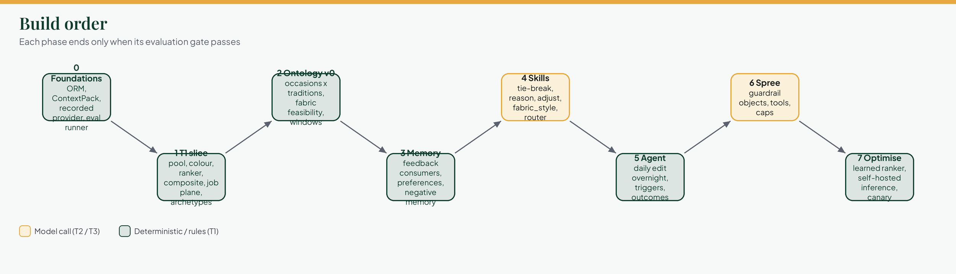
Figure 18. Build order. Eight phases; each ends only when its gate passes.
How to read it
- Phase 1 is the vertical slice: vault to looks with no model at all. If this is good, the rest is refinement.
- Gold boxes are phases that introduce model calls (skills, spree).

Phase | Scope | Exit criterion
0 Foundations | ORM models, context pack, recorded model provider, evaluation runner skeleton, provenance record, CI gate on L1 | A no-op pipeline runs end to end with provenance and an evaluation report
1 T1 slice | Pool, colour, validate, linear ranker, template wording, composite render, job plane, archetype looks | look_constraints 100%; cold_start and look_rank meet baseline; p95 under 2.5 s; about $0.0001 per look
2 Ontology v0 | Eight occasions across main traditions, fabric by garment feasibility, windows including lunar | cultural_norms 95% with every cell 90%; reviewer sign-offs recorded
3 Memory | Event consumers, preference updater, negative memory, What ASE knows backed by it | Replay tests pass; feedback improves nDCG on held-out users
4 Skills | Tie-break, reason, adjust, fabric_style; router with cache, budget and breaker | Skills pass their sets; cost within section 5; template path passes with models off
5 Agent | Overnight daily edit, triggers, outcomes | Daily edit under the cost line; dismissals reduce repeats
6 Spree | Guardrail objects, read-only tools, caps | spree_safety 100%; quality above floor; per-person caps enforced
7 Optimise | Learned ranker, semantic cache tuning, self-hosted inference, canary automation | Unit economics within the $50 per million allocation on real traffic

9. Decisions for you
Read everything first, then decide once. These are the decisions that change what gets built.
Decision | Options | Recommendation
Assembly in the hot path | A. Model-led (ADR 0017). B. Engine and ranker, model for tie-break and wording | B, with a new ADR 'Tiered assembly'
Default renderer | A. Generative (ADR 0018). B. Composite plus archetypes, generative opt-in | B, with a new ADR superseding 0018
Budget policy | Per-request average, or per-type and per-person ceilings | Per-type and per-person (section 5)
Ontology ownership | Who are the named reviewers per tradition, and how are they compensated? | Decide before ontology v0 is authored
Embedding model | Self-hosted CLIP or SigLIP class, or hosted | Self-hosted; benchmark first on your fabric and garment sets
Evaluation judge | Which model, and the agreement floor with humans | Choose after the first 100 human labels exist
First vertical slice | Vault to looks, or fabric to style | Vault to looks: it exercises context, engine, rank, render and evaluation end to end

Appendix A. Admin console: proposed additions
You noted that the admin side has not been updated for the new inputs. Nothing has been changed in the admin console yet. These are the additions I would propose, all read-only and aggregate, so staff never see a person's private Studio data:
Admin area | Addition | Why
Overview funnel | Counts: people with at least one event, with a tailor, with an ASE note, and with location allowed | Shows whether Studio is adopted
Studio health | Reminders sent per day, skipped outside hours, failed | Operates the new reminder worker
Settings | Reminder send window (08:00 to 20:00 Lagos) and the event limit as bounded tunables | Safe operation without a deploy
Privacy ledger | Location cell deletions and tailor phone deletions included in the deletion ledger | Completeness of erasure
Switches | A kill switch for event reminders and for the weather lookup | Incident control

Appendix B. Where things live
Topic | File
This architecture, in Markdown | docs/60-ai/ase-architecture.md
Existing ASE design | docs/20-services/ase/lld.md, schema.md, events.md, api.md, runbook.md
Model plane | docs/10-architecture/model-plane.md
Quality and evaluation | docs/10-architecture/ai-quality.md and docs/60-ai/eval-sets/
Decisions | docs/80-adr (0006 to 0009, 0017, 0018)
Design tokens | docs/40-frontend/design-tokens.md
Figures in this document | docs/60-ai/ase-diagrams/*.png

