PIMCodec Design Document

This confidential document is the property of Benq Co. and must not be copied or circulated without permission.

Version : [0.0]
Date: [07/02/2007]

Author: [Mei.Yang]
Approval: [ ]

DOCUMENT VERSION HISTORY
Version | Date | Author | Comments
[0.0] | 2007/07/02 | Mei Yang | Creation

Note
[0.0]: Create PIMCodec Design Document

Glossary
- Abbreviation
PIM Personal Information Manager
QP Quoted-Printable
UTF-8 8-bit Unicode Transformation Format

- Acronyms and Terms
Codec Encoder and Decoder
Character Set A set of characters of a certain language to facilitate the storage of text or symbols in computers and the transmission of them through telecommunication networks
Code Page A character encoding table which provides a mapping between each single octet representing integer and its associated character

Reference document
Doc # | Document Title | From
 | vCard V2.1 Specification | http://www.imc.org/pdi/
 | vCalendar V1.0 Specification | http://www.imc.org/pdi/

Content
Note III
Glossary 1
Reference document 2
1 Introduction 4
2 High Level Design 4
2.1 Architecture 4
2.1.1 Main Architecture 4
2.1.2 Data Processing Flow 6
2.2 Use Case 6
3 Low Level Design 7
3.1 Class Diagram 8
3.2 PIM Format in Common Data 9
3.3 Sequence Diagram 9
3.3.1 Decode 10
3.3.2 Encode 12

Introduction
Our main purpose of developing this PIMCodec is to decode and encode the old standard exchange format such as VCard, VCalendar, or even iCalendar into the format supported by Common Data which is developed for QSyncher 2.0 saving sync data in PC. In PIMCodec, we only deal with format transformation which makes sure of every old standard exchange format being able to transform into Common Data. However, we do not ensure the analysis of semantics.

Inside this design document we will describe both the high level and the low level design of PIMCodec, including its architecture, classes, use case, and so on.

High Level Design
In this chapter, we talk about the overview, and use case of PIMCodec with the aids of flow charts and diagrams to clearly describe the mechanisms which we used to parse old standard exchange format.

Architecture/Overview

Main Concepts
Primarily, PIMCodec separates into two parts. One is Decoder, and the other is Encoder. The main concepts are shown as figure 2-1-1 (Decoder) and 2-1-2 (Encoder).

Split Raw Data into raw lines and insert them into a vector
Decoder
Raw lines
[Raw Data]

BEGIN:VCALENDAR
VERSION:1.0
BEGIN:VEVENT
SUMMARY:test
DTSTART: 19960401T083000Z
DTEND: 19960401T093000Z
END:VEVENT
END:VCALENDAR

Group lines into Entity Block by parsing Tag BEGIN and END and Set Entity Block name
Entity Block
Split Parameter and Value for parsing separately and Save Property Name
Parameters
Save Parameter Name and Parameter Value into Common Data
Values
Save Values into Common Data
Entity Block Name
Save Entity Block Name into Common Data and Set LUID
Common Data
Figure 2-1-1: Decoder

Get Entity Block Name in order to access entities
Encoder
lines
Common Data

Combine lines and put them between Property Begin and End
Entity Block
Parameter line
Join Parameter Name and Parameter Value in a line
Value line
Join Values in a line
Raw Data
Combine Parameter and Value into a line
Figure 2-1-2: Encoder

Data Processing Flow

In this section, we will introduce the data processing flow of PIMCodec.

Use Case

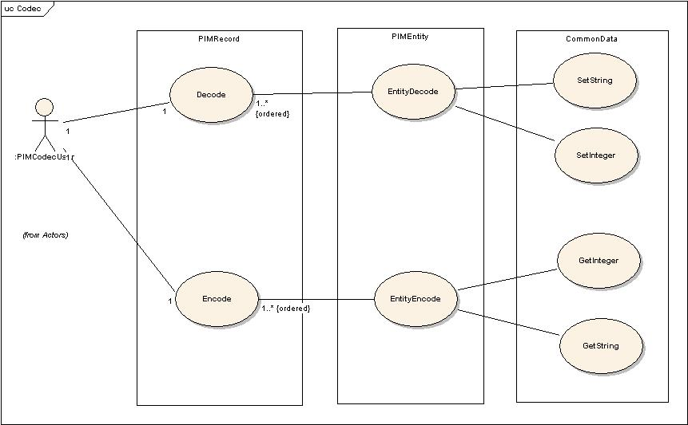
Figure 2-2-1: The Use Case of PIMCodec

The use case for PIMCodec is shown as figure 2-2-1.

Low Level Design
In this chapter, we will discuss each kernel class in PIMCodec using class diagram and sequence diagrams.

Class Diagram
Figure 3-1-1 shows the whole classes which are related to PIMCodec. The red frame in the figure indicates two main classes which implement the codec in practice. 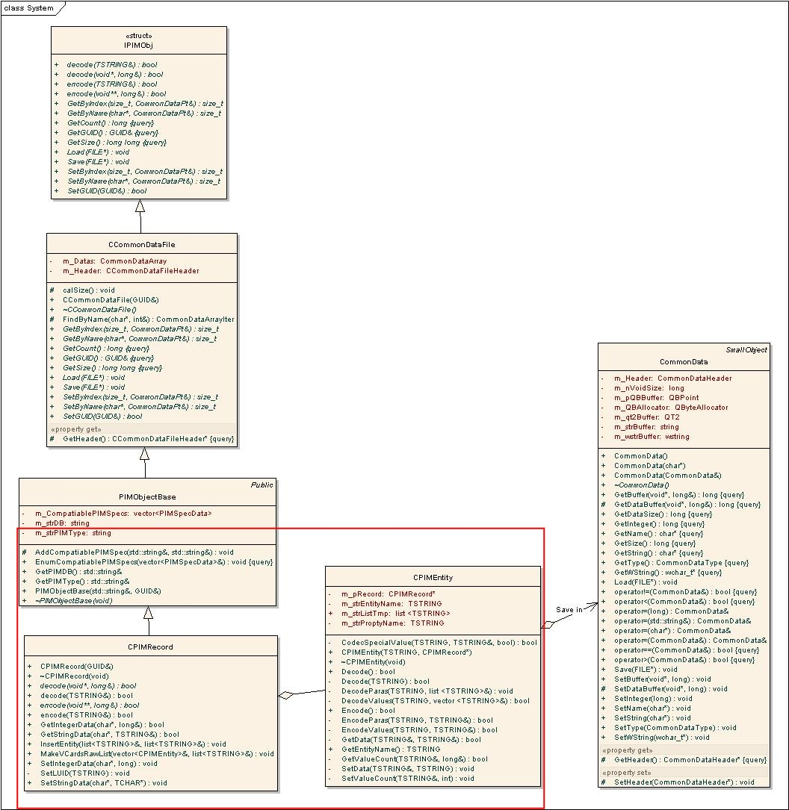
Figure 3-1-1: The Class Diagram of PIMCodec

PIM Format in Common Data
Before introducing PIM format in Common Data, there are few terms we need to describe in order to explain the terms in PIM format. Owing to PIM format being similar, we take VCalendar for example.

Object
BEGIN:VCALENDAR
VERSION:1.0
BEGIN:VEVENT
SUMMARY;CHARSET=UTF-8;ENCODING=QUOTED-PRINTABLE:Untitled event
DESCRIPTION;CHARSET=UTF-8;ENCODING=QUOTED-PRINTABLE:None
DALARM:20070622T065500Z;P0000Y00M00DT00H00M00S;000
UID:155
END:VEVENT
END:VCALENDAR

We call the above format an Object. In this object, we call the fragment between the VCalendar terms BEGIN and END a Entity. Besides, Entity name is the term following behind BEGIN and END which needs to be the same.

Entity
BEGIN:VEVENT
SUMMARY;CHARSET=UTF-8;ENCODING=QUOTED-PRINTABLE:Untitled event
DESCRIPTION;CHARSET=UTF-8;ENCODING=QUOTED-PRINTABLE:None
DALARM:20070622T065500Z;P0000Y00M00DT00H00M00S;000
UID:155
END:VEVENT

So, in this Entity example, Entity name is VEVENT.

Property
SUMMARY | ; | CHARSET | = | UTF-8 | ;ENCODING=QUOTED-PRINTABLE | : | Untitled event
Property Name |  | Parameter Name |  | Parameter Value | Parameter |  | Value

In each line of Entity, we call it a Property. A Property contains three parts: Property Name, Parameter, and Value. In this example, SUMMARY is a Property Name, CHARSET=UTF-8;ENCODING=QUOTED-PRINTABLE is a Parameter, and Untitled event is Value. Parameter can be Separated into two parts or not. We name those parts Parameter Name and Parameter Value. In VCard, it’s possible for Parameter not to be separated, but we still force it to be separated into NULL and Parameter Value. Parameter and Value can be more than one.

After describing terms, there is the PIM format in Common Data as below table 3-2-1.

Quantity | Common Data Format |  | Necessity  (Yes/No)
Quantity | Key | Value | Necessity  (Yes/No)
1 | [KEYWORD_OBJECT_NAME] | Entity Name1; Entity Name2… | Yes
1 | Object | Entity Name1; Entity Name2… | Yes
Amount of Entities | [KEYWORD_PROPERTY_NAME] | Property Name1; Property Name 2… | Yes
Amount of Entities | Entity Name: PropertyName | Property Name1; Property Name 2… | Yes
Amount of Entities  *  Amount of Properties | [KEYWORD_PARAMETER_NAME] | Parameter Name1; Parameter Name2… | No
Amount of Entities  *  Amount of Properties | Entity Name: Property Name: ParaName | Parameter Name1; Parameter Name2… | No
Amount of Entities  *  Amount of Properties | Entity Name: Property Name: Parameter Name | Parameter Value1; Parameter Value2… | No
Amount of Entities  *  Amount of Properties | [KEYWORD_PROPERTY_NULL] | Parameter Value1; Parameter Value2… | No
Amount of Entities  *  Amount of Properties | Entity Name: Property Name: NULL | Parameter Value1; Parameter Value2… | No
Amount of Entities  *  Amount of Properties | [KEYWORD_PROPERTY_COUNT] | number<integer>(0 or more than 2 including 2) | No
Amount of Entities  *  Amount of Properties | Entity Name: Property Name: Count | number<integer>(0 or more than 2 including 2) | No
Amount of Entities  *  Amount of Properties | Entity Name: Property Name(:0…number-1) | Property Value(0…number-1) | Yes
Table 3-2-1: PIM Format in Common Data

To Save data into Common Data, there are two values, Key and Value which should be provided seeing that Common Data is saved in a map. We can save several types of Value in Common Data. In our PIMCodec, we only have two types of Value, TSTRING and Integer. And the Integer type will only be used in saving the count of Property Value if it is more than one.

Sequence Diagram
There are two actions PIMCodec user can take in use case described in the above chapter. Thus, we present two sequence diagrams in next two sections.

Decode
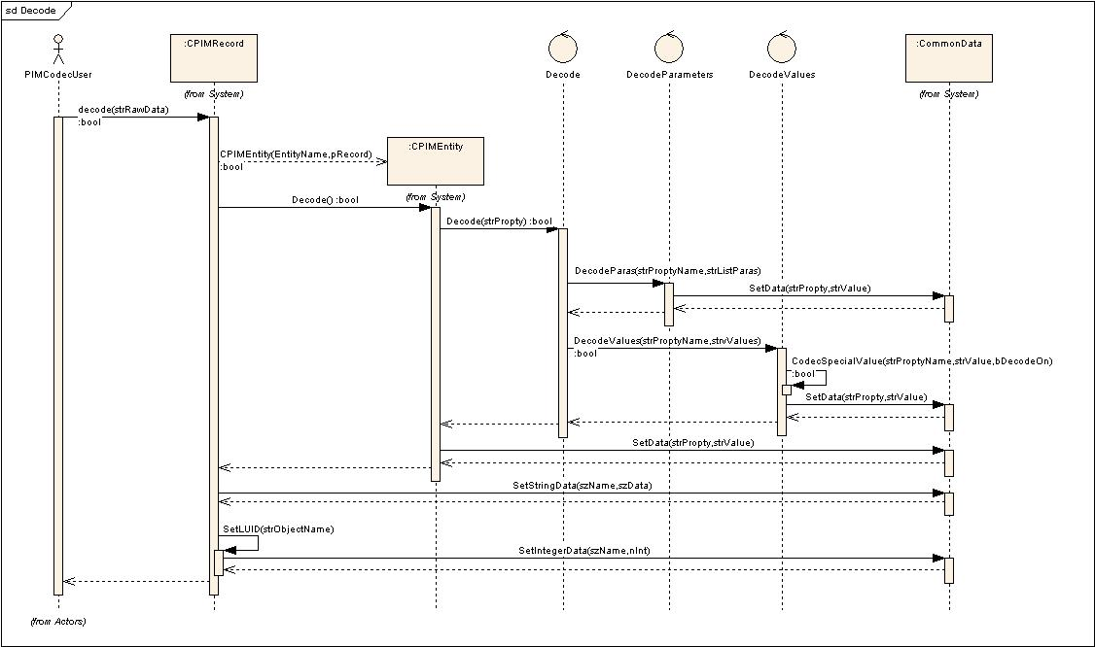
Figure 3-3-1: Decoder Sequence Diagram

As figure 3-3-1 shows,

Encode
As figure 3-3-2 shows,

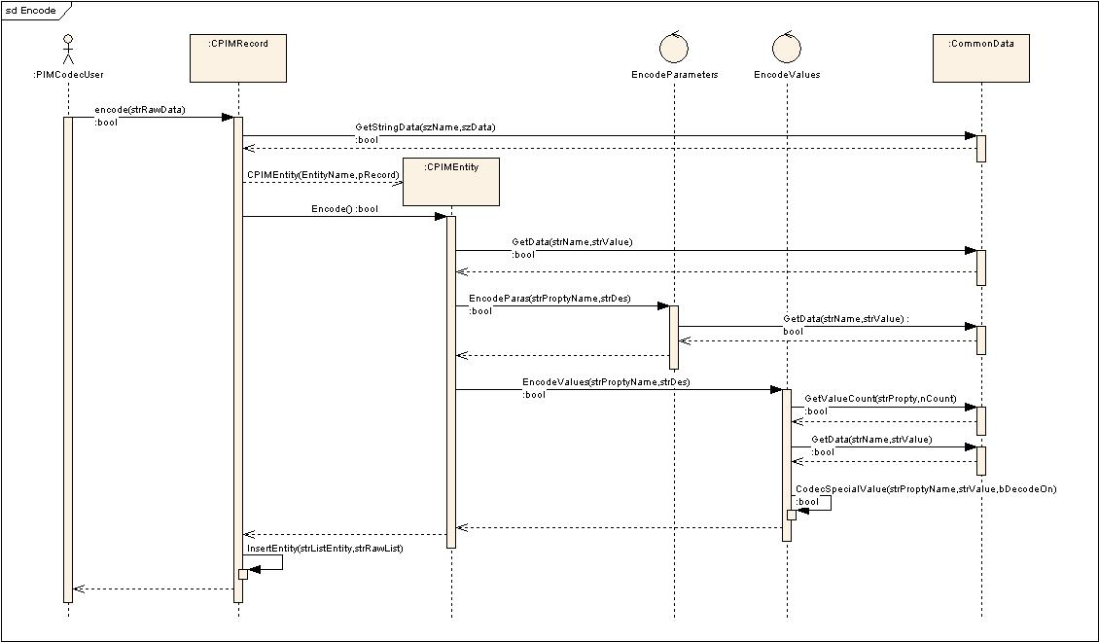
Figure 3-3-2: Encoder Sequence Diagram

