SyncML Design Document

This confidential document is the property of Benq Co. and must not be copied or circulated without permission.

Version : [0.0]
Date: [07/10/2007]

Author: [Alan Tu]
Approval: [ ]

DOCUMENT VERSION HISTORY
Version | Date | Author | Comments
[0.0] | 2007/07/10 | Alan Tu | Creation

Note
[0.0]: Create SyncML Design Document

Glossary
- Abbreviation
PIM Personal Information Manager
SyncML Sync markup language

- Acronyms and Terms
Character Set A set of characters of a certain language to facilitate the storage of text or symbols in computers and the transmission of them through telecommunication networks
Code Page A character encoding table which provides a mapping between each single octet representing integer and its associated character

Reference document
Doc # | Document Title | From
 | OMA SyncML Common Specification | http://www.openmobilealliance.org/release_program/index.html
 | SyncML_present.pdf | @Design Document folder

Content
Note III
Glossary 1
Reference document 2
1 Introduction 4
2 High Level Design 4
2.1 Architecture 4
2.1.1 Main Architecture 4
2.1.2 Data Processing Flow 6
2.2 Use Case 6
3 Low Level Design 7
3.1 Class Diagram 8
3.2 PIM Format in Common Data 9
3.3 Sequence Diagram 9
3.3.1 Decode 10
3.3.2 Encode 12

Introduction
Our main purpose of developing this SyncML is to follow standard Sync markup language to sync any kind of PIM objects between two devices. For now, only OBEX binding is working. It should support more binding like WBXML, HTTP, etc. And support VCard, VCalendar, it should support any kind of PIM like file, folder, etc.

Inside this design document we will describe both the high level and the low level design of SyncML, including its architecture, classes, use case, and so on.

High Level Design
In this chapter, we talk about the overview, and use case of SyncML with the aids of use case and diagrams to clearly describe the mechanisms which SyncML how to work.

Architecture/Overview

Main Concepts
Primarily, SyncML is getting data more efficiently. If there have no any change, it didn’t update anything. If there is one had changed, it update one only. For sync issue, we must have change log to record what had changed in local data and then we can choose changed to update.
It really case, ambiguous event happened when changed in the same data. So we need judgment to decide what’s latest.
Some special case, we want client’s data only, or we need server’s data only.
So it define six kind of sync to fit so many case.

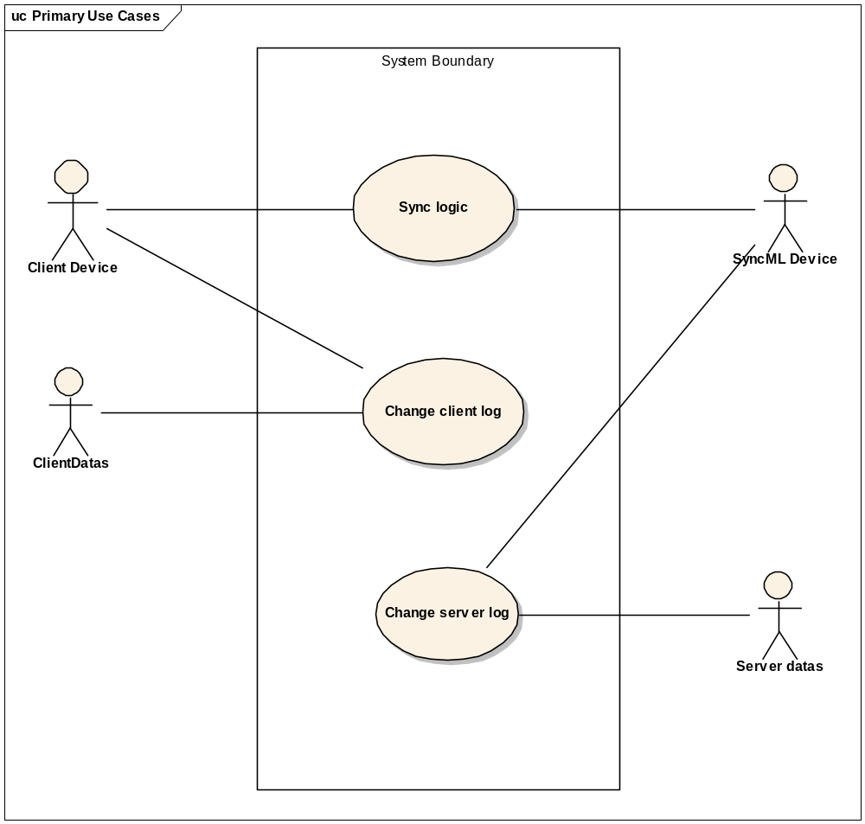
Figure 2-1-1: Use case

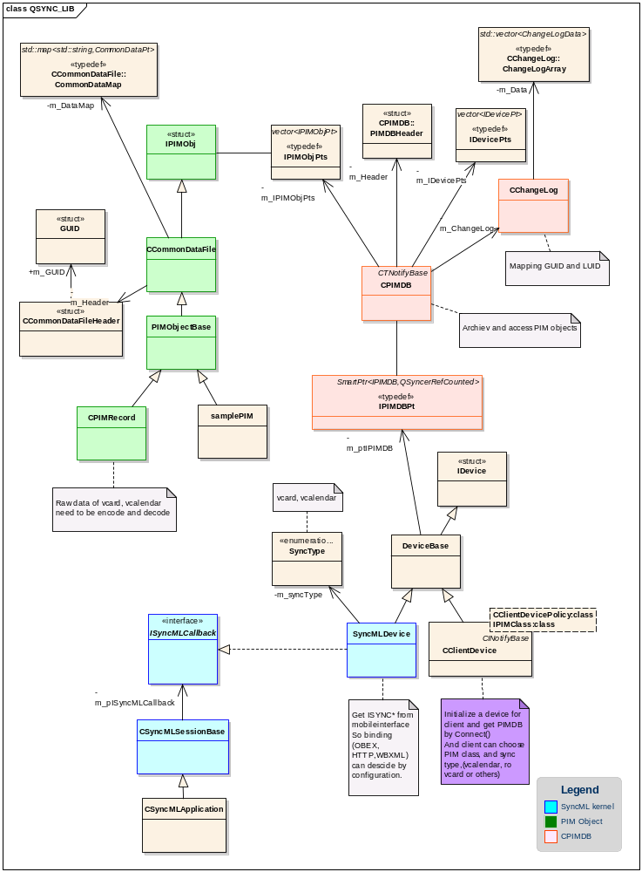
Figure 2-1-2: Architecture diagram

Data Processing Flow

In this section, we will introduce the data processing flow of PIMCodec.

Low Level Design
In this chapter, we will discuss each kernel class in PIMCodec using class diagram and sequence diagrams.

Class Diagram
Figure 3-1-1 shows the whole classes which are related to PIMCodec. The red frame in the figure indicates two main classes which implement the codec in practice.
Figure 3-1-1: The Class Diagram of PIMCodec

PIM Format in Common Data
Before introducing PIM format in Common Data, there are few terms we need to describe in order to explain the terms in PIM format. Owing to PIM format being similar, we take VCalendar for example.

Object
BEGIN:VCALENDAR
VERSION:1.0
BEGIN:VEVENT
SUMMARY;CHARSET=UTF-8;ENCODING=QUOTED-PRINTABLE:Untitled event
DESCRIPTION;CHARSET=UTF-8;ENCODING=QUOTED-PRINTABLE:None
DALARM:20070622T065500Z;P0000Y00M00DT00H00M00S;000
UID:155
END:VEVENT
END:VCALENDAR

We call the above format an Object. In this object, we call the fragment between the VCalendar terms BEGIN and END a Entity. Besides, Entity name is the term following behind BEGIN and END which needs to be the same.

Entity
BEGIN:VEVENT
SUMMARY;CHARSET=UTF-8;ENCODING=QUOTED-PRINTABLE:Untitled event
DESCRIPTION;CHARSET=UTF-8;ENCODING=QUOTED-PRINTABLE:None
DALARM:20070622T065500Z;P0000Y00M00DT00H00M00S;000
UID:155
END:VEVENT

So, in this Entity example, Entity name is VEVENT.

Property
SUMMARY | ; | CHARSET | = | UTF-8 | ;ENCODING=QUOTED-PRINTABLE | : | Untitled event
Property Name |  | Parameter Name |  | Parameter Value | Parameter |  | Value

In each line of Entity, we call it a Property. A Property contains three parts: Property Name, Parameter, and Value. In this example, SUMMARY is a Property Name, CHARSET=UTF-8;ENCODING=QUOTED-PRINTABLE is a Parameter, and Untitled event is Value. Parameter can be Separated into two parts or not. We name those parts Parameter Name and Parameter Value. In VCard, it’s possible for Parameter not to be separated, but we still force it to be separated into NULL and Parameter Value. Parameter and Value can be more than one.

After describing terms, there is the PIM format in Common Data as below table 3-2-1.

Quantity | Common Data Format |  | Necessity  (Yes/No)
Quantity | Key | Value | Necessity  (Yes/No)
1 | [KEYWORD_OBJECT_NAME] | Entity Name1; Entity Name2… | Yes
1 | Object | Entity Name1; Entity Name2… | Yes
Amount of Entities | [KEYWORD_PROPERTY_NAME] | Property Name1; Property Name 2… | Yes
Amount of Entities | Entity Name: PropertyName | Property Name1; Property Name 2… | Yes
Amount of Entities  *  Amount of Properties | [KEYWORD_PARAMETER_NAME] | Parameter Name1; Parameter Name2… | No
Amount of Entities  *  Amount of Properties | Entity Name: Property Name: ParaName | Parameter Name1; Parameter Name2… | No
Amount of Entities  *  Amount of Properties | Entity Name: Property Name: Parameter Name | Parameter Value1; Parameter Value2… | No
Amount of Entities  *  Amount of Properties | [KEYWORD_PROPERTY_NULL] | Parameter Value1; Parameter Value2… | No
Amount of Entities  *  Amount of Properties | Entity Name: Property Name: NULL | Parameter Value1; Parameter Value2… | No
Amount of Entities  *  Amount of Properties | [KEYWORD_PROPERTY_COUNT] | number<integer> | No
Amount of Entities  *  Amount of Properties | Entity Name: Property Name: Count | number<integer> | No
Amount of Entities  *  Amount of Properties | Entity Name: Property Name(:0…number-1) | Property Value(0…number-1) | Yes
Table 3-2-1: PIM Format in Common Data

To Save data into Common Data, there are two values, Key and Value which should be provided seeing that Common Data is saved in a map. We can save several types of Value in Common Data. In our PIMCodec, we only have two types of Value, TSTRING and Integer. And the Integer type will only be used in saving the count of Property Value if it is more than one.

Sequence Diagram
There are two actions PIMCodec user can take in use case described in the above chapter. Thus, we present two sequence diagrams in next two sections.

Decode
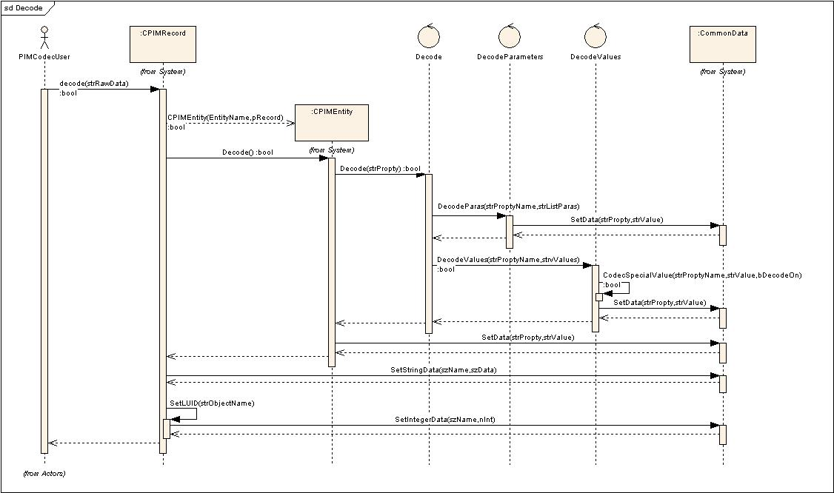
Figure 3-3-1: Decoder Sequence Diagram

As figure 3-3-1 shows,

Encode
As figure 3-3-2 shows,

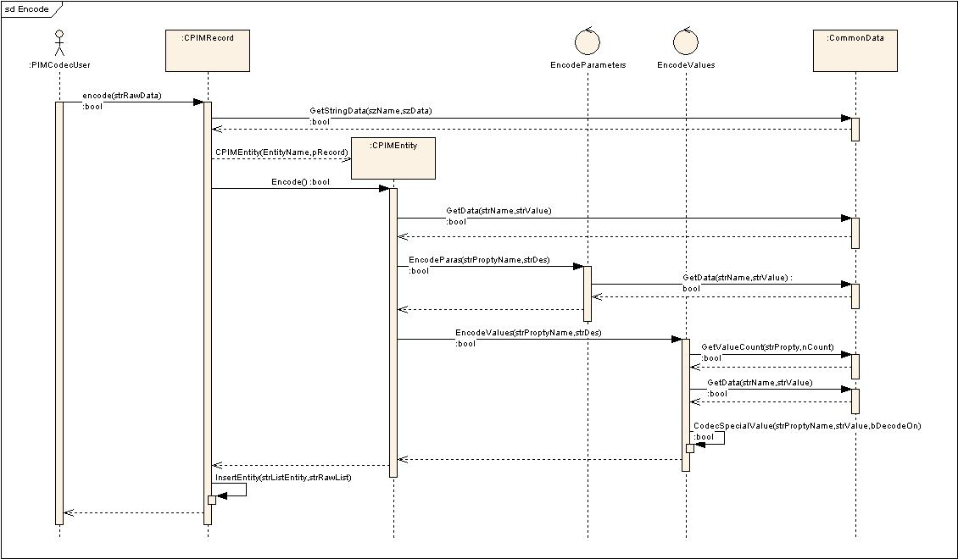
Figure 3-3-2: Encoder Sequence Diagram

