Calendar Design Document

This confidential document is the property of Benq Co. and must not be copied or circulated without permission.

Version : [0.0]
Date: [07/03/2007]

Author: [Mei.Yang]
Approval: [ ]

DOCUMENT VERSION HISTORY
Version | Date | Author | Comments
[0.0] | 2007/07/03 | Mei Yang | Creation

Note
[0.0]: Create Calendar Design Document

Glossary
- Abbreviation
(N/A)
- Terms
(N/A)

Reference document
Doc # | Document Title | From

Content
Note III
Glossary 1
Reference document 2
1 Introduction 4
2 High Level Design 4
2.1 Architecture 4
2.2 User Interface 5
2.3 Use Case 2
3 Low Level Design 3
3.1 Class Diagram 4
3.2 Sequence Diagram 5
3.2.1 Sync 5
3.2.2 New 5
3.2.3 Edit 6
3.2.4 Delete 6
3.2.5 Filter By Date 7
3.2.6 Succeed to edit an appointment 7

Introduction

High Level Design
In this chapter, we’ll discuss the system architecture, user interface, and use case of Calendar with the aids of flow charts and diagrams to clearly describe the mechanisms which we used to develop the Calendar.

Architecture
The main architecture is shown as figure 2-1-1.

Access Data
Data Flow
call
DataCtrl
CQPObjListData
PIMObject
CommonData
ListPage
ProgressBar
SubMenu
Calendar_V2View
Appointment
VCalCtrl
View
Control
Model
Figure 2-1-1: The main architecture of Calendar

User Interface

In this section, we present two user interfaces. One is main frame which user can read their appointments on BenQ cell phone, and also can take some actions to modify those appointments. The other interface which is presented in figure 2-2-2 shows when user wants to new an appointment or edit the existent appointment.

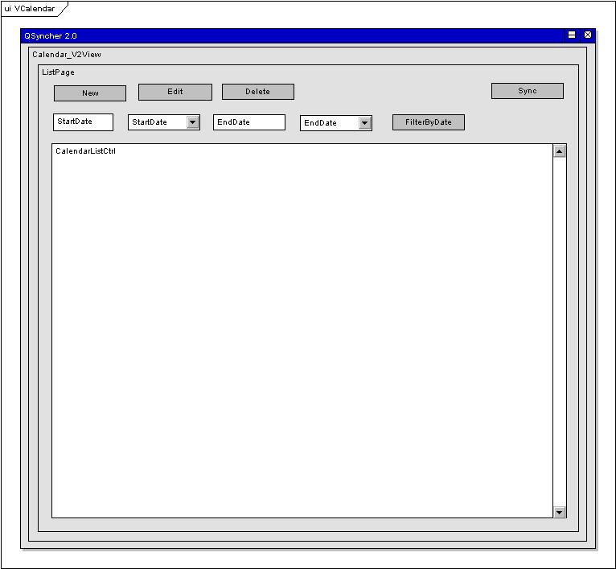
Figure 2-2-1: Main Frame of Calendar

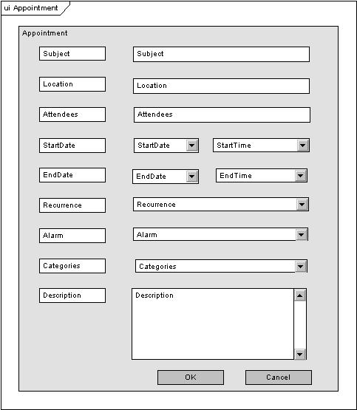
Figure 2-2-2: Appointment Editor

Use Case

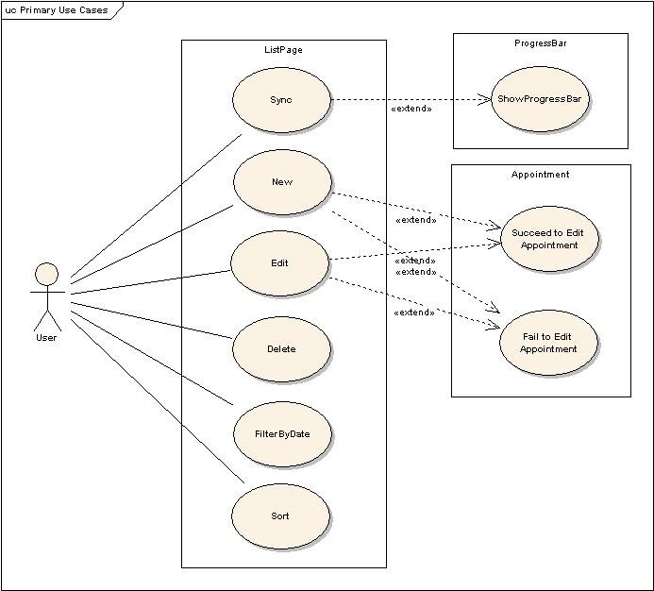
Figure 2-3-1: Use Case of Calendar

The use case for Calendar is shown as the “figure 2-3-1”.

Low Level Design
In this chapter, we will discuss each kernel process or procedure in Calendar using sequence diagrams.

Class Diagram
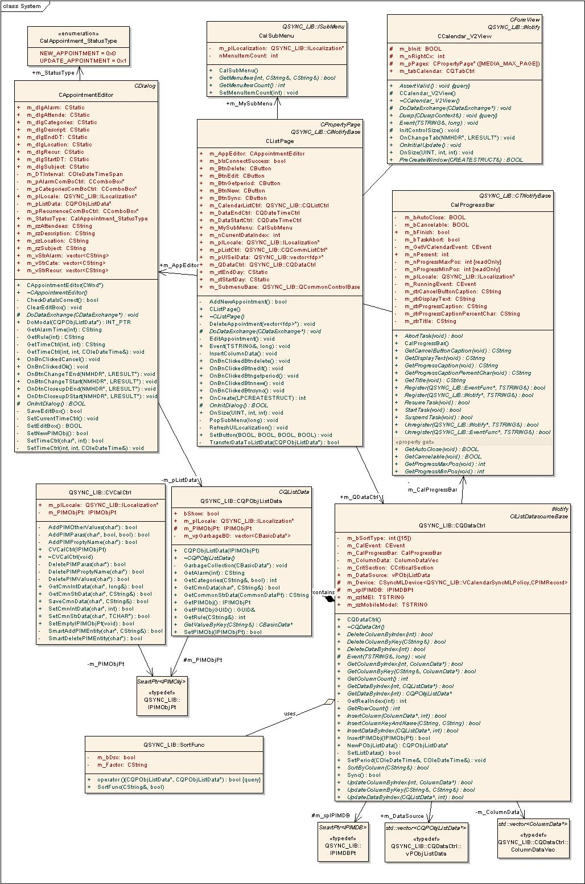
Figure 3-1-1: Class Diagram of Calendar

The class diagram of Calendar is shown as figure 3-1-1. There are several points we need to pay attention to. In Class CQPIMObjListData which inherits from CListData, it adds one PIMObj which stores an event from cell phone and several functions to access PIMObj and transform some values of PIMObj into recognizable values for user.

Sequence Diagram
We separate each synchronization in Outlook Syncer as an unique procedure, that’s to say each procedure can to be executed independently without others, no matter the underlying serial port communication or conflict resolution and so on. In the following sections, we will discuss the basic processing flow of each synchronization procedure.

Sync

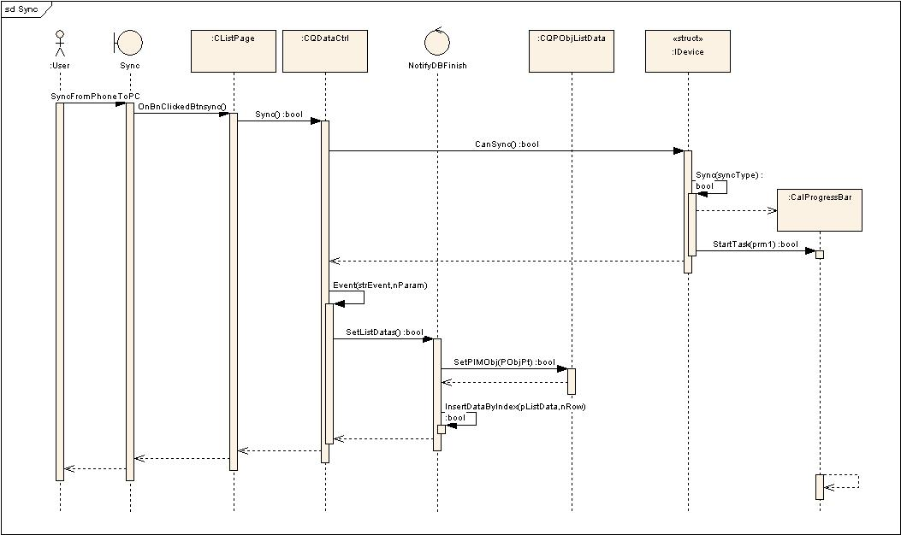
Figure 3-2-1-1: Sequence diagram of Sync

New
.

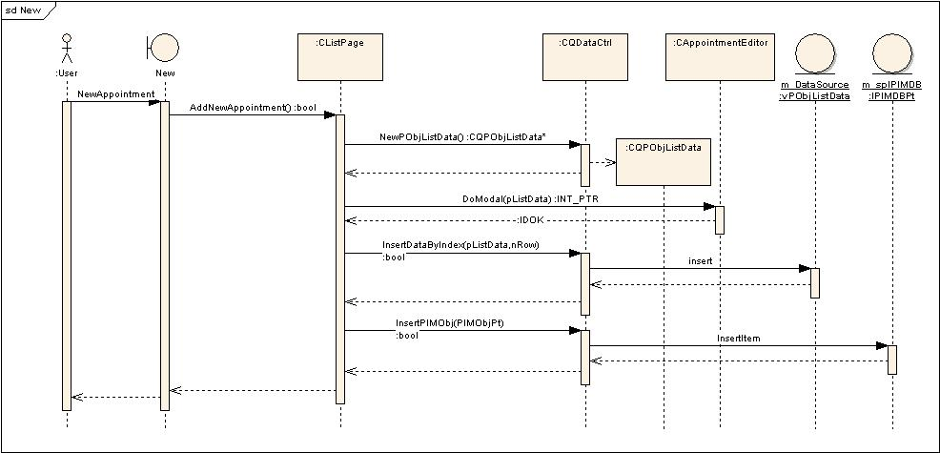
Figure 3-2-2-1: Sequence diagram of New

Edit

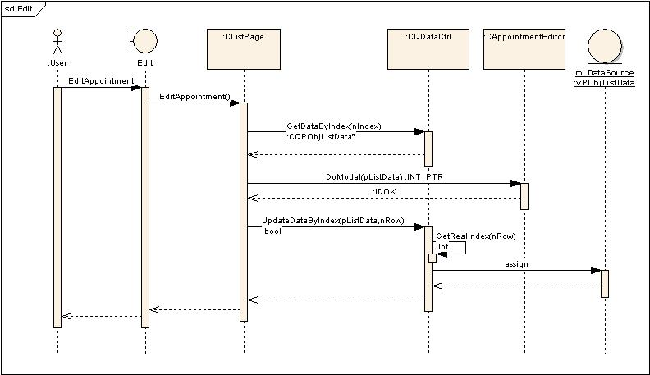
Figure 3-2-3-1: Sequence diagram of Eidt

Delete

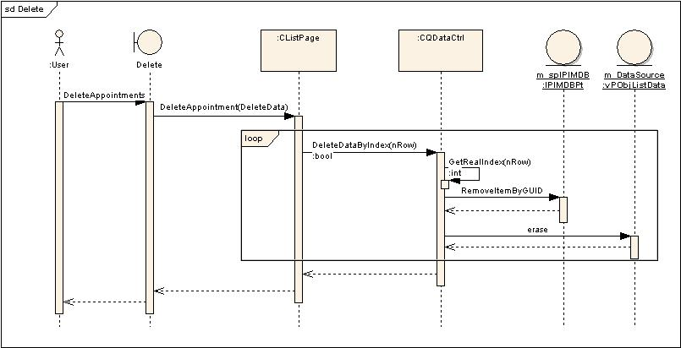
Figure 3-2-4-1: Sequence diagram of Delete

Filter By Date

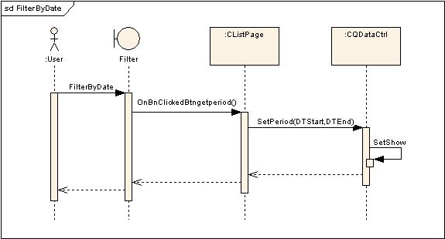
Figure 3-2-5-1: Sequence diagram of Filter By Date

Succeed to edit an appointment

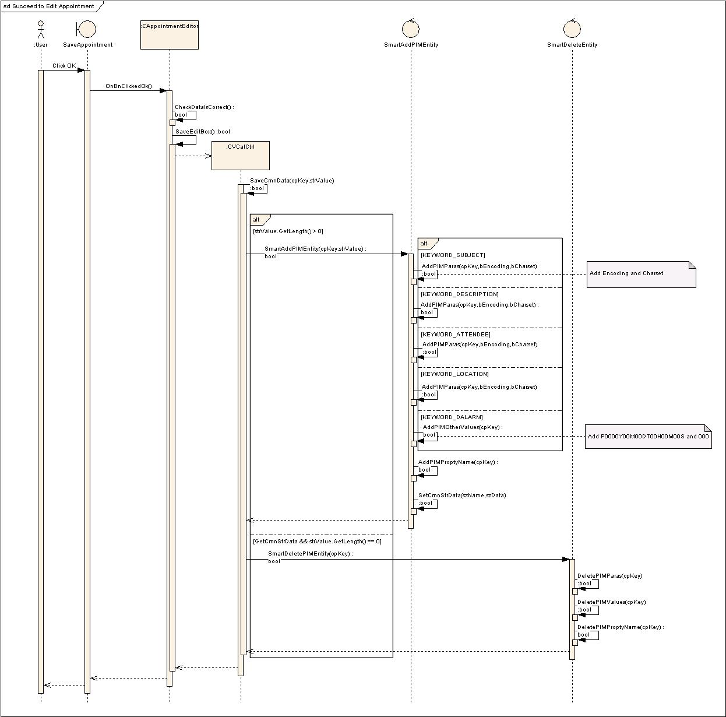
Figure 3-2-6-1: Sequence diagram of Filter By Date

