Ocupación, bajo el modelo estático (MacKenzie et al. 2002) para para las especies de mamíferos en el Parque Nacional Machalilla

Departamento Central de Investigaciones (DCI), Universidad Laica Eloy Alfaro de Manabi (ULEAM)

Abril, 2015

Diego J. Lizcano

# Duración del muestreo

Las trampas cámara permanecieron activas desde final de septiembre 204 hasta comienzos de marzo 2015.

##   
## Attaching package: 'dplyr'  
##   
## The following objects are masked from 'package:lubridate':  
##   
## intersect, setdiff, union  
##   
## The following object is masked from 'package:stats':  
##   
## filter  
##   
## The following objects are masked from 'package:base':  
##   
## intersect, setdiff, setequal, union  
##   
## Loading required package: sp  
## Checking rgeos availability: TRUE  
##   
## Attaching package: 'maptools'  
##   
## The following object is masked from 'package:xtable':  
##   
## label  
##   
## rgdal: version: 0.9-1, (SVN revision 518)  
## Geospatial Data Abstraction Library extensions to R successfully loaded  
## Loaded GDAL runtime: GDAL 1.11.1, released 2014/09/24  
## Path to GDAL shared files: C:/Users/Diego/Documents/R/win-library/3.1/rgdal/gdal  
## GDAL does not use iconv for recoding strings.  
## Loaded PROJ.4 runtime: Rel. 4.8.0, 6 March 2012, [PJ_VERSION: 480]  
## Path to PROJ.4 shared files: C:/Users/Diego/Documents/R/win-library/3.1/rgdal/proj  
## Loading required package: reshape2  
## Loading required package: plyr  
## -------------------------------------------------------------------------  
## You have loaded plyr after dplyr - this is likely to cause problems.  
## If you need functions from both plyr and dplyr, please load plyr first, then dplyr:  
## library(plyr); library(dplyr)  
## -------------------------------------------------------------------------  
##   
## Attaching package: 'plyr'  
##   
## The following objects are masked from 'package:dplyr':  
##   
## arrange, count, desc, failwith, id, mutate, rename, summarise,  
## summarize  
##   
## The following object is masked from 'package:lubridate':  
##   
## here  
##   
## Loading required package: ggplot2  
## Loading required package: reshape  
##   
## Attaching package: 'reshape'  
##   
## The following objects are masked from 'package:plyr':  
##   
## rename, round_any  
##   
## The following objects are masked from 'package:reshape2':  
##   
## colsplit, melt, recast  
##   
## The following object is masked from 'package:dplyr':  
##   
## rename  
##   
## The following object is masked from 'package:lubridate':  
##   
## stamp  
##   
## Loading required package: zoo  
##   
## Attaching package: 'zoo'  
##   
## The following objects are masked from 'package:base':  
##   
## as.Date, as.Date.numeric  
##   
## Loading required package: chron  
##   
## Attaching package: 'chron'  
##   
## The following objects are masked from 'package:lubridate':  
##   
## days, hours, minutes, seconds, years  
##   
## Loading required package: ggmap  
## Loading required package: grid  
## Loading required package: Hmisc  
## Loading required package: lattice  
## Loading required package: survival  
## Loading required package: splines  
## Loading required package: Formula  
##   
## Attaching package: 'Hmisc'  
##   
## The following objects are masked from 'package:plyr':  
##   
## is.discrete, summarize  
##   
## The following object is masked from 'package:maptools':  
##   
## label  
##   
## The following objects are masked from 'package:dplyr':  
##   
## combine, src, summarize  
##   
## The following objects are masked from 'package:xtable':  
##   
## label, label<-  
##   
## The following objects are masked from 'package:base':  
##   
## format.pval, round.POSIXt, trunc.POSIXt, units  
##   
## Loading required package: scales

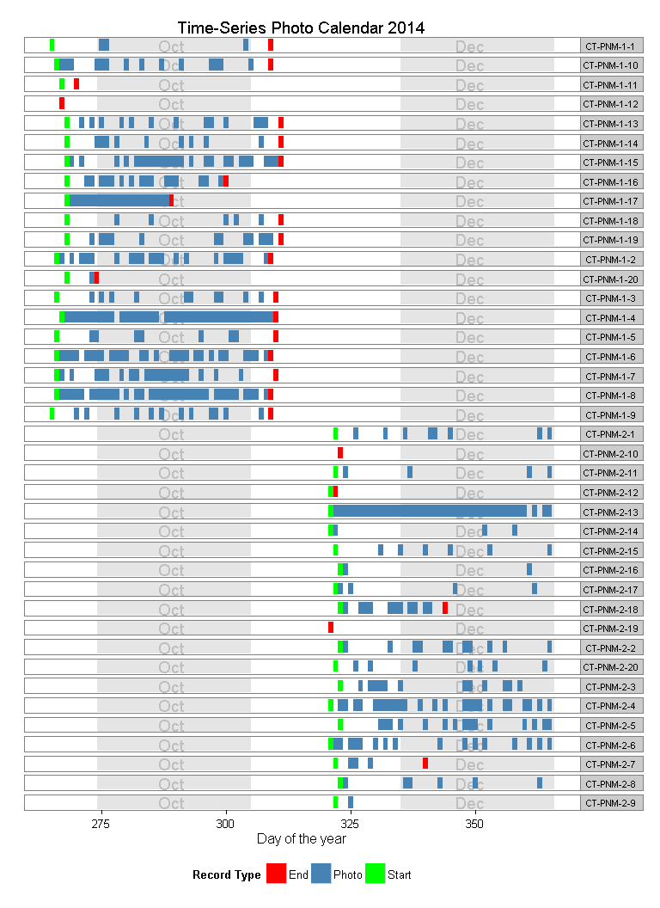

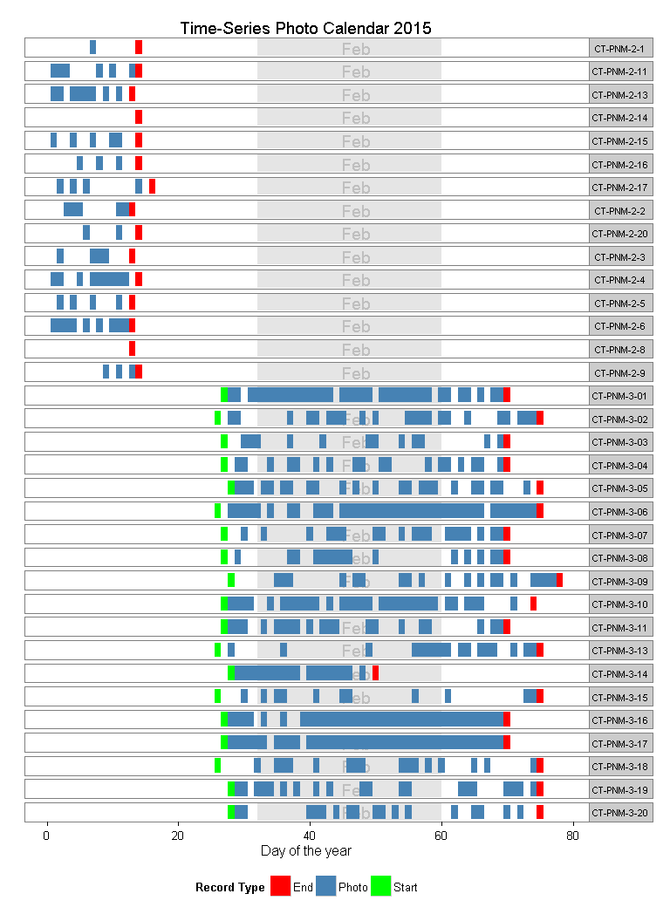

# Especies registradas

Las especies registradas en el Parque Nacional Machalilla fueron 36

% latex table generated in R 3.1.0 by xtable 1.7-4 package % Wed May 20 12:16:53 2015

# Covariables

Inicialmente se probó con cinco covariables para ajustar los modelos de ocupación. Estas cinco covariables fueron: Altitud (elev), Pendiente (slope) y Distancia a la carretera pavimentada (dis_rd) como covariables geográficas y altura del dosel, cobertura del dosel y área basal como covariables que se midieron momento de retirar las cámaras. Estas medidas se tomaron usando la metodología del cuadrante centrado en un punto.

La Altitud se obtuvo de una imagen SRTM del repositorio de [CGIAR](http://srtm.csi.cgiar.org/). La pendiente se infirió a partir de la altitud y la distancia a las carreteras se obtuvo de un mapa del Ministerio del Medio Ambiente del Ecuador.

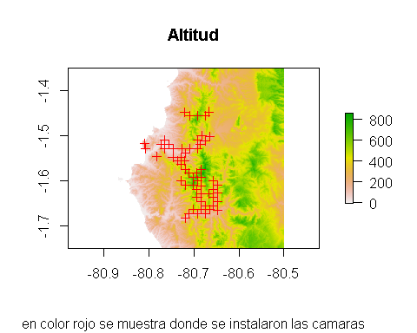 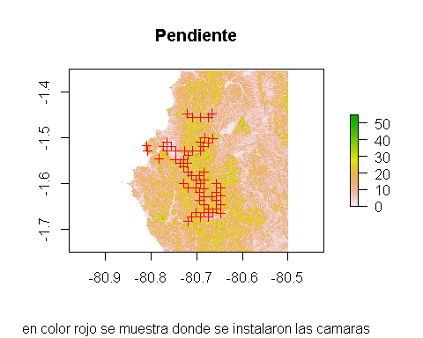 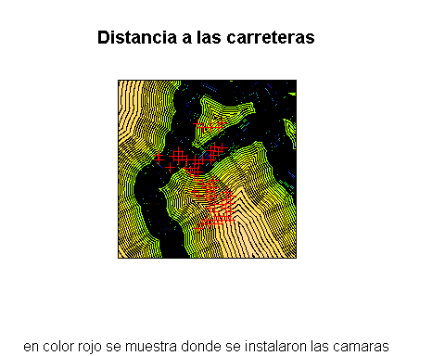 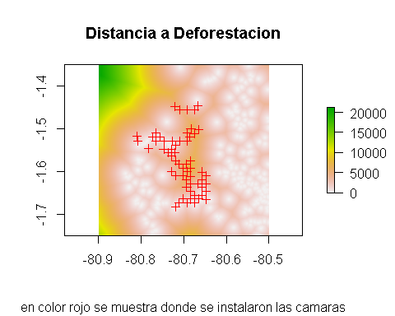

# Modelos de ocupacion por especie

## La Cabra (*Capra aegagrus*)

### Matriz de datos colapsada a 15 dias

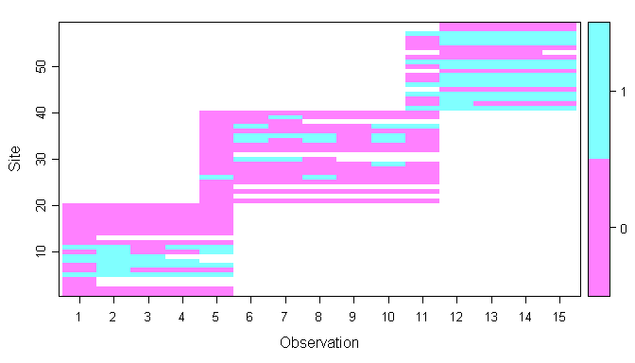

### Seleccion de Modelos

[1] "Capra aegagrus" % latex table generated in R 3.1.0 by xtable 1.7-4 package % Wed May 20 12:23:04 2015

## El Cabeza de Mate (*Eira barbara*)

### Matriz de datos colapsada a 15 dias

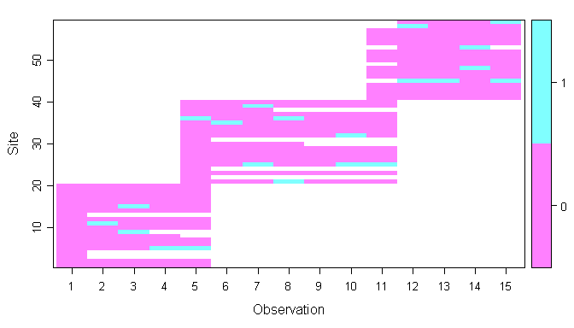

### Seleccion de Modelos

[1] "Eira barbara" % latex table generated in R 3.1.0 by xtable 1.7-4 package % Wed May 20 12:23:06 2015

## El tigrillo (*Leopardus wiedii*)

### Matriz de datos colapsada a 15 dias

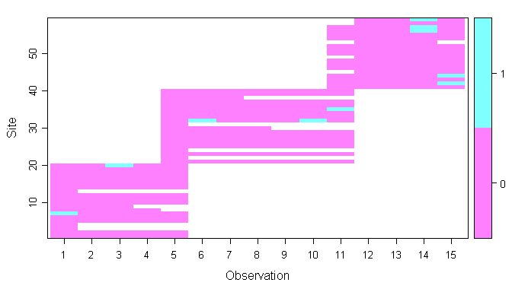

### Seleccion de Modelos

[1] "Leopardus wiedii" % latex table generated in R 3.1.0 by xtable 1.7-4 package % Wed May 20 12:23:08 2015

## La vaca (*Bos primigenius*)

### Matriz de datos colapsada a 15 dias

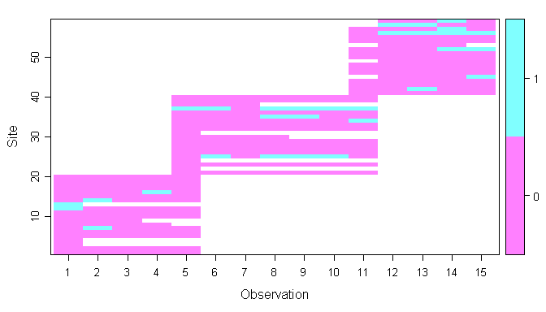

### Seleccion de Modelos

[1] "Bos primigenius" % latex table generated in R 3.1.0 by xtable 1.7-4 package % Tue May 05 17:43:37 2015

## El Perro domestico (*Canis lupus*)

### Matriz de datos colapsada a 15 dias

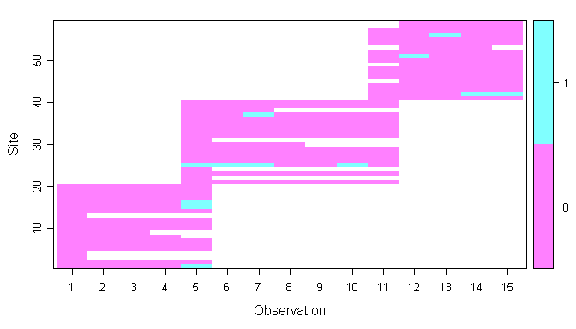

### Seleccion de Modelos

[1] "Canis lupus" % latex table generated in R 3.1.0 by xtable 1.7-4 package % Tue May 05 17:43:38 2015

## El Oso Hormiero (*Tamandua mexicana*)

### Matriz de datos colapsada a 15 dias

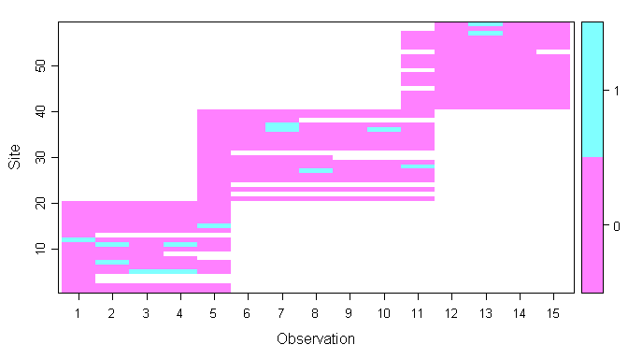

### Seleccion de Modelos

[1] "Tamandua mexicana" % latex table generated in R 3.1.0 by xtable 1.7-4 package % Tue May 05 17:43:40 2015

## El Venado (*Odocoileus virginianus*)

### Matriz de datos colapsada a 15 dias

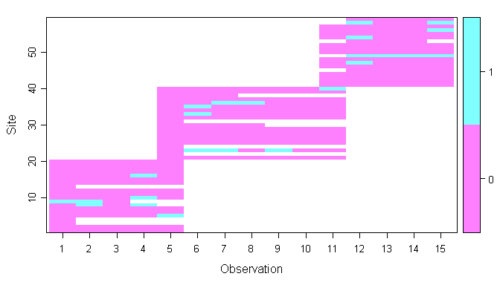

### Seleccion de Modelos

[1] "Odocoileus virginianus" % latex table generated in R 3.1.0 by xtable 1.7-4 package % Tue May 05 17:43:41 2015

## El Conejo (*Sylvilagus brasiliensis*)

### Matriz de datos colapsada a 15 dias

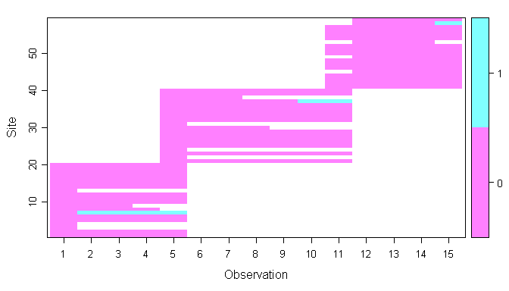

### Seleccion de Modelos

[1] "Sylvilagus brasiliensis" % latex table generated in R 3.1.0 by xtable 1.7-4 package % Tue May 05 17:43:43 2015

## El Caballo (*Equus ferus*)

### Matriz de datos colapsada a 15 dias

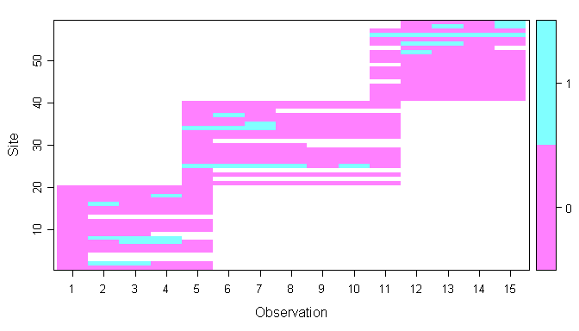

### Seleccion de Modelos

[1] "Equus ferus" % latex table generated in R 3.1.0 by xtable 1.7-4 package % Tue May 05 17:43:44 2015

## La Guanta (*Cuniculus paca*)

### Matriz de datos colapsada a 15 dias

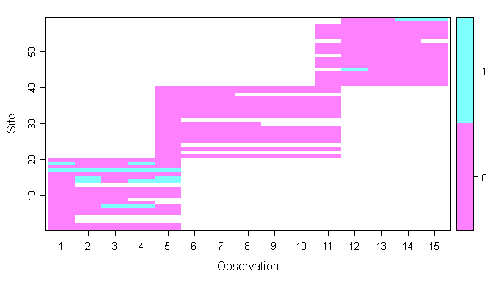

### Seleccion de Modelos

[1] "Cuniculus paca" % latex table generated in R 3.1.0 by xtable 1.7-4 package % Tue May 05 17:43:46 2015

## La Guatusa (*Dasyprocta punctata*)

### Matriz de datos colapsada a 15 dias

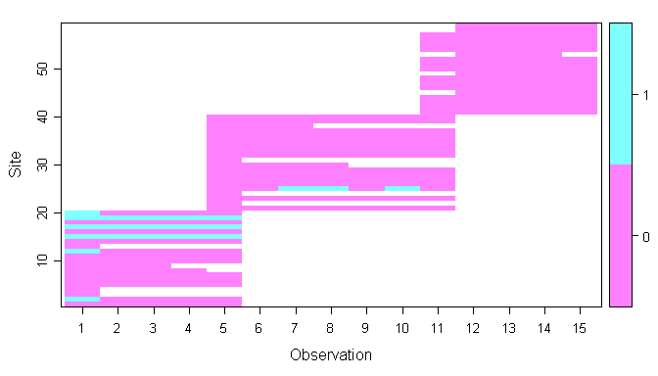

### Seleccion de Modelos

[1] "Dasyprocta punctata" % latex table generated in R 3.1.0 by xtable 1.7-4 package % Tue May 05 17:43:47 2015

## El Pecari (*Pecari tajacu*)

### Matriz de datos colapsada a 15 dias

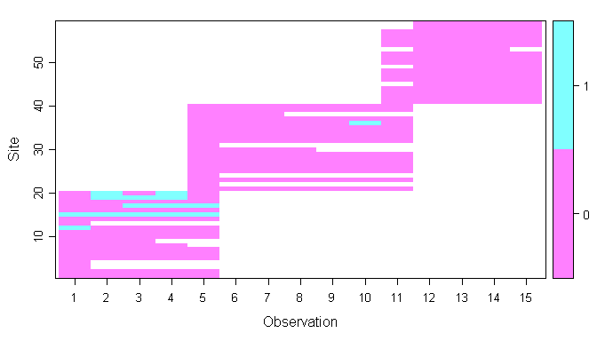

### Seleccion de Modelos

[1] "Pecari tajacu" % latex table generated in R 3.1.0 by xtable 1.7-4 package % Tue May 05 17:43:49 2015

## El Armadillo (*Dasypus novemcinctus*)

### Matriz de datos colapsada a 15 dias

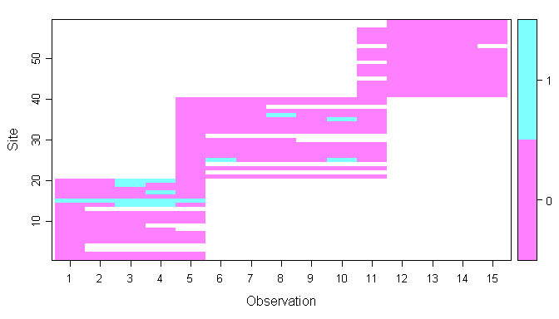

### Seleccion de Modelos

[1] "Dasypus novemcinctus" % latex table generated in R 3.1.0 by xtable 1.7-4 package % Tue May 05 17:43:50 2015

## La Ardilla de Guayaquil (*Sciurus stramineus*)

### Matriz de datos colapsada a 15 dias

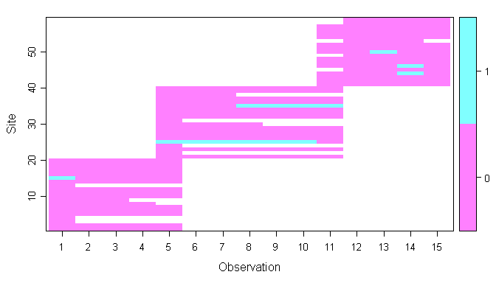

### Seleccion de Modelos

[1] "Sciurus stramineus" % latex table generated in R 3.1.0 by xtable 1.7-4 package % Tue May 05 17:43:52 2015