LunchOrganizer — User's Guide
Book, change or cancel your lunch in a few clicks

This guide is for everyone who books their lunch with LunchOrganizer. No technical knowledge is required, there is nothing to install and no password is asked for: simply open the address your administrator gave you in a web browser.
The application opens in French by default. The FR / EN selector at the top right of the page switches language at any time, and your choice is remembered on that computer.
The five most common situations are covered one after the other: booking for today, changing or cancelling today's booking, booking another day of the current week, booking for next week, and registering yourself the first time you use the application.
The one rule that really matters
Today's lunch can be booked, changed or cancelled until 09:00. After that time today's column locks: the kitchen has already received the list and nothing can be changed for today any more. The following days and the rest of the week stay open as usual.

1. Booking a lunch for today
This is the most frequent task. It takes less than a minute, provided you do it before 09:00.
- Open the application in your browser. The Book your lunch page opens straight onto the current week, Monday to Friday. There are no lunches at the weekend, so Saturdays and Sundays are not shown.
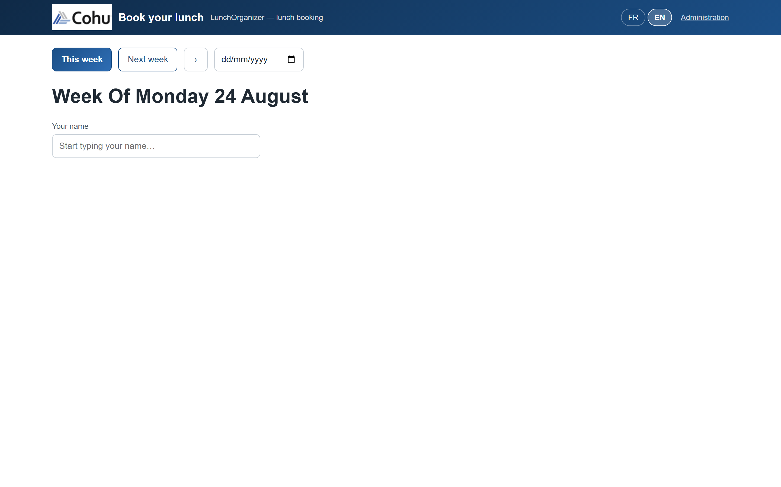
Figure 1 - The booking page as it first loads
- In the Your name field, start typing your name. After the first two letters, a list of matching names appears. Accents and capitals do not matter: typing “chloe” finds “Chloé Bernard”.
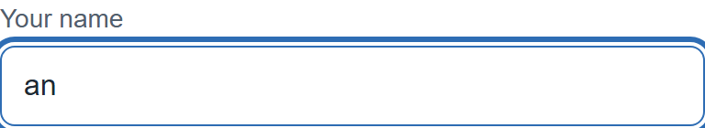
Figure 2 - The suggestion list opens from the second letter typed
- Pick your name from the list, either with the mouse or with the arrow keys followed by Enter. A banner then immediately summarises your situation for the day, for example “You haven't booked lunch for today yet”, followed by how much time you have left to do so.
Figure 3 - The daily banner shows your booking status and the time remaining
- The grid reproduces the paper sheet on screen: one column per day, one row per menu. Each day has its own menus, its own descriptions and its own price. Click the cell for the menu you want in today's column: it becomes marked as selected.
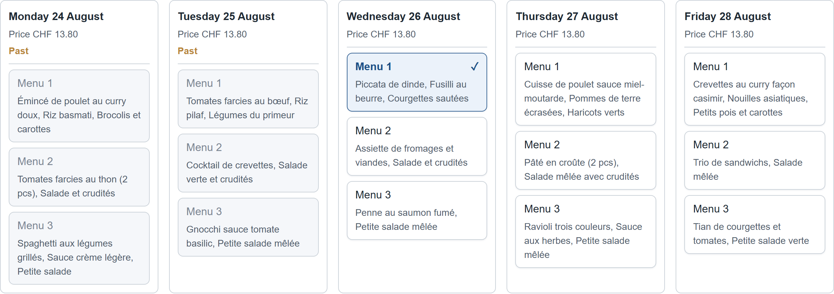
Figure 4 - A menu selected in today's column
- Finally click the Book my lunches button at the bottom of the page. A green Success notification confirms the booking, restating the menu and the day chosen. Until that notification appears, the booking has not been saved.
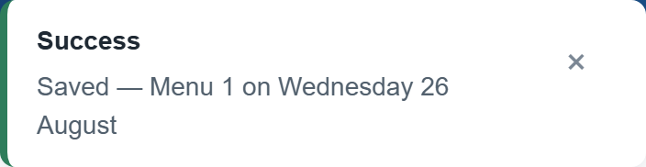
Figure 5 - The success notification confirms the booking
One lunch per day
You can only book one menu per day. If you click a second menu on the same day, it replaces the first one instead of being added to it.

2. Changing or cancelling the lunch already booked today
As long as 09:00 has not passed, today's booking remains fully editable. The procedure is the same whether you want to change menu or cancel altogether.
- Open the page and select your name as in the previous section. The grid shows your current booking: the cell of the menu already booked appears selected in today's column.
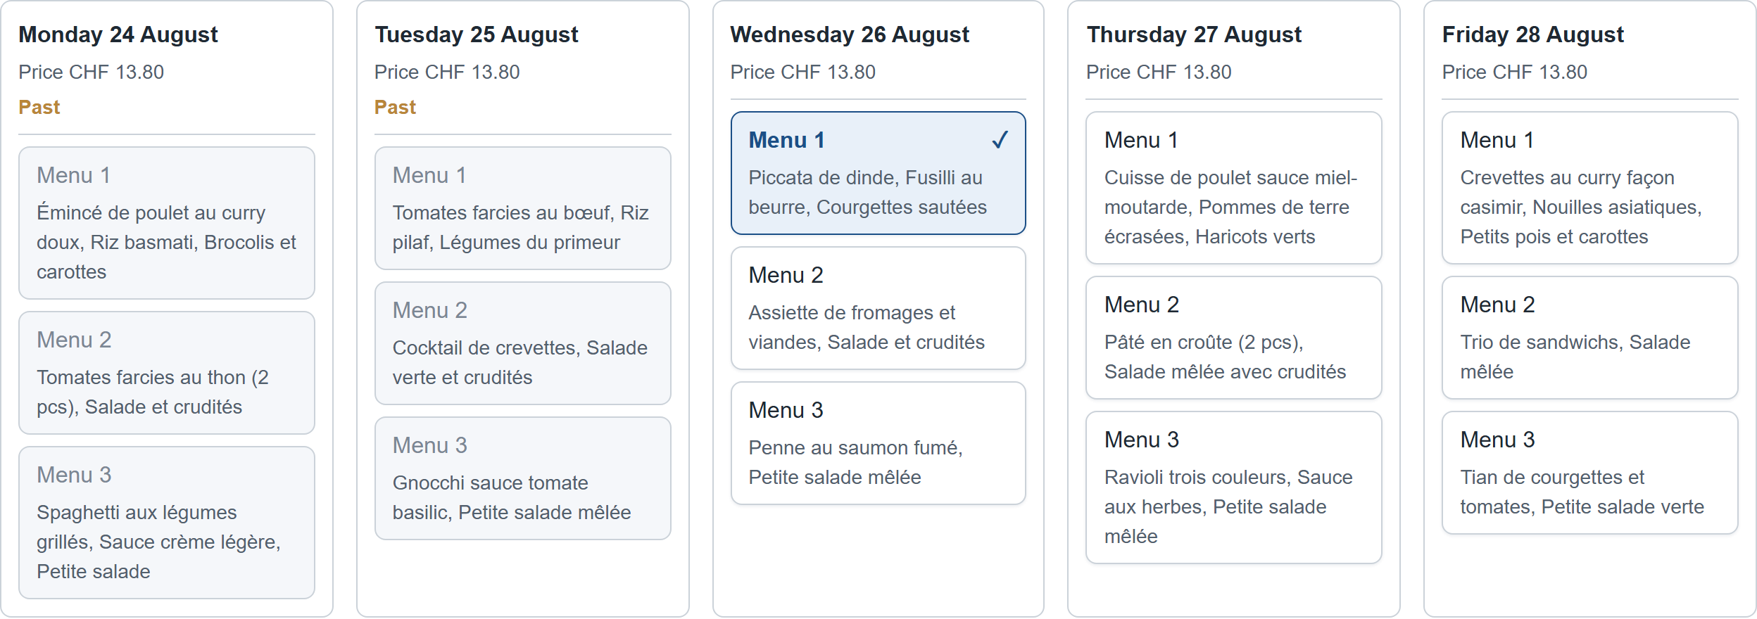
Figure 6 - The existing booking already appears selected
- To change menu, simply click the cell of another menu on the same day. The selection moves: the old menu is deselected and the new one becomes active. There is nothing to delete first.
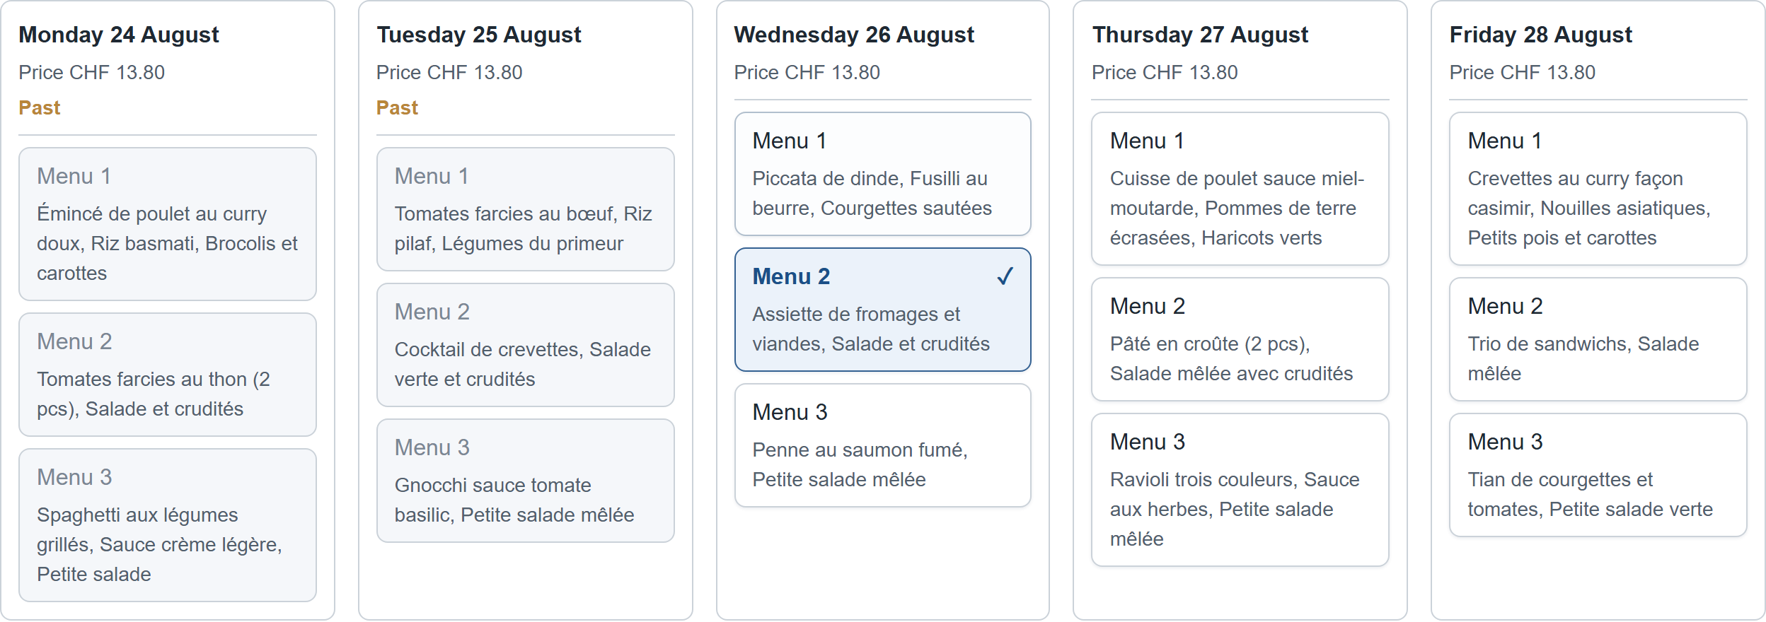
Figure 7 - The selection has moved to the other menu
- Click Book my lunches to confirm the change. The success notification confirms the new menu chosen for today.
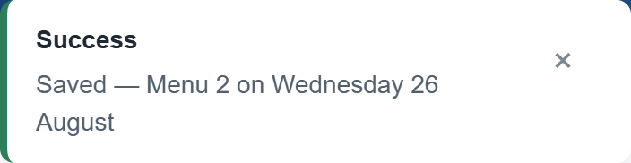
Figure 8 - Confirmation of the menu change
- To cancel the lunch altogether, click the already-selected cell a second time. It becomes deselected and no menu is booked for that day any more.
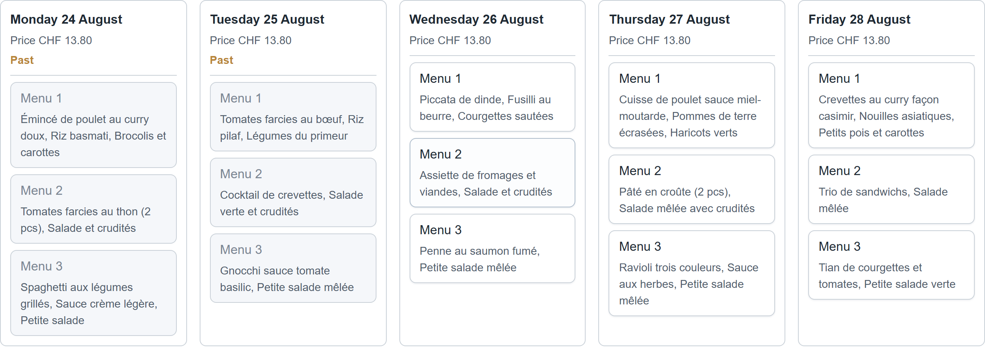
Figure 9 - No menu is selected for today any more
- Click Book my lunches again to save the cancellation. Take care: a cancellation must also be confirmed with this button, otherwise it is not taken into account.
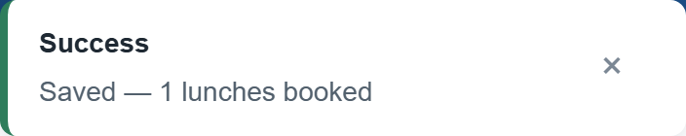
Figure 10 - The cancellation is saved in turn
After 09:00
Once the cut-off time has passed, today's column is greyed out and the banner states that today's lunch can no longer be booked. Hover over a greyed cell and the application tells you why: the day is past, or the cut-off time has been exceeded. The other days remain editable.

3. Booking a lunch for another day of the current week
The grid shows the whole week, so there is nothing special to do in order to book another day: everything happens on the same screen.
- Once you have selected your name, find the column of the day you want in the grid. Days that have already passed and days that are closed appear greyed out and cannot be clicked; all the others stay open.
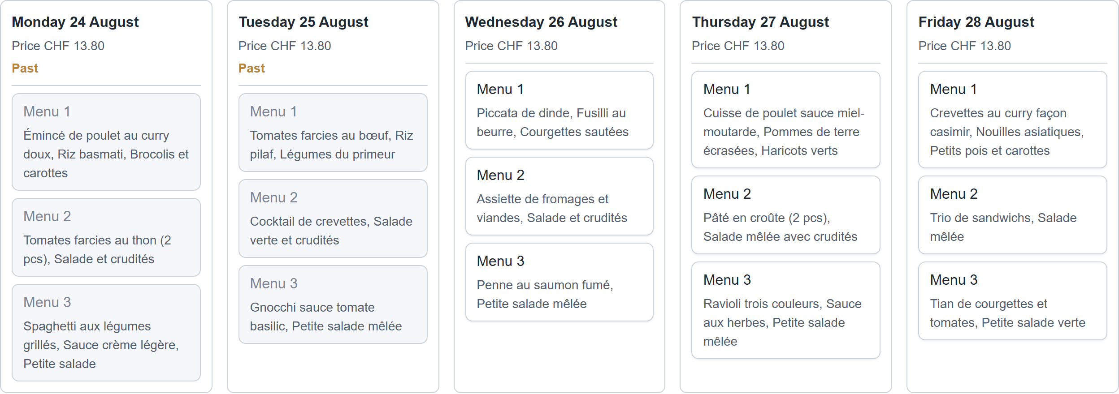
Figure 11 - The current week's grid, Monday to Friday
- Click the cell of the menu you want in that day's column. Remember that menus differ from one day to the next: Wednesday's “Menu 1” and Friday's “Menu 1” are two different dishes, so it is worth reading the description before choosing.
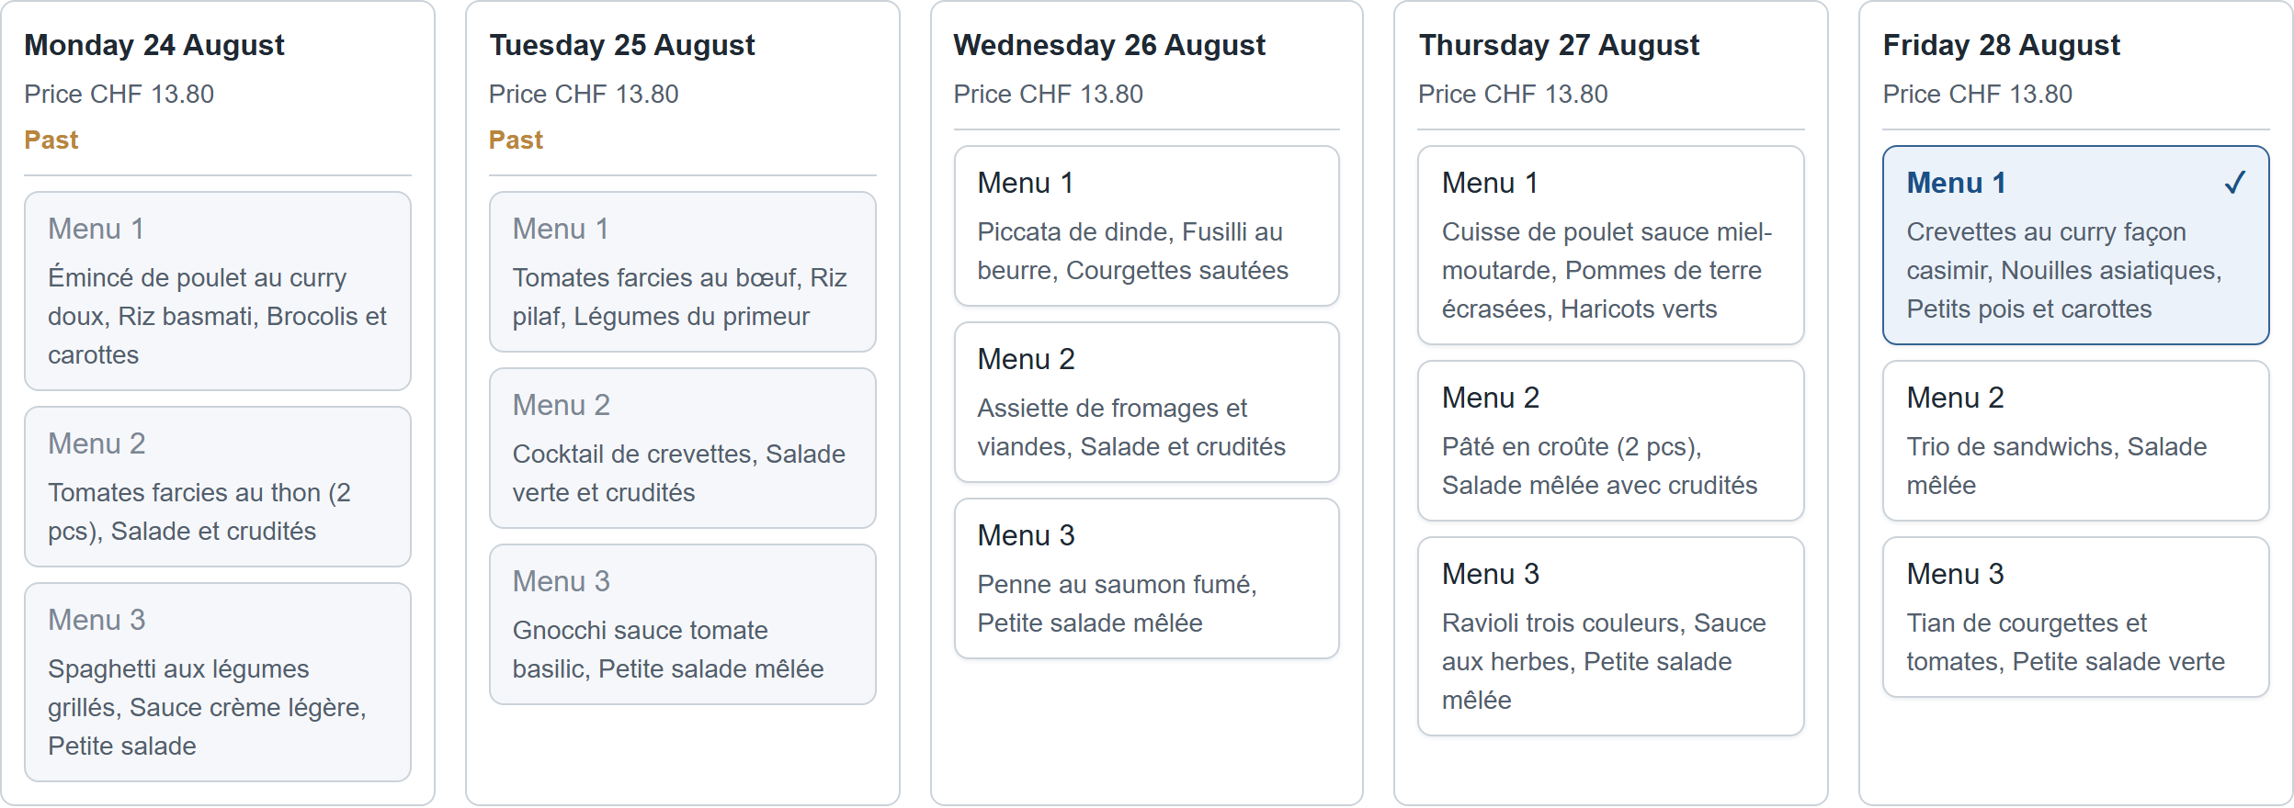
Figure 12 - A menu selected on another day of the week
- Click Book my lunches. You can select several days before saving: a single click on the button confirms all the days chosen, and the notification then states the total number of lunches booked.
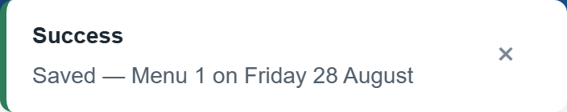
Figure 13 - Confirmation of the booking
Booking the whole week at once
Below the grid, choose a menu number then click Apply Menu N to every open day. The application fills in every day that is still open, then states exactly what it did: the days applied, and the days skipped together with the reason (day past, cut-off time exceeded, or that menu not offered that day). Do not forget to confirm afterwards with Book my lunches.

4. Booking a lunch for next week
Bookings are not limited to the current week. A selector at the top of the page moves from one week to the next.
- At the top of the page, click the Next week button. The This week button next to it takes you back to the current week at any time.
Figure 14 - The “Next week” button, at the top of the page
- The grid reloads on the following week. The heading spells the week out in words, for example “Week of Monday 31 August”, rather than giving a week number. Every day is open there, since none of them has passed yet.
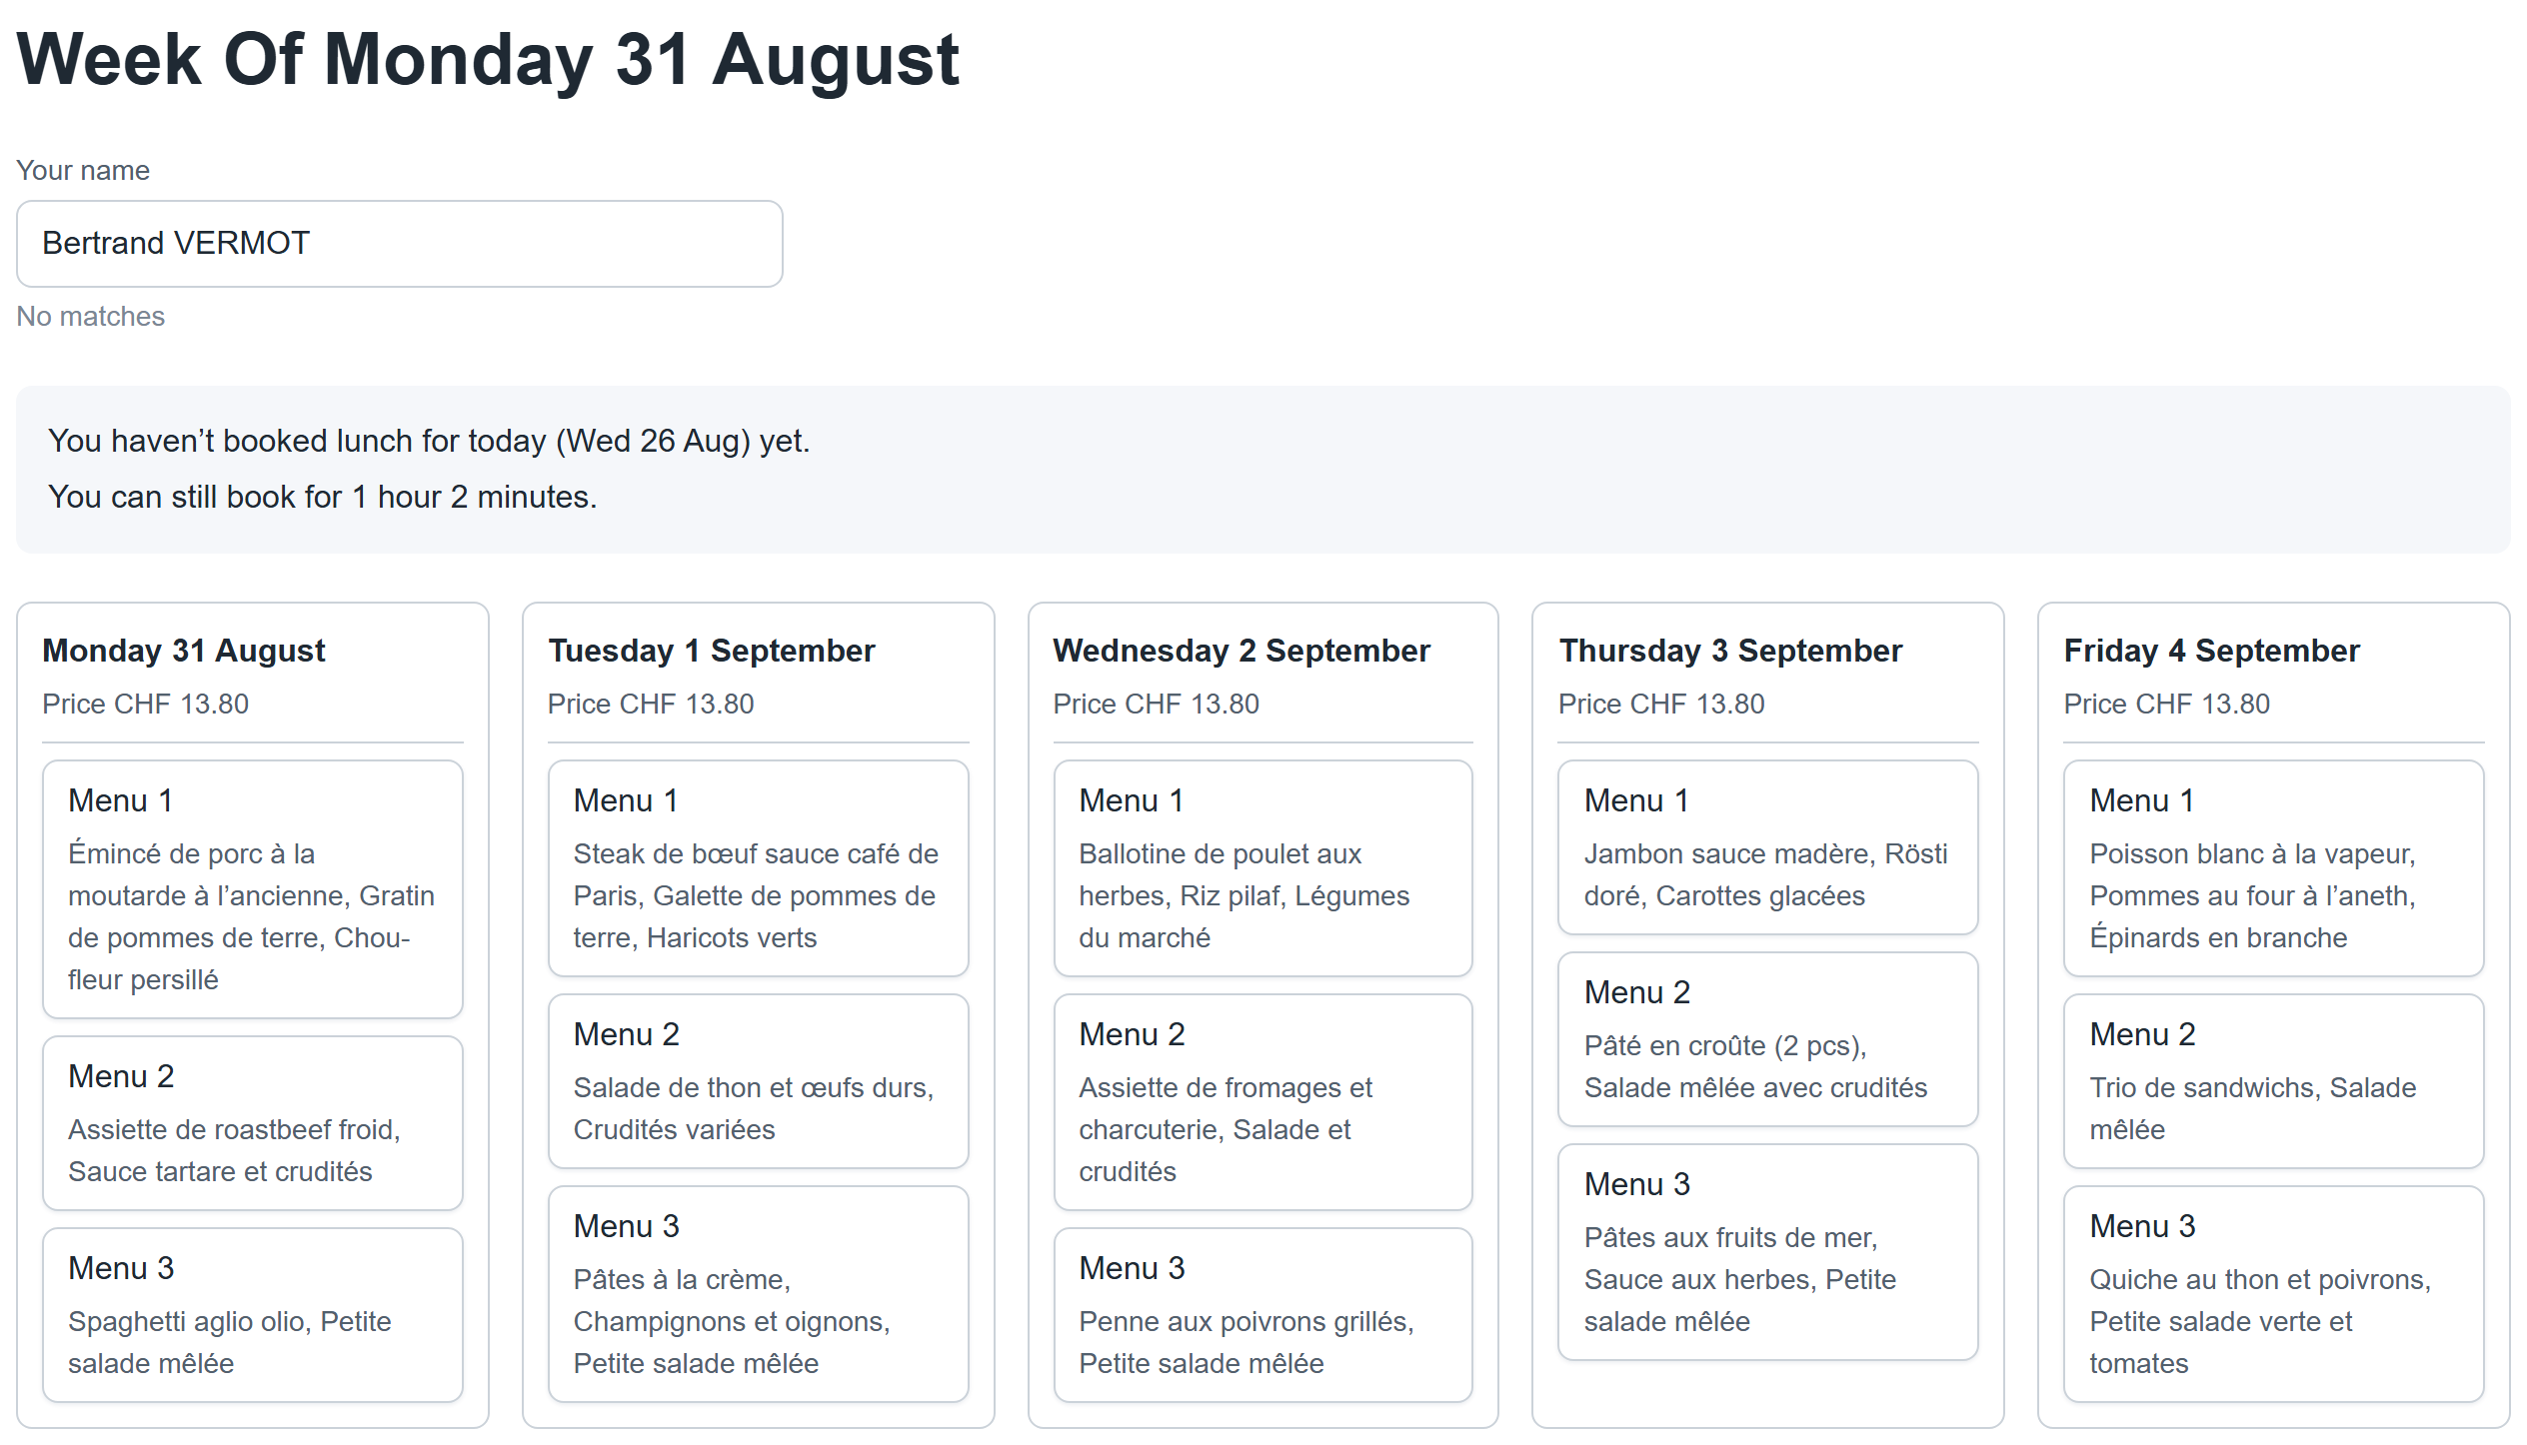
Figure 15 - Next week's grid and its heading
- Click the cell of the menu you want in the column of the day you want, exactly as for the current week.
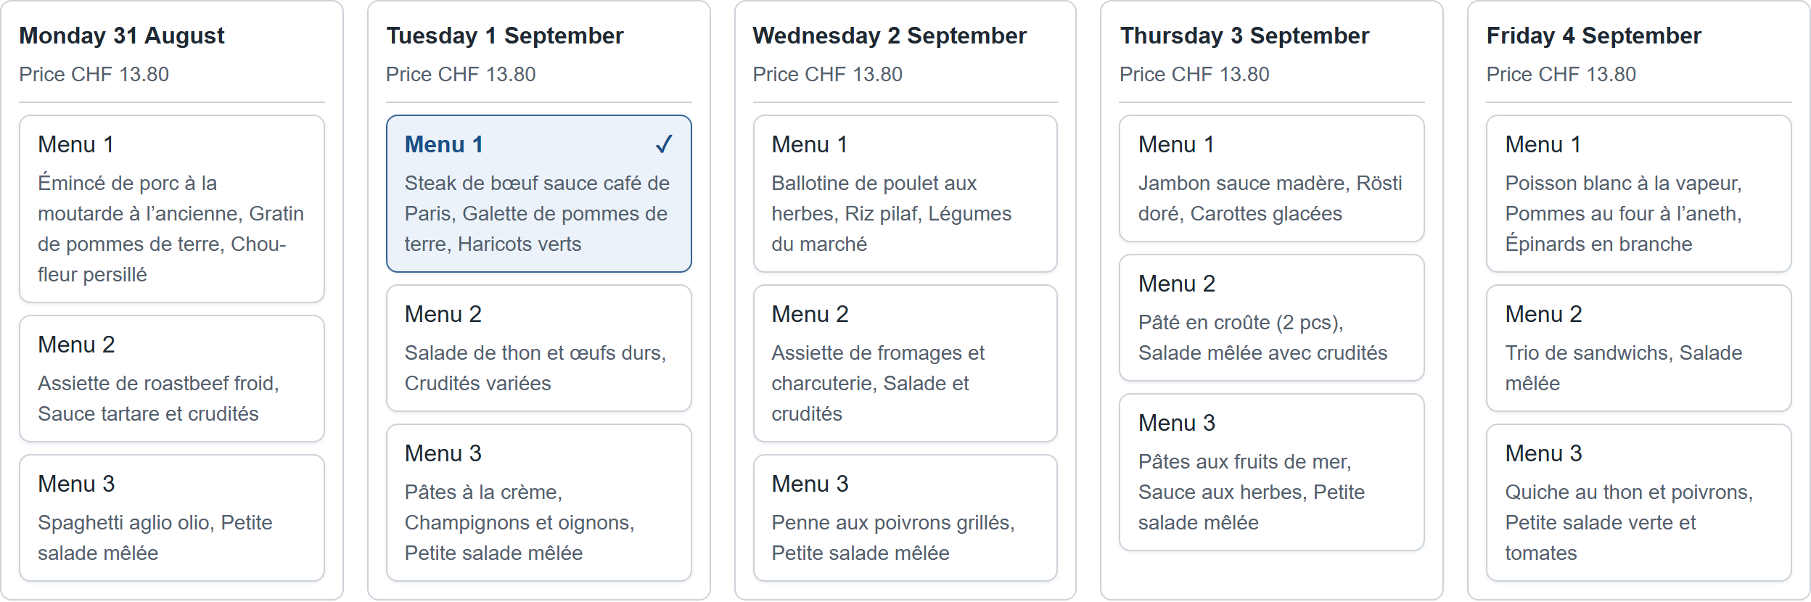
Figure 16 - A menu selected in next week's grid
- Click Book my lunches to save. The small arrow next to the two buttons reaches the weeks beyond that, if menus have already been published for them.
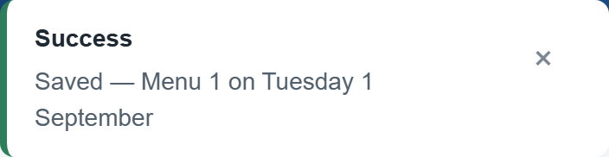
Figure 17 - Confirmation of the booking for next week
No going back
On the current week there is no “previous” arrow: past weeks can no longer be booked or consulted from this screen.

5. Registering the first time you use the application
If your name is not in the list yet, you can register yourself, directly from the booking page and without going through an administrator.
- Type your full name in the Your name field. Since no employee matches, the application shows a registration panel asking “Register "your name" as a new employee?”.
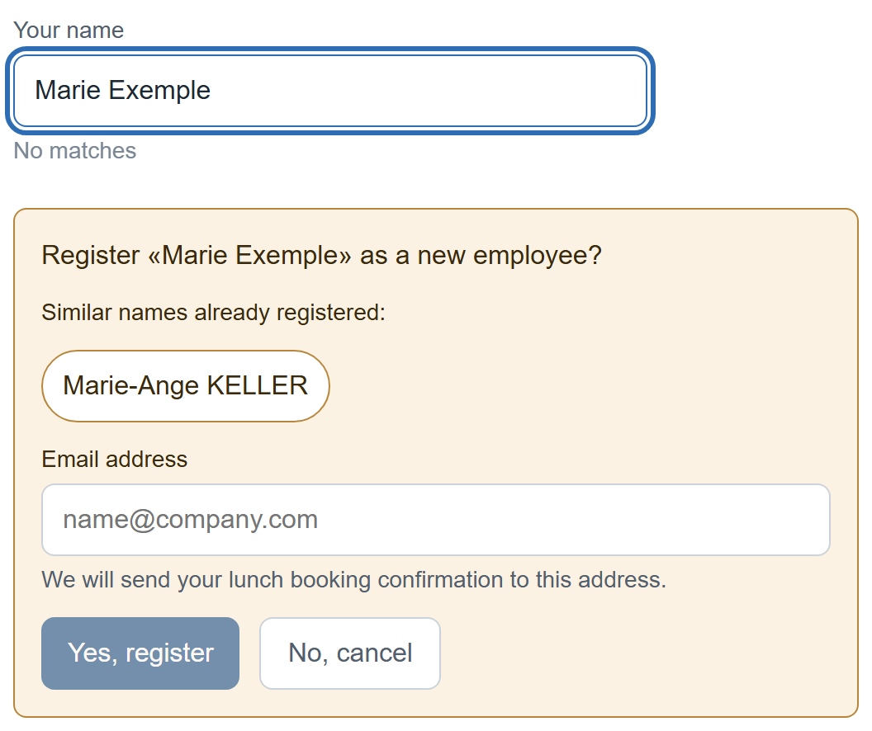
Figure 18 - No employee matches the name typed
- If similar names already exist, they are offered first, under the heading “Similar names already registered”. Check that list before continuing: “Jean Dupont” and “Jean Dupond” are two different people, and the kitchen will cook for both. If one of those names is yours, click it rather than registering yourself a second time.
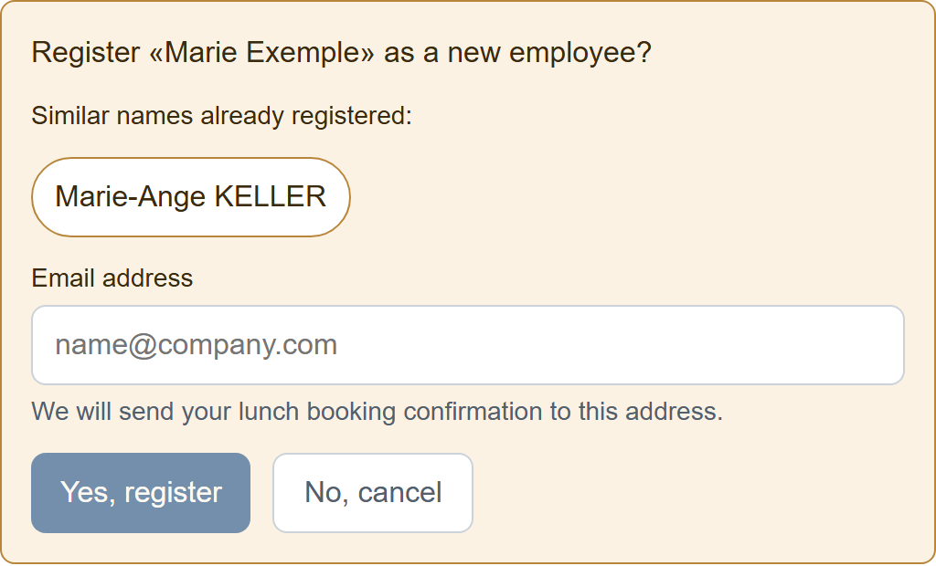
Figure 19 - The registration panel, with its mandatory “Email address” field
- Enter your work email address. This field is mandatory: until a valid address has been entered, the Yes, register button stays inactive. If the address is malformed, the application says so immediately below the field.
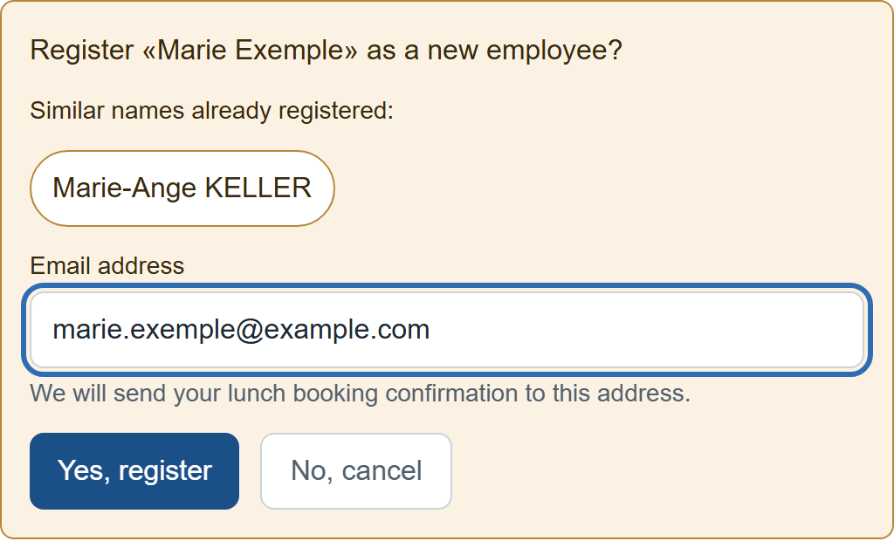
Figure 20 - Once a valid address is entered, the register button becomes active
- Click Yes, register. Your name is created and automatically selected: the grid becomes usable and you can book straight away, as described in the previous sections. This registration only has to be done once.
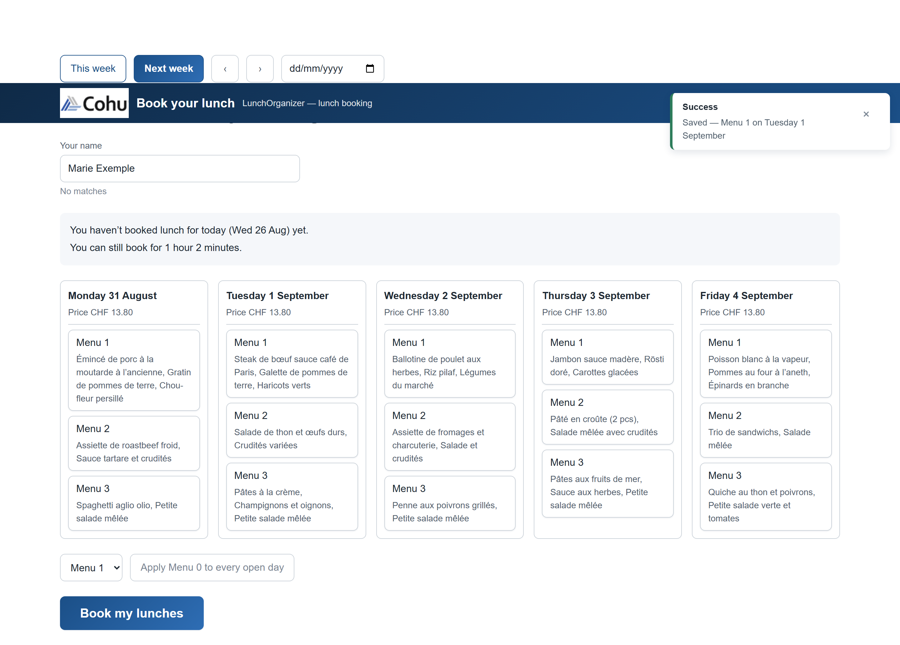
Figure 21 - The new employee is registered and selected
Why is an email address required?
Because every booking is confirmed to you by email. The address entered here is the one to which LunchOrganizer will send confirmation of your bookings: it is your proof that the lunch really was recorded, and the way to check which menu you chose without having to reopen the application. It is also the reason the application refuses to register you without a valid address: without one, no confirmation could reach you. The address is used only for these confirmations.

