AEGIS
GATE 2 - Technical Solution & Architecture
Zero-Trust Identity for AI Agents on the Network

5G Academy 2026, Fastweb + Vodafone, Topic 2, Security

Team 4
- Fauzan Ejaz (Captain)
- Adithya Zacharia Valavi
- Ghazanfar Anees Siddiqui
- Llagami Tedi

2.1 Proposed Technical Solution
As AI agents, orchestration bots, and closed-loop automations increasingly issue commands directly to 5G network control services, classical authentication is no longer sufficient to establish trust. A stolen token, a leaked client certificate, or a compromised automation account will still pass authentication, the credential is valid, even though the actor behind it is not the legitimate agent. Classic AAA answers “is the credential valid?” It cannot answer “is this really the agent we onboarded, behaving the way it always behaves?”
AEGIS answers that second question. It is a zero-trust gate for machine identities: it builds a behavioural fingerprint of each legitimate agent from how it actually calls the network's APIs, and continuously scores every new request against that fingerprint, aligned with NIST SP 800-207 zero-trust principles (never trust, always verify; verify continuously; assume breach).
One-line pitch: credentials prove what you have; AEGIS verifies how you behave.
Scope. AEGIS targets service/automation agents (orchestration, closed-loop automation, OSS/BSS jobs, API clients) calling network control APIs, modelled on the 5G Service-Based Architecture (SBA) / Service-Based Interface (SBI): AMF, SMF, NRF, NEF, PCF, UDM. End-user devices, the data plane, and general “AI safety” are explicitly out of scope: AEGIS guards the control-plane API surface used by machine actors, which keeps the problem concrete and solvable within the PoC timeline rather than open-ended.

The solution in one pipeline
OBSERVE request patterns and metadata (id, timing, call sequence, payload shape) -> FINGERPRINT a known-good behavioural baseline per agent -> SCORE with rules plus an ML anomaly/spoof score -> DECIDE PASS / STEP-UP / BLOCK (zero-trust gate dashboard).

Threats the solution is built to catch
We assume an attacker who has already obtained a valid credential (the realistic case) or controls a legitimate agent, and must therefore be caught by behaviour, not by credential checks:
# | Threat | Behavioural signal AEGIS keys on
T1 | Identity spoofing / impersonation | Fingerprint mismatch: wrong endpoint mix, timing, sequence for that identity
T2 | Compromised agent | Drift from its own baseline: new endpoints, new methods, elevated error rate
T3 | Reconnaissance / enumeration | High cardinality of endpoints/targets, many 403/404s, breadth over depth
T4 | Volumetric abuse / DoS | Request-rate spike far above the agent's normal envelope
T5 | Low-and-slow exfiltration | Abnormal read/GET ratio and payload sizes, off-hours persistence
T6 | Replay / sequence anomaly | Broken call-sequence pattern vs the agent's normal call graph
T7 | Privilege / scope creep | Calls to NFs never in the agent's baseline scope

This directly extends the Gate 1 feasibility case: the technology (behavioural fingerprinting and anomaly detection), the risks, and the economic rationale (enabling safe automation, NIS2/GDPR/EU-AI-Act audit evidence) were validated at Gate 1. Gate 2 delivers the concrete architecture (2.2, with a full system diagram), a working implementation (2.3), and numerical proof that the approach works (2.4), the three things Gate 1 could only describe as intent.

2.2 Architecture
AEGIS is structured as a four-stage pipeline sitting logically in front of the network's control-plane APIs. Every request an agent sends to a Network Function is observed by the gate before (in production) or in parallel with (in the PoC) reaching the NF.

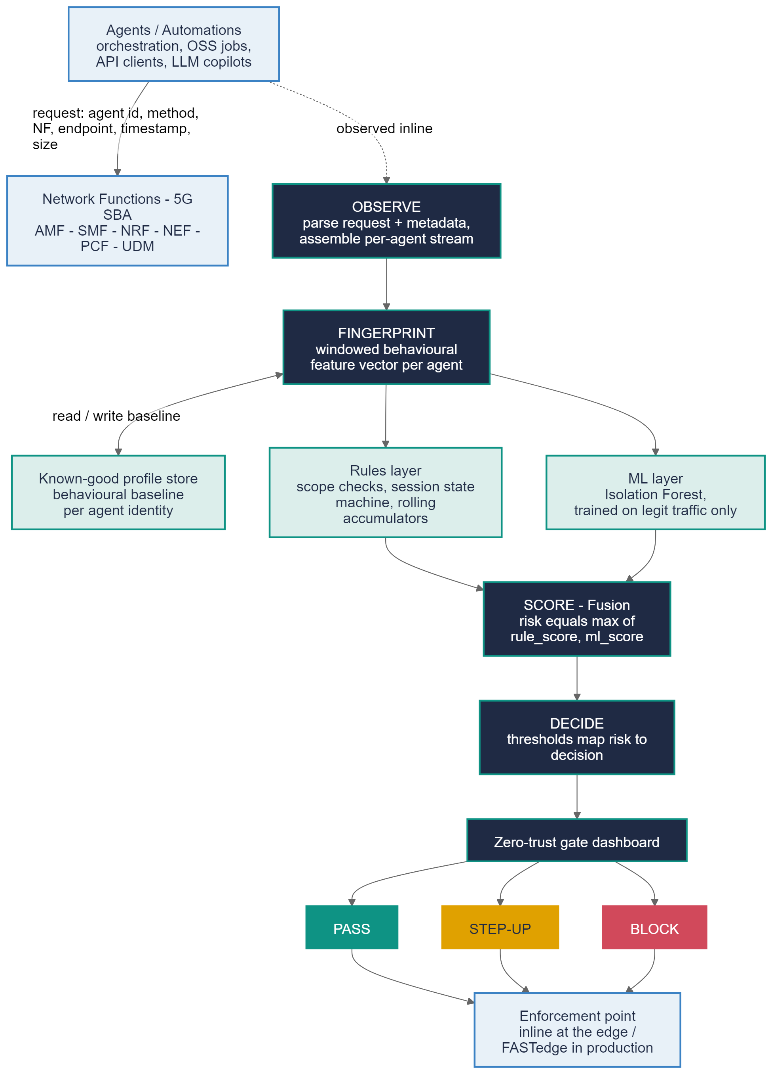
Figure 2.1. AEGIS system architecture: OBSERVE -> FINGERPRINT -> SCORE -> DECIDE, with the rules layer, ML layer, and known-good profile store feeding SCORE, and PASS / STEP-UP / BLOCK as the three decision outcomes.

Component description
- OBSERVE. Every request is parsed into a normalized event: agent identity, HTTP method, target Network Function, endpoint, timestamp, and payload size. Events are grouped into a per-agent stream, the unit the rest of the pipeline operates on.
- FINGERPRINT. Requests are aggregated into sliding 60-second windows and turned into a feature vector per agent, per window: volume/rate, surface (distinct NFs/endpoints/target IDs), method mix, sequence, errors, payload, temporal (hour-of-day), and cross-window breadth (a rolling union of endpoints/NFs and error count over the trailing 5 minutes, so reconnaissance spread thin enough to look quiet in any single window is still caught). These vectors are compared against a known-good profile store, the behavioural baseline built for each agent during onboarding.
- SCORE. Two layers run in parallel and are fused. The rules layer (fast, explainable) applies hard caps and forbidden transitions, a session-state machine that tracks PDU-session lifecycle (catching orphaned update/release calls, T6), and rolling 5-minute accumulators (breadth, error count, peak payload) that catch cumulative anomalies too sparse for any single window, the mechanism behind T3 and T5 detection. The ML layer is an Isolation Forest trained only on legitimate traffic, engaging once an agent has at least 10 requests in the trailing 5 minutes. Fusion: risk equals the maximum of the rule score and the ML score. Thresholds are tuned for a realistic false-positive budget (about 1.5 percent) rather than maximum sensitivity, which is why detection is intentionally not uniform across threats (see 2.4).
- DECIDE. The fused risk score maps to PASS (low risk, behaves like its known-good self), STEP-UP (medium risk: re-authentication, approval, or throttling), or BLOCK (high risk: quarantine the identity, alert the SOC).
- Trust boundary. Every request from an agent to a Network Function crosses the AEGIS gate. In production this is envisioned as an inline policy check at the edge (FASTedge); for the PoC it runs as an offline/log-replay analysis over synthetic SBI-style traffic.
- Dashboard / enforcement surface. A Streamlit application exposes, per agent, current risk, PASS/STEP-UP/BLOCK status, a breakdown of detections by threat type, and an incident inspector with a plain-language explanation of why a request was flagged.

2.3 Implementation Strategy
Methodology. AEGIS is built bottom-up, PoC-first, and evaluation-driven: the ML/security equivalent of test-driven development. No rule or model change is kept unless it is immediately re-scored against the full labelled dataset and shown to improve (or at least not regress) the numbers in 2.4. Each of the four architectural stages is a separately runnable, separately verifiable script, so the pipeline can be inspected and debugged stage by stage rather than as one opaque system.

Tools and platforms
Layer | Tool / platform | Role
Language/runtime | Python 3.12 | Single language across generation, detection, and dashboard
Data generation & processing | pandas, NumPy | Synthetic SBI-traffic generation, windowing, feature engineering
Anomaly detection | scikit-learn (Isolation Forest) | Unsupervised ML layer, trained on legitimate traffic only
Visualization / gate UI | Streamlit, Matplotlib | Live zero-trust gate dashboard and evaluation charts
Deck/report tooling | python-docx, python-pptx | Reproducible generation of the Gate decks and reports
Delivery | Git/GitHub, GitHub Pages | Version control and a public showcase site

Implementation phases
Phase | Output | Primary file(s)
1. Synthetic environment | Labelled SBI-style traffic, 5 agents, T1-T7 | generate_synthetic_traffic.py
2. Fingerprinting | Per-agent windowed feature vectors | aegis_detect.py (build_windows)
3. Rules layer | Deterministic scope/session/rolling checks | aegis_detect.py (rule_score)
4. ML layer | Isolation Forest fit on legit-only traffic | aegis_detect.py (ml_scores)
5. Fusion & decision | Risk scoring, PASS/STEP-UP/BLOCK | aegis_detect.py (main, decision)
6. Dashboard | Live zero-trust gate UI | aegis_dashboard.py
7. Evaluation & iteration | Metrics, charts, bug-fixing loop | aegis_baseline_metrics.md

Step-by-step, and what the evaluation loop caught
- Synthetic traffic generation produced 210,000 requests across 5 legitimate agent profiles with realistic PDU-session lifecycles, plus the seven threat scenarios injected as labelled anomalous segments, removing the dependency on real operator logs.
- Feature engineering turned the windowed request stream into the behavioural feature vectors described in 2.2.
- The rules layer implements deterministic scope, rate, and session-sequence checks. An earlier T6 window-count heuristic was replaced with a session-ID state machine after it was found to false-fire on legitimate bursty traffic.
- The ML layer, an Isolation Forest, is fit only on legitimate traffic with a held-out calibration split.
- Fusion and decision policy combine rule and ML scores into PASS / STEP-UP / BLOCK.
- The dashboard exposes per-agent risk, decisions, per-threat breakdown, and the incident inspector.
- Evaluation and iteration: re-scoring after every change surfaced two real bugs, not just tuning cosmetics. First, T3 and T5 are naturally sparse per window; rolling 5-minute accumulators fixed this generically. Second, the initial T2 and T5 attack scenarios both had the injected agent call a Network Function outside its own onboarded scope, indistinguishable from T7 to the rules layer, so both were trivially caught by the scope rule rather than the drift/payload logic they were meant to test.

2.4 Numerical Performance Analysis
Benchmarking against real-world detection systems, not just internal targets. Before finalizing the operating point, we researched how comparable systems perform in practice, since a PoC that reports 100 percent detection on everything is a red flag to anyone who has looked at production security data, not a strength.
- Published NIDS studies on CICIDS2017/UNSW-NB15 consistently show volumetric/DoS attacks detected at 97 to 99.8 percent (large, unambiguous signal), while reconnaissance and other low-frequency attack classes detect far lower unless heavy class-balancing is applied.
- Industry SOC data (Microsoft/Omdia State of the SOC 2025, SANS 2025 Detection and Response Survey) puts typical false-positive rates at 46 to 83 percent, with elite, well-tuned SOCs under 10 percent, and under 5 percent considered excellent.
- UEBA/insider-threat research shows a hard precision/recall tradeoff: models reporting near-perfect recall do so by sacrificing precision, sometimes to as low as 0.54; low-and-slow exfiltration is consistently the hardest category, consistent with the roughly 77-day average real-world dwell time cited for insider threats.
We therefore tuned AEGIS's decision thresholds and rule sensitivities for a realistic false-positive budget (about 1.5 percent), in the well-tuned-not-superhuman range, rather than for maximum sensitivity, and treated a non-uniform, threat-dependent detection rate as the expected, correct outcome rather than something to eliminate.Test set: approximately 11,365 held-out windows (11,010 legitimate, 355 attack), 60-second window size, decision thresholds STEP-UP at 0.6 or above and BLOCK at 0.85 or above.

Headline metrics (rules + ML fused)
Metric | Value
ROC-AUC | 0.965
Precision | 0.672
Recall (detection rate) | 0.907
F1 score | 0.772
False-positive rate (legit traffic flagged) | 1.43%
ROC-AUC, ML only (no rules) | 0.721

These sit comfortably inside the range reported in the literature above: an FPR under 2 percent is elite-SOC territory, not the near-zero rate that would raise suspicion of a leaky evaluation, and a precision of 0.67 is in line with, in fact better than, several published UEBA results that trade precision for recall.

Detection rate per threat type, deliberately not uniform
Threat | Windows | Detected | Why this level
T4 - Volumetric abuse / DoS | 60 | 100% | Loud rate spike, the easiest signal in the literature
T7 - Privilege / scope creep | 35 | 100% | Deterministic policy/ACL check, not statistical inference
T1 - Identity spoofing / impersonation | 54 | 96% | Mostly a scope mismatch, with a stealthier in-scope variant mixed in
T6 - Replay / sequence anomaly | 57 | 93% | An isolated single anomaly without context is treated as ambiguous
T2 - Compromised agent | 43 | 91% | Drift confined to the agent's own scope, relies on genuine behavioural drift
T3 - Reconnaissance / enumeration | 60 | 80% | Enumeration within an agent's own scope, hardest class in NIDS benchmarks
T5 - Low-and-slow exfiltration | 46 | 76% | Hardest threat category industry-wide, caught only via rolling accumulation

Two of these threats (T4, T7) are legitimately near 100 percent because they are not statistical detection problems, a rate cap and a scope/ACL check are deterministic lookups, and real production systems are expected to catch these essentially every time. The other five sit in a genuine 76 to 96 percent spread that tracks the strength of their underlying behavioural signal: loud beats subtle, and diffuse/low-and-slow attacks are always the hardest.

Gate decisions on the test set
Decision | Windows | Share
PASS | 10,886 | 95.8%
STEP-UP | 148 | 1.3%
BLOCK | 331 | 2.9%

Interpretation
- A 1.43 percent false-positive rate sits inside the well-tuned-SOC band from the industry data above (elite under 10 percent, excellent under 5 percent) without claiming an implausible near-zero rate.
- 90.7 percent recall means roughly 9 in 10 attacks are caught before reaching PASS, strong but honestly short of perfect, consistent with recall figures reported for real behavioural/UEBA systems at comparable false-positive budgets.
- The precision of 0.67 reflects the same recall/precision tension documented across the UEBA literature: catching subtle threats (T3, T5) at a low false-positive rate necessarily means the gate occasionally flags legitimate but unusual behaviour, which the STEP-UP tier absorbs without disrupting the agent outright.
- These results still substantially exceed the two baselines identified in the threat model, a naive rate-threshold rule and a random gate.

2.5 Expected Proof of Concept (PoC)
Unlike a purely forward-looking PoC description, AEGIS already has a working, demonstrable baseline implementing the full pipeline end to end on synthetic data, matching the architecture in Figure 2.1 exactly, not a simplified stand-in for it.

PoC readiness at Gate 2
Capability | Status
Synthetic SBI-style traffic generator (5 agents, T1-T7) | Done
Fingerprinting, rules layer, ML layer, fusion, decision policy | Done
Live dashboard with incident inspector | Done
Numerical evaluation (ROC-AUC, recall, precision, FPR, per-threat) | Done
ROC operating-point / threshold sensitivity analysis | Done
Real M2M / API-gateway traffic | Not yet, synthetic only, blocked on Fastweb/Vodafone data access

What this validates: that a behavioural-fingerprint plus rules/ML gate is a practical way to add a continuous-verification layer on top of existing credential-based authentication for machine identities on 5G control-plane APIs, trainable without labelled attacks, and numerically effective at a realistic operating point, without requiring changes to the underlying Network Functions themselves.

Path to Gate 3
- Closing the gap on the hardest threats (T3 recon at 80 percent, T5 exfiltration at 76 percent) with richer features, for example per-target-ID cardinality, not just per-endpoint.
- Integrating real M2M / API-gateway logs if made available by Fastweb/Vodafone, the one open item outside our control.
- Recording the final video demonstration from the live demo script above.
- Expanding the number of agent and attack variants to stress-test generalization beyond the current 5-agent / 7-threat catalogue.

AEGIS, Zero-Trust Identity for AI Agents, Team 4, 5G Academy 2026

