Project Case | 
MOBI6006 | MOBI6006001 | MOBI6006003 | MOBI6021 | MOBI6021016 | MOBI6021049
Mobile Community Solution | Mobile Programming
Mobile Application & Technology | O232-MOBI6006-VN01-00
Valid on Odd Semester Year 2022/2023 | Revision 00

- Software yang digunakan pada matakuliah ini adalah sebagai berikut:
Software will be used in this subject are described as follows:
Software
Software
Android SDK API 27
Android Studio 2021.2.1 Patch 1

- Ekstensi file yang harus disertakan dalam pengumpulan tugas mandiri, proyek, dan uap untuk matakuliah ini adalah sebagai berikut:
File extensions should be included in assignment, project, and final exam collection for this subject are described as follows:
Tugas Mandiri  Assignment | Proyek  Project | UAP  Final Exam
Folder Project (JAVA, CLASS, XML, Image Files (JPG / PNG)) | Folder Project (JAVA, CLASS, XML, Image Files (JPG / PNG)) | -

Soal
Case

Nocturne Cinema

Nocturne Cinema is one of the most famous companies that provide high-quality films worldwide. Currently, Nocturne Cinema is trying to reach even more customers by creating a mobile application based on Android Operating System that may be downloaded by customers, thus increasing Nocturne Cinema's popularity. The application provides user authentication features, viewing all films, buying the films, and checking for Nocturne Cinema store's location via Google Map.
For the database engine, you are required to use SQLite. Below is the Entity-Relationship Diagram (ERD) used in this application.
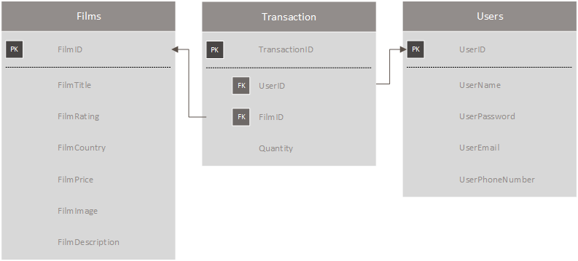
Figure 1. ERD of the application’s database

As stated above, this application will then need several pages to fulfill its purpose. The breakdown of those pages is described below:
- Login Page
This page contains a login form that will authenticate users to the application. The authentication process requires the user to input the registered username and password. The page has several components and validation, which are:
- Use EditText for the username and password input field. Adjust the component’s type to suit the proper purpose.
- Use the Button for the user to log in.
This button will validate and authenticate the user. The login processes are:
  - Validate that username must be filled.
  - Validate that password must be filled.
  - Validate that username and password are registered in the application’s database.
- If the validation fails, the application will show an error message according to the failure using Toast.
- If the validations are fulfilled, generate the OTP Code by random four numbers and send it using SMS to authenticate the user’s phone number.
- Redirect the logged-in user to the OTP page.
- Use TextView that contains “Didn’t have an account? Register here!”. This component will direct users to the Register Page whenever clicked by the user.

- Register Page
This page contains a registration form that will be used to register a new user, which will then be stored in the application’s database. The registration process requires a username, password, email, and phone number. The requirements for this form are:
- Use EditText for the username, password, email, and phone number input field. The component’s type must be adjusted to suit the proper purpose.
- Use Button for the user to register.
This button will validate and register the user. The registration processes are:
  - Validate that all fields must be filled.
  - Validate that username must be unique and not registered by other users.
  - Validate that password’s length of at least five characters.
  - Validate that the email must end with ‘.com’.
- User ID will be an integer that always increments.
  - If any validation fails, the application will show an error message according to the failure using Toast.
  - Otherwise, register the given information and store it in the application’s database. The user will then be directed to the Login Form.
- Use TextView for Login. This component contains “Already has an account? Log in here” which will redirect the user to the Login Page when clicked.

- OTP Page
This page contains an OTP form that will be used to re-authenticate the user by OTP Code sent through SMS. The requirements for this form are :
- Validate that OTP Edit Text must be filled.
- Validate that the code typed by the user must be the same as the OTP Code in the SMS. If the OTP Code is not valid, show an error message using Toast.
- Otherwise, redirect the user to Home Page.

- Home Page
This home page contains three sections: the home section, transaction section, and profile section. You can use anything (menu item, navigation drawer, tabs, or bottom navigation) for these sections. The details for the sections will be explained below :
- Home Section
- Show your application’s Logo or application’s Jumbotron Image with Image View.
- Show list all available film data from the application’s database. But you must retrieve the data from JSON first, then store it in the application’s database. Use the Volley library to fetch and extract information from the JSON data. The JSON data is available at https://mocki.io/v1/ce4395c2-d593-45ae-b392-78fe2238369c.
- You must use Recycler View to show the data. Show film’s cover in every film item.
- When the specific film is clicked, redirect the user to the corresponding film detail page.
- Transaction Section
- Get the transaction list with a specific logged-in user from the application’s database.
- You must use Recycler View to show the data. Show film’s cover, film’s title, film’s rating, film’s country, film’s price, and transaction quantity in every transaction item.
- Provides update and delete button in every transaction item.
- If the user clicks the update button, prompt the user to input the quantity. Then validate the quantity with the validation details below :
- Validate quantity must be a number and more than 0.
- If any validation fails, the application will show an error message according to the failure using Toast.
- Otherwise, update the quantity of the selected transaction data in the application’s database.
- If the user clicks the delete button, show a confirmation dialog before deleting the transaction to avoid human error.
- If the user has confirmed, delete the selected transaction in the application’s database.
- Profile Section
- Show username, email, and phone number from the user logged in.
- Provides Logout Button to log out the user from the application.
- Show confirmation dialog before user log out to avoid human error.
- Redirect the user to Login Page after the user successfully logged out.
- Detail Film Page
This page will show detailed film information for a specific film from the application’s database. Show film’s cover, film’s title, film’s rating, film’s country, film’s price, and film’s description. This page also provides a form for users to buy the film. The requirements for this form are:
- Use EditText to enter the quantity that the user wants to buy. The components’ type must be adjusted to suit the proper purpose.
- Use Button for the user to buy the film.
This button will validate the transaction and insert the transaction data into the application’s database. The transaction process details will be explained below :
- Validate quantity must be filled.
- Validate quantity must be a number and more than 0.
- If any validation fails, the application will show an error message according to the failure using Toast.
- Otherwise, insert the transaction of the selected film and the quantity in the application’s database.

- About Us Page
This page will show the user of Nocturne Cinema’s location with a marker. The requirements for this page are specified below:
- Provide a TextView that serves as a header that writes “About Us”.
- Provide another TextView that Shows the company description.
- Use Google Play Services for Android Maps SDK.
- Put the marker on the specified location (latitude & longitude) and name the marker. The details will be specified below:
Google Map Details
Longitude | 106.781592
Latitude | -6.201733
Marker’s Name | Nocturne Cinema

Here are the rules that you must follow to create your project:
- Use appropriate software for this subject based on Sistem Praktikum that can be downloaded from Binusmaya.
- Use the techniques taught during practicum.
- Collect appropriate files for this subject based on Sistem Praktikum that can be downloaded from Binusmaya.
- Include the other files that can support your project, such as:
  - All files in your project.
  - Other files (image, audio, video, etc.) used in your project.
  - *.doc file (documentation of your project) that contains all pages in your project, reference links of additional files (image, audio, video, etc.) used in your project, the description about how to use your application, etc.
- If there are some hidden creativities, please note them in the existing documentation because they can greatly affect your project score.

If you do not understand, please ask your assistant! Do not make your own assumption!

