**KEYLOGGER**

**ABSTRACT:**

A Key-logger is a type of surveillance software that has the capability to record every keystroke you make to a log file, usually encrypted. Every type of key-logger is dangerous as they can record your keystrokes, tracks your activity and can record the open sites. By this, your any account can be easily hacked by the hackers. These key-loggers can detect your bank accounts passwords too. And such type of key-logger can also be created with the notepad text editor.

Reading the key-logger definition, you might think all key-loggers are illegal. They aren’t they do have legitimate, useful applications. For example, key-loggers are often used by IT departments to troubleshoot problems and systems. Also, they can keep an eye on employee activities. Key-logging goes south and becomes a threat is malicious intent. Simply put, if you install a key-logger on a device you own, it is legal. If a key-logger is installed behind the back of the actual owner to steal data, it is illegal.

**INTRODUCTION:**

A Key-logger can be software or can be hardware. Mainly key-loggers are used to steal passwords or confidential details. First key-logger was invented in 1970’s and was a hardware key-logger and first software key-logger was developed in 1983.

**1 .SOFTWARE KEY-LOGGERS:**

Software key-loggers are the computer programs which are developed to steal password from the victim’s computer. However key-loggers are used in IT organization to troubleshoot technical problems with computers and business networks.

* **JavaScript based key-logger-**It is a malicious script which is installed into a web page, and listens for key to press such as one Key-Up(). These scripts can be sent by various methods, like sharing through social media, sending as a mail file, or RAT file.
* **Form Based Key loggers –** These are key-loggers which activates when a person fills a form online and when click the button submit all the data or the words written is sent via file on a computer. Some key-loggers works as API in running application it looks like a simple application and whenever a key is pressed it records it.

**2 .HARDWARE KEY-LOGGERS:**

These are not dependent on any software as these are hardware key-loggers. Keyboard hardware is a circuit which is attached in a keyboard itself that whenever the key of that keyboard pressed it gets recorded.

* **USB key-logger –** There are USB connector key-loggers which has to be connected to a computer and steals the data. Also some circuits are built into a keyboard so no external wire is used or shows on the keyboard.
* **Smartphone sensors –** Some cool android tricks are also used as key loggers such as android accelerometer sensor which when placed near to the keyboard can sense the vibrations and the graph then used to convert it to sentences, this technique accuracy is about 80%.

**PROPOSED SYSTEM :**

The method is very simple and easy and you don’t need any tool to do this but just a notepad to perform the task. So just follow the below steps to proceed.

**Creating Key-logger With Notepad:**

**Step1.** First of all, you need to open notepad in your windows by pressing **Window**button and then selecting the **notepad** from the options.Now , In notepad copy and paste the below code in it.

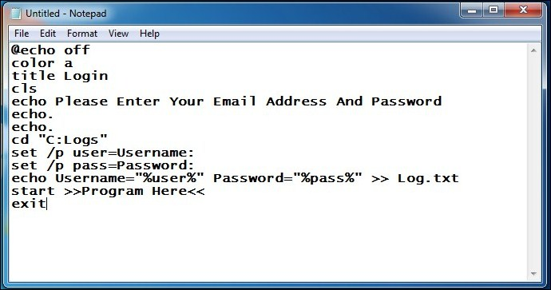

**Step2.** Now save this file as **Logs.bat**on your desktop.

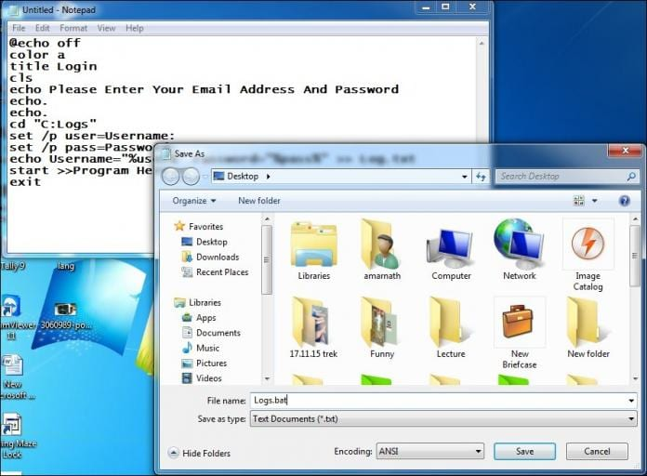

**Step3.** Now create a new folder named **logs.** (Note that key-logger will only work if the folder name is logs). Cut the folder and paste it into**drive C**

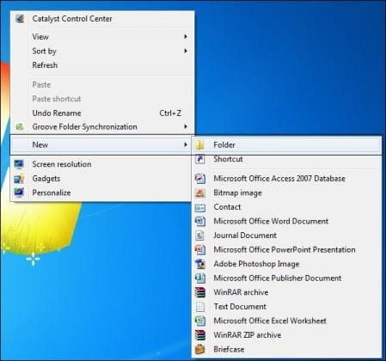

**Step4.** Now test your file Log.bat and then after entering the Username and password

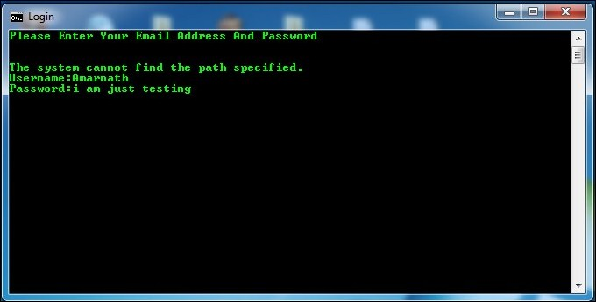

**Step5.** Open the folder in C drive and see all saved key logs there as a text file created there automatically.

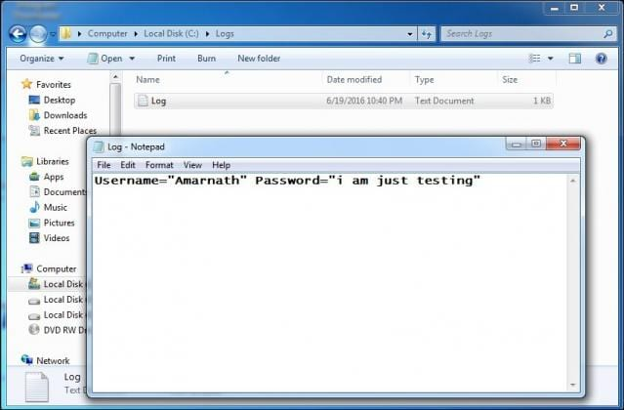

That’s it! We have successfully created a **key-logger in notepad**.

**SECURITY CONCERN**

**Prevention from key-loggers:**

These are following below-

1. As **Anti-Key-logger –** the name suggests these are the software which are anti / against key loggers and main task is to detect key-logger from a computer system.
2. **Anti-Virus –**Many anti-virus software also detect key loggers and delete them from the computer system. These are software anti-software so these cannot get rid from the hardware key-loggers.
3. **Automatic form filler –** This technique can be used by the user to not fill forms on regular bases instead use automatic form filler which will give a shield against key-loggers as keys will not be pressed.
4. **One-Time-Passwords –** Using OTP’s as password may be safe as every time we login we have to use a new password.
5. **Patterns or mouse-recognition –** On android devices used pattern as a password of applications and on PC use mouse recognition, mouse program uses mouse gestures instead of stylus.
6. **Voice to Text Converter** – This software helps to prevent Key-logging which targets a specific part of our keyboard.

These techniques are less common but are very helpful against key-loggers.

**RESULT:**