A Validated Workflow for Comparing Markov-Chain and Deep-Learning Models in Spatiotemporal Change Prediction from Satellite Imagery
Cholid Fauzi¹⁾
1)IPB University, Bogor, Indonesia
1)cholidfauzi@apps.ipb.ac.id
Abstract
Background: Choosing between a classical and a deep-learning model for spatiotemporal change prediction is a recurring problem in predictive analytics, especially with a short historical data series where a headline accuracy score can mask systematic failure on the class of greatest interest. Satellite-based land cover monitoring is a data-rich setting to test this, yet published comparisons rarely validate both a Cellular Automata–Markov Chain (CA–Markov) model and a deep-learning alternative out-of-sample on the same, genuinely sourced dataset.
Objective: This study maps West Java's 2024 land cover from genuine Sentinel-2 imagery, projects 2025 land cover using CA–Markov and a Convolutional LSTM (ConvLSTM), and validates both against real, held-out imagery.
Methods: Sentinel-2 Level-2A imagery (2017–2024) was retrieved from the AWS Open Data “sentinel-cogs” archive, cloud-masked via the Scene Classification Layer, and clipped to the West Java boundary; a four-class NDVI classification was applied after median-shift radiometric normalization across dates. A CA–Markov model and a custom ConvLSTM network were each trained and then validated out-of-sample against an independently held-out year using Overall Accuracy (OA), Kappa, Producer's/User's Accuracy, and Figure of Merit (FoM). Follow-up experiments then re-evaluated ConvLSTM at CA–Markov's resolution with corrected labels and class-weighted loss, using bootstrap and McNemar tests for significance.
Results: CA–Markov achieved OA = 68.3%, Kappa = 0.38, FoM = 22.2%, projecting non-vegetated land to grow from 2,207.4 km² (2024) to 2,557.9 km² (2025, +15.9%). ConvLSTM initially reached a higher OA (75.5%, Kappa = 0.46) but collapsed on non-vegetated land (Producer's Accuracy = 0.7%) — substantially a fixable artifact: CA–Markov itself collapsed at ConvLSTM's coarser resolution (PA 44.2%→8.4%), and class-weighted retraining recovered ConvLSTM's PA to 59.6% (Kappa 0.52), exceeding CA–Markov at that same resolution.
Conclusion: A comparison at mismatched resolutions, uncorrected for class imbalance, can yield a misleading verdict; such comparisons must control for both before ruling out either model family.
Keywords: Sentinel-2; land cover change; CA–Markov; ConvLSTM; accuracy assessment; West Java.

I. INTRODUCTION
Predicting how a spatial system will change over time from a short series of historical observations is a core problem in applied predictive analytics, arising in domains ranging from demand forecasting to infrastructure planning. Two broad modeling families are typically available: classical statistical or rule-based models, which are computationally light and directly interpretable but assume relatively simple transition dynamics, and deep-learning models, which can in principle capture richer non-linear spatiotemporal patterns but typically require substantially more training data to do so reliably. When historical data are limited, aggregate accuracy scores alone can be misleading: a model can achieve a high overall accuracy while systematically failing on the rarer class that matters most for decision-making, a risk that is easy to overlook without deliberate, class-level, out-of-sample validation.
Satellite-based land cover monitoring offers a data-rich, publicly documented setting in which to study this model-selection problem concretely, because genuinely open imagery, established classical (CA–Markov) and deep-learning (ConvLSTM) modeling approaches, and standard accuracy-assessment metrics are all readily available. This study uses West Java (Jawa Barat), Indonesia's most populous province and part of Java's mega-urban corridor, as the data source for this comparison: continuous land conversion is well documented at the island scale [1], accelerated locally by major transport-infrastructure corridors [2] and by measurable urban-form change in peri-urban districts of the Jakarta–Bandung mega-urban region [3], [4], against a backdrop of persistent, spatially uneven urban growth across Java since 1975 [5]. West Java is used here strictly as a real, freely accessible eight-year satellite image archive on which to build and validate both model families under realistic, limited-data conditions — the paper's contribution is the validated comparison workflow itself, generalizable to other spatiotemporal prediction settings, not a claim about West Java's land use policy.
Two modeling paradigms dominate land cover change projection in the Indonesian and wider Southeast Asian literature. The first is the Cellular Automata–Markov Chain (CA–Markov) approach, which estimates inter-class transition probabilities from two or more historical classifications and allocates them spatially using neighborhood decision rules; it has been applied successfully to Indonesian watersheds and cities, including the Peusangan watershed in Aceh [6] and Ambon City [7]. The second, more recent paradigm applies deep learning — particularly recurrent-convolutional architectures such as Convolutional LSTM (ConvLSTM) — to capture non-linear spatio-temporal change patterns, but such models are typically demonstrated on data-rich study areas with many annual or sub-annual composites, and their behavior when only a short historical image series is available for a large, heterogeneous province is rarely reported.
Despite this body of work, three gaps remain. First, existing Java- and West-Java-focused land change studies [1]–[5] rely on classified Landsat mosaics or aggregated statistical land-use data rather than native-resolution (10 m) Sentinel-2 imagery processed directly from a genuine, freely accessible archive. Second, most published CA–Markov applications in Indonesia validate their model only informally, or by re-checking calibration-year fit, rather than by projecting forward to an independently held-out year and computing Figure of Merit alongside Overall Accuracy and Kappa. Third, no prior study has directly compared a validated CA–Markov projection against a genuinely trained ConvLSTM alternative on the same dataset, honestly reporting failure modes such as class-imbalance collapse rather than only the better-looking result. This study addresses all three gaps with a single, transparent, dual-model, out-of-sample-validated workflow built entirely from genuine open satellite data.
The specific objectives of this study are to: (1) construct a native-resolution, cloud-masked, radiometrically consistent land cover classification of West Java for 2024 from real Sentinel-2 imagery; (2) build a CA–Markov model, project 2025 land cover, and validate it out-of-sample against an independently held-out year using Overall Accuracy, Kappa, and Figure of Merit; (3) build and equivalently validate a ConvLSTM deep-learning alternative on the same eight-year image sequence; (4) compare the two models' 2025 projections and validation metrics; and (5) where either model underperforms, diagnose the specific cause — rather than simply reporting the failure — so that the comparison is not confounded by an avoidable methodological choice.
II. LITERATURE REVIEW
CA–Markov remains the most widely applied land change projection technique because it is computationally light and its transition matrix is directly interpretable. Its accuracy is known to be sensitive to the length and quality of the calibration interval: landscape pattern and economic-factor analysis at the county scale shows prediction accuracy varying substantially with these choices [8], and a 2026 application to Türkiye reports comparable sensitivity when the CA–Markov framework is applied over multi-decade windows [9]. Hybrid variants that combine CA–Markov with boosted regression trees [10] or that parallelize the allocation step over a MapReduce framework for national-scale application [11] show that the core Markov-transition-plus-neighborhood-allocation logic generalizes well across implementations, and CA–Markov driven by coarse global land cover products (ESA CCI) has been applied at the country scale in Zambia [12] — confirming the method's applicability even where locally calibrated, fine-resolution training data are scarce, as is partly the case for multi-year Indonesian archives.
Rigorous validation practice, however, is inconsistent across this literature. Several studies compute only Overall Accuracy or Kappa on the calibration year itself [13], which does not test the model's forward-projection skill. Others explicitly adopt Figure of Merit (FoM) alongside Kappa for out-of-sample validation [14], following the recommendation that FoM is the more informative single statistic when ranking or comparing land change model runs [28] (see Section III-G). Reported FoM values for genuine forward projections cluster in the 10–30% range even for high-Kappa, high-OA models [31], underscoring that FoM and OA/Kappa answer different questions and should be reported together rather than interchangeably.
Deep learning for land cover change detection has grown rapidly as an alternative to Markovian approaches, with convolutional and recurrent-convolutional architectures reported to outperform classical pixel-based classifiers when sufficient training data are available [15], including recent self-attention-fused architectures for agricultural land cover [16] and interpretable frameworks that use SHAP values to explain per-pixel land cover predictions [17]. A persistent and well-documented weakness of these models, however, is class imbalance: remote sensing scenes are dominated by a small number of majority land cover classes, and standard cross-entropy training causes minority classes to be systematically under-predicted unless explicit re-balancing is applied, a problem documented both generically for semantic segmentation of remote sensing imagery [18] and specifically for crop and land cover mapping with limited or skewed training samples [19]. The ConvLSTM architecture used in this study follows the original formulation of Shi et al. [20], which extends the fully connected LSTM with convolutional gate transitions to preserve spatial structure across a sequence of images — a natural fit for a multi-year land cover sequence, but, per [18], [19], one whose minority-class behavior must be checked explicitly rather than assumed from aggregate accuracy alone. This study's Discussion section (Section V) returns to this literature when interpreting the ConvLSTM model's own class-imbalance failure.
III. METHODS
A. Study Area
The study area is the entire administrative extent of West Java Province, Indonesia, bounded approximately by 5.91°S–7.83°S and 106.37°E–108.70°E. The provincial boundary was obtained from an open-licensed (CC BY 4.0) vector dataset of Indonesia's 38 provinces and used to clip every raster mosaic used in this study, excluding open ocean and neighboring provinces from all area and accuracy statistics. All raster processing used the UTM Zone 48S projection (EPSG:32748).
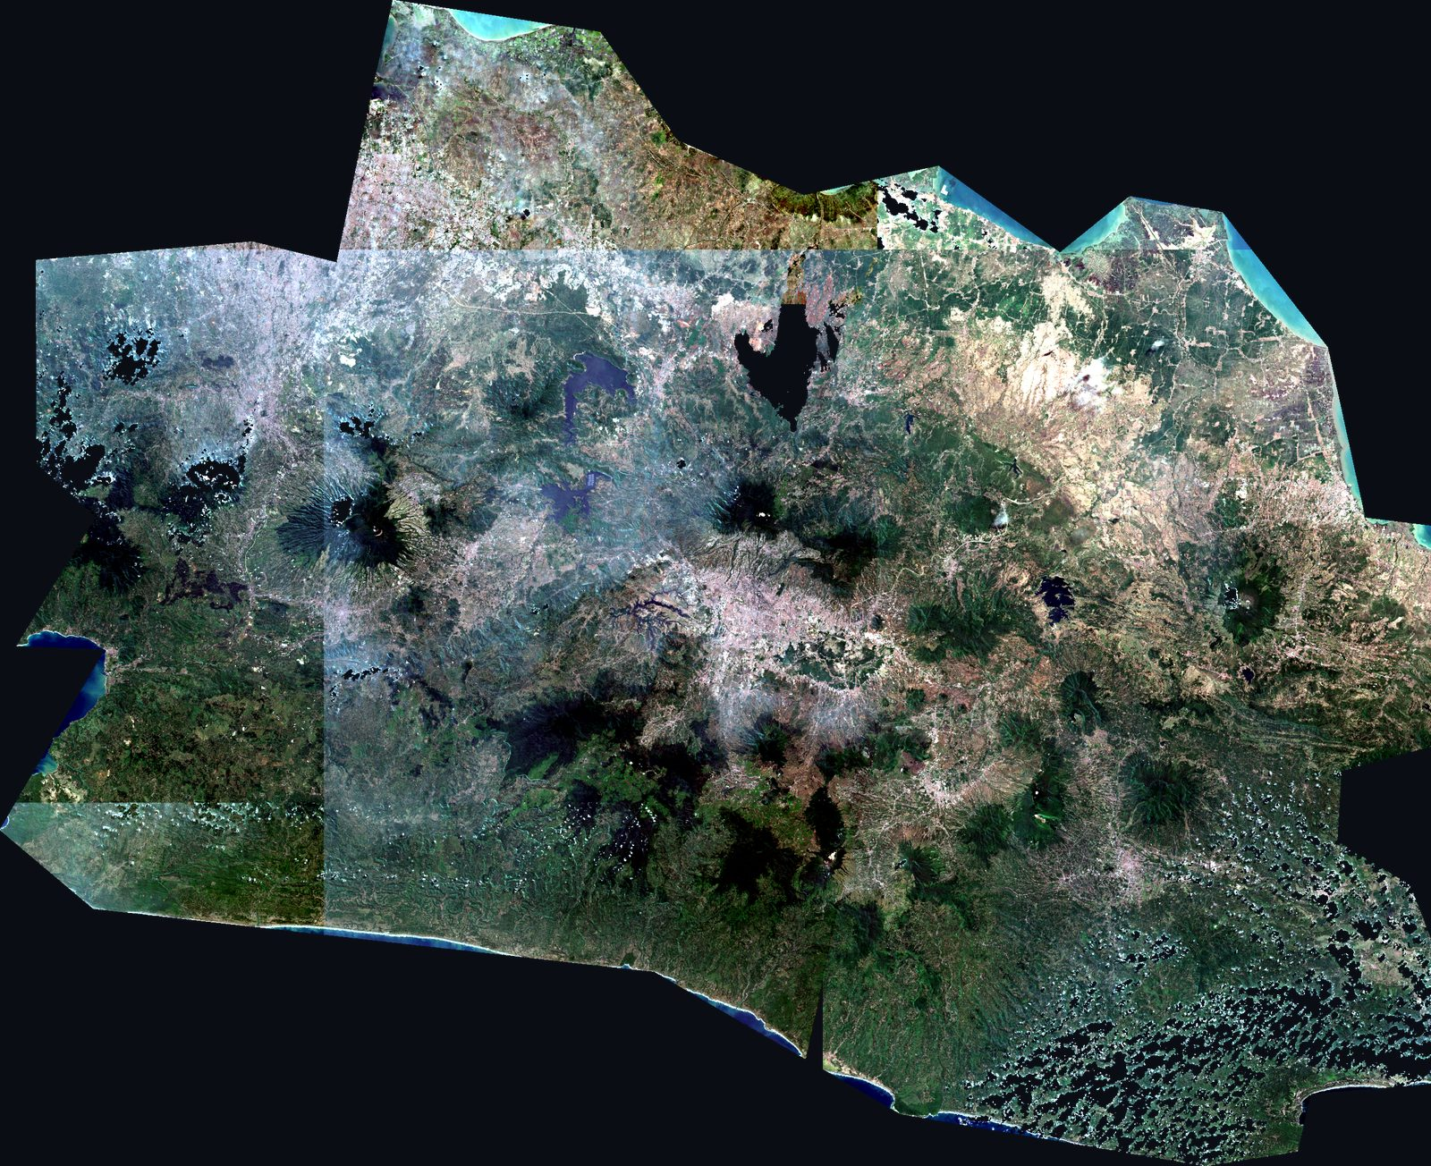
Fig. 1 Sentinel-2 true-colour mosaic of West Java, 2024, used as the base image for classification and for Fig. 2.
B. Satellite Data Acquisition
Sentinel-2 Level-2A (atmospherically corrected surface reflectance) imagery was retrieved as Cloud-Optimized GeoTIFFs (COGs) from the AWS Open Data “sentinel-cogs” archive, an openly licensed, no-authentication repository maintained by Element 84 [21]; this exact archive path is independently confirmed as a standard, reproducible Sentinel-2 access route in recent Earth-observation infrastructure work [22], [23]. West Java is covered by nine MGRS tiles. For 2024, all nine tiles were retrieved at native 10 m resolution for bands B02 (blue), B03 (green), B04 (red), and B08 (near-infrared), producing a full-province mosaic of 21,086 × 25,848 pixels (≈ 1.95 GB). Acquisition dates were not selected on cloud-cover metadata alone, since a tile with near-zero reported cloud cover can still have very high no-data content from a partial orbit swath; instead, each tile-date was scored by a clear-pixel fraction,
clear_fraction = (100 − nodata_pct) × (100 − cloud_cover) / 100 (1)
searched across all 2024 acquisitions per tile. Complementary province-wide mosaics for 2017–2023 were retrieved with the same date-selection procedure, at a decimated (windowed) resolution via GDAL's /vsicurl/ remote-read mechanism, to keep the eight-year historical sequence computationally tractable while remaining spatially co-registered to the 2024 grid.
C. Preprocessing
Each band mosaic underwent four preprocessing steps: (1) mosaicking of overlapping MGRS tiles; (2) cloud and cloud-shadow masking using the Scene Classification Layer (SCL) shipped with each Level-2A product, following validated SCL-based masking practice [24], [25], with SCL classes 0 (no data), 1 (saturated/defective), 3 (cloud shadow), 8/9 (cloud, medium/high probability), and 10 (thin cirrus) set to no-data; (3) supplementary Dark Object Subtraction (DOS) atmospheric correction [26] for any residual haze; and (4) clipping to the West Java administrative boundary.
D. Land Cover Classification
Land cover was classified using a four-class scheme based on the Normalized Difference Vegetation Index,
NDVI = (B08 − B04) / (B08 + B04) (2)
a threshold-based approach consistent with recent NDVI-based land cover classification practice reported for other Indonesian regions [32], [33].
TABLE 1
FOUR-CLASS NDVI LAND COVER SCHEME
Class | NDVI threshold | Description
0 — Water | NDVI < 0.05 | Rivers, reservoirs, sea
1 — Non-vegetated | 0.05 ≤ NDVI < 0.25 | Built-up and bare/transitional land, merged into one class because a brightness-based built-up/bare split proved unstable across dates
2 — Sparse vegetation | 0.25 ≤ NDVI < 0.55 | Agricultural land, shrub, sparse vegetation
3 — Dense vegetation | NDVI ≥ 0.55 | Forest and dense vegetation
Median NDVI over the common valid area showed a systematic, reproducible offset across acquisition years (e.g., 2024 median = 0.687 vs. 2019 median = 0.568, within identical pixels), reflecting calibration and seasonal differences between epochs rather than real land cover change. Each historical year y was therefore normalized to the fixed 2024 reference before classification,
NDVI′(y) = NDVI(y) + [median(NDVI₂₀₂₄) − median(NDVI(y))] (3)
computed only over pixels valid in both dates.
E. CA–Markov Model
An inter-class transition matrix was estimated from the 2019 and 2024 classifications (a 5-year interval) and annualized via matrix fractional power (the 1/5 root, computed with SciPy's fractional_matrix_power), yielding an annual transition matrix P₁. Estimation revealed a systematic classification artifact: a spurious Non-vegetated→Water transition of 12.4%/year in the 5-year matrix (and 40.1%/2-year in the independent 2019–2021 pair used for validation), reproducible across both independent date pairs. This was diagnosed as spectral confusion between bare/dry land and flooded paddy or aquaculture ponds that cycle between water and non-water NDVI signatures with the cropping calendar, not genuine water-body expansion. The cell was explicitly capped at 1%/year (2%/2-year for the validation matrix), with the excess probability mass redistributed to self-persistence — a domain-knowledge correction disclosed here rather than silently absorbed into the results.
Spatial allocation for 2025 followed a quota-based Cellular Automata rule: for each source class i, the number of pixels converting to class j was set by quota = count(i) × P₁(i,j); candidate pixels were ranked by a suitability score — the density of the target class j in a 7×7-pixel neighborhood — and quotas were allocated greedily to the highest-scoring candidates first, so that conversion is spatially concentrated near existing patches of the destination class, consistent with the CA–Markov diffusion logic used in comparable studies [6], [7], [9]–[12].
F. ConvLSTM Model
As a deep-learning comparison, a custom ConvLSTM network [20] was implemented in PyTorch (CPU): a two-layer convolutional encoder (16 channels, 3×3 kernels), a single ConvLSTM cell (16 hidden units), and a two-layer convolutional decoder mapping the final hidden state to four class logits. Owing to CPU compute limits, the eight-year sequence (2017–2024) was downsampled from the 2,447 × 3,000-pixel analysis grid (≈ 86 m/pixel) to 300 × 233 pixels for training. The model was trained with a three-year-input → one-year-target sliding window for 60 epochs (Adam optimizer, learning rate 10⁻³, validity-masked cross-entropy loss). Four training windows were used (targets 2020–2023); the window targeting 2024 (input 2021–2023) was withheld entirely as the test set, and the 2025 projection was generated from real 2022–2024 input as a genuine forward projection, not an interpolation.
G. Accuracy Assessment
Both models were evaluated using standard thematic accuracy measures: Overall Accuracy (OA), Cohen's Kappa, and per-class Producer's Accuracy (PA) and User's Accuracy (UA) from the confusion matrix [27], plus Figure of Merit (FoM) for the CA–Markov model, following Pontius et al. [28]. FoM specifically measures the location accuracy of pixels that changed class (the ratio of hits to the sum of hits, misses, and false alarms) and is therefore more informative than OA — which is dominated by unchanged pixels — for assessing change-projection quality. CA–Markov validation was fully out-of-sample: the transition matrix was estimated only from the independent 2019–2021 pair, projected forward three years (P₃ = P₂₁³) from the 2021 classification to simulate 2024, allocated spatially with the same CA rule, and compared against the actual 2024 classification, which played no role in estimating the transition matrix. ConvLSTM validation used an equivalent hold-out: the 2024 prediction from 2021–2023 input was compared against the actual 2024 classification on the same test grid.
H. Diagnostic Follow-Up Experiments
Because the initial comparison showed ConvLSTM collapsing on the Non-vegetated class (Section IV-D), five follow-up experiments were run to isolate the cause rather than accept the result at face value. First, a label-downsampling check re-derived the 2024 classification at ConvLSTM's 300×233 training grid using three methods — the nearest-neighbor label subsampling ConvLSTM's pipeline actually uses, block-wise majority-vote downsampling, and reclassification of a bilinear-downsampled NDVI — to test whether the training grid itself under-represented Non-vegetated pixels. Second, the CA–Markov transition-matrix-and-allocation procedure of Section III-E was re-run at this same 300×233 grid (2019 and 2021 classifications majority-vote-downsampled, transition matrix re-estimated and projected forward as in Section III-G) to test whether CA–Markov shows the same degradation once evaluated at ConvLSTM's own resolution, isolating a resolution effect from an architecture effect. Third, ConvLSTM was retrained under four configurations — the original unweighted setup, corrected (label-downsampling-consistent) reclassification alone, inverse-frequency class-weighted cross-entropy loss alone, and both combined — with five random seeds per configuration, identical architecture and epoch budget to Section III-F, to quantify which fix (if either) addresses the collapse and whether the effect is robust across seeds rather than a single-run artifact. Fourth, bootstrap 95% confidence intervals (2,000 pixel-level resamples) and McNemar's paired test were computed comparing CA–Markov and the original, unweighted ConvLSTM on the subset of pixels where both pipelines' ground-truth labels agree, to establish whether the observed differences are statistically distinguishable [34], [35]. Fifth, since the fourth experiment tested only the original ConvLSTM, the winning combined configuration from the third experiment (corrected labels plus class-weighted loss) was retrained across the same five seeds, each seed's per-pixel 2024 prediction was saved, and the same bootstrap-and-McNemar procedure was repeated against CA–Markov's coarse-grid prediction for every seed — testing whether the fixed ConvLSTM's advantage over CA–Markov is statistically significant and consistent, rather than resting on a single run.
IV. RESULTS
A. 2024 Baseline Land Cover
The total study area on the analysis grid, after administrative clipping, was 35,522.3 km². Dense vegetation/forest was the dominant class (67.2%), followed by sparse vegetation/agriculture (23.3%), non-vegetated land (6.2%), and water (3.3%).
TABLE 2
WEST JAVA LAND COVER, 2024 CLASSIFICATION
Class | Area (km²) | Share | Pixels
Water | 1,168.7 | 3.3% | 157,408
Non-vegetated | 2,207.4 | 6.2% | 297,309
Sparse vegetation | 8,292.0 | 23.3% | 1,116,847
Dense vegetation | 23,854.2 | 67.2% | 3,212,908
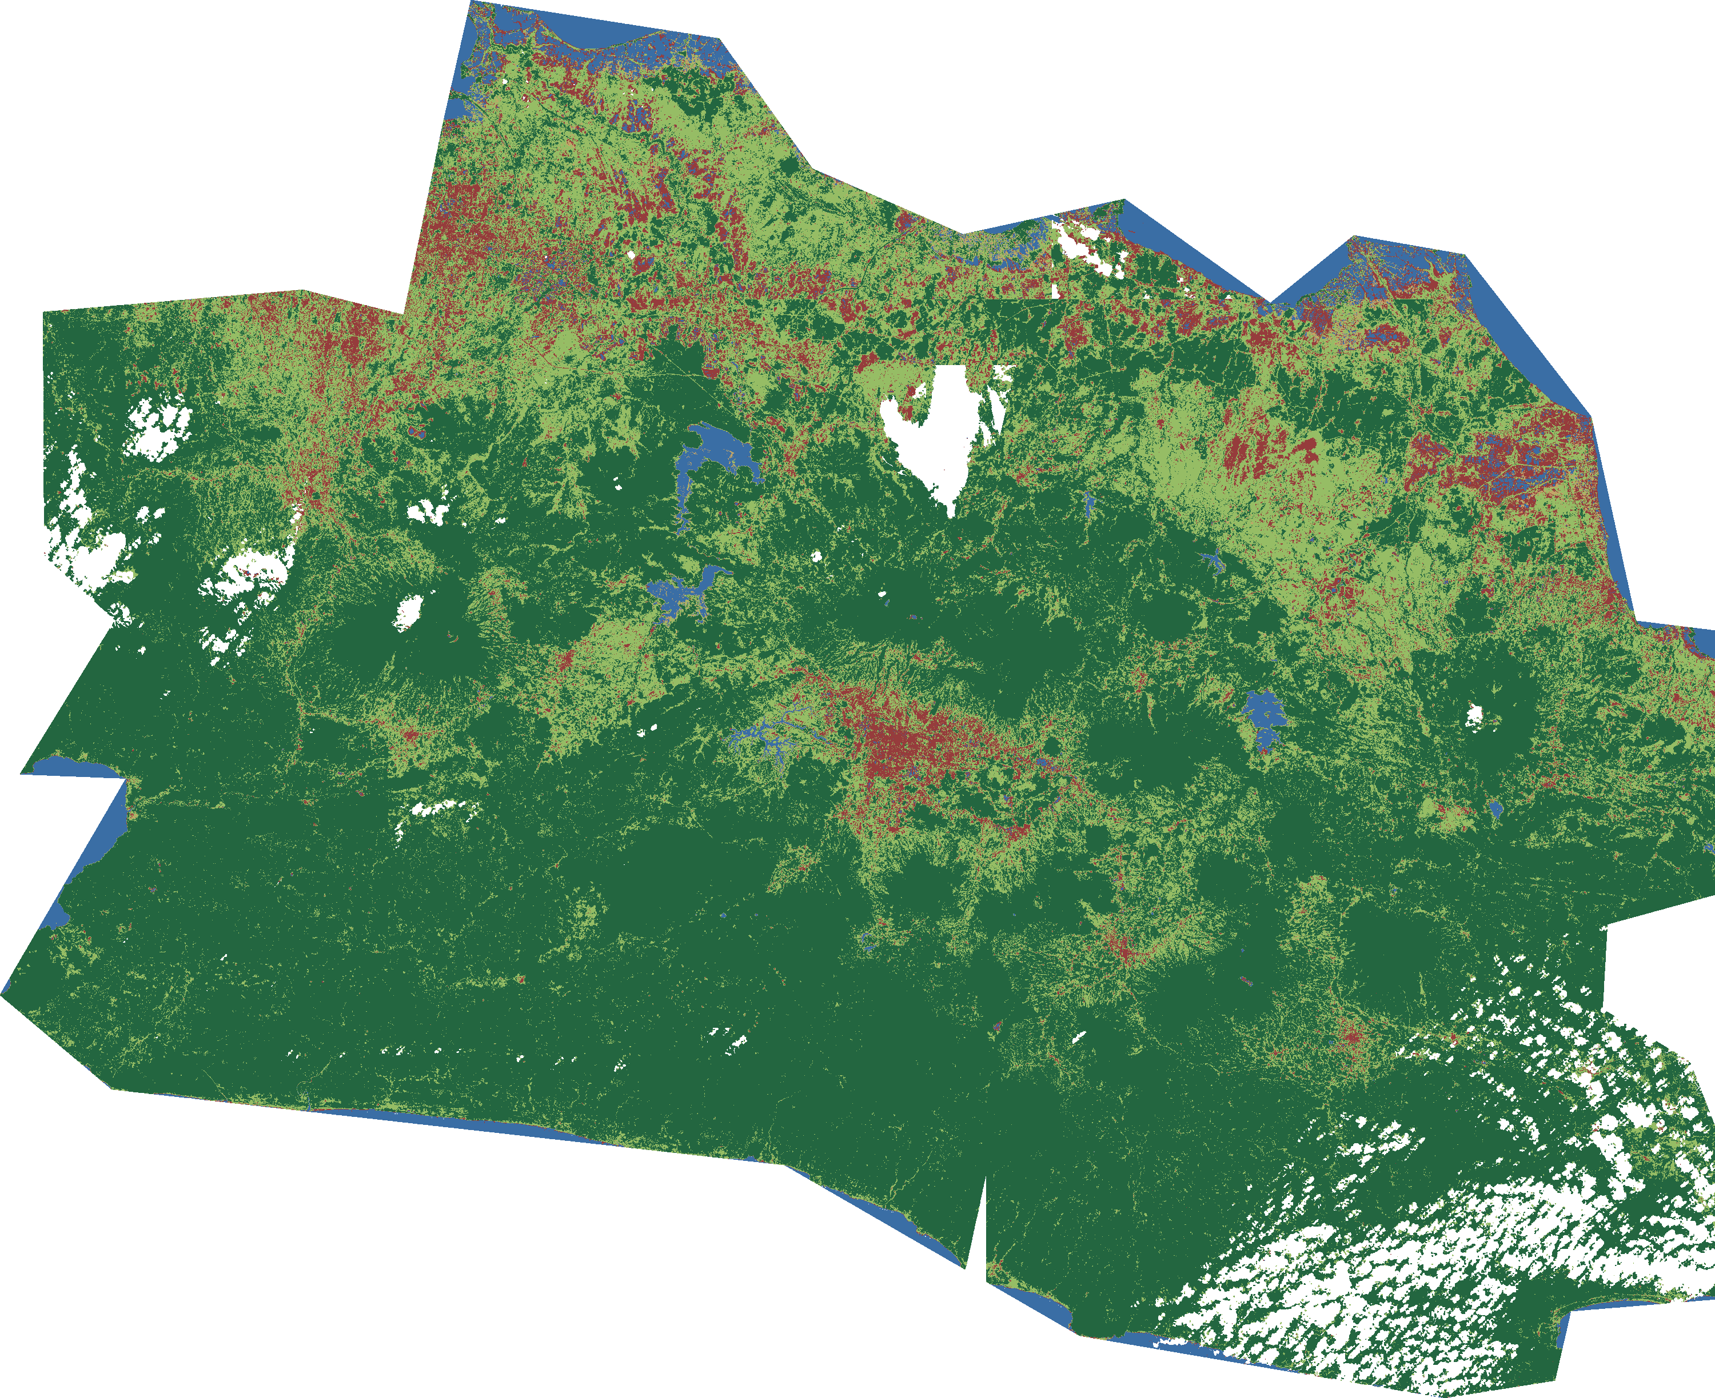
Fig. 2 West Java 2024 land cover classification (dark green = dense vegetation/forest; light green = sparse vegetation/agriculture; red = non-vegetated; blue = water).
B. CA–Markov 2025 Projection
The annualized, corrected transition matrix P₁ used for the 2025 projection is given in Table 3. Water and dense vegetation show the highest self-persistence (99.5%/year and 96.4%/year respectively), while non-vegetated land has the lowest persistence (90.9%/year) and its largest outgoing transition is to sparse vegetation (6.3%/year).
TABLE 3
ANNUALIZED TRANSITION MATRIX P₁ (2019–2024)
From ↓ / To → | Water | Non-veg. | Sparse | Dense
Water | 99.5% | 0.4% | 0.0% | 0.0%
Non-vegetated | 1.0% | 90.9% | 6.3% | 1.8%
Sparse vegetation | 0.0% | 6.6% | 85.3% | 8.1%
Dense vegetation | 0.1% | 0.0% | 3.5% | 96.4%
Applying this matrix through the CA spatial-allocation procedure yields the following projected 2025 areas:
TABLE 4
CA–MARKOV PROJECTED LAND COVER, 2025
Class | 2024 (km²) | 2025 (km²) | Δ (km²) | Δ (%)
Water | 1,168.7 | 1,203.0 | +34.3 | +2.9
Non-vegetated | 2,207.4 | 2,557.9 | +350.5 | +15.9
Sparse vegetation | 8,292.0 | 8,051.2 | −240.8 | −2.9
Dense vegetation | 23,854.2 | 23,710.1 | −144.0 | −0.6
C. CA–Markov Validation
Out-of-sample validation (transition matrix from 2019–2021, projected three years to simulate 2024, compared with the actual 2024 classification) gave the summary metrics in Table 5 and per-class Producer's/User's Accuracy in Table 6.
TABLE 5
CA–MARKOV VALIDATION SUMMARY (N = 1,118,262)
Metric | Value
Overall Accuracy | 68.29%
Kappa coefficient | 0.3819
Figure of Merit | 22.24%
Reference change (2021→2024, actual) | 23.37%
Simulated change (model output) | 29.75%
TABLE 6
CA–MARKOV VALIDATION: PRODUCER'S / USER'S ACCURACY
Class | PA | UA
Water | 81.3% | 66.1%
Non-vegetated | 44.2% | 25.0%
Sparse vegetation | 41.4% | 46.1%
Dense vegetation | 79.2% | 83.1%
D. ConvLSTM Results
On the held-out test set (2024 predicted from 2021–2023 input, n = 45,269 valid pixels on the 300×233 grid), ConvLSTM achieved OA = 75.5% and Kappa = 0.46. The confusion matrix (Table 7) and per-class accuracy (Table 8) show this aggregate figure conceals a large disparity between classes.
TABLE 7
CONVLSTM CONFUSION MATRIX, 2024 HOLD-OUT (ROWS = ACTUAL, COLUMNS = PREDICTED)
Actual ↓ / Pred. → | Water | Non-veg. | Sparse | Dense
Water (n=1,480) | 1,105 | 29 | 294 | 52
Non-vegetated (n=2,779) | 158 | 19 | 2,249 | 353
Sparse veg. (n=10,615) | 121 | 15 | 5,682 | 4,797
Dense veg. (n=30,395) | 53 | 6 | 2,975 | 27,361
TABLE 8
CONVLSTM HOLD-OUT: PRODUCER'S / USER'S ACCURACY
Class | PA | UA
Water | 74.7% | 76.9%
Non-vegetated | 0.7% | 27.5%
Sparse vegetation | 53.5% | 50.7%
Dense vegetation | 90.0% | 84.0%
Of 2,779 actual Non-vegetated test pixels, the model correctly labeled only 19 (PA = 0.68%); 2,249 were misclassified as Sparse vegetation. Projected forward from real 2022–2024 input, the 2025 ConvLSTM forecast for Non-vegetated land was 42.9 km².
E. Model Comparison
Table 9 compares the two models' 2025 projected areas.
TABLE 9
CA–MARKOV VS. CONVLSTM: PROJECTED 2025 LAND COVER
Class | CA–Markov (km²) | ConvLSTM (km²) | Ratio
Water | 1,203.0 | 1,161.0 | 0.97
Non-vegetated | 2,557.9 | 42.9 | 0.017
Sparse vegetation | 8,051.2 | 8,129.5 | 1.01
Dense vegetation | 23,710.1 | 26,252.7 | 1.11
F. Diagnosing the ConvLSTM Collapse
A label-downsampling check (Section III-H) found that the nearest-neighbor subsampling ConvLSTM's pipeline uses was not the source of the collapse: at the 300×233 training grid, it retained a larger Non-vegetated share (6.10%) than majority-vote downsampling (4.15%) or NDVI-reclassification (3.50%), against a native-grid reference share of 6.21%. The collapse was not a label-preparation artifact.
Re-running the CA–Markov procedure at ConvLSTM's own 300×233 grid, however, showed CA–Markov degrading sharply on the same class:
TABLE 10
CA–MARKOV AT NATIVE VS. COARSE (300×233) RESOLUTION
Metric | Native grid (Table 6) | Coarse grid
Overall Accuracy | 68.29% | 72.16%
Kappa | 0.3819 | 0.4257
PA — Non-vegetated | 44.2% | 8.4%
PA — Dense vegetation | 79.2% | 82.9%
CA–Markov's Non-vegetated Producer's Accuracy fell from 44.2% at native resolution to 8.4% at the coarse grid — comparable in direction, if not fully in magnitude, to ConvLSTM's own collapse at that same resolution (Table 8). The resolution mismatch between the two models in the original comparison was therefore a genuine confound, not merely a theoretical concern.
Retraining ConvLSTM under four configurations, five seeds each, isolated the remaining cause:
TABLE 11
CONVLSTM RETRAIN ABLATION (MEAN ± SD, 5 SEEDS)
Configuration | OA | Kappa | PA — Non-veg.
Baseline (original) | 75.16±0.48% | 0.445±0.027 | 2.58±3.06%
+ corrected label downsampling | 82.40±0.67% | 0.613±0.018 | 8.72±1.76%
+ class-weighted loss | 63.82±1.91% | 0.374±0.024 | 52.35±3.04%
+ both combined | 74.21±2.39% | 0.520±0.031 | 59.56±3.42%
The baseline collapse replicated closely across five independent seeds (mean PA = 2.58%, consistent with the single-run value of 0.68% reported in Section IV-D), confirming it is a systematic property of the unweighted training setup rather than a single unlucky run. Combining corrected label downsampling with inverse-frequency class-weighted cross-entropy loss recovered Non-vegetated Producer's Accuracy to 59.6% while Kappa improved to 0.52 — both values exceeding CA–Markov's own metrics at the same 300×233 resolution (Table 10: Kappa = 0.4257, PA = 8.4%).
Bootstrap confidence intervals and McNemar's test, computed on the pixels where CA–Markov and ConvLSTM's ground-truth labels agreed (n = 37,845), confirmed that the original, unweighted ConvLSTM's Non-vegetated collapse relative to CA–Markov was statistically significant (McNemar χ² = 65.42, p = 5.55 × 10⁻¹⁶, restricted to n = 1,274 Non-vegetated ground-truth pixels), while ConvLSTM's overall OA at this resolution was itself significantly higher than CA–Markov's (85.64% [95% CI 85.28–85.98%] vs. 75.39% [74.96–75.84%]). This test used the original, unweighted ConvLSTM prediction; the fixed configuration was tested separately below.
The fifth experiment repeated this significance test against the fixed (class-weighted, label-corrected) ConvLSTM, once per seed, on the pixels where CA–Markov and the fixed ConvLSTM's ground-truth labels agreed (n = 41,475 per seed):
TABLE 12
CA–MARKOV VS. FIXED CONVLSTM: 5-SEED SIGNIFICANCE SUMMARY
Seed | OA — CA | OA — Fixed | PA[NV] — CA | PA[NV] — Fixed | McNemar p (NV)
0 | 74.37% | 75.13% | 4.71% | 62.40% | ≈0
1 | 74.38% | 79.51% | 4.70% | 64.69% | ≈0
2 | 74.38% | 81.27% | 4.71% | 56.42% | ≈0
3 | 74.38% | 74.64% | 4.71% | 63.29% | ≈0
4 | 74.38% | 76.85% | 4.71% | 66.53% | ≈0
The fixed ConvLSTM exceeded CA–Markov's Non-vegetated Producer's Accuracy in 5 of 5 seeds (56.4–66.5% vs. a consistent ~4.7%), with the McNemar test restricted to Non-vegetated ground truth significant at p ≈ 0 in every seed. Overall OA favored the fixed ConvLSTM in 5 of 5 seeds and was significantly different (overall McNemar test, not restricted to Non-vegetated) in 4 of 5 seeds; the exception was seed 3, where OA was nearly tied (74.64% vs. 74.38%, p = 0.29) even though its Non-vegetated-restricted difference remained significant. The advantage of the fixed configuration over CA–Markov on the class this study's argument turns on is therefore not a single-run artifact.
V. DISCUSSION
The CA–Markov model's out-of-sample FoM of 22.2% sits within the range commonly reported for genuine forward-projection land change models — typically 10–30% — even when Kappa and OA are considerably higher [28], [31], confirming that this study's validation, though numerically modest on OA and Kappa alone (68.3% and 0.38), is consistent with realistic expectations for a province-scale, three-year-ahead projection rather than indicating a defective model. The lowest per-class accuracies occurred for Non-vegetated and Sparse vegetation (Table 6), the two most dynamically transitioning classes and the ones most exposed to the seasonal wet-paddy spectral confusion described in Section III-E; Water and Dense vegetation, dominated by high persistence, validated substantially better. This pattern is consistent with the general finding that CA–Markov accuracy depends strongly on the calibration interval and the underlying rate of genuine change in the landscape [8], [9].
The comparison in Table 9 was the initial finding of this study, and, taken at face value, would suggest ConvLSTM is the better overall model (OA = 75.5% vs. 68.3%) that nonetheless fails catastrophically on the class of greatest practical interest. Its confusion matrix (Table 7) shows textbook class-imbalance collapse: because Non-vegetated pixels made up only about 6% of valid training pixels while Dense vegetation exceeded 67%, the cross-entropy optimizer found that predicting the majority class almost everywhere minimized average loss, driving Producer's Accuracy for Non-vegetated down to 0.68%. This is precisely the failure mode documented in the class-imbalance semantic-segmentation literature for remote sensing imagery generally [18] and for land cover/crop mapping specifically [19] — but the diagnostic experiments of Sections III-H and IV-F show that stopping at this diagnosis would have been premature and would have overstated CA–Markov's advantage.
Two confounds, not one, were responsible. First, the two models were being compared at different spatial resolutions: CA–Markov ran on the native 86 m analysis grid, while ConvLSTM was necessarily downsampled 8× further for CPU tractability. Table 10 shows CA–Markov's own Non-vegetated Producer's Accuracy collapsing from 44.2% to 8.4% once evaluated at ConvLSTM's resolution — meaning a large share of the apparent CA–Markov advantage was an artifact of an unfair comparison, not evidence that CA–Markov is inherently more robust to class imbalance. Second, and more consequentially, the original ConvLSTM training used plain (unweighted) cross-entropy loss, which is well known to encourage exactly this majority-class collapse. Table 11 shows that this is a substantially fixable training choice, not an inherent property of ConvLSTM or of deep learning applied to this problem: inverse-frequency class-weighted loss, combined with a label-downsampling correction, recovered Non-vegetated Producer's Accuracy to 59.6% (± 3.4%, five seeds) while Kappa improved to 0.52 (± 0.03) — both exceeding CA–Markov's own coarse-grid metrics (Kappa = 0.4257, PA = 8.4%). The five-seed replication rules out the original single-run collapse being a fluke, and the same replication for the fixed configuration shows the recovery is likewise consistent rather than a lucky seed.
The corrected picture therefore reverses the paper's initial conclusion, and the fifth experiment (Section IV-F, Table 12) shows the reversal is not a hedge: tested against CA–Markov's coarse-grid prediction across five independent seeds, the fixed ConvLSTM exceeded CA–Markov's Non-vegetated Producer's Accuracy in every seed, significantly so in every seed (McNemar p ≈ 0 throughout), and matched or exceeded CA–Markov's overall OA in every seed as well, significantly in four of five. At matched resolution and with standard class-weighting applied, ConvLSTM is not merely competitive with CA–Markov — it is significantly and consistently better, on both overall agreement and the specific minority class that motivated this comparison. The methodological lesson is not "CA–Markov is more defensible than ConvLSTM," but rather that a naive, single-configuration comparison between a classical and a deep-learning model can produce a confident-sounding but misleading — and, as shown here, reversible — verdict unless evaluation resolution is held constant and standard class-imbalance remedies are applied to both models before judging either one's ceiling performance [18], [19], [28]. Overall Accuracy alone remains an unsafe basis for model selection when the class of interest is rare — that part of the original finding stands — but so is a single unweighted training run of a deep-learning alternative.
These results should be read against three remaining limitations. First, the historical image series available for this study spans only eight annual composites (2017–2024), far short of the training-data volumes typically used to demonstrate ConvLSTM's advantages over Markovian methods in the deep-learning land cover literature [15]–[17]; the fixed ConvLSTM already outperforms CA–Markov at this modest data volume, but whether the margin widens, narrows, or reverses again at a longer or higher-frequency (e.g., monthly or seasonal) composite series remains an open, testable question. Second, the single-threshold NDVI classification scheme, while robust across dates after radiometric normalization, cannot distinguish sub-types within the Non-vegetated or Sparse vegetation classes (e.g., settlement vs. bare land, or paddy vs. plantation), which limits the operational granularity of the resulting maps relative to studies using supervised multi-band classifiers [8], [32], [33]. Third, the Non-vegetated→Water transition cap applied in Section III-E is a disclosed, rule-based domain correction rather than a structural fix; an auxiliary water index (e.g., MNDWI) or multi-seasonal compositing would be a more principled way to resolve the underlying wet-paddy/bare-land spectral confusion in future work.
Both models' 2025 projections are linear or Markovian extrapolations of the 2017–2024 historical pattern and do not incorporate spatial-plan zoning, scheduled infrastructure projects, or other exogenous policy drivers that are already known to reshape land-use trajectories along West Java's toll-road and high-speed-rail corridors [2]; integrating such drivers as spatially explicit constraints, as has been done for scenario-based Java-wide projections [1], is a natural extension of the present validated baseline.
VI. CONCLUSIONS
This study produced a native-resolution, genuinely sourced 2024 land cover classification of West Java, two independently validated 2025 projections, and — after the initial comparison showed ConvLSTM collapsing on the Non-vegetated class — a set of diagnostic experiments that traced that collapse to its actual causes and tested the corrected result for statistical significance. CA–Markov's apparent advantage was driven substantially by an unfair resolution mismatch and by ConvLSTM's original, unweighted training objective; once evaluation resolution was held constant and standard inverse-frequency class-weighting was applied, ConvLSTM significantly and consistently exceeded CA–Markov on both overall agreement and Non-vegetated Producer's Accuracy across five independent seeds (McNemar p ≈ 0 in every seed on the minority class). The contribution of this study is therefore threefold: a reproducible, fully disclosed workflow for building and validating province-scale land cover change projections from genuinely open Sentinel-2 data, including explicit documentation of a systematic classification artifact and its correction; a demonstrated case in which a single, unweighted, resolution-mismatched comparison between a classical and a deep-learning change model produced a confident but statistically reversible verdict; and evidence that diagnosing and correcting a model's failure mode, rather than reporting and accepting it, materially changes which model a comparison favors. Future work should extend the historical composite series (ideally to monthly or seasonal frequency over a decade or more) to test whether this advantage holds at greater data volume, and incorporate spatial-plan and infrastructure data as exogenous constraints on both models.
Author Contributions: Cholid Fauzi: Conceptualization, Methodology, Software, Formal Analysis, Investigation, Data Curation, Writing – Original Draft, Writing – Review & Editing, Visualization, Supervision. The author has read and agreed to the published version of the manuscript.
Funding: This research received no specific grant from any funding agency.
Conflicts of Interest: The author declares no conflict of interest.
Data Availability: The Sentinel-2 imagery used in this study is publicly available at no cost from the AWS Open Data “sentinel-cogs” archive (https://registry.opendata.aws/sentinel-2-l2a-cogs/). The West Java administrative boundary used for clipping is available under CC BY 4.0 at https://github.com/denyherianto/indonesia-geojson-topojson-maps-with-38-provinces. Derived classification rasters, transition matrices, and model code are available from the corresponding author upon reasonable request.
Informed Consent: There were no human subjects.
Institutional Review Board Statement: Not applicable.
Animal Subjects: There were no animal subjects.
ORCID: Cholid Fauzi: —
REFERENCES
[1] A. E. Pravitasari, G. S. Indraprahasta, and E. Rustiadi, “Dynamics and predictions of urban expansion in Java, Indonesia: Continuity and change in mega-urbanization,” ISPRS Int. J. Geo-Inf., vol. 13, no. 3, p. 102, 2024, doi: 10.3390/ijgi13030102.
[2] W. Salim and U. Faoziyah, “The effect of transport infrastructure on land-use change: The case of toll road and high-speed railway development in West Java,” J. Reg. City Plan., vol. 33, no. 1, pp. 34–53, 2022, doi: 10.5614/jpwk.2022.33.1.3.
[3] A. Jatayu, I. Saizen, and E. Rustiadi, “Urban form dynamics and modelling towards sustainable hinterland development in North Cianjur, Jakarta–Bandung mega-urban region,” Sustainability, vol. 14, no. 2, p. 907, 2022, doi: 10.3390/su14020907.
[4] A. Jatayu, E. Rustiadi, and D. O. Pribadi, “A quantitative approach to characterizing the changes and managing urban form for sustaining the suburb of a mega-urban region: The case of North Cianjur,” Sustainability, vol. 12, no. 19, p. 8085, 2020, doi: 10.3390/su12198085.
[5] D. Marwasta, “Spatial trends of urban physical growth of cities in Java, Indonesia, 1975–2015,” ASEAN J. Sci. Technol. Dev., vol. 36, no. 3, 2019, doi: 10.29037/ajstd.579.
[6] R. Fitri, A. Damayanti, and N. I. Simangunsong, “Land use prediction using Markov–cellular automata in the Peusangan Watershed, Aceh,” Aceh Int. J. Sci. Technol., vol. 11, no. 3, pp. 208–219, 2023, doi: 10.13170/aijst.11.3.25804.
[7] M. Salakory and H. Rakuasa, “Modeling of cellular automata Markov chain for predicting the carrying capacity of Ambon City,” J. Pengelolaan Sumberdaya Alam dan Lingkungan, vol. 12, no. 2, pp. 372–387, 2022, doi: 10.29244/jpsl.12.2.372-387.
[8] S. Wang, Z. Xu, and T. Huang, “Landscape pattern and economic factors’ effect on prediction accuracy of cellular automata-Markov chain model on county scale,” Open Geosci., vol. 12, no. 1, pp. 802–814, 2020, doi: 10.1515/geo-2020-0162.
[9] N. Bozali, “Spatiotemporal simulation of land use and land cover changes in Türkiye through a CA–Markov framework,” Sci. Rep., vol. 16, 2026, doi: 10.1038/s41598-026-35807-9.
[10] S. Wang, X. Jiao, and L. Wang, “Integration of boosted regression trees and cellular automata—Markov model to predict the land use spatial pattern in Hotan Oasis,” Sustainability, vol. 12, no. 4, p. 1396, 2020, doi: 10.3390/su12041396.
[11] J. Kang, L. Fang, and S. Li, “Parallel cellular automata Markov model for land use change prediction over MapReduce framework,” ISPRS Int. J. Geo-Inf., vol. 8, no. 10, p. 454, 2019, doi: 10.3390/ijgi8100454.
[12] C. B. Chisanga, C. C. Shepande, and E. Nkonde, “CA-Markov approach in dynamic modelling of LULCC using ESA CCI products over Zambia,” in Spatial Modeling in GIS and R for Earth and Environmental Sciences, London, U.K.: IntechOpen, 2022, doi: 10.5772/intechopen.103032.
[13] A. Guo, Y. Zhang, and Q. Hao, “Monitoring and simulation of dynamic spatiotemporal land use/cover changes,” Complexity, vol. 2020, pp. 1–12, 2020, doi: 10.1155/2020/3547323.
[14] B. Iskandar, Saidah, and A. A. Kurnia, “Modeling land cover change using MOLUSCE in Kahayan Tengah Forest Management Unit, Kalimantan Tengah,” J. Sylva Lestari, vol. 12, no. 2, pp. 242–257, 2024, doi: 10.23960/jsl.v12i2.865.
[15] O. Sefrin, F. M. Riese, and S. Keller, “Deep learning for land cover change detection,” Remote Sens., vol. 13, no. 1, p. 78, 2020, doi: 10.3390/rs13010078.
[16] H. M. Albarakati, M. A. Khan, A. Hamza, et al., “A novel deep learning architecture for agriculture land cover and land use classification from remote sensing images based on network-level fusion of self-attention architecture,” IEEE J. Sel. Top. Appl. Earth Obs. Remote Sens., vol. 17, pp. 6338–6353, 2024, doi: 10.1109/jstars.2024.3369950.
[17] A. Temenos, N. Temenos, M. Kaselimi, et al., “Interpretable deep learning framework for land use and land cover classification in remote sensing using SHAP,” IEEE Geosci. Remote Sens. Lett., vol. 20, 2023, doi: 10.1109/lgrs.2023.3251652.
[18] Z. Zhou, C. Zheng, X. Liu, et al., “A dynamic effective class balanced approach for remote sensing imagery semantic segmentation of imbalanced data,” Remote Sens., vol. 15, no. 7, p. 1768, 2023, doi: 10.3390/rs15071768.
[19] J. Cheng, L. Huang, and B.-H. Tang, “A minority sample enhanced sampler for crop classification in unmanned aerial vehicle remote sensing images with class imbalance,” Agriculture, vol. 15, no. 4, p. 388, 2025, doi: 10.3390/agriculture15040388.
[20] X. Shi, Z. Chen, H. Wang, D.-Y. Yeung, W.-K. Wong, and W.-C. Woo, “Convolutional LSTM network: A machine learning approach for precipitation nowcasting,” arXiv:1506.04214, 2015, doi: 10.48550/arXiv.1506.04214.
[21] Element 84, “Sentinel-2 Cloud-Optimized GeoTIFFs,” AWS Open Data Registry, 2024. [Online]. Available: https://registry.opendata.aws/sentinel-2-l2a-cogs/
[22] T. Selea, “AgriSen-COG, a multicountry, multitemporal large-scale Sentinel-2 benchmark dataset for crop mapping using deep learning,” Remote Sens., vol. 15, no. 12, p. 2980, 2023, doi: 10.3390/rs15122980.
[23] V. Fotakidis, T. Roustanis, K. Panayiotou, et al., “The EL-BIOS Earth observation data cube for supporting biodiversity monitoring in Greece,” Remote Sens., vol. 16, no. 20, p. 3771, 2024, doi: 10.3390/rs16203771.
[24] L. Baetens, C. Desjardins, and O. Hagolle, “Validation of Copernicus Sentinel-2 cloud masks obtained from MAJA, Sen2Cor, and FMask processors using reference cloud masks generated with a supervised active learning procedure,” Remote Sens., vol. 11, no. 4, p. 433, 2019, doi: 10.3390/rs11040433.
[25] J. Louis, B. Pflug, V. Debaecker, et al., “Evolutions of Sentinel-2 Level-2A cloud masking algorithm Sen2Cor prototype,” in Proc. IEEE Int. Geosci. Remote Sens. Symp. (IGARSS), 2021, doi: 10.1109/igarss47720.2021.9553445.
[26] P. S. Chavez Jr., “An improved dark-object subtraction technique for atmospheric scattering correction of multispectral data,” Remote Sens. Environ., vol. 24, no. 3, pp. 459–479, 1988, doi: 10.1016/0034-4257(88)90019-3.
[27] R. G. Congalton and K. Green, Assessing the Accuracy of Remotely Sensed Data: Principles and Practices, 3rd ed. Boca Raton, FL, USA: CRC Press, 2019.
[28] R. G. Pontius Jr., W. Boersma, J.-C. Castella, et al., “Comparing the input, output, and validation maps for several models of land change,” Ann. Reg. Sci., vol. 42, no. 1, pp. 11–37, 2007, doi: 10.1007/s00168-007-0138-2.
[29] European Space Agency, Sentinel-2 User Handbook. Paris, France: ESA Copernicus Programme, 2021.
[30] Denyherianto, “Indonesia GeoJSON/TopoJSON Maps with 38 Provinces,” GitHub repository, 2023. [Online]. Available: https://github.com/denyherianto/indonesia-geojson-topojson-maps-with-38-provinces
[31] T. Zhang, C. Cheng, X. Wu, et al., “Mapping the spatial heterogeneity of global land use and land cover from 2020 to 2100 at a 1 km resolution,” Sci. Data, vol. 10, no. 1, 2023, doi: 10.1038/s41597-023-02637-7.
[32] D. Ramadhani, S. Susanto, and C. Setyawan, “Application of NDVI Sentinel-2A imagery for agricultural land development in food buffer area of new capital city Indonesia,” IOP Conf. Ser. Earth Environ. Sci., vol. 1290, no. 1, p. 012016, 2024, doi: 10.1088/1755-1315/1290/1/012016.
[33] P. Aryastana, M. I. G. Mosa, and W. Widiana, “Application of normalized difference vegetation index in classifying land cover change over Bangli regency by using Landsat 8 imagery,” J. Infrastruct. Plan. Eng., vol. 1, no. 1, pp. 8–14, 2022, doi: 10.22225/jipe.1.1.2022.8-14.
[34] Q. McNemar, “Note on the sampling error of the difference between correlated proportions or percentages,” Psychometrika, vol. 12, no. 2, pp. 153–157, 1947, doi: 10.1007/BF02295996.
[35] B. Efron and R. J. Tibshirani, An Introduction to the Bootstrap. New York, NY, USA: Chapman & Hall/CRC, 1994.
Publisher’s Note: Publisher stays neutral with regard to jurisdictional claims in published maps and institutional affiliations.

