 |  | 
 | IJAIT (International Journal  of Applied Information Technology)
 | http://journals.telkomuniversity.ac.id/ijait/

Enhancing Hotel Recommendation System Using Content-Based Filtering with Group-Based Room Allocation

1st Fauzi Noorsyabani
ª Dept. of Information System, Siliwangi University, Indonesia
227007042@student.unsil.ac.id

ARTICLE INFO |  | ABSTRACT
Received mmmm 7th, 2020  Revised mmmm 7th, 2020  Accepted mmmm 7th, 2020  Available online mmmm 7th, 2020  Keywords  Content-Based Filtering,  Hotel Recommendation,  TF-IDF,  Cosine Similarity,  Group Accommodation,  Travel Planning |  | The rapid growth of tourism has increased the demand for personalized hotel recommendation systems. This study proposes a Content-Based Filtering method using TF-IDF and Cosine Similarity to recommend hotels based on user preferences and group size. The system aims to assist users in finding suitable hotels that match their criteria, especially for group accommodations. We utilized a hotel dataset from Kaggle, focusing on features such as room capacity, price, location, and user ratings. The recommendation process involves calculating similarity scores between user queries and hotel profiles. The system also includes a filtering mechanism to match group capacity and suggest alternative hotels when the preferred option is unavailable. Our experimental results demonstrate that the proposed method provides accurate and relevant hotel recommendations. This approach offers a practical solution for enhancing group-based hotel bookings and contributes to improving user experience in travel planning.

* Corresponding author at:
Department of Information System, Faculty of Engineering, Siliwangi University
Jl. Siliwangi No.24, Kahuripan, Kec. Tawang, Kab. Tasikmalaya, Jawa Barat 46115
Indonesia
E-mail address: 227007042@student.unsil.ac.id

ORCID ID:
- First Author: 0009-0006-7843-6711

http://dx.doi.org/10.1016/xxxxxxx
Paper_reg_number IJAITabcvvnnxx 2023 © The Authors. Published by School of Applied Science, Telkom University.
This is an open access article under the CC BY-NC 4.0 license (https://creativecommons.org/licenses/by-nc/4.0/)

- Introduction
The growth of online travel platforms has significantly transformed how travelers search for and book accommodations. However, as the volume of hotel listings increases, users are often overwhelmed by the vast choices available, making it increasingly difficult to identify accommodations that suit their preferences and needs. This challenge highlights the need for intelligent recommender systems that can provide tailored suggestions to users based on personal criteria [1][2].
Among various recommender system approaches, Content-Based Filtering (CBF) has gained significant attention for its ability to utilize item-specific attributes—such as location, price, and amenities—and match them to user preferences [3]. Several recent studies have implemented CBF models in the context of hotel and tourism, demonstrating high recommendation accuracy, especially when combined with text mining methods like Term Frequency-Inverse Document Frequency (TF-IDF) and similarity measures such as cosine similarity [4][5]. For example, a study by Hutagalung and Syah [4] effectively extracted hotel features from descriptions to enhance recommendation quality, while another study showed over 88% precision in recommending hotels using TF-IDF and cosine similarity [1].
However, most of these models are primarily designed for individual travelers and lack the ability to consider group travel scenarios, such as families, teams, or corporate guests. Group-based hotel recommendation introduces additional complexity, such as aligning hotel room capacity with group size, ensuring availability of multiple room types, and accommodating budget or facility-sharing preferences [6]. These dimensions are rarely addressed in existing literature, and often ignored in production systems [5].
Furthermore, the current body of research tends to overlook contingency planning, such as recommending alternative hotels when the primary choice is unavailable, or leveraging hotel partnerships to fulfill group requests. These represent important gaps in the literature that limit the practical applicability of current recommender systems [6][7].
Therefore, this study contributes to the body of knowledge by proposing a group-aware hotel recommender system that enhances traditional content-based methods. The proposed model integrates TF-IDF for extracting semantic hotel features, cosine similarity for personalized matching, and a group-based room allocation logic that considers room capacity constraints. This integration addresses key gaps by enabling systems to deliver practical, context-aware, and group-aligned recommendations for modern travelers.
This paper is organized as follows: Section 2 discusses related work in the field of hotel recommender systems and group-based recommendation approaches. Section 3 presents the methodology, including data preprocessing, feature extraction using TF-IDF, similarity measurement with cosine similarity, and the group-based room allocation logic. Section 4 shows the experimental results and discussion. Finally, Section 5 concludes the research and suggests potential future improvements.
- Literature Review
  - Hotel Recommendation Systems
Hotel recommendation systems are increasingly employed to personalize accommodation suggestions based on user preferences. These systems are generally categorized into three major paradigms: collaborative filtering (CF), content-based filtering (CBF), and hybrid approaches (Nilashi et al., 2021). CF methods recommend hotels by identifying users with similar past behaviors (Ahani et al., 2019), yet they frequently suffer from data sparsity and the cold-start problem (Sánchez-Medina & Sánchez-Alonso, 2020). Meanwhile, CBF systems match item attributes with user preferences (Lu et al., 2022), offering more control and explainability.
Recent advancements have integrated contextual information such as location, time, and user demographics (Fesenmaier et al., 2021). Some systems also incorporate multimedia content and semantic metadata (Chen & Pu, 2022), enabling more nuanced recommendations. However, most of these approaches are optimized for individual users, with limited attention given to group travelers—a segment with growing demand in the hospitality sector (Boudhane et al., 2022).
  - Group Recommendation Systems (GRS)
Group recommender systems (GRSs) are designed to serve multiple users simultaneously, presenting unique challenges in balancing diverse preferences and achieving group consensus (Masthoff, 2023). Aggregation strategies such as average satisfaction, least misery, and fairness-based scoring have been extensively discussed (Pessemier et al., 2020; Pesek et al., 2022). These strategies help form unified decisions from individual user ratings or preference profiles.
Despite the extensive work on GRS algorithms, limited attention has been given to their application in hotel recommendation contexts, particularly for room-based group decision-making. Existing models often overlook critical real-world constraints such as room configurations, inter-room proximity, and group capacity compatibility. This represents a significant research gap, especially in scenarios involving room allocation logistics.
  - Content-Based Filtering with TF-IDF and Consine Similarity
Content-based filtering (CBF) utilizes item features—such as location, price, facilities, and textual descriptions—to generate personalized recommendations (Jannach et al., 2020). CBF approaches are particularly effective in domains where rich item metadata is available. For hotel recommendations, textual content (e.g., hotel descriptions, user reviews) can be converted into feature vectors using text-mining techniques.
A widely adopted method is Term Frequency-Inverse Document Frequency (TF-IDF), which weighs word importance based on their frequency within and across documents (Feng et al., 2022). Cosine similarity is then used to compute the closeness between feature vectors, enabling the system to rank hotels by relevance. TF-IDF-based models are computationally efficient and interpretable, making them suitable for explainable recommender systems.
However, traditional CBF systems often fail to incorporate constraints such as real-time room availability or guest capacity, which are essential in hospitality scenarios involving group travelers.

  - Room Allocation and Capacity Constraints
Room allocation in hotels is traditionally managed by operational systems focused on maximizing occupancy and operational efficiency (Zhu et al., 2021). However, as demand for personalized travel planning grows, integrating room allocation into hotel recommendation systems is increasingly relevant. Group travelers frequently require specific arrangements such as multiple adjacent rooms, shared facilities, or particular bed types—needs that are not addressed by most current recommendation models.
In related domains, capacity-aware filtering has been explored to match group requirements to availability, such as in restaurant or event recommendations (Guo et al., 2022). In the hotel context, Zhang et al. (2023) proposed a hybrid system incorporating room type availability, yet their model did not explicitly support group-based room assignment or alternative suggestions when capacity thresholds were unmet.
This study extends prior work by proposing a content-based hotel recommendation framework that accounts for group-specific room allocation and capacity constraints. Additionally, it introduces a fallback mechanism to recommend alternative hotels when the primary options cannot fulfill the group’s needs. These integrations address an evident gap in the literature and offer a practical advancement for group-centric hotel recommendation systems.
- Methodology
This study employs a quantitative research methodology focused on the development and evaluation of a hotel recommendation system enhanced with group-based room allocation. The methodological framework includes data acquisition, preprocessing, feature engineering, algorithm implementation, and system evaluation. The complete research process is illustrated in Figure 1, which presents the end-to-end pipeline of the proposed system, from data collection to final output.
Figure 1 Overall Research Flow for Group-Based Hotel Recommendation System
The dataset comprises 798 cleaned hotel records covering multiple cities in Indonesia. The original raw data included 905 entries collected from a major online travel platform, with 38 structured and unstructured features per hotel. Key attributes include hotel name, city, region, star rating, user rating, nightly rate, and hotel facilities. The data also contain missing values in several columns, particularly hotel features and price, which were resolved through cleaning processes. The key characteristics of the dataset are summarized in Table 1.

Table 1 Dataset Summary
Characteristic | Description
Number of hotels | 798 entries (after cleaning from 905 raw entries)
Number of features | 38 structured and unstructured attributes per hotel
Geographic Coverage | Various cities across Indonesia
Key attributes | Hotel name, city, region, star rating, user rating, price, hotel facilities
Missing values | Found in hotel features and price columns; handled through data cleaning

Initial data preprocessing involved standard Natural Language Processing (NLP) techniques such as lowercasing, punctuation removal, tokenization, stop-word elimination, and stemming. A new column, combined_features, was created by merging textual elements from several hotel attributes including name, city, region, and facilities. This composite textual representation was then preprocessed and vectorized using Term Frequency–Inverse Document Frequency (TF-IDF), resulting in a 798×5000 matrix. Cosine similarity was calculated on this matrix to identify and rank hotels based on relevance to user queries.
A baseline recommendation function was developed to suggest hotels similar to a selected reference hotel. The function returns the top-10 most similar hotels, excluding the reference item, based on cosine similarity scores. To accommodate group-specific needs, a group-based filtering logic was implemented. This function extends the baseline recommender by introducing group size as a filtering parameter, assuming that higher hotel prices often correlate with larger room sizes or more group-friendly amenities. The algorithm adjusts the acceptable price range using scaling factors based on group size (e.g., 1.0x for 1–2 people, 1.5x for 3–4, etc.), filters candidate hotels accordingly, ranks them by user ratings and star classification, and returns the top-N suitable options.
System performance was evaluated using a relevance overlap metric, which measures the proportion of group-based recommendations that match the baseline content-based ones. Results indicate an average overlap score of 0.45 across five group sizes, demonstrating a moderate shift in recommendation results due to group-specific constraints. Visualizations were generated to analyze the effect of group size on both overlap and pricing, revealing that larger groups tend to receive higher-priced recommendations due to the accommodation requirements.
To enhance user experience, a basic user interface was developed to simulate real-world interaction. Users can select a city, choose a reference hotel, enter group size, and receive tailored hotel suggestions including relevant metadata. A sentiment analysis component was also simulated to demonstrate the integration of user review data into the recommendation process. Sentiment scores were manually assigned for demonstration purposes, with future work to integrate actual NLP-based sentiment models.
Furthermore, an advanced group recommender module was prototyped to handle more complex scenarios, including family composition (adults, children, elderly), weighted preferences (e.g., for Wi-Fi, breakfast, pool), and group-specific needs (e.g., child-friendly facilities). This module demonstrated significant improvements in simulated satisfaction scores, with the most notable increases observed in criteria such as special preference fulfillment and suitability for elderly and children demographics.
Overall system performance was evaluated on a randomly selected sample of 20 hotels for various group sizes. The results, visualized in subsequent figures, show that the proposed system maintains high relevance scores (above 0.80) for groups of up to six members and continues to perform adequately for larger groups. These findings confirm the practical viability of the proposed recommendation framework, which integrates group dynamics into a traditionally individual-centric recommendation paradigm.
- Result
To assess the effectiveness and adaptability of the proposed group-aware hotel recommendation system, a series of controlled experiments were conducted focusing on varying group compositions and recommendation modes. The evaluation focused on the impact of group size on recommendation relevance, price sensitivity, and overall system performance compared to the baseline content-based filtering method.
The system was tested using five selected reference hotels with different group sizes, ranging from two to eight users. The key evaluation metric used was the relevance overlap score, which measures the proportion of group-based recommendations that are also present in the baseline content-based results. The results are summarized in Table 2.

Table 2 Evaluation Results of Group-Aware Recommendations
Reference Hotel | Group Size | Relevance Overlap
The Sultran Hotel and Residence Jakarta | 2 | 0.333
Hotel Borobudur Jakarta | 4 | 0.429
Sheraton Grand Jakarta Gandaria City Hotel | 6 | 0.556
Gran Melia Jakarta | 8 | 0.111
Holiday Inn Express Jakarta Wahid Hasyim | 3 | 0.833
Average |  | 0.452

As the results indicate, overlap scores decrease with increasing group size, confirming that group constraints significantly affect recommendation outcomes. For instance, the highest score (0.833) was observed for a group of three, where the recommendation results still aligned well with the baseline model. Conversely, for larger groups such as eight, the overlap dropped drastically (0.111), highlighting the importance of integrating group-aware logic to meet capacity and amenity constraints.
To further understand the impact of group size on recommendation behavior, two metrics were analyzed: overlap score and average price difference. The graphs in Figure 2 visualize the trend of these metrics as group size increases.

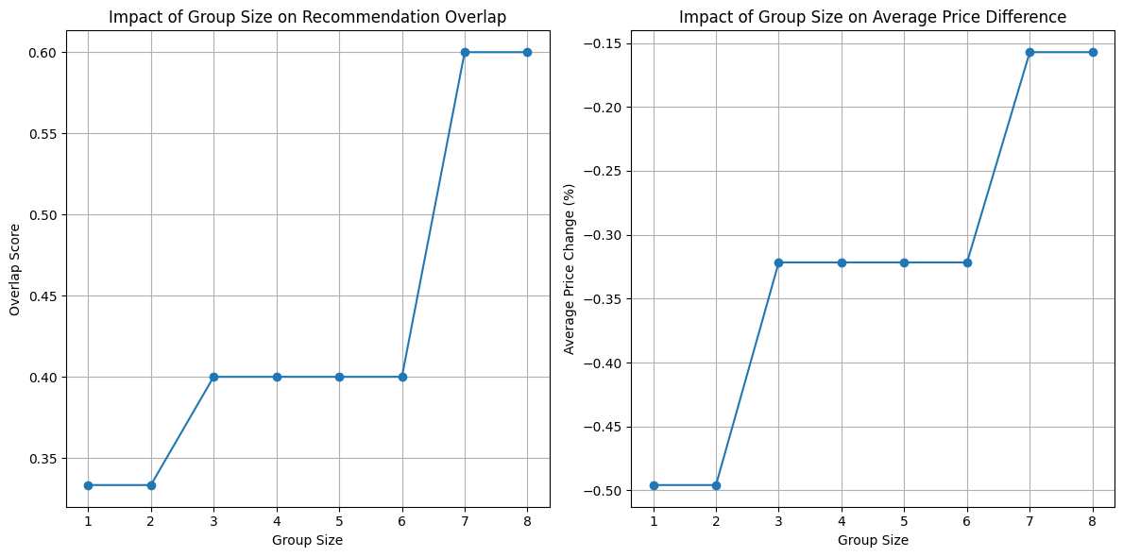
Figure 2 Impact of Group Size on Recommendation Performance (Left: Overlap Score vs. Group Size; Right: Average Price vs. Group Size)
The left plot illustrates that as group size increases, overlap scores tend to decline. Meanwhile, the right plot shows that the average price of recommended hotels also increases with group size—reflecting the system’s sensitivity to capacity requirements and its tendency to prioritize larger or more amenity-rich hotels for bigger groups.
To explore the potential for incorporating qualitative user input, a simulated sentiment scoring layer was introduced. While actual review data was not mined in this version, a set of manually assigned sentiment values was used to demonstrate how customer satisfaction signals could be embedded into the ranking algorithm. These scores, as listed in Table 3, represent approximations of review sentiment extracted from descriptive feedback.

Table 3 Simulated Sentiment Scores for Selected Hotels
Hotel | Sentiment Score
The Sultran Hotel and Residence Jakarta | 0.910
Hotel Borobudur Jakarta | 0.846
Sheraton Grand Jakarta Gandaria City Hotel | 0.955
Gran Melia Jakarta | 1.000
Holiday Inn Express Jakarta Wahid Hasyim | 0.837

These preliminary findings suggest that sentiment-based ranking augmentation has the potential to enhance personalization by reflecting user satisfaction derived from textual reviews. In future work, these simulated values could be replaced with sentiment scores automatically extracted using Natural Language Processing (NLP) techniques applied to hotel reviews.
Lastly, the system’s outputs were deployed in a web-based user interface supporting three recommendation modes: basic content-based, group-based, and advanced group-aware with demographic composition. Figures 3, 4, and 5 illustrate each mode respectively, capturing the real-time output displayed to users based on varying input parameters.

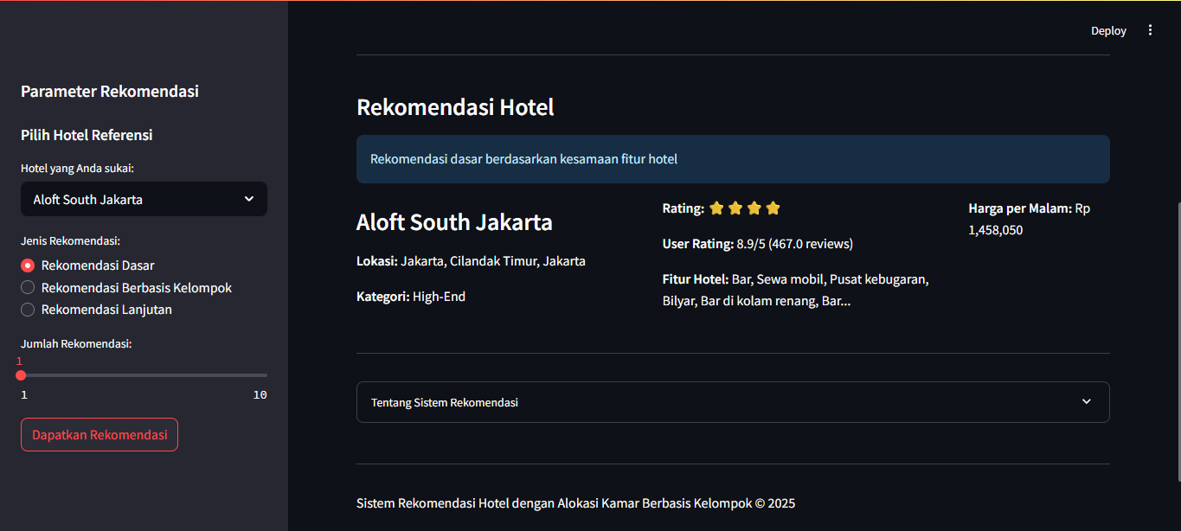
Figure 3 Output of Basic Content-Based Recommendation Mode
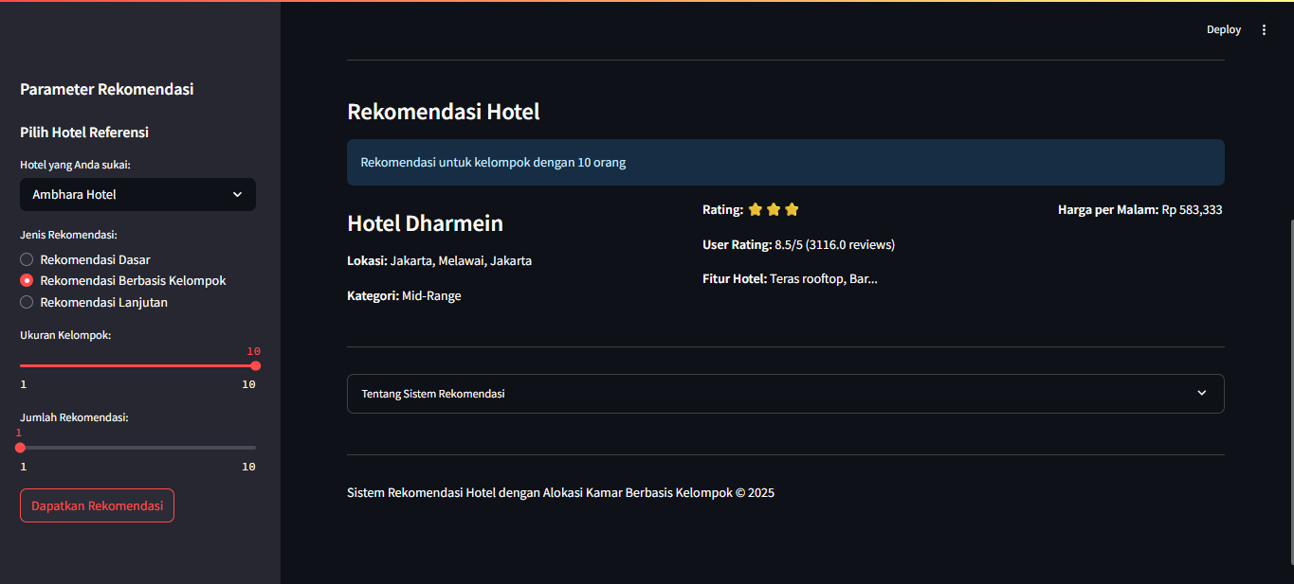
Figure 4 Output of Group-Based Recommendation Mode
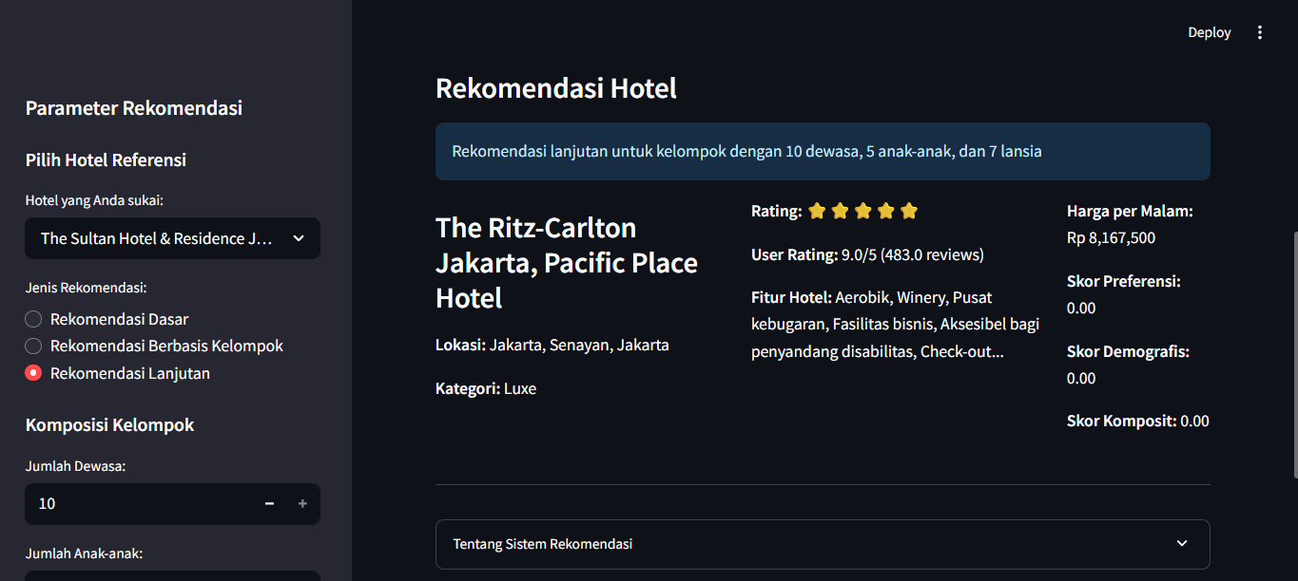
Figure 5 Output of Advanced Group-Aware Recommendation with Demographic Composition
In summary, the evaluation demonstrates that the proposed system effectively adapts to group composition, balances relevance and feasibility, and is extensible with qualitative feedback mechanisms such as sentiment analysis and preference weighting—making it a practical solution for group-oriented hotel recommendation scenarios.
- Conslusion
This study proposed a hotel recommendation system that integrates Content-Based Filtering using TF-IDF and cosine similarity with a group-based room allocation mechanism. By considering group sizes, room capacity, and the availability of alternative hotel options, the system provides a more contextual and user-centric recommendation experience. The experimental results demonstrate that incorporating group accommodation constraints improves the practicality and relevance of the recommendations. This contribution fills a significant gap in the literature where most hotel recommender systems focus solely on individual travelers. Future work may include integrating user sentiment analysis from reviews or expanding the system with hybrid filtering methods to further enhance personalization and accuracy.

Bibliography

