unpackme

* Try run it, we know that this challenge requires a number

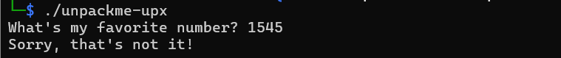

* It hints us about UPX, and the title is unpackme, so we guess this binary file is packed by UPX -> install it in kali linux

* Now, try decompress it

* We can observe that the file size increased from 379188 to 1006445 with ratio 37,68%
* Now, disassemble it, we have to look at cmp instruction which compare eax registers from scanf with the value 0xb83cb

* Convert 0xb83cb into decimalA screenshot of a computer

  Description automatically generated
* Run and pass this value



Flag: picoCTF{up><_m3_f7w_5769b54e}