StereoGene Version 2.13
User Manual
Contents
Introduction 2
Software availability 2
Source code and license 2
Input and output 3
How to run: an example 3
The calculation workflow 3
Preprocessing 3
Computing correlation 4
Results output 5
Advanced features 6
Partial correlation 6
Models as input data 6
Batch mode 6
Nucleosomes as a Confounder 6
Program Confounder 7
Program Projection 7
Analysis of gene features 9
Testing 10
Simple testing. 10
Description of parameters (arguments) 12
Standard Arguments 12
Procedure for setting the parameters. 12
Argument for file location. 12
Preparation phase arguments 12
Analysis phase 14
Custom kernel 14
Partial correlation. 14
Input files. 15
Comment line 15
Comprehensive list of parameters 15
Output files formats 19
*.bkg – Array of correlations of shuffled windows 19
*.fg – Correlations in coherent windows. 19
*.dist – Distances distribution (correlation function) for background, foreground, chromosomes. 19
*.bgraph – a bed graph file for local kerneled correlations 19
*.LChist – histogram of the local kerneled correlations distributions 20
*.spect – Average spectrum energy for tracks 20
*.chrom – chromosome statistics 20
Statistics – total statistics for all runs 21
Parameters – additional information: parameters 21
Statistics.xml 22
*.r – R script for plots drawing 22
*_report.r – R script for html report 23

Introduction
High throughput sequencing methods produce massive amounts of data. The most common first step in the interpretation of these data is to map the data to genomic intervals and then overlap with genome annotations. A major interest in computational genomics is a spatial genome-wide correlation among genomic features (e.g. between transcription and histone modification). The key hypothesis here is that features that are similarly distributed along a genome may be functionally related.
Here, we propose the StereoGene method that rapidly estimates genomewide correlation of two genomic annotations. The method enables correlation of continuous data so that the loss of data that occurs upon reduction to intervals is unnecessary. To include analysis of nonoverlapping but spatially related features, we use kernel correlation. Another novel powerful feature of our approach is the local correlation track output that enables overlap with other correlations (correlation of correlations).

Software availability
The StereoGene C++ source code, program documentation, Galaxy integration scrips and examples are available at the project homepage at http://stereogene.bioinf.fbb.msu.ru/ and at the github repository https://github.com/favorov/stereogene.

The repository includes four folders:
- src is the source folder
- www contains a fresh copy of the project web page
- galaxy contains the stub files for Galaxy (https://galaxyproject.org/) integration
- example is a set of files for a minimalistic run

Source code and license
The software is provided in a form of C++ source code with a makefile for GCC compiler. The code was tested both with 4 and 5 versions of GCC. After cloning or downloading and unpacking the source, say command ‘make’ from the shell in the source folder.
Our source code is covered by MIT artistic license. We use FFT code by Jens Jorgen Nielsen, its license is shown in the mixfft.c source file.

Input and output
The program reads standard (bed, wigg, etc) formats for the features to be correlated and a tab-delimited text file with chromosome name and its length pairs on each line as the chromosome length file. The output is a set of text files. A pair of them (statistics and parameters) is a report that grows line-by-line with each StereoGene start in the current working folder. Others are text files that correspond to a naming scheme (see below) that allow batch post-processing. If requested (by Rscript parameter), StereoGene generates R script and an R markdown template that generate a report in human-readable form. The R itself is not run by the program, it is supposed to be done by the user.

How to run: an example
StereoGene has a lot of parameters that modify the software behavior. Still, all of them has reasonable defaults, actually a run requires two track files and a file with chromosome lengths. The example below is started from the example folder. First, copy (link) the StereoGene executable to the example folder. Then, in a shell prompt, say:
./StereoGene chrom=chromLength H3K4me1.bed H3K4me1.bed
There are more examples or run is example.sh and example-cnf.sh files in the example folder.
In short words, the chrom is the only necessary parameter, the name of the chromosome length file. Any parameter can be shown in ‘par=value’ form or in ‘-par value’ as a command-line switch, or as par=value line in the configuration file. The configuration file is referenced to by -cnf command-line parameter. Important parameters are introduced in the introduction of parameters below. All the parameters are described in the ‘comprehensive list of parameters’ table below.

The calculation workflow
Being started, the software first pre-processes the input data and then it executes the requested calculations. The pre-processing step results are saved to save time. The next runs of StereoGene on the same track can reuse the pre-processing results.

Preprocessing
The input is read from the track text file in one of the standard formats for genomic tracks (BED, WIG, bedGraph, and broadPeak) and then it is converted into a proprietary binary format file for correlation analysis. The conversion averages all the input profiles in small tiling windows (bins) defined in the bin parameter. The values are scaled to an integer value [0..250] to fit into a single byte. The scaling can be either linear (y=ax) or logarithmic (y=a log (1+scaleFactor * x)). The scaling mode is either set by the scale parameter or chosen automatically (recommended) between linear and logarithmic by the input data analysis.
The software allows users to refer to specific properties of specific data types. For example, for genes the user can additionally specify what elements of annotation are to be used, intron, exons, gene or intron starts (intervals parameter). Moreover, the user can specify whether to use or not the strand information. The BroadPeak format standard defines a list of possible values for each nucleotide position, and the user can specify which of this BroadPeak data types are to be used (bpType parameter).
The software allows to users to combine several input tracks in a linear combination and use the results of the linear model as one of the tracks used for correlation analysis.

Computing correlation
Instead of correlating the whole genome, we calculate the correlation of the preprocessed tracks within large windows of fixed size (~1,000,000 bp). The size of these windows is specified in two input parameters (wSize and wStep). In these parameters, wSize is the width of the window and wStep is the distance between starting coordinates of each window. If wSize equals to wStep (default), the windows are tiling and do not overlap. The windows are smaller than whole chromosomes to increase the efficiency and to obtain a distribution of values from which to estimate correlation p-values. wSize is a technical parameter. If it is too large, there are too few windows for a statistical estimate and the program is too slow, still, if wSize is too low, we get a very wide variety of local correlation measure instead of a common, whole-genome correlation. We recommend using wSize = wStep = 100k..1M.
The data on the input tracks are routinely are gapped. Some wig files carry zeros. They also contain genomic regions not covered with data. There are several ways to interpret this missing data. The coverage of an area could actually be unknown, for example, because of a mapping problem. On the other hand, the level could really be 0. Provided how do we interpret the empty areas (NA parameter) either we write zeroes into these areas or we cover them with random values defined by noiseLevel parameter. The data that is written to the profile is defined by formula x=Norm(e, noiseLevel*sd), where Norm – is a random normally distributed value, e, sd – mean and standard deviation of the input data. If the input data is highly sparse, there appear the windows that contain only 0 or NA values. The correlation in these windows is undefined, hence the program ignores them. There are parameters (maxZero, maxNA) that define which windows are to be treated as noninformative.
If the DNA strand is known, complFg parameter shows whether the information is accounted for in the correlation. The finite size of windows could cause marginal effects, to avoid them, the user can ask the program to add random-signal flanks to each window (flankSize parameter). Still, our experience shows that the flanks have minimal influence on the correlation for large window sizes (e.g. the default 100,000 bp).
It is challenging to analytically estimate the null distribution of the correlation coefficients that accounts for dependencies of all features in the neighboring positions of the genome. We use a permutation to test the statistical reliability of the result. To do this, we randomly sample pairs of windows, first from one track, second from the other, and assess the correlation value for each pair. The number of sampled pairs is defined by parameter nShuffle.
Another usecase to compare the result with a null model in the case when we work with coverage tracks that are supplied with the input track for control is to calculate the concordant window pairs correlation distribution (foreground distribution) for a pair of features (tracks) and to compare it with the same distribution for a feature and the input of other feature or with the distribution for input-to-input comparison. In this case, the background calculation is for all the runs is switched off by the corrOnly=ON switch.

Results output
The main results of the program are the foreground Kernel Correlation (KC) for coherent windows, the background KC over the shuffled windows (null distribution), and the p-value for the difference in the distribution between the foreground and background KC. Each value in foreground and background distribution is a correlation (real value in [-1..1] band) of the two features in a pair of windows, coherent for foreground or randomly sampled for background. The program reports the total correlation as well, it is the average correlation over the coherent windows.
The program provides a variety of additional result output types. First, the details of each of the run of StereoGene is saved into two files: params and statistics. Each run has a unique id, which hashes the parameters and the time of the start. A single run appends a line to the params and statistics. Each line starts with the run id. The results also can be written as XML to statistics.xml file if it is required by the outRes parameter. We append to the files rather than rewriting to make the batch runs simpler.
The set of the output files is defined by several input parameters. The outDistr parameter outputs the distribution of the KC values when setting ON (default) or excludes them when setting OFF to *.dist file. The outDistr= OFF mode is useful when the user needs only the correlation values, one number per comparison. Distances specify that the program to output cross-correlation function (CCF) between input tracks computed chromosome-wise (DETAIL), the common CCF (TOTAL), or not to output it (NONE) to *.dist file. Rscript writes an R script that prepares the report with plots and results included when setting ON into *.r file. asks to output local correlations in a wig track and the local correlations distribution to a text file.

Advanced features
There are a variety of additional options that the program can be run with in addition to the standard options described above. One can switch off the permutation-based background calculation by the setting the corrOnly parameter from its default value of OFF to ON . This option can be useful to reduce computational cost if only the correlation estimation is of the interest (e.g. in a batch multi-sample run preparing a distance matrix) or if the user wants to use another foreground distribution as a background for current run, e.g. to compare the correlations of a feature with signal of some NGS experiment and its correlation with the input of the same experiment.

Partial correlation
The two-track correlation can be calculated in a space that is orthogonal to some third track. In other words, partial correlation of two tracks conditional the third is calculated. This usecase is to remove a confounder, which is represented by the third track, from the data correlation. The third track data is provided in the same way as the two correlated tracks.

Models as input data
The model is a combination of the tracks defined by a formula. Instead of each track data, a model can be used.

Batch mode
For batch mode, lists of tracks can be specified as the two input parameters for tracks and all the calculation will be run for each pair of a track from first and second lists of tracks.

Nucleosomes as a Confounder
On analysis the epigenomic marks, one can see an overrepresentation of positive correlations. This phenomenon reflects strong nucleosome positioning. To decrease this bias we use the following procedure. 1. We calculate all-against-all (non-kerneled) covariations. 2. We find the first eigenvector – this is a combination of the input track that represents a confounder. 3. We use partial correlation approach – we calculate the kernelled correlation for tracks for projections on subspace orthogonal to the confounder track.

Program Confounder
The program takes as input set of tracks. As usually it may be defined as a list of files or the files can be enumerated in the command line. The program 'confounder' calculates a covariation matrix and finds the first eigenvector for this matrix. The covariation matrix, eigenvectors, and eigenvalues are presented in the file '*.cvr' in the working directory. Example of the .cvr file:
H3K18ac.LL321.wig H3K36m3.LL160.wig H3K27ac.LL313.wig H3K27m3.LL314.wig H3K4m1.LL311.wig H3K4m3.LL312.wig
H3K18ac.LL321.wig 1.3811 0.4401 1.8043 1.5606 0.6713 4.1672 1.6933 0.7876 2.7330
H3K36m3.LL160.wig 0.4401 1.9544 0.5828 0.7424 0.2640 0.6892 0.8751 1.4842 1.0102
H3K27ac.LL313.wig 1.8043 0.5828 3.2405 0.9840 0.8175 10.0687 2.3071 0.8576 4.1945
H3K27m3.LL314.wig 1.5606 0.7424 0.9840 16.8083 0.8319 4.8891 2.0219 1.8389 1.5586
H3K4m1.LL311.wig 0.6713 0.2640 0.8175 0.8319 0.4825 0.9627 0.7028 0.4096 1.3416
H3K4m3.LL312.wig 4.1672 0.6892 10.0687 4.8891 0.9627 39.8395 9.4113 1.2574 9.5512
H3K9ac.LL240.wig 1.6933 0.8751 2.3071 2.0219 0.7028 9.4113 4.2219 1.6883 3.1178
H3K9m3.LL218.wig 0.7876 1.4842 0.8576 1.8389 0.4096 1.2574 1.6883 9.7084 1.5734
H4K5ac.LL323.wig 2.7330 1.0102 4.1945 1.5586 1.3416 9.5512 3.1178 1.5734 6.7601
eigenVectors
0.115 0.053 0.085 -0.303 -0.038 -0.165 0.488 0.269 -0.738
0.031 0.065 0.178 -0.123 -0.551 0.797 0.010 0.089 -0.030
0.237 -0.057 0.079 -0.251 0.223 0.179 0.390 -0.796 0.061
0.176 0.940 -0.281 0.003 0.051 0.020 -0.037 -0.041 0.015
0.037 0.044 0.057 -0.218 -0.032 -0.100 0.589 0.389 0.661
0.881 -0.209 -0.149 0.323 0.077 0.098 -0.019 0.195 0.005
0.229 0.031 0.129 -0.048 -0.748 -0.531 -0.084 -0.271 0.076
0.065 0.243 0.884 0.345 0.182 -0.044 0.005 0.024 0.000
0.255 -0.002 0.228 -0.746 0.207 -0.039 -0.504 0.143 0.090
eigenValues
49.44360; 16.37786; 10.04123; 5.16612; 1.91869; 1.35024; 0.25728; -0.24223; 0.08389;
Then the program produces a confounder profile as a linear combination of the input profiles with weights were taken from the first eigenvector. The name of the confounder track is defined by the parameter 'confounder'. This parameter should be used without extension. The profile is written as a bed-graph file and as binary profiles for the following use.

Program Projection
This program calculates the projection of the input files to subspace orthogonal to the confounder profile. The confounder profile should be defined by a parameter 'confounder'. The filename in this parameter should be given without extension but the confounder profile should have the extension '.bgraph'. If the confounder was defined by the program confounder all the rules will be satisfied automatically.
The program produces the bed-graph files and binary profiles. The bed-graph output can be switched off using the parameter outPrjBGr=0. The location of these files defined by the rule:
<path for projection bed-graph files>=<trackPath>/<confounder_name.proj>
<path for projection binary profiles>=<profilePath>/<confounder_name.proj>
The program produces also a new cfg file with paths to these files: <confounder_name.cfg>. The new configuration file contains a reference to the old configuration. Example:
cfg=sg.cfg
trackPath=H1/cnf.proj
profPath=H1/profiles/cnf.proj
resPath=H1/res/cnf.proj
This configuration file can be used for calculation of the correlations of the projections. The program also produces a log file 'projections' that contains the following information: track name, min, max, and mean values on the projection files and a coefficient Z that was used for calculating of the projection:
projTrack=input – confounder * (input,confounder)/(confounder,confounder)=input – confounder*Z
Example of file 'projections' :
confounder=<cnf>
track min max e proj_coeff
<H3K18ac.LL321.wig> -23.799593 106.205428 0.431067 0.117623
<H3K36m3.LL160.wig> -10.730125 78.813723 0.538846 0.044828
<H3K27ac.LL313.wig> -39.421706 86.037206 0.261490 0.216654
<H3K27m3.LL314.wig> -55.651868 197.948620 0.505580 0.209306
<H3K4m1.LL311.wig> -4.940504 22.137996 0.281699 0.020346
<H3K4m3.LL312.wig> -138.932810 44.508238 -0.915253 0.798433
<H3K9ac.LL240.wig> -50.752137 214.143605 0.607753 0.256185
<H3K9m3.LL218.wig> -32.892473 331.902264 1.163738 0.120257
<H4K5ac.LL323.wig> -52.687797 102.294034 0.681517 0.297623

Program Binning
The program takes input track(s) and produces binned output track(s). Output tracks have bedGraph format. The name of the output is formed using the input name by adding binsize: <output>=<input>_<binsize>. Usage:
$binning <input_track> bin=1000

Program Smoother
The program takes input track(s) and produces smoothed output track(s) using defined kernel. The name of the output is formed using the input name by adding “_sm”: <output>=<input>_sm. Usage:
$smoother <input_track> kernelSigma=10000

Analysis of gene features
A program 'parse_genes' produces bed files for genes/exons/introns starts/bodies/ends. The program takes as input RefSeq bed-file or GENCODE gtf-file.
The program produces a set of the bed files:
genes_refSeq_gene.bed | Gene bodies
genes_refSeq_g_beg.bed | Gene starts
genes_refSeq_g_end.bed | Gene ends
genes_refSeq_exn.bed | Exon bodies
genes_refSeq_e_beg.bed | Exon starts
genes_refSeq_e_end.bed | Exon ends
genes_refSeq_ivs.bed | Intron bodies
genes_refSeq_i_beg.bed | Intron starts
genes_refSeq_i_end.bed | Intron ends

On parsing GENCODE gtf-files user can define the parameter pgLevel – minimal GENCODE confidence level (1..3) to be taken into account (the default value =2).

Testing

Simple testing.
The software was intensively tested on the different simulated datasets for validation. To demonstrate how the program works we created three test wig-files with following data:
sin.wig: x=500*(1+sin(pos/10000.));
msin.wig=500*(1-sin(pos/10000.));
cos.wig=500*(1+cos(pos/10000.)).
The test genome length were L=100M, Kernel width=1000, wSize=50k. We got following correlations:
Profile | expected | observed
sin.wig~sin.wig | 1 | 1
sin.wig~cos.wig | 0 | 0.00054
sin.wig~msin.wig | -1 | -0.99

Kernel width. To show the influence of the Kernel width on the program result we run StereoGene for the Fetal brain h3k27me3 vs gene starts from RefSeq annotation. The results are presented in the following Table 1. The dependence of the Kernel width is obvious.

Table 1. Fetal Brain H3K4me3 vs gene-starts. Widow size=1Mb

Kernel width, bp | total KC | average-KC | p-val
10 | 0.07 | 0.09 | 0
100 | 0.11 | 0.12 | 0
1000 | 0.36 | 0.42 | 0

Window size. To understand the dependence of the results on the window size we run the program for Fetal Brain H3K4me3 vs Fetal Brain H3K4me1 with different window sizes. When the window size became greater than 30k the total KC does not change. The average KC changes slightly after the window size became greater than 100k. The foreground and background distributions of KC over the windows became more narrow when the window size increases. If small windows are used, a variety of properties of the windows becomes large and the distributions became wide. The recommended window size is wSize>100k. But if the data are very sparse the number of significant non-zero windows may become small to get appropriate statistics. In this case, a smaller window size recommended.
Table 2. Dependence of the results on the window size for Fetal Brain H3K4me3 vs Fetal Brain H3K4me1: Kernel width=1000 bp
Window | total KC | av-KC | p-val | time*, s | Distributions of KC over the windows
10000 | 0.2870 | 0.169 | 0** | 10.1 | 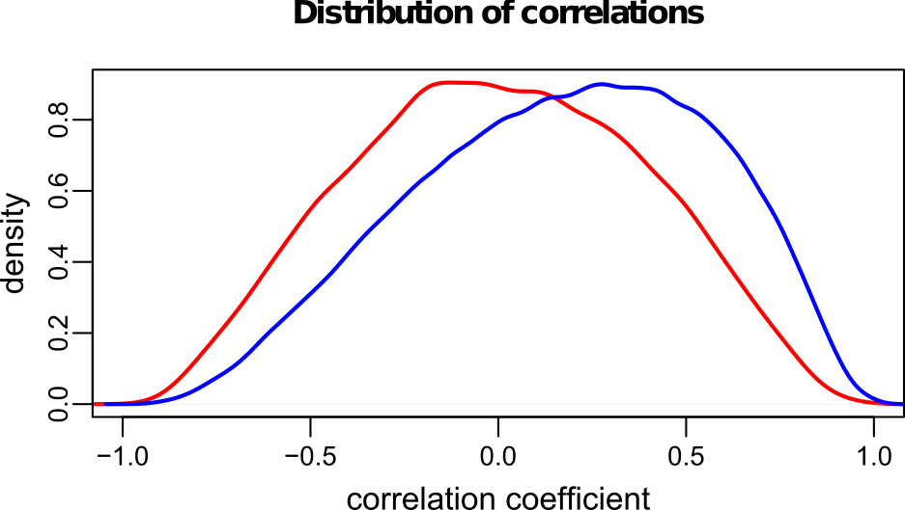
30000 | 0.2803 | 0.242 | 0 | 11.2 | 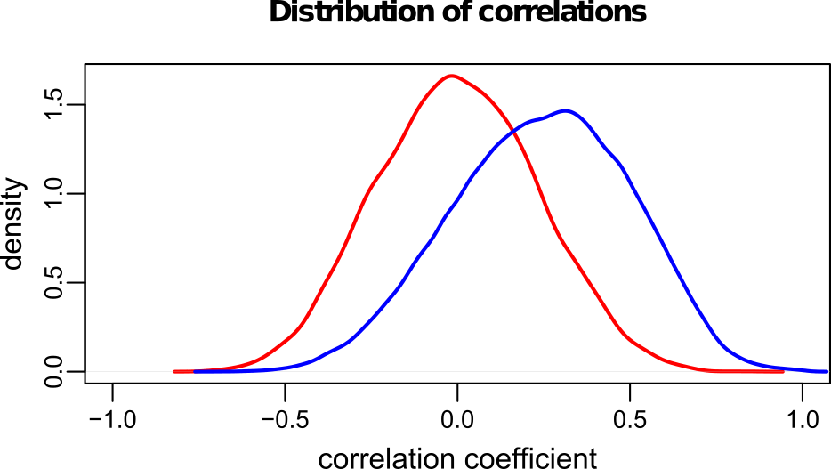
100000 | 0.2725 | 0.302 | 0 | 13.3 | 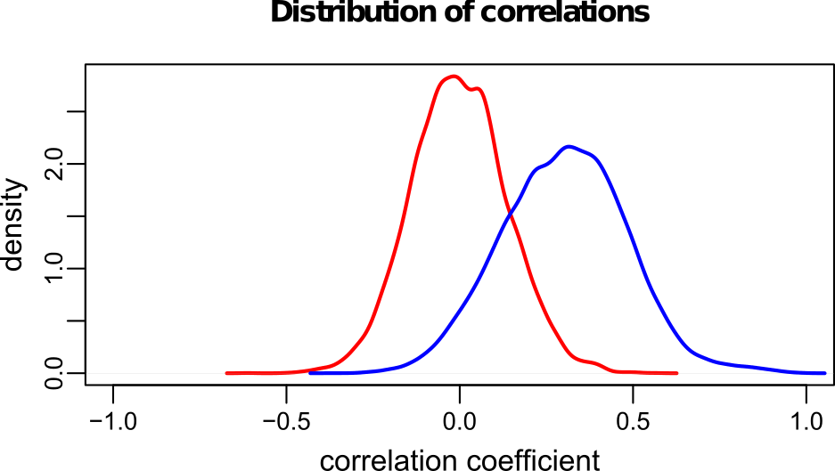
300000 | 0.2659 | 0.339 | 0 | 14.6 | 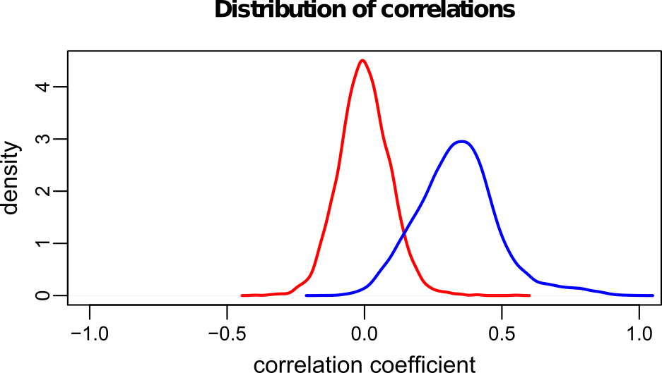
1000000 | 0.2588 | 0.372 | 0 | 15.5 | 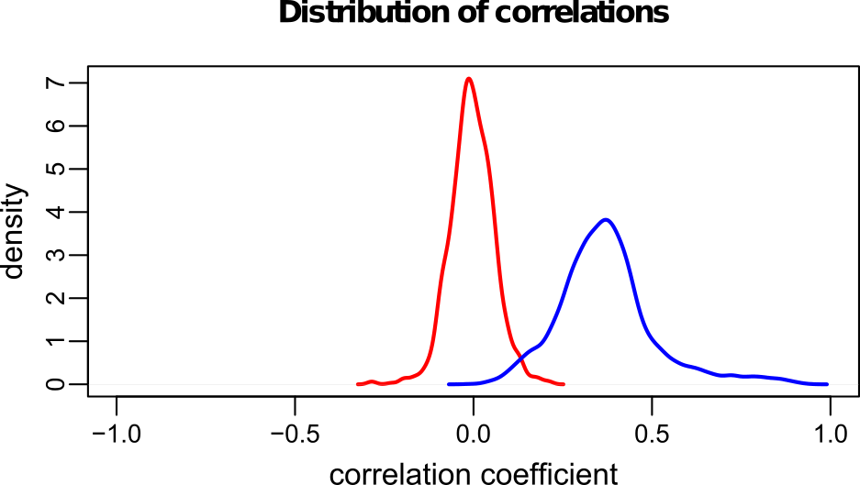
*without preprocessing
** p-value of 0 actually means that p-value is lower that the precision; still we did not change it in output for the sake of parsing

Description of parameters (arguments)

Standard Arguments

Procedure for setting the parameters.
The parameters are passed to the program by a command line. The parameter can be defined as paramName=value no space character allowed
or as
-paramName value
For convenience, the parameters can be defined in a configuration file. The reference to the cfg file can be defined in the command line attribute cfg=<fname>. The program can take as an input multiple configuration files. In this case parsing the command line parameters will be determined in the following order:
<config1 <config2 <... <Command_line
the parameter value can be overridden by configuration files in the order of the command line. Finally, the parameter can be overridden on the command line.
Example of a command line (parameters definition with '=')
$./StereoGene B_G.H3K4me1.wig B_G.H3K4me3.wig chrom=a.sizes log=sgLog -v
Or equivalent command line
$./StereoGene B_G.H3K4me1.wig B_G.H3K4me3.wig -chrom a.sizes -log sgLog -v

Argument for file location.
You can specify the path for input and output files. In this case, the file will be added to the appropriate paths. It is assumed that the source files of the tracks are in one directory, binary profiles - in the other, the resulting files - in the third.

Preparation phase arguments
On the preparation phase, the program reads the source files in BED, WIG, bedGraph, broadPeak formats and convert the data into a universal binary format. The binary profile contains two files:
*.bprof | the binary data
*.prm | text file with additional supporting data important for the data decoding. Do not edit these files!
The binary representation of the data (binary profile) store the score values into one byte. 2) The track data are averaged with given small window (parameter bin, usually bin =100 bp).
Input data. The data type is defined by the filename extension automatically. If using the track file and the track definition line in the track file exists, it will define the type of the track.
Valid extensions and their interpretation (extensions are interpreted case-insensitive):
BED | BED format
WIG | WIG format
BEDGRAPH  BED_GRAPH  B_GRAPH  BGR | Bed Graph format
BROADPEAK  BROAD_PEAK  B_PEAK  BPEAK | ENCODE BroadPeak format
MODEL  MOD | A model (see model description)
The initial data can be interval (e.g., genes), or functional (e.g., the coverage level). For the interval data the parameter intervals can be defined. If this parameter is defined the program will ignore the score field in the bed or bedgraph tracks and the scores value will be set to 1. Otherwise the data from the score field will be used.
Gene RefSeq track contains information about strand and exon-intron structure. On the preparation phase, the program is able to produce the binary profile for entire genes or for exons, introns, gene starts etc. The selection of the feature that will be converted into the binary file is defined by special parameter (see parameters description).
Model track. The program can take not only single track file but a combination of the tracks – a Model. The model is defined in the model file (*.mod or *.model). The file contains a formula for the model track calculation. Each track should be taken in the square brackets ([track_name]). The track in the model is a function of the position. The track term in the model can be defined as a function of position explicitly, like [K4me3](x+1000) or implicitly [K4me3] that means [K4me3](x). The User can use arithmetic operations and functions (log, exp, sqtr, sin, cos, tan, atan, abs, sign). The internal variables also can be used. The variable 'x' means absolute position on the genome. An Example of the model description:
K27=[H3K27m3.LL314.wig];
K4=[H3K4m3.LL312.wig](x+1000);
K27*K4;
Here K27 and K4 are internal variables; x – genome position. The formula can be presented in a single line as well in multiple lines. This model is equivalent to the following model:
[H3K27m3.LL314.wig](x) * [H3K4m3.LL312.wig](x+1000)
Enother example of the model that uses profile binarization with the threshold 20:
K4=[H3K4m3.LL312.wig];
1+sign(K4-20)
Usage of the model decreases program speed about twice.
Chromosome file – Chromosome file genome – file with chromosome lengths. This file can be downloaded from UCSC Genome Browser website. As an example, we provide the chromosome length file (chromLength file in the src folder) for Human Genome hg19.

Analysis phase
During the analysis phase, the program compares two tracks. It calculates the kerneled correlation in pairs of windows of given size (parameter wSize, default wSize=100000). On the first step, the program selects random independent windows in two profiles and produces a background distribution of correlation. Then the program analyses coherent pairs with the sliding window and calculates the correlation (foreground distribution). Statistical significance is calculated using Mann-Whitney test. The program produces following files (depending on output parameters):
*.bkg | Background distribution for correlation function (shuffled frames).
*.fg | Foreground distribution for correlation function (coherent frames).
*.bkg | The background distribution of genome distances between the profiles
*.fg | The Foreground distribution of genome distances between the profiles
*.dist | Distance distributions (cross-correlation function)
*.bpeak | File in BroadPeak format, that containes significal frames. pVal and qVal are thresholds.
*.wig | Standard wig-file with Local Correlations
*.LChist | Histogram for the distributions of the Local Correlation
*.r | R script for visualization of the results
*.spect | Average spectrum density
*.chrom | Statistics for chromosomes – average input signal values for the tracks and average window correlation.
statistics | Summary file with the results. For each run it contains: the names of the source files, the name for the resulting file, the parameters of the Mann-Whitney statistics .
parameters | Summary file with the parameters of runs. Correspondence with the statistics is established using id.
log | a log-file

Custom kernel
The user can define an own kernel function by parameter customKern. The user can put here any expression containing arithmetic operations and standard functions: {sin, cos, tan, exp, log, sqrt, abs, sign}. Two variables are predefined by the apropriate parameters e, sigma. A formula can contain some expression that defines internal variables. These expressions should be separated by ';'.
example1: Gaussian kernel
customKern="y=(x-e)/sigma; exp(-y*y)"
Here: customKern – the custom kernel parameter name; y – an internal variable that is used for calculation of the formula; e, sigma – the external variables that are defined by the parameters kernelShift, kernelSigma. The expression without character '=' will be used as a result.
example2: Mix of two Gauss
customKern="y1=(x-e)/sigma; sgm=sigma*2; y2=(x+e)/sgm; exp(-y1*y1)/sigma+exp(-y2*y2)/sgm"
Important! If a config file is used the entire declaration should be placed to a single line.

Partial correlation.
The program can calculate the correlation of the tracks projection on the space orthogonal to the third track (pcorProfile=<fname>).

Input files.
- Chromosome file genome – file with chromosome lengths. This file can be downloaded from UCSC Genome Browser website. We provide a chromosome file for Human Genome hg19.
- Track files. This can be BED, WIG, BED_GRAPH or BROADPEAK tracks. Type of track can be automatically recognized following extensions (case insensitive): BED, WIG, BEDGRAPH, BED_GRAPH, B_GRAPH, BGR, B_PEAK, BPEAK, BROAD_PEAK, BROADPEAK. If the filename starts with '_' the derivative of the profile will be used.
- File list (extension = LIST or LST) – just list of input files. Every file name should be typed on separate line.
- Model – Linear combination of the profiles (extension = MODEL or MOD or MDL).
The program will compare every Track with every Track. Tracks from the same list are not subject of comparison. If more than two input files are defined the program will work with all pairs of Tracks.

Comment line
In all input files and in the configuration file the character '#' means comment and lines started with this symbol will be ignored.

Comprehensive list of parameters
Parameter
 | Paths
trackPath=<path> | Path to the input tracks
profPath=<path> | Path to profiles
resPath=<path> | Path to the result files
 | File names
<fname> | Input file. The name of the appropriate path is added - trackPath. The Program can take up to 256 input files and calculate the correlation for every pair of the tracks. | mandatory
chrom=<fname> | Input file with names of chromosomes and their lengths (can ne downloaded from the Genome browser), the parameter can be set in the config file or in the command line or as an environment variable SG_CHROM. | mandatory
cfg=<fname> | Config file. It is possible to use more then one cfg-files. It is applied in order of appearance. Parameters defined in the command line overrides the parameters in the config file.
confounder=<fname> | The filename for confounder. | confounder
pcorProfile=<fname> | Profile for partial correlation. The name is completed with trackPath
statistics=<fname> | File with the cumulative statistic for all the programm runs. | ./statistics
params=<fname> | File for save the parameters for all the programm runs | ./params
aliases=<fname> | File with aliases for brief track names. The format of file is:  Old_name_fragment=new_name_fragment . For example:  UCSF-UBC.=  Adult_Liver=AL  Brain_Germinal_Matrix=BGM
log=<fname> | Log-file name. To toggle log output OFF use empty name for the log file. If the user starts the log-file name with '$' the '$' character will be replaced by the current output filename. Example:  log=$.log | ./stereogene.log
id_suff=<suffix> | Suffix that will be added to the run ID
 | General
verbose=<ON|OFF> | The program workflow is printed to standard output | OFF
-v | Is used for command line only. Equivalent to verbose=ON
silent=<ON|OFF> | If ON the general results are not printed to stdout. | OFF
-s | Is used for command line only. Equivalent to silent=ON
syntax=<ON|OFF> | If this flag is set ON the program will terminate with error on wrong line in input profile; the line will be ignored otherwise | ON
-syntax | Is used for command line only. Equivalent to syntax=OFF
NA=<0 | 1> | The way to treat uncertain values. If flag is 0, then uncertain (not covered with profile) values are considered as 0. Otherwise it is filled by a random noise (see noiseLevel parameter). This fag has a sense only for WIG tracks. For other track types this flag is ignored and uncertain values are considered as 0. | 0
-na | Is used in command line only. Is equal to NA=1
BufSize | Size of the buffer in swap-file-arrays | 1000000
 | "Preparation" mode
clear=<0 | 1> | Force profile preparation | 0
-c | Is used in command line only. Is equal to clear=1
bin=< num > | bin for sliding frame. Optional. | 100
lAauto=< num > | The maximum distance (kilobases) to calculate the autocorrelation. The autocorrelation function is written to a file *. Acf. If lAauto = 0, the autocorrelation is not considered. | 0
bpType=<SCORE  |SIGNAL  |LOGPVAL> | The value used as a score for BroadPeak format – column Score, Signal, or pval | SCORE
 | "Analysis" mode
wSize=< num > | Frame size (in nucleotides) | 100000
wStep=< num > | Frame step (in nucleotides) | 100000
kernelType=< NORMAL | LEFT_EXP  | RIGHT_EXP > | Kernel type:  NORMAL – Normal  LEFT_EXP – left exponent  RIGHT_EXP – right exponent | NORMAL
customKern=  <expression> | An expression that defines the kernel function. See the section Custom Kernel. If the custom kernel defined the prameter kernelType will be ignored.
KernelSigma=< num > | Kernel span (in nucleotides) | 1000
kernelShift=< num > | Kernel mean (for Gauss) or Kernel start for exponent | 0
kernelNS=< num > | Kernel correction for non-specificity in zero position, %. The kernel values in the interval [-100,100] will be multiplied by (1- kernelNS) | 0
complFg=< COLLINEAR | COMPLEMENT  | IGNORE_STRAND> | Flag:  IGNORE_STRAND – ignore strand;  COLLINEAR – compare collinear strands;  COMPLEMENT – compare opposed strands.  If the binary profiles are not separated by strand that works in IGNORE_STRAND | IGNORE_STRAND
flankSize=< num > | Size of added flanks (in nucleotides). Nesessary to avoid side effects. | 0
noiseLevel=< num > | Noise level used to fill flanks and uncertain values. The uncertain values is defined as rExp()∙sd∙noiseLevel, where rExp() – standard exponential random value, sd – standard deviation of track values. | 0.2
maxNA=< num > | Maximum fraction of uncertain values in a frame (in %). If at least one of the compared frames has maxNA (or more) of uncertain values, then the comparison is not applied. | 95
maxZero=< num > | Maximum fraction of zero values in a frame (in %). If at least one of the compared frames has maxZero (or more) of zero values, then the comparison is not applied. If parameter the takes 100, it is possible to get false peak for correlation value 1. | 95
nShuffle=< num > | Number of permutations to build the background distribution. | 10000
threshold=< num > | The threshold values for the binary profile. If the binary value is less than the threshold profile, it is replaced by 0.  0 < threshold < 256 | 0
corrOnly=<0|1> | Consider only the correlation function (without kernel and random permutations) | 0
LCFg=<BASE | CENTER> | Produce the local correlation with subtracting mean (CENTER) or not (BASE) | CENTER
-corr | Is used in command line only. Equal to corrOnly=1
 | Output definition parameters
outRes=<XML|TAB|  BOTH|NONE> | Output cumulative result and parameters:  XML – output in xml-like format  TAB - output in tabbed form  BOTH - output in both format  NONE – not output cumulative information | BOTH
outPrjBGr=<0|1> | Flag: write bed-graph files for Projections. | 1
outDistr=<0|1> | Flag: write foreground and background distributions into files *.fg, *.bkg | 1
outChrom=<0|1> | Write statistics by chromosomes (file *.fg) | 0
Distances=<0|1> | Flag: write Distance correlations (file *.dist)  If the parameter outChrom is ON the distance information will be given by chromosomes. | 1
Rscript=<0|1> | Write the script to the R to display the results. The name of the script file is generated from the output file name. There will be *.R and *_report.R generated, first to create pdf plot, second to create html report. The subsidiary file report_r_template.Rmd will be generated, if not exists. | 0
-r | Is used in command line only. Equals to Rscrpit=1
outLC=<0|1> | Flag: Write local kerneled correlations into a bedgraph file.  lc=∫g'ρ∙∫f'ρ, where f'=f-mean(f), g'=g-mean(g) | NONE
-lc | Is used in command line only. Equals to outLC=1
LCScale=<LIN|LOG> | Scaling for the Local Correlation output:  LIN – Use linear scaling to the interval (0..1000)  LOG – Use logarithmic scaling:  v = sign(w)*log(1+|w|) | LOG
L_FDR=<num> | Threshold for local kernel correlation FDR (not percent, but value) for low (usually negative) local correlations to be written into the local correlation file. | 0
R_FDR=<num> | Threshold for local kernel correlation FDR for high local correlations (not percent, but value) to be written into the local correlation file. | 0.5
outSpectr=<0|1> | Write average spectrum | 0
pgLevel=<1|2|3> | Minimal confidence level in the GENCODE gtf file | 2

Output files formats

*.bkg – Array of correlations of shuffled windows
0.320268
0.178365
-0.419948
-0.124017
0.298771
...

*.fg – Correlations in coherent windows.
Format:
Chromosome window_start window_end correlation
chr1 7500000 7500100 -0.093813
chr1 7750000 7750100 -0.531958
chr1 8000000 8000100 -0.425593
chr1 8250000 8250100 -0.479256
chr1 9750000 9750100 -0.466759
...

*.dist – Distances distribution (correlation function) for background, foreground, chromosomes.
Contains:
Distance (nucl)
Bkg – background correlation function
Fg – foreground correlation function
FgPlus – correlation function for positive windows
FgMinus – correlation function for negative windows
chr1,...– foreground correlation function for chromosomes (fields exist only if lag Distances=DETAIL)
Format:
Header
x, Bkg, Fg, FgPlus, FgMinus, chr1, …
x Bkg Fg FgPlus FgMinus chr1 chr2 chr3
-125000 -0.19 -0.78 -0.82 0.039 -0.98 -0.69 -0.70
-124900 -0.21 -0.84 -0.88 0.036 -1.06 -0.74 -0.717
...

*.bgraph – a bed graph file for local kerneled correlations
Format: Standard bed graph format (see Genome browser documentation). The file may contain a comment line that defines segments with no data. These segments appear when the source tracks contain no data here. The values can be positive and negative.
track type=bedGraph name="H3K27m3.LL314~H3K36m3.LL160" description="Local correlation"
#chr1 0 860800 ?
chr1 860800 860900 1.2
chr1 860900 861000 1.3
chr1 861000 861100 1.4
chr1 861100 861600 1.5
chr1 861600 861700 1.4
chr1 861700 861800 1.3
#chr1 861800 875400 ?
chr1 875400 875600 1.2
chr1 875800 876000 1.2 ...

*.LChist – histogram of the local kerneled correlations distributions
Contains:
General information about the foreground and background distributions and FDR evaluation.
min, max – minimal observed values
hMin, hMax, bin – minmimal and maximal boundaries for the histogram and the histogram bin. e0, sd0, n0, e1, sd1,n1 – mean, standard deviation and number of observations for observed and expected distributions
value | the normalized LC value
obs | the observed distribution density
nObs | the number of observation for given LC value
exp | the background LC distribution density.
nExp | the number of background observation for given LC value
r_CDF_obs | 1-cdf for the observed distribution
r_CDF_exp | 1-cdf for the background distribution
R_FDR | the right FDR reflects. Reflects unexpected large value
l_CDF_obs | cdf for the observed distribution
l_CDF_exp | cdf for the background distribution
L_FDR | the left FDR . Reflects unexpected small or negative values

# min=0.090 max=1000.000
# hMin=9.04e-002f hMax=1.48e+003f bin=2.958
# Observed: e0=0.012 sd0=2.012 n0=26259000
# Expected: e1=0.002 sd1=0.744 n1=9411001
value | obs | nObs | exp | nExp | r_CDF_obs | r_CDF_exp | R_FDR | l_CDF_obs | l_CDF_exp | L_FDR
-2.832 | 0.00e+000 | 0 | 1.21e-005 | 5 | 1.00e+000 | 1.00e+000 | 100.00 | 0.00e+000 | 5.00e-007 | 100.00
-2.790 | 0.00e+000 | 0 | 4.84e-006 | 2 | 1.00e+000 | 1.00e+000 | 100.00 | 0.00e+000 | 7.00e-007 | 100.00
-2.749 | 0.00e+000 | 0 | 4.84e-006 | 2 | 1.00e+000 | 1.00e+000 | 100.00 | 0.00e+000 | 9.00e-007 | 100.00
-2.708 | 0.00e+000 | 0 | 1.21e-005 | 5 | 1.00e+000 | 1.00e+000 | 100.00 | 0.00e+000 | 1.40e-006 | 100.00

*.spect – Average spectrum energy for tracks
Format:
Wave_length Spect_first_track Spect_second_track
41666.67 5.38019 5.60809
35714.29 4.88332 4.92231
31250.00 4.49339 4.501
27777.78 4.15111 4.06332
25000.00 3.85675 3.74989
...

*.chrom – chromosome statistics
Contains:
Chrom Chromosome name
track1_av Average signal in track1
track2_av Average signal in track2
cc Average correlation
count Number of non-zero windows
Format:
First_track_name
Second_track_name
Header
Chrom. track1_av track2_av
UCSF_UBC.Fetal_Brain.H3K27me3.HuFNSC01.wig
UCSF_UBC.Fetal_Brain.H3K36me3.HuFNSC01.wig
chrom av1 av2 cc count
chr1 1.51 1.69 -0.12 905
chr2 1.35 1.48 -0.07 957
chr3 1.32 1.46 -0.08 782
...

Statistics – total statistics for all runs
Contains:
id | Run ID
Date | Date/Time of the end of the run in format: 13.05.17 15:13:59
version | Progran version
name1 | Name of the first track
name2 | Name of the second track
nFgr | Number of foreground observations
nBkg | Number of background observations
Fg_Corr | Total coherent correlation
Fg_av_Corr | Average correlation for coherent windows
FgCorr_sd | Standard deviation of the correlation for coherent windows
Bg_Corr | Total correlation for shuffled windows
Bg_av_Corr | Average correlation for shuffled windows
BgCorr_sd | Standard deviation of the correlation for shuffled windows
Mann-Z | Man-Whitney Z-score
p-value | Man-Whitney p-value
kernelSigma | Kernel Width
wSize | Window size

Format:
Header
Information in tabbed format

Parameters – additional information: parameters
Contains:
id | Run ID
version | Progran version
bin | Bin size
profPath | Path to track files
trackPath | Path to the result files
resPath | Partial correlation profile
chrom
bpType | How to read broad_peak file – use signal, or score
pcorProfile | Confounder for partial correlation
NA | Flag: NA as 0
threshold | Threshold for track
kernelType | Kernel type
customKern | Custom kernel function
kernelSigma | Kernel width
kernelShift | Kernel shift
wSize | Window size
wStep | Window step
flankSize | Flank size
maxNA | Max number of possible NA in window
maxZero | Max number of possible zeros in window
nShuffle | Number of shuffles
noiseLevel | Noise level (how to fill NAs and flanks)
complFg | Complement flag: collinear or complement
LCFg | flag for the Local Correlation type: CENTER or BASE
outSpectr | Out spectrum
outChrom | Output by chromosomes
writeDistr | Write distributions
Rscript | Write R script
Distances | Write Cross-correlations
outLC | Write Local correlations
L_FDR | FDR for the low values in the local correlations
R_FDR | FDR for the high values in the local correlations
AutoCorr | Write auocorrelations
pdf | R script will produce a pdf output

Format:
Header
Information in tabbed format

Statistics.xml
An xml-like output for cumulative results and parameters.
<xml>
<run id="3fcf166d" Date="03.12.17 16:10:18" version="2.13">
<input name1="g_lincRNA_MN_locus_sm.bgr" name2="g_non_all_sm.bgr"/>
<res nFgr="1080" nBkg="2000" Fg_Corr="0.0929" Fg_av_Corr="0.317" FgCorr_sd="0.154" Bg_Corr="-1.33e-002" Bg_av_Corr="7.57e-004" BgCorr_sd="0.0816" Mann-Z="43.163" p-value="0.00e+000"/>
<prm bin="500" profPath="Gav2/profiles/" trackPath="Gav2/" resPath="Gav2/res/" chrom="human_chrom" bpType="SIGNAL" pcorProfile="back.bgr" NA="0" threshold="0" kernelType="NORMAL" customKern="NONE" kernelSigma="3e+003" kernelShift="0" wSize="2500000" wStep="2500000" flankSize="0" maxNA="1e+002" maxZero="1e+002" nShuffle="2000" noiseLevel="0.2" complFg="IGNORE_STRAND" LCFg="CENTER" outSpectr="0" outChrom="0" writeDistr="1" Rscript="1" Distances="1" outLC="0" L_FDR="0" R_FDR="0.5" AutoCorr="0" pdf="0" />
</run>
</xml>

*.r – R script for plots drawing
# Read the data

fg <- read.table('UCSF_UBC.Fetal_Brain.H3K27me3.HuFNSC01~UCSF_UBC.Fetal_Brain.H3K36me3.HuFNSC01.fg')
bkg<- read.table('UCSF_UBC.Fetal_Brain.H3K27me3.HuFNSC01~UCSF_UBC.Fetal_Brain.H3K36me3.HuFNSC01.bkg')
fgCorr <- read.table('UCSF_UBC.Fetal_Brain.H3K27me3.HuFNSC01~UCSF_UBC.Fetal_Brain.H3K36me3.HuFNSC01.fgCorr')
bgCorr <- read.table('UCSF_UBC.Fetal_Brain.H3K27me3.HuFNSC01~UCSF_UBC.Fetal_Brain.H3K36me3.HuFNSC01.bgCorr')

# Define plot limits

y_lim1 <- max(max(density(bkg[,1])$y),max(density(fg[,4])$y))
y_lim2 <- c(-8.42,6.34)
x_lim2 <- c(-125000,124900)

# set x scale to kilobases
fgCorr[[1]] <- fgCorr[[1]]/1000
bgCorr[[1]] <- bgCorr[[1]]/1000
x_lim2 <- x_lim2/1000

# create the plot

old.par <- par( no.readonly = TRUE )
par( mfrow = c( 2, 1 ), oma = c( 0.5, 0, 2, 0 ),mar=c(2.5,3,1.5,1),mgp=c(1,0.3,0))

plot(density(bkg[[1]]), xlim=c(-1,1), ylim=c(0, y_lim1), xlab='correlation coefficient',ylab='density',
col='red', main='Distribution of correlations',
cex.axis = 0.8, cex.lab = 0.8, cex.main = 0.8,lwd=2)

lines(density(fg[,4]), col='blue', lwd=2)

plot(fgCorr[[1]],fgCorr[[2]], type='l',col='blue', ylim=y_lim2, xlim=x_lim2,
main='Correlation function',xlab='Distance (kb)',ylab='%',cex.axis = 0.8, cex.lab = 0.8, cex.main = 0.8,lwd=2)
lines(fgCorr[[1]],fgCorr[[3]], col='cyan',lwd=2)
lines(fgCorr[[1]],fgCorr[[4]], col='brown',lwd=2)
lines(bgCorr, col='red',lwd=2)
title('UCSF_UBC.Fetal_Brain.H3K27me3.HuFNSC01\nUCSF_UBC.Fetal_Brain.H3K36me3.HuFNSC01',cex.main = 0.8, outer = TRUE)

par( old.par )

*_report.r – R script for html report
library("markdown")
args = commandArgs(TRUE)
fname1<-"UCSD.Lung.H3K4me3.STL002.wig"
fname2<-"UCSD.Lung.H3K27me3.STL002.wig"
pc_fname <- ""

if (length(args)>=2) {
#track names
fname1 <- args[1]
fname2 <- args[2]
}

if (length(args)==3){
#partial correlation track
pc_fname <- args[3]
}

rmarkdown::render("report_r_template.Rmd", "html_document",
params=list(
track1=fname1,
track2=fname2,
pc=pc_fname,
name="UCSD.Lung.H3K4me3.STL002~UCSD.Lung.H3K27me3.STL002",
window="200000",
kernel="N",
nFgr="14370",
nBkg="10000",
Bkg_av="0.0017",
Fg_av="0.4037",
Bkg_sd="0.1420",
Fg_sd="0.3226",
tot_cor="0.2405",
avCorr="0.4037",
Mann_Z="87.8536",
p_value="0.00e+00"
), output_file = file.path(getwd(), "UCSD.Lung.H3K4me3.STL002~UCSD.Lung.H3K27me3.STL002.html"))

