

INTERNAL AUDIT DEPARTMENT
CVM engagement
Q2 2026
Draft Report

Restricted

Table of Contents
1 Background 3
2 Objective and Scope 4
2.1 Objectives: 4
2.2 Scope: 4
2.3 Limitations of Internal Audit: 5
3 Acknowledgment 5
4 Audit Team 5
5 Risk Classification 6
6 Summary and Conclusion 7
6.1 Overall opinion 7
6.2 Audit Issues Dashboard 7
6.3 List of Audit Issues 8
7 Detailed Audit Issues 9
7.1 New Audit Issues 9
Appendixes 18

Background
The audit engagement covers the review of prepaid promotions administered through CVM (Campaign Management tools). This review focuses on the offer creation flow and associated fulfillment activities relating to these promotions. The audit was formally notified via correspondence from Ameera Haji to Mohamed Yusuf and Ahmed Hasan on February 5, 2026. The CVM modules enable targeted marketing campaigns and streamlined program execution for prepaid customer segments.
Revenue and fulfillment trends from October 2025 to January 2026 were analyzed for three offer types: Conditional, Notification, and UnConditional. These were extracted from the monthly performance sheet to identify variations in program uptake and financial outcomes. Conditional offers demonstrated variable revenue across the period, while Notification offers reported zero revenue and fulfillment. UnConditional offers maintained consistent revenue flow. The total fulfillment count indicated overall campaign reach and acceptance levels.
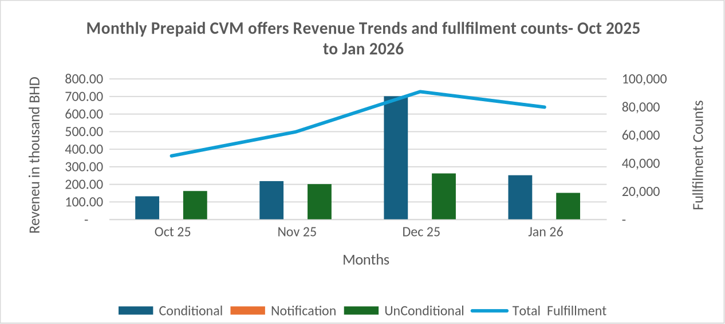
Figure 1: Monthly Prepaid CVM offers Revenue Trends and fullfilment counts- Oct 2025 to Jan 2026
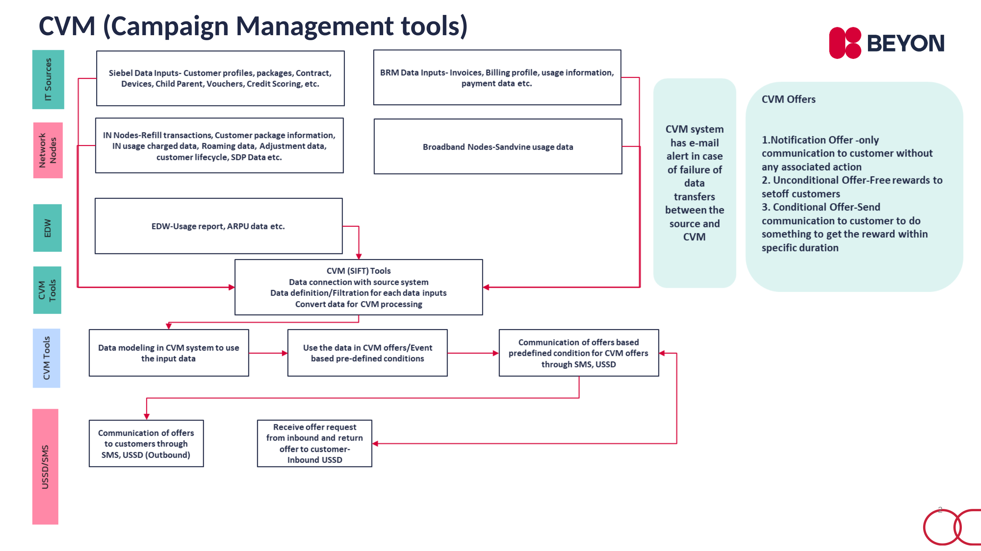
Figure 2: CVM (Campaign Management tools) (slide 2 of Prepaid_Promotion_CVM_Process Understanding.ppt)
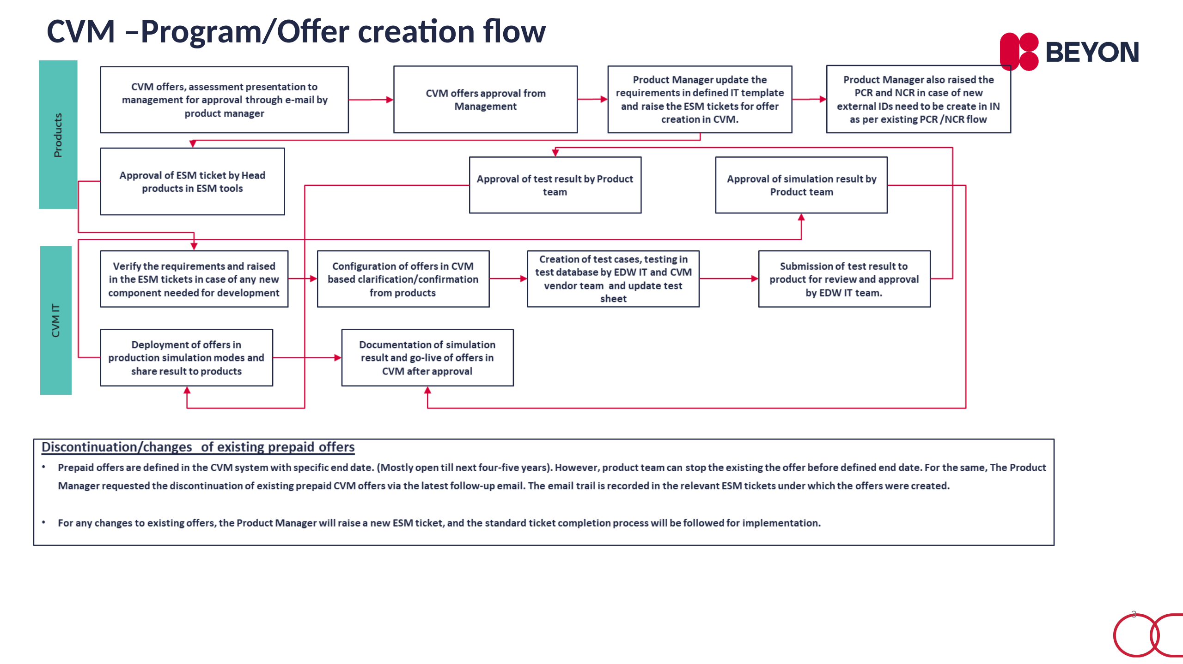
Figure 3: CVM –Program/Offer creation flow (slide 3 of Prepaid_Promotion_CVM_Process Understanding.ppt)

Objective and Scope

Objectives:
- CVM-related business rules, procedures, and approval frameworks for prepaid promotions and campaigns are formally documented, approved, and aligned with the Delegation of Authority (DOA).
- User access to the CVM system is appropriately restricted, authorized, and managed in line with defined roles, responsibilities, and segregation of duties.
- Data inputs from source systems into the CVM platform are complete, accurate, and reliable to support correct campaign targeting, execution, and billing.
- CVM prepaid promotions and campaigns are appropriately designed, reviewed, approved, and governed in accordance with documented procedures and approved authority limits.
- Promotions and notifications are accurately configured in the CVM and Intelligent Network (IN) systems including pricing, eligibility criteria, validity periods, and customer benefits.
- Post-campaign performance and financial impact are reviewed, documented, and assessed to evaluate campaign effectiveness and inform future promotional decisions.
- Customer eligibility and charging for CVM prepaid promotions are accurately determined and applied in accordance with the approved offer configurations.
- Customer communications relating to CVM prepaid promotions are accurate, complete, timely, and consistent with the approved promotion terms.

Scope:
- Review of CVM governance including documented business rules, procedures, and approval frameworks for prepaid promotions and campaigns.
- Assessment of promotion design and approval processes to confirm compliance with documented procedures and Delegation of Authority limits.
- Verification of CVM and IN system configurations to confirm promotions and notifications are set up in line with approved pricing, eligibility, validity, and benefits.
- Testing of customer eligibility and charging accuracy for selected CVM prepaid promotions.
- Review of customer communications to assess accuracy, completeness, and consistency with approved promotion terms.
- Assessment of user access controls over the CVM system, including authorization and segregation of duties.
- Evaluation of data inputs and interfaces from source systems into the CVM platform to confirm completeness and accuracy.
- Review of post-campaign monitoring and analysis to assess campaign performance and financial impact.
Review period: 1st January 2025 till 31st January 2026

Limitations of Internal Audit:
For the purpose of internal audit, we rely on information and representations made available to us by the management. Our work includes enquiries, observations and limited tests of transactions on a sample basis.
The matters raised in this and other reports that will flow from the audit are only those which have come to our attention arising from or relevant to our audit that we believe need to be brought to your attention.
Internal audit procedures alone, even when carried out with due professional care, do not guarantee that fraud will be detected. Accordingly, our examinations as internal auditors should not be relied upon solely to disclose or discover fraud, defalcations or other irregularities which may exist.
Our work does not in any way diminish the responsibilities of the management. The design, development, implementation, operation of internal control systems and detecting fraud and irregularities are responsibilities of the Company’s management and ultimately of those who are charged with governance. They are accountable for ensuring that adequate controls exist in the areas of their responsibility and should not rely solely on our periodic visits as a means of monitoring the adequacy and integrity of controls.

Acknowledgment
We wish to place on record our appreciation for the co-operation and assistance rendered to us by ……………………………teams.

Audit Team

Auditor  Kamal Jain | Audit Manager  Ameera Haji | Chief of Internal Audit  Buddhadeb Samanta

Risk Classification
Audit observations have been graded based on the following risk scale:

Active Management (Very High) | Risk where current treatment options require active review & management due to absent or flawed control design. This rating requires immediate management attention to correct the reported issue or control deficiency. Such issues refer to a weakness that could potentially expose the company to significant losses and inefficiencies. These issues may also have significant adverse impact on the company in terms of its customers, business partners and/or other stakeholders. Management should immediately begin the corrective actions and actively monitor the implementation progress, ensuring that the relevant compensatory controls are in place till the action completion. Management should also establish a high frequency review mechanism to ensure continuity of the controls.

Continuous Review (High) | Control design is presently adequate but implementation issues were observed. Such issues indicate towards a weakness that could potentially expose the company to significant losses and inefficiencies, if continuity of controls is not ensured. These issues may also have adverse impact on the company in terms of its customers, business partners and/or other stakeholders. Management should complete the corrective actions on noted control lapses within 3 months and monitor the progress on a continuous manner, ensuring that the relevant compensatory controls are in place till the action completion. Management should also establish a high frequency review mechanism to ensure continuity of the controls.

Periodic Monitoring (Medium) | Control is not strong or not documented, but risk impact is not high. Though this rating requires early management attention, the corrective action on these issues can be deferred to some extent where implementation of the action has external dependencies. Compensating controls should be placed till the implementation of agreed action and the corrective action should be completed within 6 months. Management should also establish a periodic frequency review mechanism to ensure continuity of the controls.

No Major Concern (Low) | Risk where systems and processes managing the risk are adequate and subject to minimal monitoring. This rating refers to weaknesses that do not have significant impact and is presented as an information to the management. Corrective action should be completed within 12 months and required compensatory controls should be put in place till such completion.

Summary and Conclusion

Overall opinion
Based on the observations and results of our audit, the rating for the overall control system is “Improvement Required”. Critical control deficiencies do not exist in the systems of internal control. Although the systems of internal control, as designed, meet minimum standards of internal control, audit findings include some of the areas which need improvement. Management is generally aware of the control points and risks and has implemented at least minimum controls. Some assurance exists that significant objectives will be achieved.

Audit Issues Dashboard
Business Area | Very High  Risk | High  Risk | Medium  Risk | Low  Risk | Total
Product Lifecycle Management / Governance | - | - | - | - | -
IT General Controls / Access Management | - | - | - | - | -
Total | - | - | - | - | -

List of Audit Issues

No. | Risk | Audit Issue | Owners | Target Date | Page
1 | M | Gaps and Inconsistencies in CVM Product Lifecycle and Approvals |  |  | 1
2 | M | User Access Management and Change Control Weaknesses in CVM Systems |  |  | 1

Detailed Audit Issues

New Audit Issues

1. Gaps and Inconsistencies in CVM Product Lifecycle and Approvals
Residual Rating: M
Criteria: All CVM prepaid promotional offers should be logged, approved, and terminated through formal, documented workflows as per the CVM Business Rule Document and defined process standards. Approvals must follow the Delegation of Authority (DOA) and should be evidenced as per control requirements.
Condition: The review of CVM prepaid offer creation, approval, modification, and termination revealed several process gaps and deviations from stated procedures and business rules: 1) CVM offers were logged and approved in the ESM system, rather than through the CVM workflow as required by business rules; 2) Approvals for launch were inconsistent, with authority levels varying between Director – Consumer Products, GM – Consumer, GM – Finance, and CEO, without clear DOA guidance; 3) Some approvals were obtained via email and lacked system evidence; 4) No impact analysis or assessment was documented for certain offers; 5) Offers were discontinued before the defined end date via email requests, without formal ESM ticket approval or Segment Head sign off.
Offers reviewed for approval (creation and launch): 8 (covering 43% total fulfilment in Jan 2026)
Offers reviewed for expiry/termination process: 15 (including 4 disconnected early)
Risk: Absence of standardized, documented, and system-based approval, modification and termination processes creates risk of unauthorized offer launches, inconsistent authority application, lack of audit trail, and potential misalignment with business objectives and controls. It can also lead to financial, regulatory, and reputational exposures due to uncontrolled product lifecycle management.
Recommendation: Update the CVM Business Rule Document and process standards to clearly define and enforce the required workflow for offer creation, approval (with authority levels per DOA), modification, and termination. Ensure all approvals, including impact analysis and offer expiry/termination, are documented and evidenced through the designated system (CVM workflow/ESM tool), with no exceptions permitted for email-only processes.

2. User Access Management and Change Control Weaknesses in CVM Systems
Residual Rating: M
Criteria: 1. User access to CVM tools should be aligned to their respective department and role as per documented access management procedures. Admin access and IT Group rights should be restricted to those with approved business need.
2. All changes to prepaid CVM offers must be supported by prior approval from the Head – Product and documented through an approved Service Request (SR) in the ESM system, as per process requirements.
Condition: Review identified (a) mismatches between user access rights and assigned department in the CVM portal, including Admin or IT Group access for product users and cross-department access instances; and (b) one sampled prepaid CVM offer ('Pre_LMRA_Program') was modified without a corresponding approved Service Request (SR) in ESM, relying instead on email approval from the product team.
Sample size of prepaid CVM offers reviewed: 10
Number of program offers with changes supported by ESM ticket: 4
Number of program offers with no changes in review period: 5
Number of offers changed via email approval (not ESM SR): 1
Root Cause: Insufficient evidence provided to determine a specific root cause; the observations indicate potential gaps in user access management and change approval enforcement, but documentation on procedural lapses or system limitations is not conclusive.
Risk: Inappropriate user access may enable unauthorized changes or data management in CVM tools, increasing the risk of fraud, errors, and data integrity issues. Changes to offers without adherence to the formal approval process may result in unapproved modifications, potentially impacting compliance, auditability, and consistency in CVM offer management.
Recommendation: Review and align user access rights in CVM tools to ensure only appropriate roles have elevated or cross-department privileges. Reinforce the requirement that all changes to prepaid CVM offers are supported by approved Service Requests in ESM; actively monitor and remediate any instances of non-compliance with established approval processes.

 |  | Active Management (Very High)
Audit Issue | Management Action:

 |  | Continuous Review (High)
Audit Issue | Management Action:

 |  | Periodic Monitoring (Medium)
Audit Issue | Management Action:

 |  | No Major Concern (Low)
Audit Issue | Management Action:

Area for Improvement
Management Action:

Areas for Improvement

Gaps in File-Level Processing and Monitoring in CVM System Inputs
Criteria: Input data and files from all source systems should be completely and accurately processed into the CVM tools on a defined periodic basis, with effective monitoring in place to promptly detect and resolve any failures.
Condition: There is record-level monitoring available in the CVM system via dashboards, and email notifications are generated when failures in data transfer occur. However, there is no centralized tracker to monitor completeness of file-level processing status across all input source systems. Sample evidence reviewed includes email alerts for missing files and dashboards for record-level processing, but only a one-day dashboard was provided, which showed a significant number of records rejected due to predefined rules.
One-day dashboard showing significant records rejected or filtered: Large number of records rejected as per predefined processing rules
Root Cause: There is insufficient evidence to determine the root cause underlying the lack of centralized file-level processing trackers in CVM; a vendor change request is noted, but full causation cannot be confirmed from available evidence.
Risk: Without a centralized mechanism to track file-level processing status across all source systems, there is a risk that missing or incomplete file processing may not be promptly or comprehensively detected, leading to inaccurate or incomplete campaign input data and potential impact on downstream marketing actions.
Recommendation: Implement a centralized file-level processing tracker within the CVM system to ensure completeness and accurate monitoring of all input files from source systems, complementing the existing record-level monitoring and alert mechanisms.

Appendixes

