PENETRATION TESTING REPORT
FOOTPRINTING & NETWORK SCANNING
[WK2-PM-FINAL | CYBERSECURITY | NETWORKWALKS]
Name | Favour Ayang
Program / Batch | B083 NetworkWalks
Date | 17 September 2026
Modules covered | W2-PM1 Multiple Kali Linux Tools & W2-PM5 Zenmap Scanning
Target(s) | Networkwalks.com (authorized training target) & my local LAN
Permission secured? | Yes
Phases covered | Phase 1: Reconnaissance & Footprinting, Phase 2: Scanning & Network Discovery

1. Disclaimer
Everything described in this report was carried out only against systems I had written permission to test, or equipment that belongs to me. The purpose of this work is entirely educational, it's part of a structured training program, not an attempt to cause harm or gain unauthorized access to anything. None of the techniques here should be used against a system without the owner's explicit consent; doing so is illegal in most places even if no actual damage occurs, and I take full personal responsibility for how I apply what I've learned.

2. Introduction
This report walks through two activities I completed as part of my training: gathering public information about a target domain (foot printing) and mapping out devices on a network I have access to (scanning). Looking at these two skills together gives a decent picture of how someone might move from researching a target from the outside to identifying live systems once they have some form of access to the network.
This project is a part of the Week 2 ongoing internship provided by Networkwalks. The programs ran on this project were Kali Linux (for foot printing) and Zenmap (used for scanning).
For each tool below I've noted the command I ran, what results came back, and what it would mean if someone were using this information with bad intentions.

3. Tools Used
A quick rundown of what I used and why:
Tool | What I used it for
Kali Linux | Operating system that will be used for foot printing.
‘WHOIS’ | This command pulls public resignation information, who registered the domain, which registrar, creation/expiry dates and name servers.
‘nslookup’ | This command gives you the underlying IP address the domain points to using DNS.
WhatWeb | A fingerprint web technology that uses servers, CMS, plugins or IP
Curl -I | This command fetches only the HTTP headers of a website.
WAFW00F | A web application firewall fingerprinting tool identifies if a website is protected by WAF and determines its type. It sends HTTP requests, analyses responses and matching them against known WAF signatures.
DNSRecon | An enumeration tool that can perform multiple types of DNS record lookups (NS, MX, SPF, TXT, SRV)
Zenmap /Nmap GUI | A network scanner that scans the local subnet to find live hosts, IPs and MAC addresses.
Windows CMD | Identifies local MAC & IP addresses

4. What I Did

4.1 Footprinting & Reconnaissance
I carried out reconnaissance on the networkwalks.com domain using six different Kali Linux tools:
WHOIS, WhatWeb, Nslookup, Curl, Wafw00f and DNSRecon. I used each tool for a specific purpose to gather different types of information about the target domain.
To begin, I used WHOIS to find publicly available information about the domain, including its registration details and name servers. This helped provide an initial overview of the domain and some of the infrastructure associated with it.
Evidence:
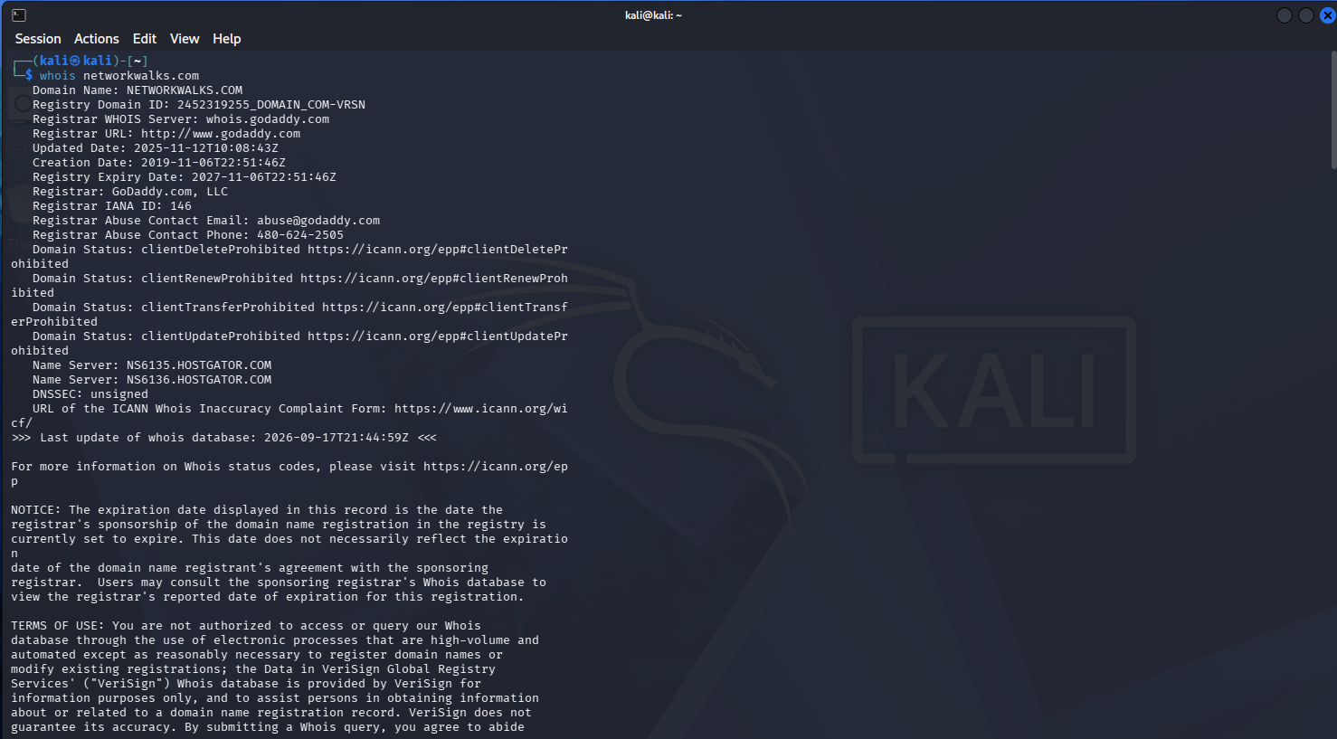
I then used WhatWeb to identify the technologies being used by the website. The scan detected WordPress 7.0.4 and WP Download Manager 3.3.58, as well as other information that was publicly exposed by the website.
Evidence:
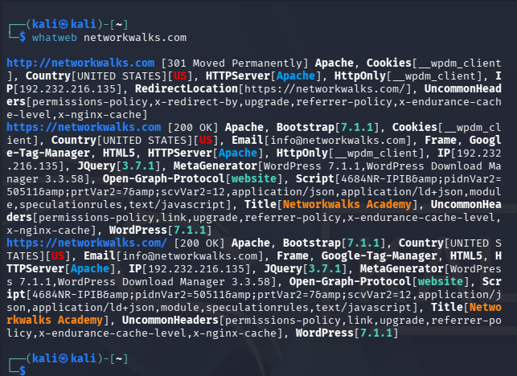

Next, I used Nslookup to find the IP address associated with the domain. The result showed that networkwalks.com resolved to 192.232.216.135.
Evidence:
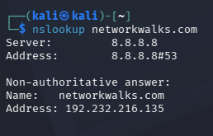
After this, I used Curl with the -I option to examine the HTTP response headers returned by the website. This gave me further information about the web application and also showed that the WordPress REST API endpoint /wp-json/ was accessible.
Evidence:
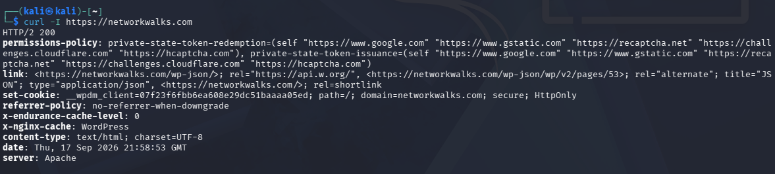

I also ran Wafw00f to check whether a Web Application Firewall (WAF) was being used to protect the website. The results indicated that ModSecurity (SpiderLabs) was detected.
Evidence:
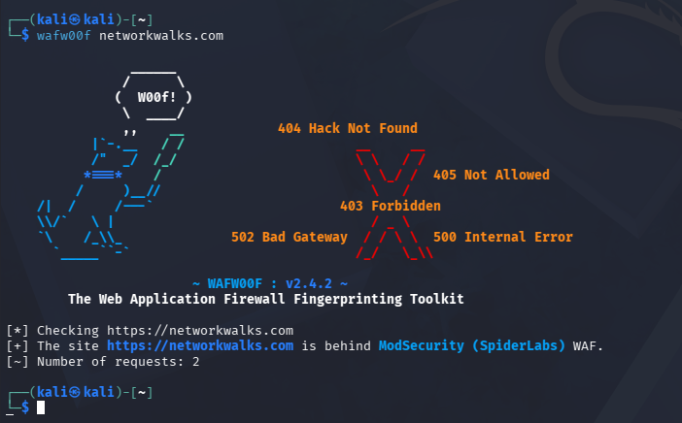
Finally, I used DNSRecon to gather additional DNS information about the domain. This included details about the name servers, mail servers, SPF/TXT records, service records and DNS software. Overall, using these tools together provided a broader picture of the domain's publicly accessible infrastructure.
Evidence:
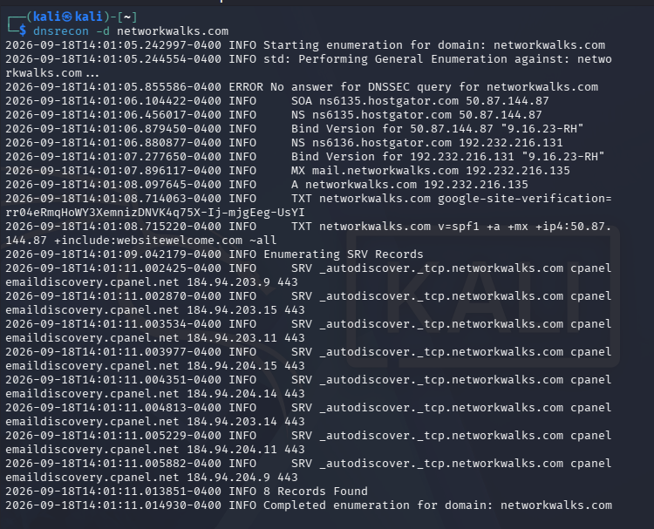

4.2 Network Scanning using Zenmap
For the second part, I switched to mapping out my own local network rather than working from the outside in.
I used Zenmap to carry out network discovery on my local network. The aim of this practical was to find my local IP address and subnet, identify which devices were active on the network, record their IP and MAC addresses, and create a visual representation of the network topology.
Evidence:
[upload ss of zenmap install/setup]

Before starting the scan, I used the Windows ipconfig command to check my local IP address and determine the subnet of my LAN.
192.168.1.0/24
I then entered the relevant subnet (192.168.1.0/24) into Zenmap and selected the Ping Scan option. This allowed me to check which devices were currently active on the network.
The scan turned up the following live hosts on the network:
192.168.1.1
- 192.168.1.1 |
- 192.168.1.20
- 192.168.1.62
- 192.168.1.140
- 192.168.1.196
- 192.168.1.25
The scan also returned the MAC addresses associated with the discovered devices.
Once the network scan was complete, I went to the Topology section in Zenmap to view the discovered devices as a network diagram. I enabled the legend to make the topology easier to understand and then exported the completed topology as a PDF, as required for the practical.
[upload picture here]
Topology map generated in Zenmap after the ping sweep, showing localhost at the center connected to all 6 discovered hosts, plus an additional device (192.168.1.200) picked up in this scan that hadn't appeared in the earlier CLI run.
For my final report, I would replace the example IP addresses, subnet information, number of hosts and MAC addresses with the results obtained from my own network scan.

5. Risk Analysis
Based on what came out of the footprinting and scanning work, here's what stood out as worth flagging:
# | Finding | Evidence | Why it matters | Risk level
1 | Web technology stack exposed | WhatWeb identified Apache, WordPress 7.1.1, WP Download Manager 3.3.58, jQuery 3.7.1 | Named software versions make it easier to look up known vulnerabilities for that specific version | Medium
2 | Server IP address identifiable | nslookup resolved networkwalks.com to 192.232.216.135 | Reveals the network location of the hosting server | Low
3 | HTTP headers reveal backend details | curl -I returned Apache as the server, plus WordPress REST API paths (/wp-json/) | Confirms platform and exposes API endpoints that could be probed further | Low
4 | WAF identifiable | WAFW00F detected ModSecurity (SpiderLabs) protecting the site | Reveals part of the security architecture, which an attacker could research for known bypass techniques | Low
5 | Domain registration and name server details exposed | WHOIS showed registrar (GoDaddy), creation/expiry dates, and name servers (Hostgator, DomainControl) | Standard public WHOIS data, but combined with other findings helps build a fuller profile of the target's infrastructure | Low
6 | IoT device identifiable on local network | Nmap scan (192.168.1.0/24) identified host 192.168.1.140 with MAC vendor traced to Hikvision, likely a network camera | Could indicate an unmanaged device with default credentials or exposed services | Medium
7 | Flat network with no device segmentation | Zenmap topology map showed all 6 hosts (router, personal devices, camera) on one flat subnet | If any single device is compromised, an attacker has direct visibility into every other device on the network | Medium

It's worth being clear that none of these findings amount to a confirmed vulnerability. What I carried out was reconnaissance and host discovery , not exploitation or active vulnerability testing. Spotting a software version, an IP address, or a DNS record doesn't mean a system is actually exposed to attack; it simply means that information exists and would need closer, authorized investigation before anyone could draw conclusions about real risk.

6. Recommendations
A few practical suggestions that came out of this exercise:
- Keep an eye on what technology details are publicly visible and tidy up anything that doesn't need to be exposed.
- Stay current with software and plugin updates and check them against known advisories regularly.
- Review HTTP response headers periodically to avoid leaking more than necessary.
- Audit DNS records on a schedule so only what's actually needed stays public.
- Make sure the WAF is properly configured and monitored rather than just switched on.
- Run internal network discovery scans regularly to keep track of what's connected.
- Follow up on any device that shows up on a scan but isn't accounted for.
- Keep network documentation up to date so topology changes don't go unnoticed.
- Only ever run this kind of testing with clear, documented authorization.

7. Conclusion
Working through both halves of this exercise gave me a much clearer picture of how the two skills actually connect. Footprinting felt almost like detective work, piecing together small, publicly available details that on their own don't mean much, but together start to sketch out how a target is built and hosted. Scanning my own network afterward was a good contrast, since it was less about searching for scattered clues and more about getting a direct, honest snapshot of what's actually connected right now.
What stood out most was how much information is just sitting out in the open without anyone needing to do anything particularly advanced to find it, a simple WHOIS lookup or a ping sweep was enough to surface details that, in the wrong hands, could feed into something more serious. That's also what made the authorization point feel less like a formality and more like the whole foundation of doing this work responsibly: the exact same commands that helped me document my own systems would be a problem the moment they're pointed at something I don't have permission to touch.
If I had to pick the one skill, I'll carry forward the most, it's probably just the habit of looking at a system the way an outsider would, and asking what it reveals about itself before anyone even tries to break in.

8. Evidence
Screenshots from each step are included below as supporting evidence.
‘WHOIS’ results:
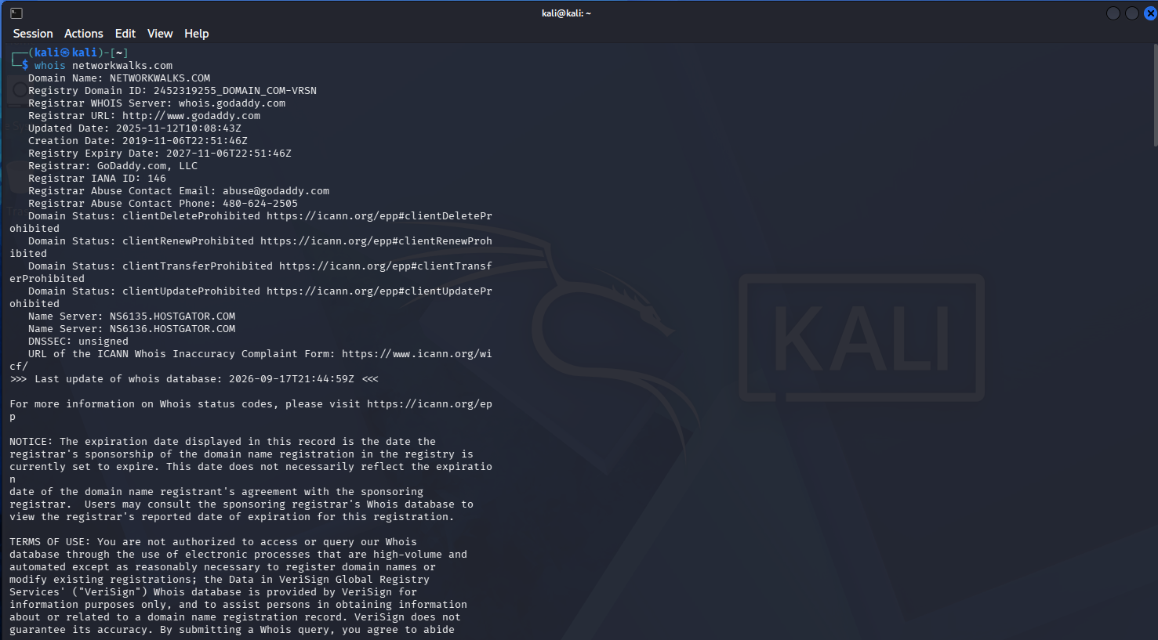
‘whatweb’ results:
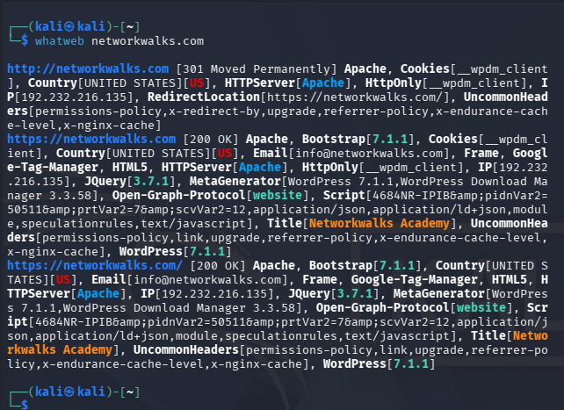

‘nslookup’ results:
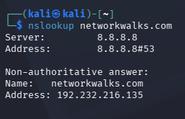
‘curl -I’ results:
‘wafw00f’ results:
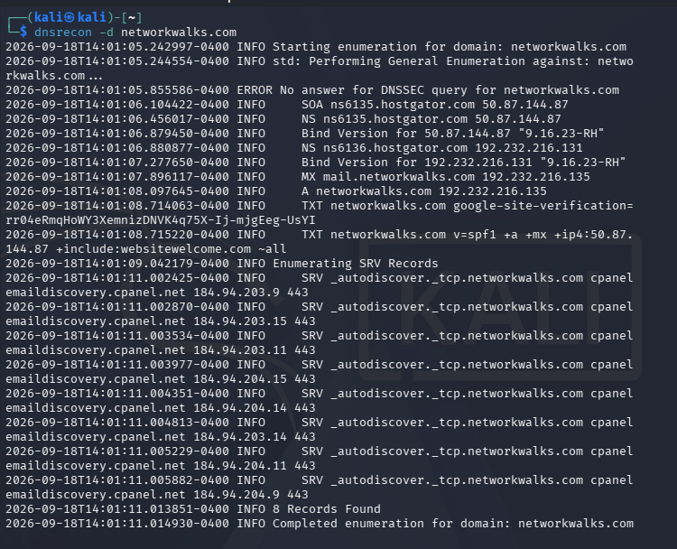
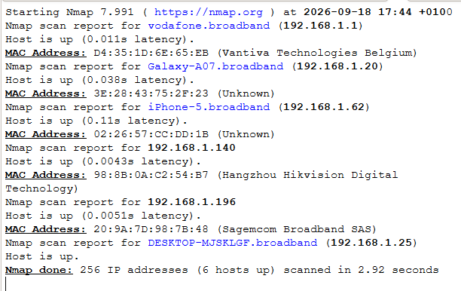
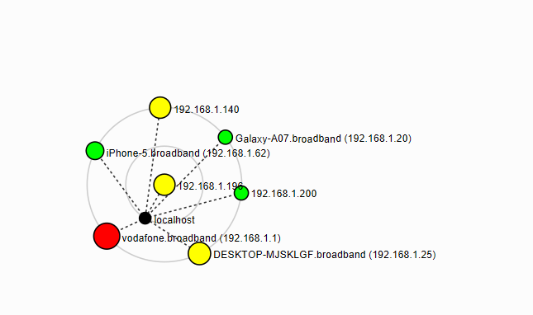
— End —

Author
Favour Ayang | Cybersecurity Professional B083
LinkedIn: www.linkedin.com/in/favour-ayang/

