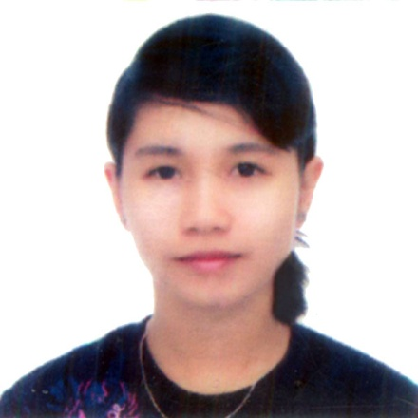Ma. Cecille A. Narca

**Address:** #18C Kalayaan Avenue V-Luna Quezon City

**Contact:** 09309814722/09269339233

**Email:** cecille.narca@yahoo.com

**OBJECTIVE**

* I am looking for a suitable On-the-Job Training where I could practice my knowledge and developed my personality as a career person while utilizing my skills.

**PERSONAL INFORMATION**

**Age:** 20

**Date of Birth:** October 7, 1993

**Gender:** Female

**Civil Status:** Single

**Height:** 5’1”

**Weight:** 37 kg

**Nationality:** Filipino

**Religion:** Roman Catholic

**QUALIFICATION**

* Dedicated and Hardworking individual
* God-Fearing
* Willing to learn

**SKILLS**

* Oriented in Microsoft Office such as:

Microsoft Word

Microsoft Excel

Microsoft Power Point

* Capable of Editing Files and Presentation using different Microsoft Applications
* Can make basic web pages using HTML editors.
* Can make basic programs using VB 6.0

**EXPERIENCE**

On the Job Training

Eastern Blends Food Corporation (Encoder)

November 14 2012- January 25, 2013

**CERTIFICATE**

Leadership Award 2012

**EDUCATIONAL BACKGROUND**

**Tertiary:** Asian Institute of Computer Studies 2012-Present

Bachelor of Science in Computer Science

Commonwealth, Quezon City

Asian Institute of Computer Studies 2010-2012

Computer Science (Associate 2 yrs)

Cubao, Quezon City

**Secondary:**  Quirino High School 2006-2010

Proj. 3 Molave Quezon City

**Elementary:**  Malaya Elementary School 2000-2006

Bgry. Malaya V-Luna Quezon City

**REFERENCES**

Engr. Mrs. Nerissa G. Torres

HR/Manager in Eastern Blends Food Corporation

921-44-88