ABOUT ETRONICAL
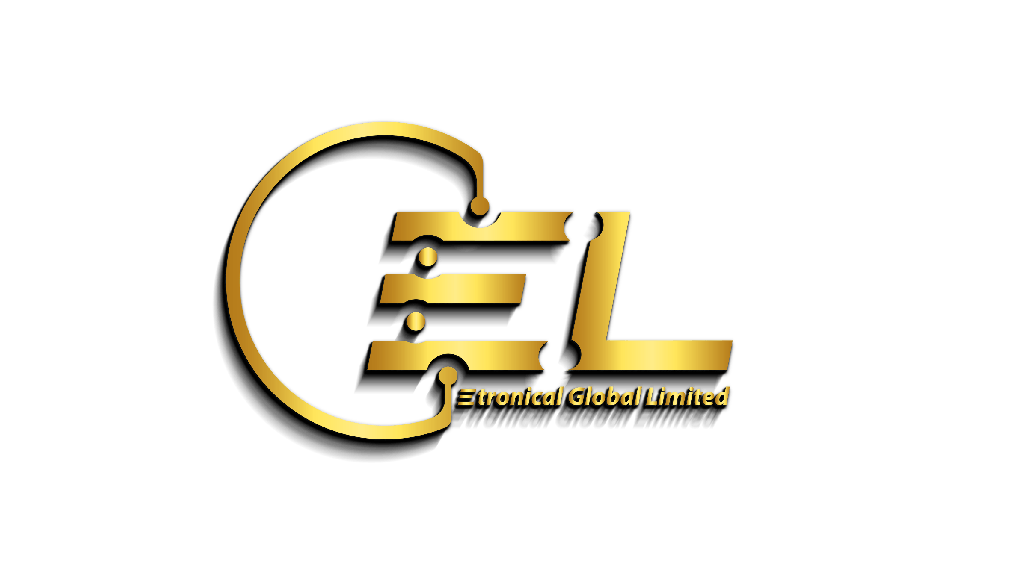
About Etronical Global Limited
Etronical Global Limited (EGL) was established in 2020 in the Federal Capital Territory (FCT), Abuja, in response to the growing demand for reliable obsolescence management, electronics repair, automation, and technology integration solutions for homes, businesses, and industrial organizations across Nigeria.
At EGL, we leverage the extensive experience and technical expertise of our highly skilled engineers and specialists to deliver innovative, cost-effective, and customer-focused solutions. We design, develop, install, and maintain technology systems that improve operational efficiency, enhance security, extend equipment lifespan, and support business continuity.
Our core expertise lies in providing software and hardware development services for organizations that depend on legacy systems, particularly in mission-critical and safety-sensitive environments. We understand that replacing aging equipment is often expensive and disruptive; therefore, we develop customized solutions that enable organizations to modernize, maintain, and optimize existing systems while minimizing operational risks and costs.
Our solutions serve a broad range of sectors, including government agencies, private organizations, educational institutions, healthcare facilities, financial institutions, manufacturing industries, hospitality businesses, and residential clients. Every solution is carefully designed and tailored to meet each customer's unique operational requirements and long-term objectives.
In addition to systems development, Etronical Global Limited specializes in the supply, installation, and maintenance of renewable energy and electronic security systems. We provide professional installation of:
- Solar inverter and backup power systems
- CCTV surveillance and security camera systems
- Access control and electronic security solutions
- Networking and communication infrastructure
- Smart home and office automation systems
Our services are available throughout the Federal Capital Territory and across all states in Nigeria.
EGL is also recognized for its expertise in the design, fabrication, installation, and maintenance of high-quality digital signage solutions. We understand that a business's visual presentation creates the first impression for customers and stakeholders. Our digital display systems are designed to enhance brand visibility, improve customer engagement, deliver dynamic advertising content, and strengthen corporate identity.
With over 10 years of combined industry experience in electronics engineering, repairs, embedded systems, and industrial technology, our team possesses extensive practical knowledge gained through hands-on field experience. This expertise enables us to diagnose complex technical challenges, restore faulty equipment, and deliver dependable engineering solutions that exceed client expectations.
One of our greatest strengths is helping clients reduce unnecessary replacement costs. Rather than recommending expensive new equipment, we focus on repairing, refurbishing, upgrading, and extending the useful life of existing electronic systems whenever practical. This approach saves money, reduces downtime, and contributes to environmental sustainability by minimizing electronic waste.
Our repair and maintenance services cover a wide range of consumer, commercial, industrial, and office electronic equipment and appliances, ensuring that individuals and organizations can continue to rely on their existing investments with confidence.
At Etronical Global Limited, quality, innovation, integrity, and customer satisfaction are at the heart of everything we do. We are committed to delivering reliable technology solutions that empower our clients, improve productivity, enhance security, and support sustainable development through professional engineering excellence.
Whether you require electronics repair, software and hardware development, solar energy solutions, surveillance systems, digital signage, automation, or customized engineering services, Etronical Global Limited is your trusted technology partner—delivering innovative solutions that keep your systems running efficiently today while preparing your business for tomorrow.

