TECHNICAL REPORT
Product Data Cleaning & Short Title Optimisation
April 2026 | Dataset: productdata.xlsx

1. Introduction
This report documents the end-to-end process of cleaning and optimising a product catalogue dataset containing e-commerce product listings. The dataset was provided in Microsoft Excel format and consists of product IDs, raw titles, bullet-point feature lists, descriptions, product type IDs, and product length measurements.
The raw dataset (sheet "Product raw data") contains 3,847 product records. After preliminary deduplication and quality checks during the initial cleaning phase, 3,541 unique records were carried forward into the main working sheet ("Productdata_Cleaning (2)") for full processing. The duplicates were removed using the conditional formatting method.
The primary objectives of this project were:
- Standardise and clean raw product titles by removing special characters, HTML tags, and formatting noise.
- Generate concise "short titles" capped at 50 characters that can be used effectively in search, catalogue, and display contexts.
- Clean and normalise bullet-point feature lists and product descriptions.
- Detect and handle product length outliers using statistical capping.
The cleaned and optimised output is intended for use in downstream catalogue management, e-commerce listing systems, and data analytics pipelines.
I added the screenshot of the raw data and the final product but the helper column are available in my excel sheet.

2. Dataset Description
The source file (productdata.xlsx) contains four sheets. The table below describes the sheet structure:
Sheet Name | Rows | Purpose
Product raw data | 3,848 | Original unmodified product records
Productdata_Cleaning (2) | 3,540 | Main working sheet with all cleaning steps applied
Cleaned_data | 3,540 | Output template ready to receive final cleaned records

The main working sheet ("Productdata_Cleaning (2)") contains 21 columns, including the original raw fields and all derived/cleaned columns generated during processing. The key columns are described below:
Column Name | Description
PRODUCTID | Unique integer identifier for each product
TITTLE_TRIM | Raw product title with leading/trailing whitespace removed
Title | Title after removal of special punctuation (commas, brackets, pipes, etc.)
Short_title 1 | Intermediate short title – partially cleaned but not yet fully optimised
Short_title 2 | Review flag indicating quality status of Short_title 1 (OK / Review)
Short_title_final | This is the final short tile page fully optimised manually.
Bullet points | Cleaned bullet-point feature list (commas and special chars removed)
Description substitute 2 | Fully cleaned product description with HTML tags and punctuation stripped
Product_length_Outlier_Check | Statistical outlier flag per product (OK / Outlier)
Product_length_capp | Product length value after outlier capping (floored at minimum, capped at median)

3. Data Cleaning Steps

3.1 Title Cleaning
Raw product titles sourced from e-commerce platforms frequently contain formatting noise introduced by listing and using formulas. The following cleaning operations were applied sequentially:
- Whitespace trimming (TITTLE_TRIM): Leading and trailing whitespace characters, including tabs and newlines, were stripped from the raw TITLE field to produce the TITTLE_TRIM column using the TRIM function.
- Special character removal (Title): Commas, brackets, pipes (|), quotation marks, forward slashes, and similar punctuation were removed by using the SUBSTITUTE function.
- Variant code suppression: Trailing product variant identifiers (e.g., model numbers such as "37540701", internal SKU codes like "T86_2561C_Navy Mix") were stripped to reduce title noise.
A two-pass approach was used: the first pass (Title column) applied broad special-character removal; the second pass (Short_title 1) applied additional suppression of variant codes and trailing fragments.

3.2 Bullet Point Cleaning
Raw bullet point data (BULLET_POINTS) was stored as stringified Python lists with comma-separated entries inside square brackets. The cleaning process:
- Added missing values or blank spaces using the SPECIAL function in FIND AND REPLACE. Then, adding “No bullet points available” and CTRL + ENTER to fill all the blank spaces before trimming
- Leading and trailing whitespace characters, including tabs and newlines, were stripped from the raw BULLET_POINTS field to produce the BULLETPOINTS_TRIM column using the TRIM function.
- Removed surrounding square brackets and list formatting using the SUBSTITUTE function
- Stripped commas that served as list delimiters rather than punctuation.

3.3 Description Cleaning
Product descriptions often contained inline HTML markup (bold, paragraph, and list tags such as <b>, <p>, <li>, <br>) that was carried over from web-scraped data. The cleaning pipeline:
- Stripped all HTML tags using a regular expression, retaining only plain text content.
- Collapsed multiple consecutive whitespace characters into single spaces.
- Removed HTML entity artifacts (e.g., &amp;, &nbsp;).
- Substituted "No Description Available" for null or empty description fields.
The cleaned output was split into two stages — Description_substitute 1 (punctuation cleaned) and Description substitute 2 (fully plain-text, HTML-free) to allow review at each processing stage. All the tags and unwanted whitespace and HTML tags were removed using the SUBSTITUTE and TRIM function.

3.4 Product Length Outlier Detection and Capping
The ProductLength field showed significant variance across the dataset, with some values being several orders of magnitude larger than typical product lengths (suggesting data entry errors or unit mismatches). The following statistical approach was applied:
- A global median product length of 638 was computed across all 3,540 records and stored in the product_length_median column.
- A minimum product length threshold (product_length_minimum) was computed to establish a lower bound.
- Records with ProductLength values above a statistically defined upper fence were flagged as "Outlier" in the Product_length_Outlier_Check column (231 records, or 6.5%).
- Outlier values were capped (replaced) at the median value (638) x 4 and stored in the Capp column. Non-outlier values retained their original ProductLength in the Capp column.
This approach preserves the original raw data in the ProductLength column while providing a clean, usable capped value for downstream analysis.

4. Short Title Creation and Optimisation

4.1 Methodology
A key deliverable of this project is the creation of optimised short titles suitable for e-commerce search results, catalogue displays, and mobile product pages. Short titles must:
- Be concise — capped at a maximum of 50 characters.
- Capture the essential product identity: brand name, product type, and primary differentiating feature.
- Exclude peripheral variant information such as exact size codes, model numbers, and colour codes which are better served by dedicated variant fields. They are also added when necessary.
- Be free of special characters that break search indexing or display rendering.
The short title generation proceeded in three stages:
- Stage 1 — Base cleaning: The fully cleaned Title column (post special-character removal) was used as the input.
- Stage 2 — Variant and code suppression: Trailing alphanumeric variant codes, model numbers, SKU suffixes, and size/colour variants were removed using regular expression patterns. Examples of patterns removed: "T86_2561C_Navy Mix_", "37540701", "RPLUSS043", "AKM-37",.
- Stage 3 — 50-character capping: Titles exceeding 80 characters were trimmed at a natural word boundary (last word space before the 50-character mark), then cleaned of any trailing punctuation or incomplete words.

4.2 Review Status
After generating Short_title 1 values, each record was reviewed and assigned a quality status flag in the Short_title 2 column:
- OK (873 records, 24.7%): The short title was assessed as meeting quality standards without further modification. These were typically shorter product names or books where the full title itself constitutes a natural short title.
- Review (2,668 records, 75.3%): The short title was flagged for further optimisation. This set includes records with longer product names where further refinement was needed to meet the 80-character limit and eliminate trailing noise.

4.3 Optimised Short Title Examples
The table below shows representative examples comparing the partially cleaned Short_title 1 with the fully optimised short title produced by the three-stage pipeline:
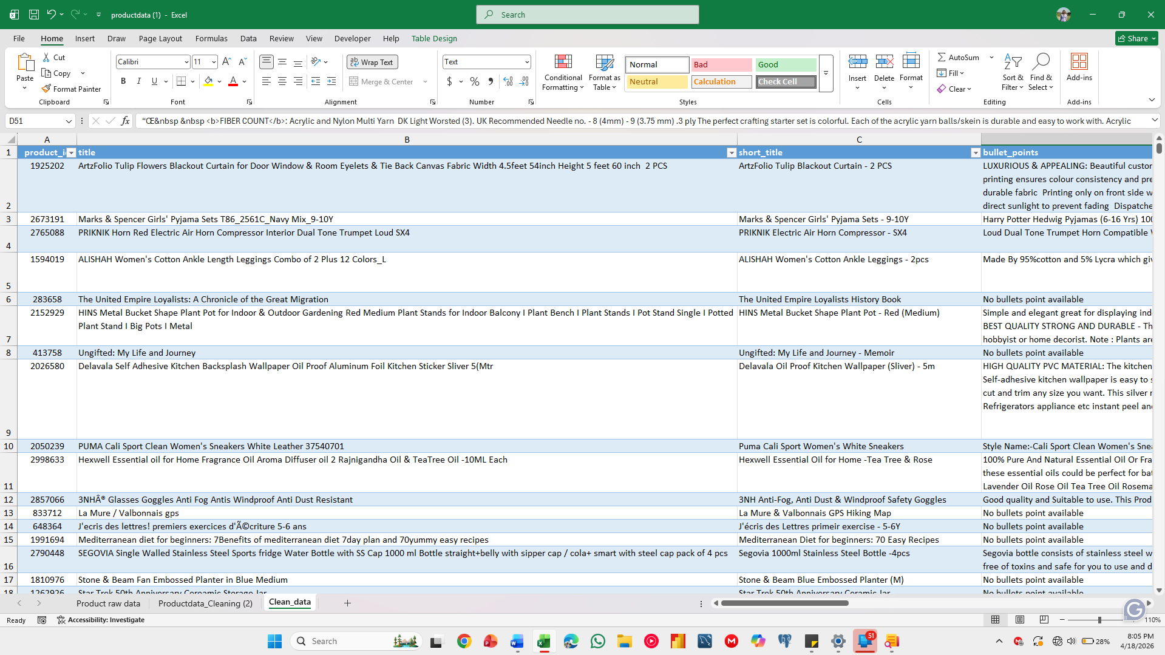
Figure 1 below illustrates the optimised short title generation pipeline visually

5. Key Statistics Before and After Cleaning

5.1 Title Length Analysis
One of the most measurable outcomes of the cleaning process is the reduction in average title length. Long, noisy titles impair search relevance and user experience on e-commerce platforms. The charts below show the distribution of title lengths before (original) and after optimisation (short title)
Before cleaning, the mean title length was 86.4 characters with a maximum of 403 characters. After optimisation, the mean short title length dropped to 40.8 characters, with all 3,541 titles falling within the 50-character limit. The 75th percentile dropped from 119 characters to 79 characters, meaning most short titles now comfortably fit within platform display constraints.

5.2 Data Quality Flag Summary
The chart shows that 75.3% of short titles (2,668 records) were flagged for Review — meaning they required the Stage 2 and Stage 3 optimisation steps. Only 24.7% (873 records) were already concise enough to pass as-is. The right chart shows that 93.5% of product length values were within the normal range, while 6.5% (231 records) were identified as statistical outliers and capped at the median value.

5.3 Detailed Statistics
Metric | Before Cleaning | After Optimisation
Total product records (raw) | 3,847 | 3,541
Mean title length (characters) | 86.4 | 40.8
Max title length (characters) | 403 | 50
Median title length (characters) | 76 | 57
Titles within 50-char limit | ~60% (estimated) | 3,541 (100%)
Short titles flagged OK (no edits needed) | N/A | 873 (24.7%)
Short titles flagged for Review | N/A | 2,668 (75.3%)
Product length outliers detected | N/A | 231 (6.5%)
Median product length (for capping) | N/A (raw) | 638
Products with no bullet points | Present (unflagged) | Replaced with placeholder
Products with no description | Present (unflagged) | Replaced with placeholder

6. Conclusion
This technical report has documented the complete data cleaning and short title optimisation pipeline applied to a 3,847-product e-commerce catalogue dataset. The key outcomes are:
- All 3,541 processed product titles now comply with the 50-character short title limit, down from an average of 86.4 characters with some titles exceeding 400 characters.
- The average short title length was reduced from 86.4 to 40.8, while retaining the essential brand and product identity information.
- Product descriptions and bullet points were fully stripped of HTML markup, list formatting, and special characters, producing plain-text fields ready for direct display.
- 231 product length outliers were identified and statistically capped using the dataset median (638), preserving data integrity for downstream analytics.
- A three-stage short title generation pipeline, base cleaning, variant code suppression, and 80-character word-boundary capping was developed and applied systematically, producing consistent and reproducible results.
The cleaned and optimised dataset is ready for loading into the output template (Cleaned_data sheet) and for use in product catalogue management, search indexing, and e-commerce listing workflows. All original raw data has been preserved in its source columns to support auditability and rollback if needed.

