Features Explained

This document is just to give further context on the features considered for this project.

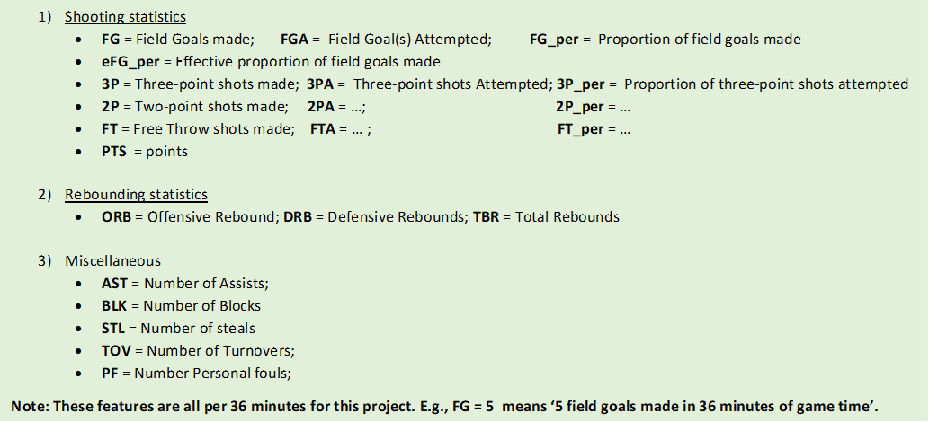

# Shooting statistics

* Two-point shots = shots taken within the three-point arc (see figure 1). They are worth 2 points.
* Three-point shots = shots taken outside the three-point arc (see figure 1). They are worth 3 points.
* Free Three shots = shots taken from the free throw line typically after a player is fouled whilst in the action of shooting. They are worth 1 point.
* FG = 2P +3P
* FGA = 2PA +3PA
* PTS = $2P×2 + 3P×3 + FT×1$

# Rebounding Statistics

* Rebound = when a player grabs a loose ball from the air.
* ORB = when a player gets a rebound in the opponent’s half of the court.
* DRB = when a player gets a rebound in their team’s half of the court.
* TRB = ORB + DRB

# Miscellaneous Statistics

* Assist = the last pass made before a player makes a shot.
* Block = dispossessing a player from above shoulder height.
* Steal = dispossessing a player below shoulder height.
* Turnover = losing possession .
* Personal foul = fouling an opposing player.

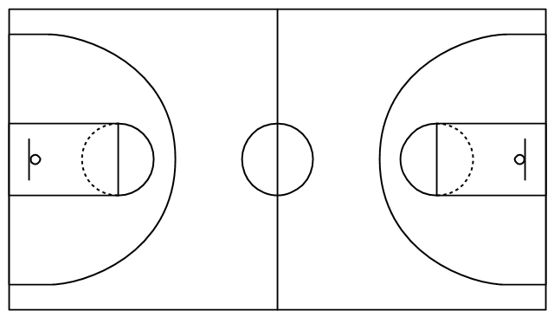

Three-point arc

Free Throw Line

Figure 1: Basketball Court schematic(<https://www.conceptdraw.com/examples/simple-basketball-court>)

# References

Basketball Court image: <https://www.conceptdraw.com/examples/simple-basketball-court>