**Name: Fawad Iqbal**  **RegNo:FA21-BSE-012**

**Task 1:**

**1: ls /bin ls/sbin**

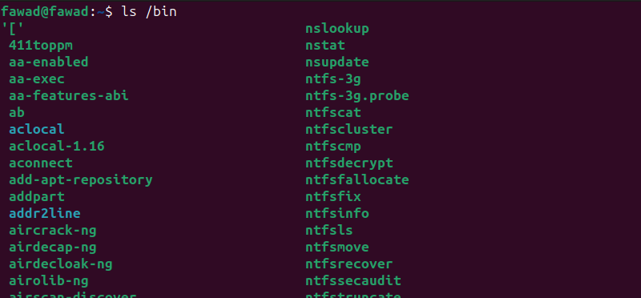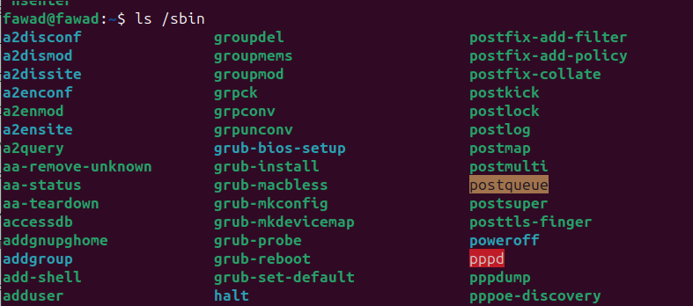**2: change dir to mydir 2**

**3:goto desktop**

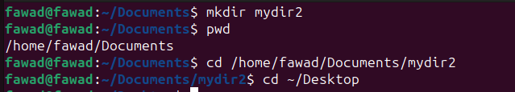

**4:writing contents from one to another file**

**5:combine two to create output**

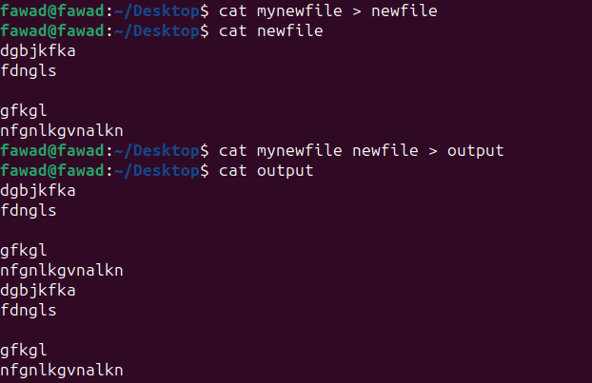**Task 2:**

**1: create a pulbic dir in root**

**2. testfile and change permission**

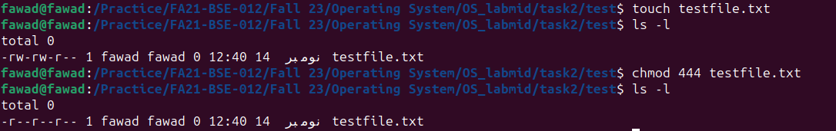

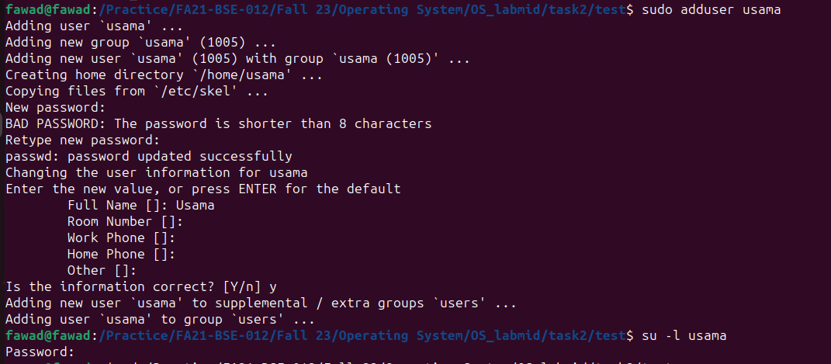**3. create a user usama run the shell as usama**

**4. read testfile from usama**

**5. logout usama**

**6. giving all permission**

**7. run shell as usama**

**8.read file from usama**

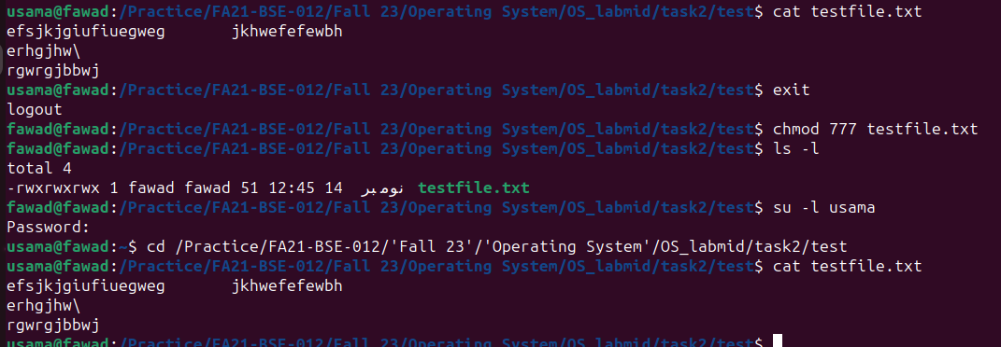

**Task 3:**

**1: sort command**

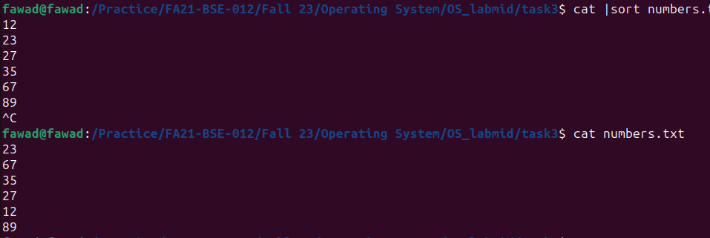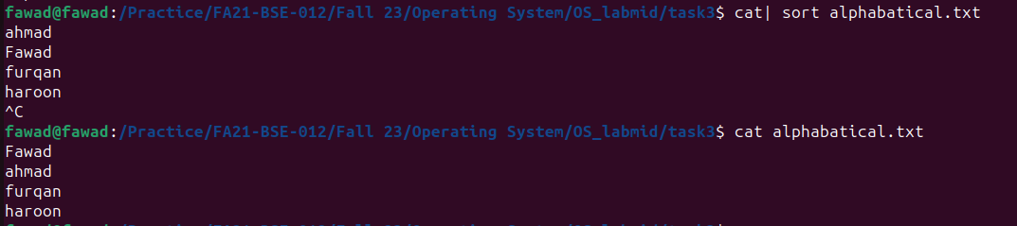

**2. head tail**

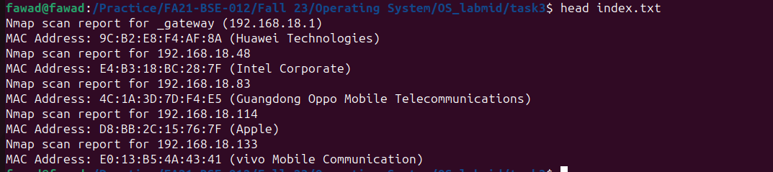

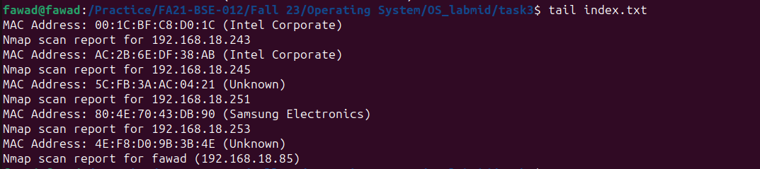

**3. Find last three lines**



**4. print lines words bytes**

**5.nice renice packettracer**

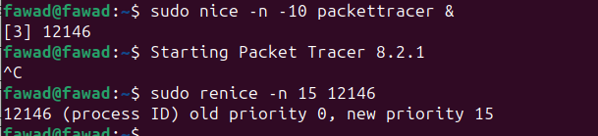

**Task 4:**

**1. Code**

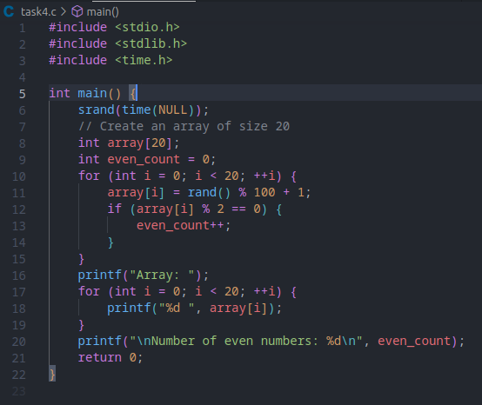

**Output:**

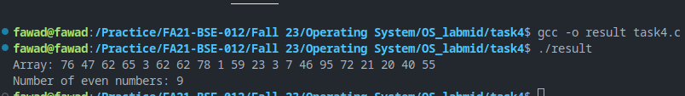

**Task 5:**

**Code:**

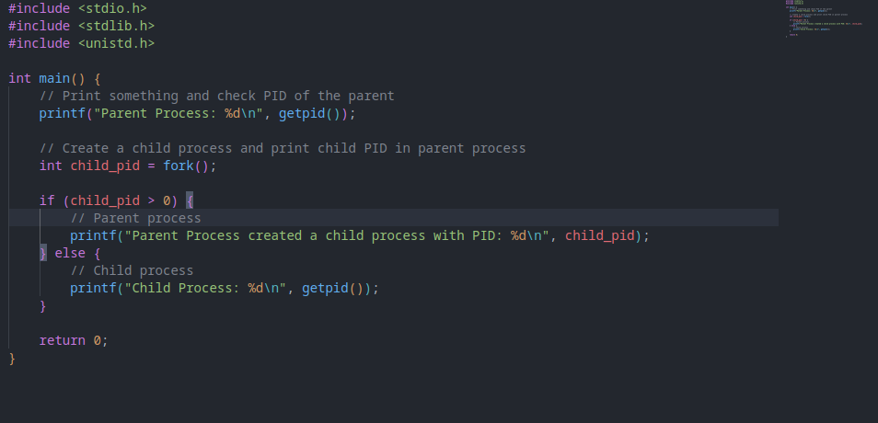

**OUTPUT:**

