**Name: Fawad Iqbal**

**Reg No: FA21-BSE-012**

**Control Flow Graph:** 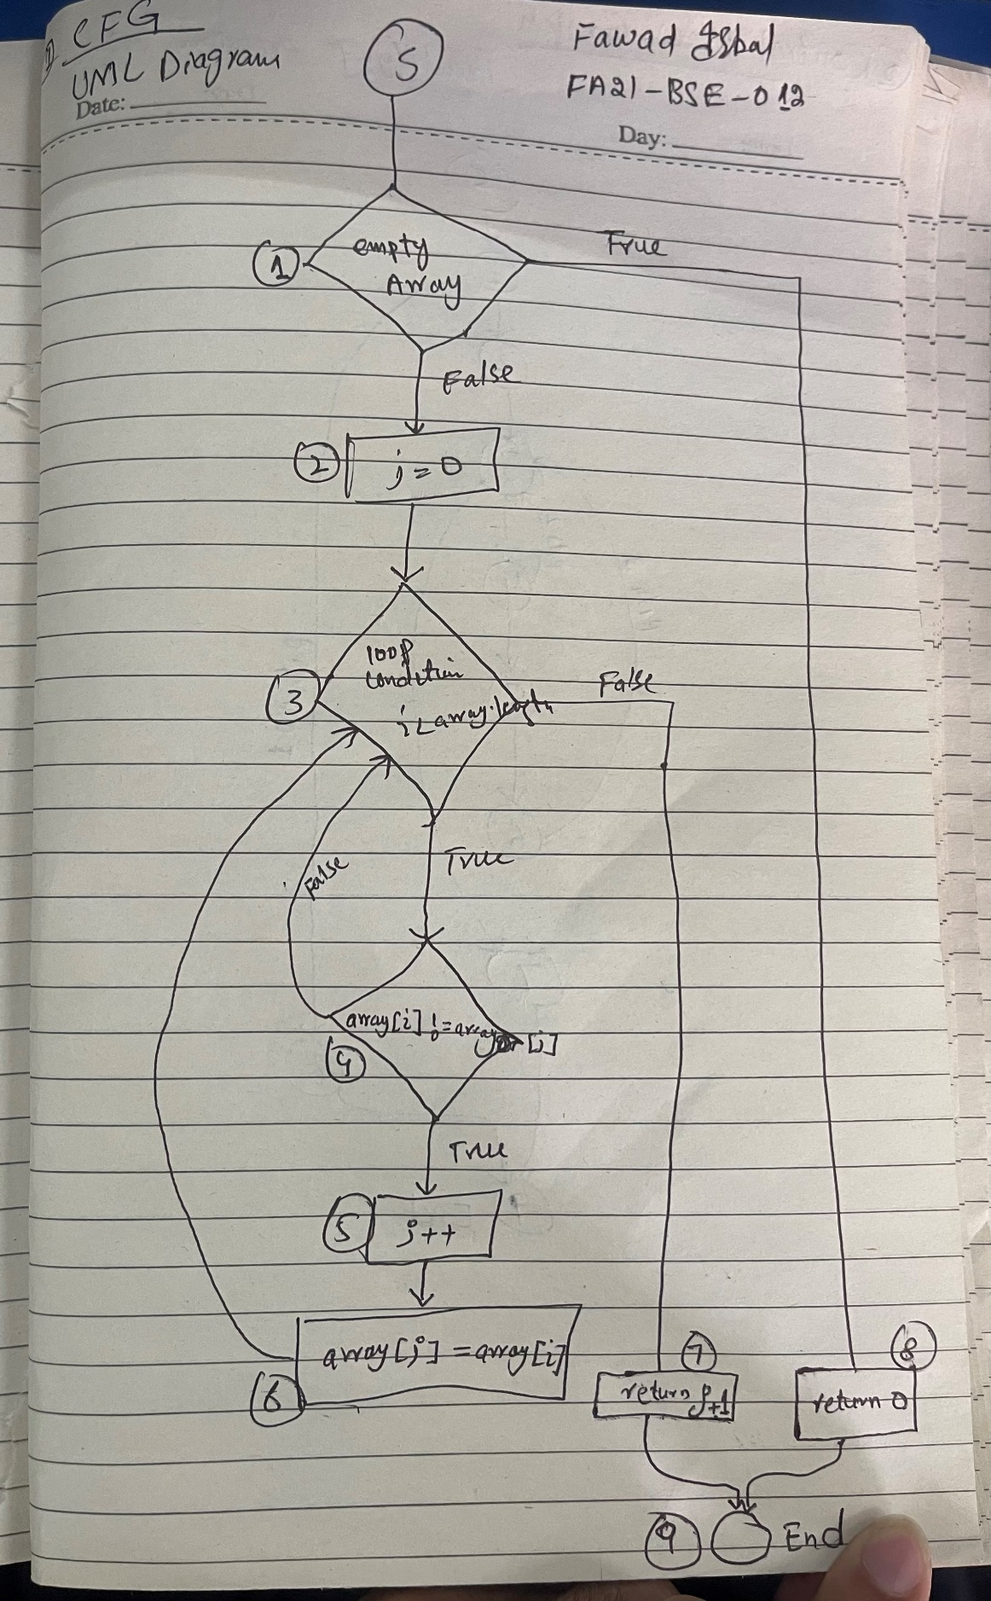

**Test Cases:**

|  |  |  |  |  |
| --- | --- | --- | --- | --- |
| **Test Case No** | **Description** | **Expected Value** | **Actual Value** | **Status** |
| 1 | Empty array | 0 | 0 | Passed |
| 2 | Array with no duplicates | 3 | 3 | Passed |
| 3 | Array with duplicates | 3 | 3 | Passed |