Nama : Fawaz Al Rasyid

NIM : 1301213016

Stack.h

Stack.cpp

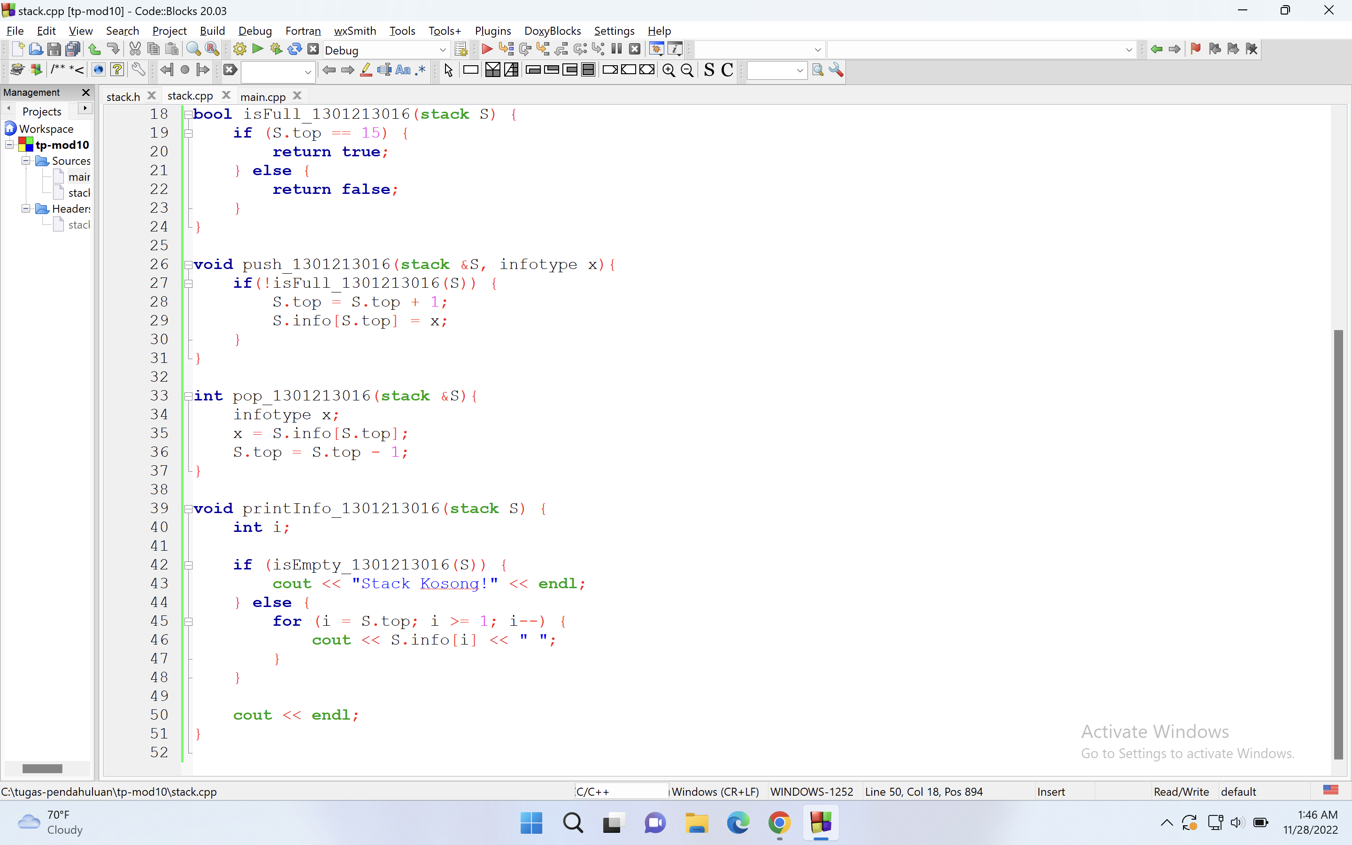

Main.cpp

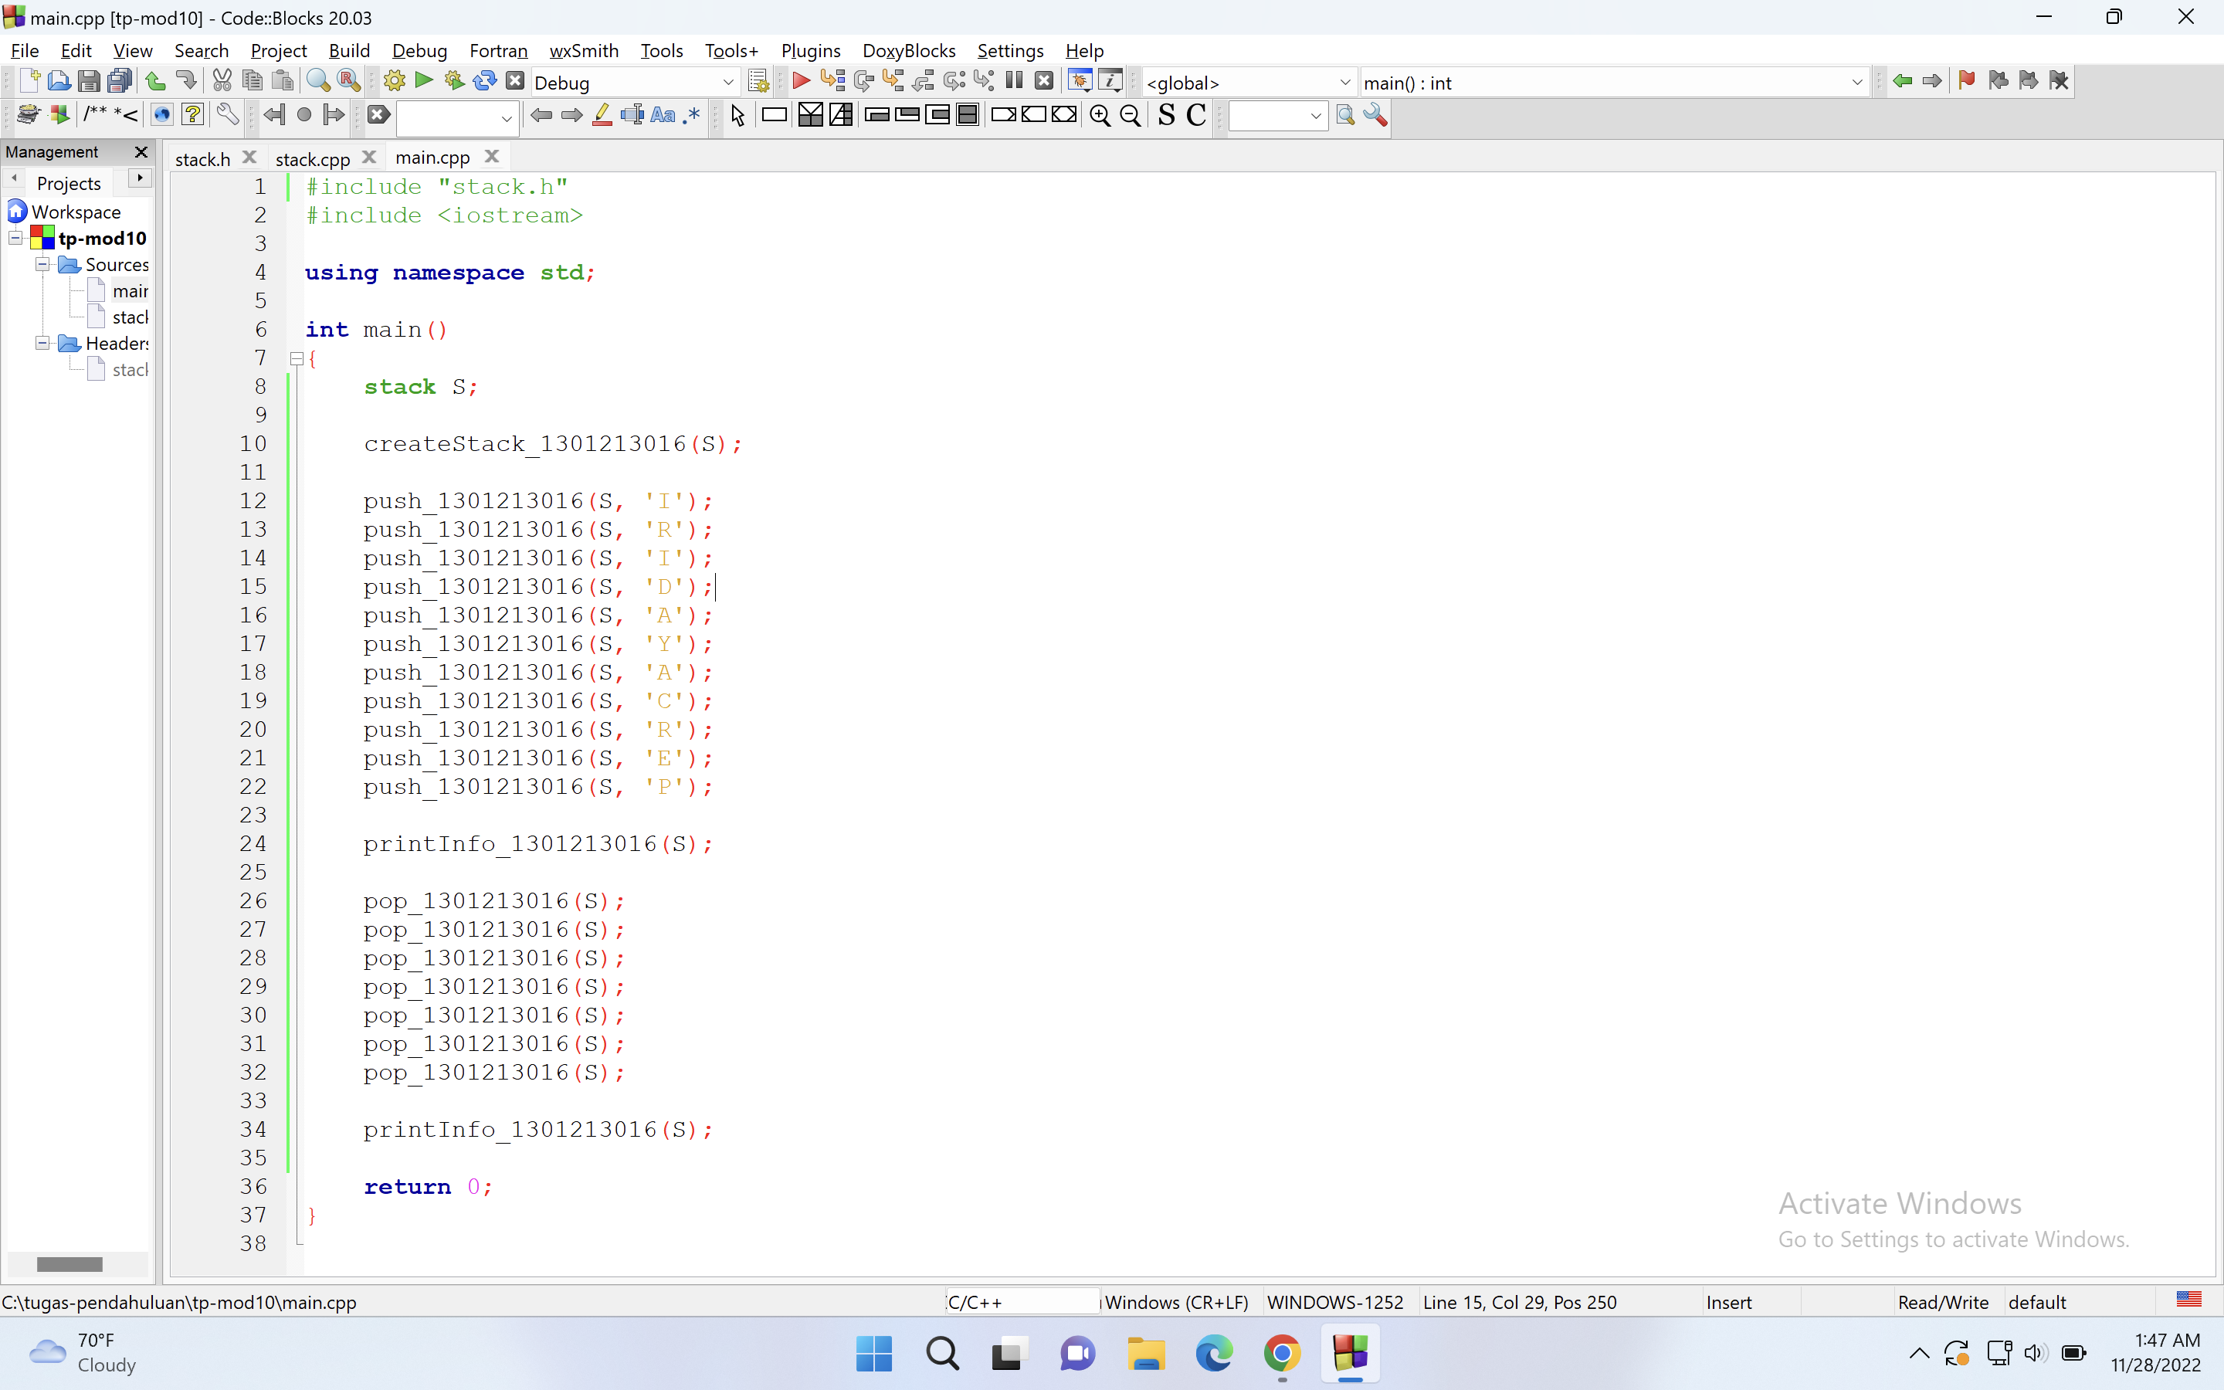

Output

