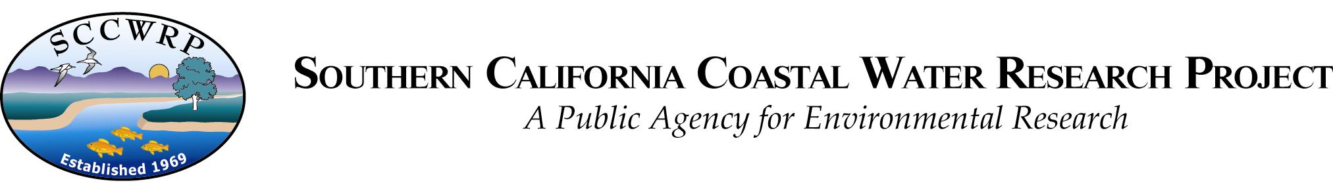

February 16th, 2019

Dr. Charles Hawkins
Chief Editor
Freshwater Science

I am pleased to submit our manuscript, “The importance of open science for biological assessment,” to be considered as a perspectives article in Freshwater Science.

Open science methods that promote transparency, accessibility, and reproducibility have been advocated as valuable tools in the environmental sciences. To date, these methods are uncommon in the bioassessment community despite the potential for open science to effectively bridge the research-management divide. This manuscript reviews the basic principles of open science and provides an argument for how these tools can improve bioassessment applications between researchers, stakeholders, regulators, and managers. We offer tangible examples using a case study from California and provide a discussion of challenges and opportunities when adopting open science principles. We feel that the adoption of open science in bioassessment is long overdue and we present this work to facilitate how this can be accomplished.

We are submitting this paper with an example application that is the sole focus of a paper currently in review with FWS (“Prioritizing management goals for stream biological integrity within the developed landscape context”, manuscript no. 2018118). The previous submission describes the theory and application behind the example, whereas the content herein uses the open science principles applied in the example to demonstrate how these tools can benefit bioassessment implementation. There is little overlap between the two papers given that the previous describes our approach for bioassessment in “developed landscapes” and the current focuses on the elements of open science that were used.

Our organization agrees to submit payment for page charges if the paper is published. We are confident that readers of FWS will find this manuscript informative and appreciate the opportunity to publish our work in this venue.

Marcus W. Beck (marcusb@sccwrp.org), 714-755-3217
S. California Coastal Water Research Project
3535 Harbor Blvd. Suite 110
Costa Mesa, CA 92626

On behalf of my co-authors:

Raphael D. Mazor (raphaelm@sccwrp.org), Susanna T. Theroux (susannat@sccwrp.org), David J. Gillett (davidg@sccwrp.org), Casey O'Hara (ohara@nceas.ucsb.edu), Julia Stewart Lowndes (lowndes@nceas.ucsb.edu), Belize Lane (belize.lane@usu.edu), Greg Gearheart (greg.gearheart@waterboards.ca.gov)

