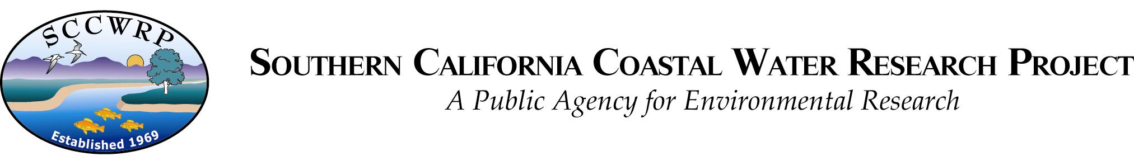

December 20th, 2017

Mark S. Peterson
Editor-In-Chief
Gulf and Caribbean Research

On behalf my co-authors, I am pleased to submit our revised manuscript, “Water quality trends following anomalous phosphorus inputs to Grand Bay, Mississippi, USA”, for publication in Gulf and Caribbean Research.

We sincerely thank the reviewers and associate editor for the helpful comments on our manuscript. Our revision includes a detailed response to each of these comments. Overall, we have 1) addressed the concerns of autocorrelation of the time series, 2) added information on the changepoint analysis, and 3) moved all supplementary figures and tables to the main text.

Please feel free to contact me with any questions or concerns about our submission. We appreciate the opportunity to publish our work with Gulf and Caribbean Research.

Sincerely,

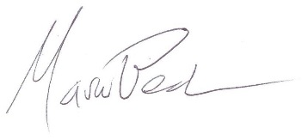

Marcus W. Beck, PhD
marcusb@sccwrp.org
714-755-3217

