Water quality trends following phosphorus inputs to Grand Bay, Mississippi, USA
Condensed title: Water quality trends in Grand Bay, MS

Kimberly Cressman¹, Cher Griffin¹, Jane Caffrey², and Marcus W. Beck³*

¹Grand Bay National Estuarine Research Reserve, Mississippi Department of Marine Resources, 6005 Bayou Heron Road, Moss Point, MS 39562

²Center for Environmental Diagnostics and Bioremediation, University of West Florida, 11000 University Parkway, Pensacola, FL 32514

³USEPA National Health and Environmental Effects Research Laboratory, Gulf Ecology Division, 1 Sabine Island Drive, Gulf Breeze, FL 32561

* Corresponding author, beck.marcus@epa.gov
Abstract
Grand Bay National Estuarine Research Reserve (GBNERR) is an 18,400-acre protected area in southeastern Jackson County, MS. In 2005, a levee breach at a fertilizer manufacturing facility released highly acidic and phosphate rich wastewater into the reserve. A second spill occurred in September 2012 following Hurricane Isaac. We used orthophosphate (PO₄) concentrations to categorize the two events, post-event periods, and an intervening period between the two spills. We examined patterns in nutrients, chlorophyll, pH and other parameters within and between time periods. After the first event, pH at the Bangs Lake water quality station decreased to 3.7, returning to background levels after several days. PO₄ increased to over 4 mg/L compared to background levels below the detection limit of 0.01 mg/L. PO₄ concentrations slowly declined to baseline levels after approximately one year and remained at or below detection limits until the second event. Sampling three weeks after Hurricane Isaac showed phosphate concentrations over 1 mg/L in Bangs Lake. Elevated PO₄ levels were detected at other monitoring locations for 3-5 months, depending on distance from the fertilizer facility. However, in Bangs Lake, phosphate remained elevated for over two years. Temporal patterns of other nutrients had apparent long-term trends, particularly increasing chlorophyll a and decreasing ammonium. Overall, this study provides a rare description of decadal water quality trends in a shallow, temperate estuary in response to discrete spill events with known causes.
Key Words: events, estuary, monitoring, phosphogypsum, trend
Introduction
Anthropogenic nutrient inputs into natural water bodies have been well-described and our view of eutrophication continues to evolve with new information (e.g., Cloern 2001). Most estuaries are nitrogen (N)-limited (Howarth and Marino 2006, Conley et al. 2009), though many, including Pensacola Bay (Murrell et al. 2002, Juhl and Murrell 2008), the Louisiana shelf (Sylvan et al. 2006), and several North Carolina estuaries (Mallin 1994), can exhibit seasonal phosphorus (P)-limitation. The potential effects of sustained inputs of non-limiting nutrients have been less studied, and there are few examples of long-term datasets that document the effects of phosphorus inputs to nitrogen-limited systems.
Grand Bay National Estuarine Research Reserve (GBNERR) is nitrogen-limited (Blackburn 2000, Amacker 2013, Baine 2017) and adjacent to a phosphate fertilizer production facility (Mississippi Phosphates Corporation, MPC; Fig. 1). MPC produced Diammonium Phosphate (DAP) fertilizer from the 1960s until late 2014. Calcium sulfate, or phosphogypsum, is a byproduct of this process; this waste is stored in large stacks that are rich in phosphorus and highly acidic. These waste products also include impurities such as radionuclides, heavy metals, ammonium, fluoride, and sulfide (Rutherford et al. 1994; Tayibi et al. 2009; USEPA 2015). Waste products from fertilizer production have been released into GBNERR on two occasions. The first event occurred in April 2005 when 43.2 cm of rainfall was recorded, of which 26 cm occurred in less than 24 hours. A levee containing the phosphogypsum stacks breached on April 14th causing a spill of 17.5 million gallons of wastewater. Damage to marsh vegetation, fish, and oysters at the Bangs Lake site of GBNERR was estimated at over $2 million (Viskup 2005; State of Mississippi 2008). The second event occurred from August 28th to 30th 2012, when 76 cm of rainfall was recorded from Hurricane Isaac (MPC 2012a; MPC 2012b). As permitted, MPC released overflow wastewater into Bayou Casotte to the west, whereas an unknown quantity was likely and unintentionally released to Bangs Lake to the east. A subsequent fish kill was observed in Bayou Casotte (MDEQ documents).
Very little is known regarding the long-term impacts on ecosystem condition of fertilizer inputs to nitrogen-limited estuaries. The few studies of the effects of phosphogypsum discharge have focused on relatively short periods of time or specific impacts given questions of interest. For example, Tampa Bay is a large nitrogen-limited estuary on the Gulf Coast of Florida that has historically received inputs from fertilizer manufacturing (Greening and Janicki 2006, Sherwood et al. 2015). Wastewater removal from phosphogypsum stacks was required following closure of a phosphate plant near southern Tampa Bay in 2001 (Garrett et al. 2011). The potential effects of effluent on the growth of harmful algal bloom (HAB) species was of concern, particularly for Karenia brevis. Although growth of K. brevis was not stimulated, other HAB species increased in abundance near the effluent, demonstrating differential species response to wastewater inputs (Garrett et al. 2011). An example in the Huelva estuary in Spain provided evidence suggesting phosphogypsum inputs contain additional impurities. Perez-Lopez et al. (2007) and Perez-Lopez et al. (2010) found that uranium and other heavy metals are present in higher concentrations in phosphogypsum than in raw phosphate ore and are readily mobilized in the environment.
In this analysis, we examined the effects of two different discharge events of MPC wastewater to GBNERR using ten years of continuous monitoring data. To our knowledge, this is the first study to examine the long term effects of phosphorus inputs on a shallow, nitrogen-limited estuary, particularly regarding byproducts of fertilizer production. We hypothesized that phosphogypsum spills would lead to significant differences in water quality parameters (salinity, pH), dissolved nutrients (nitrate, ammonium and phosphate), and chlorophyll a. However, the effects were expected to vary based on distance from the source, time following inputs, and the nature of each spill (short-term vs long-term). Long-term monitoring programs often have goals of detecting and describing change, and results from these programs can be used to guide management decisions. As such, the results presented herein demonstrate the utility of a long-term dataset in studying the effects of phosphorus inputs in the estuary, with relevance for coastal systems in the Gulf of Mexico.
Materials and Methods
Study Area
GBNERR was established in 1999 as one of 29 reserves in the National Estuarine Research Reserve (NERR) System (http://oceanservice.noaa.gov/ecosystems/nerrs/, Fig. 1). The estuary covers approximately 18,400 acres of coastal habitat and is shallow with a mean depth of 0.9 m (GBNERR 2013). Tides are diurnal and microtidal with a mean range of 0.6 m (Peterson et al. 2007, GBNERR 2013). Salinity ranges from 0-30, with a long-term median of 22 (GBNERR 2013). The reserve is a retrograding delta system and does not have significant freshwater inflows except during flood events with inputs from the Escatawpa River. GBNERR also has extensive bayou systems where water originates from localized runoff and groundwater (GBNERR 2013). The watershed of GBNERR is generally undeveloped (GBNERR 2013) and nutrients are low compared to similar systems. However, failing septic systems in the watershed have likely contributed to elevated levels of fecal coliform (LaSalle 1997, MSU-CREC 2000). The NOAA 30-year climate normal (1981-2010) for total annual precipitation in Pascagoula is 166 cm (NOAA NCDC 2015).
Monitoring Data
Monitoring stations at GBNERR were installed in 2004 as part of the System Wide Monitoring Program (SWMP, Wenner et al. 2004). The original stations include four continuous water quality stations (Bayou Heron, BH; Bayou Cumbest, BC; Bangs Lake, BL; and Crooked Bayou, CR) and one weather station (Fig. 1). For this analysis, we did not include Bayou Heron data since it has a very different hydrologic regime than the other monitoring stations. Monthly nutrient sampling at the water quality stations began in March 2005. An additional nutrient monitoring station, Bangs North (BN), was added in May 2005 after the first phosphate spill. The Point aux Chenes (PC) station was established in August 2005 with removal of the Crooked Bayou station. All data at GBNERR are publically available, including data from all 28 NERR sites (www.nerrsdata.org).
Water quality characteristics were logged every 15 minutes by YSI dataloggers for water temperature, specific conductance, salinity, dissolved oxygen, pH, turbidity, and depth. Loggers were deployed 0.5 m above the bottom before August 2005 and 0.25 m afterwards. Weather data were logged using a Campbell Scientific datalogger and included air temperature, relative humidity, barometric pressure, wind speed and direction, photosynthetically active radiation (PAR), and precipitation every 15 minutes. The weather station was destroyed by Hurricane Katrina on August 29, 2005, and replaced on June 21, 2006. Missing weather data were supplemented with data from the Pascagoula, MS airport (station code KPQL; 4/1-5/12 2005; 8/29/05 – 6/21/06; and 9/14-9/28 2012). All monitoring data were previously verified by NERR staff and manually checked by the authors. For water quality and weather data, only data points that passed quality checks were analyzed.
Duplicate nutrient and chlorophyll a grab samples were collected monthly during low tide at each water quality monitoring station. Diel samples were also collected monthly using an ISCO automated water sampler at a single station for each calendar year. The ISCO was programmed to sample every 2 hours and 5 minutes over a complete tidal cycle. All nutrient samples (grab and diel) were placed on ice and filtered through glass fiber filters in the lab (CITE NUT SOPs). Samples were analyzed for ammonium (NH₄), nitrite/nitrate (NO₂⁻/NO₃²⁻), orthophosphate (PO₄), and chlorophyll a. NH₄, NO₂⁻/NO₃²⁻, and PO₄ were analyzed colorimetrically (American Public Health Association 1998). Chlorophyll a was analyzed using the spectrophotometric acidification method through April 2007 (American Public Health Association 1998) and using the Welschmeyer (1994) fluorometric method with a Turner trilogy starting in May 2007. Only fluorometric chlorophyll data starting in 2007 were used for analysis because of improved sensitivity. Minimum detection limits (MDLs) at GBNERR have changed over time. All nutrient values below the highest MDL of 0.01 mg/L were changed to 0.01 for this analysis. As described below, statistical analysis of the nutrient data accounted for left-censored observations.
Time Periods
The dataset was divided into six time periods based on phosphate concentrations at the Bangs Lake and Bangs North stations and occurrence of the spill events in 2005 and 2012 (Table 2, Fig. 2). Each of the two major events were divided into ‘acute’ and ‘chronic’ periods, where acute was the initial stage immediately following each event with extremely high phosphate, and chronic was the period where phosphate was higher than baseline concentrations but lower than the acute period. Two non-impact (NI) periods were also identified as baseline conditions: NI1 between the two major events and NI2 after fertilizer production stopped in December 2014. These divisions were generally supported by a changepoint analysis that identified continuous periods of time within which the statistical properties of the phosphorus time series were similar (Killick and Eckley, 2014). Between-group comparisons using alternative statistical approaches are further described below.
Statistical Analyses
Nutrient and water quality parameters collected from 2004 through 2015 were evaluated using descriptive statistics to interpret changes over time in relation to each event. In addition to time series plots for each variable, differences in phosphorus concentrations between sites were evaluated using boxplot summaries to examine distributions within the time frames. These plots were used to visually assess the extent and magnitude of changes in phosphorus concentrations from acute to non-impact years following each event. Based on our hypotheses, we expected the relative magnitudes between sites and each event period to differ. Sites closest to the spill locations (Bangs North, Bangs Lake) were expected to have elevated nutrient concentrations that persisted longer than sites that were farther or more hydrologically distinct from those near the spill locations (Bayou Cumbest, Point aux Chenes).
Non-parametric statistical tests were used to evaluate differences in phosphorus concentrations between time frames and within each site. A non-parametric or rank-based approach was required because numerous observations were at or below the minimum detection limit, particularly for the non-impact years. For each site, overall differences between time frames were evaluated using a Kruskal-Wallis one-way analysis of variance (ANOVA) followed by multiple comparisons using two-sided Mann-Whitney U tests (Hollander and Wolfe, 1999). Probability values were adjusted using the sequential Bonferroni method described in Holm (1979) to account for the increased probability of Type I error rates with multiple comparisons. An adjusted p-value less than 5% (α = 0.05) was considered a significant difference between time frames or sites. Finally, we examined long term trends in nutrient and chlorophyll a data using the non-parametric Seasonal Kendall Tau (Jassby and Powell 1990, Tian and Fernandez 1999, Helsel and Hirsch 2002). Trend tests were not used to evaluate NO₂⁻/NO₃²⁻ because more than 50% of the data were below detection.
Results
Site characteristics
Data from the GBNERR monitoring sites are summarized in Table 1. Point aux Chenes was the most ocean-influenced, with a median salinity of 24.3 and pH of 8.1. Bayou Cumbest was the most freshwater-influenced site, with lower salinity and pH, particularly after rainfall events. Dissolved oxygen was generally high at all sites. Median saturation values above 90% were observed at Bangs Lake and Point aux Chenes. Bayou Cumbest had a lower median saturation of 80.9%. Orthophosphate concentrations were highest at Bangs Lake and Bangs North. Chlorophyll a median values ranged from 5.0-6.7 µg/L between sites, with the highest concentration observed at Bayou Cumbest (max chl a 47.7 µg/L). All sites had low concentrations of NO₂⁻/NO₃²⁻ and ammonium, usually below detection.
Average annual precipitation in the Reserve between 2005 and 2014 was 126 cm, lower than the 30-year average of 166 cm at Pascagoula airport (Arguez et al. 2011). 2006 and 2011 were dry years, in the lower 20th percentile of annual totals for the period of record (75 and 79 cm, respectively). 2012 and 2013 were in the upper 80th percentile, with annual totals of 164 and 196 cm. Seasonally, July and August were the wettest months within each year. Seasonal patterns were also observed for salinity and pH (Figure 2). For example, salinity at Bangs Lake was generally lowest from April to June and highest in November, similar to pH, which was lowest from May to July.
Event 1
Precipitation beginning on March 27th, 2005 produced a total of 43.2 cm of rainfall for the first event. Initial salinity measured at Bangs Lake was between 20-21, followed by a decrease to a minimum of 2.8 on April 2nd. The levee at MPC was breeched on April 14th with a recorded salinity between 7 and 15 (Fig. 3). Both pH and orthophosphate (PO₄) changed significantly following the breech. The Bangs Lake water quality station is sufficiently shallow such that the water drops below the sensors for a short time during extremely low tides. Observed pH was 7.2 before the tide dropped below the sensors on April 14th 2005 at 21:00 CST. The observed pH was 4.8 when the sensor was again submerged at 3:30 on April 15th. Over the following tidal cycle, pH increased to 8.1 at high tide then decreased to a minimum pH of 3.7 at 22:30. This minimum was the lowest for the event and for all values in the ten-year dataset. The pH increased slightly to 4.4 before the water level decreased again below the sensor at 23:00. Observed pH values remained above 6.0 after the sensor was immersed again on April 18th at 6:30. A changepoint analysis of pH for the time series around the first spill event suggested values returned to pre-spill levels on April 19th, with values approximating the mean and variance of the pH time series of the two weeks prior to the spill.
PO₄ concentrations in Bangs Lake on April 25th, 11 days after the levee breach, averaged 4.29 mg P/L (Fig. 4). PO₄ decreased gradually to 0.60 mg/L on August 16, 2005, the last sample before Hurricane Katrina. The first samples after Katrina were taken October 19th, with a mean PO₄ concentration of 0.084 mg P/L. PO₄ concentrations at Bangs Lake were between 0.01 and 0.025 mg P/L until April, 2006 when concentrations were consistently below 0.01 mg P/L (i.e., beginning of E1C period). PO₄ spiked again in November 2006 and January 2007, to 0.064 and 0.090 mg P/L respectively, but was otherwise below or close to the detection limit of 0.01 mg P/L (Fig. 4). Similarly, PO₄ at Bangs North remained elevated throughout the E1A time period until June 2006. Concentrations decreased below detection for a short time, then spiked repeatedly (up to 0.118 mg P/L) through January 2008 (Fig. 4). Elevated PO₄ was also observed at Bayou Cumbest to the north, with a concentration of 0.426 mg P/L during the April 2005 sampling (Fig. 4).
Event 2
A substantial amount of rain and over 2 m of storm surge was produced by Hurricane Isaac on August 28-30, 2012 (Fig. 3). Prior to the storm, observed pH at Bangs Lake ranged from 7.2-7.7 and salinity ranged from 22-25. The initial storm surge on August 28th increased the pH slightly to 7.6-8.0, whereas salinity was not affected. As the surge receded on August 31st, the observed salinity decreased to a minimum of 5.6 at 18:30 and pH ranged from 7-9. After the storm passed, pH decreased and varied between 6.5-6.9 from August 31st to September 3rd. pH remained generally low (6.6-7.0, with occasional increases up to 7.8) until September 13th, after which observations stayed above 7.0 (Fig. 3).
Three weeks after Hurricane Isaac, PO₄ concentrations were elevated in monthly grab samples, with the highest concentrations at Bangs North (1.16 mg P/L), Bangs Lake (0.97 mg P/L) and Point aux Chenes (0.16 mg P/L) (Fig. 4). Concentrations from monthly grab samples declined at all 3 stations over approximately five months to less than 0.089. In February 2013, concentrations at Bangs North and Bangs Lake increased to 0.78 mg P/L and 0.2 mg P/L, respectively. pH at Bangs Lake also increased to 9.6 on March 2nd. In contrast, changes in PO₄ concentrations were not as apparent at Bayou Cumbest following Isaac. However, ISCO diel samples collected at Bayou Cumbest in 2012 showed a change in PO₄ trends before and after the storm. PO₄ concentrations were near detection and showed little change in the 24 hour sampling periods prior to the storm, whereas concentrations were near detection at low tide but increased to 0.2 mg P/L at high tide three weeks following the storm (Fig. 5??). Salinity and pH also had a strong tidal signal with higher values at high tide. This pattern persisted through 2012, with lower PO₄ concentrations each month.
Differences between sites and time periods
Within sites, Bangs North consistently had the highest PO₄ concentrations given its location near the fertilizer plant (Table 3). Bangs Lake had the second highest concentrations followed by Point aux Chenes and Bayou Cumbest, with the latter having the lowest median concentrations among all sites. These spatial patterns were consistent across all time frames (Table 4). Over time, PO₄ was highest in the initial phases of each event and decreased throughout. A notable exception was Point aux Chenes, which had the highest PO₄ concentrations during the E2C time period.
Within time frames, there were no significant differences between sites in NO₂⁻/NO₃²⁻ (Table S4), nor chl a concentrations (Table S6). Similar results were observed for NH₄ (Table S2), although Bangs North and Bayou Cumbest had significantly higher concentrations than Bangs Lake and Point Aux Chenes during NI1. The highest PO₄ concentration for Bayou Cumbest occurred in E1A. None of the time periods were significantly different from the others at this site (Fig. 6; Table 3). At Point aux Chenes, there were no obvious trends based on time period, although median PO₄ was highest in the E2C time period (Fig. 6, Table 4).
Interestingly, an increasing trend of chlorophyll a was observed at all sites (Fig S1), although this was not apparent between the time period designations (Table S5). A seasonal Kendall trend test showed a significant positive change, ranging from an increase of 19% per year to 36% per year depending on site. NH₄ concentrations did not vary significantly by time period (Fig. S1, Table S1), although seasonal Kendall tests by site showed a slight negative trend. NO₂⁻/NO₃²⁻ did not vary by time periods (Fig S1, Table S3).
Discussion
The characteristics of each event differed considerably across space and time, while both had significant ecological impacts within Grand Bay. The first event was characterized by PO₄ concentrations above 4 mg P/L, salinity below 3 and pH values below 5. Similarities with the second event were only observed in phosphorus concentrations, such that salinity and pH trends following Hurricane Isaac were not comparable to the first event. Although both events contributed to high concentrations of phosphorus in Grand Bay, differences in other water quality parameters are likely attributable to the different causes of each event. The first was a discrete spill caused by a documented and well-monitored levee breach. Discharge from the plant is managed by MPC through a canal with a backflow preventer adjacent to Bangs Lake. Automated sampling for pH and DO occurs in the canal if the backflow preventer is engaged. This automated sampling is supplemented with in situ data if water with sufficiently low pH is discharged into Bangs Lake, and grab samples for nutrients are also obtained if DO or pH values fall below established thresholds (K. McCullock, personal communication). MPC did not document a levee breach or other loss of containment discharged into Bangs Lake following Hurricane Isaac. Untreated wastewater was diverted to the west into Bayou Casotte, where a subsequent fish kill was observed (DEQ Documents). However, a plume of turbid water in Bangs Lake adjacent to the phosphogypsum stacks was observed from remote imagery (http://storms.ngs.noaa.gov), which suggests significant and undocumented discharge into Grand Bay.
The observed PO₄ concentrations following Isaac were 1,000 times higher than those observed for background conditions during the non-impact period. Independent samples collected four days after Isaac at the Bangs Lake SWMP station had a PO₄ concentration of 7 mg P/L (E.S. Darrow, unpublished data) and chlorophyll a of 60 µg/L (Condon 2015). PO₄ concentrations dropped below 0.01 mg P/L only after the plant was closed in December 2014. These observations are orders of magnitude higher than typical values in natural areas (Correll 1998, Hand et al. 2009). Additional sources of PO₄ from the watershed that could have caused the observed concentrations are unlikely given that most of the area is forested. Effluent from the phosphogysum stacks is a likely source of reduced water quality during the second event, although documentation is unavailable. Moreover, observed pH was never below 6.5 after Isaac in contrast to the first spill event. This could suggest that the water mass was from a different part of the fertilizer production process for both events. Alternatively, the wastewater path from the source to surface water could have differed between events, and perhaps a buffer mechanism intercepted wastewater flow following Isaac.
Effects of each spill on water quality were expected to be detected in other SWMP parameters, particularly ammonium, which is a known constituent of phosphogypsum waste (Rutherford et al. 1994; Tayibi et al. 2009). Other systems with phosphogypsum inputs show similarly high concentrations of PO₄ relative to DIN. For example, salt ponds in Sfax, Tunisia had average PO₄ concentrations of 4.5 mg P/L before restoration and 0.6 mg P/L after removal of contaminated sediments (Kobbi-Rebai et al. 2012). Similarly, average DIN in the salt ponds declined from 1.2 to 0.17 mg N/L after restoration. Effects were also observed in nearby coastal waters which had PO4 concentrations of 1.2 mg P/L and DIN concentrations of 0.14 mg N/L (Rekik et al. 2012). A similar study showed that water quality stations near a fertilizer plant in the Kavala Gulf, Greece had comparable ratios of PO₄ to DIN concentrations (Sylaios et al. 2005). These studies are similar to the results for Grand Bay shown in Figure S1, such that elevated nitrogen (NH₄ and NO₂⁻/NO₃²⁻) was also observed with the elevated phosphorus concentrations. These results were supported by significant within-site differences between time periods for each analyte (Tables S1, S3).
Phosphorus concentration and primary production were uncorrelated, which contrasts with Blackburn (2000). He found positive correlations between total phosphorous and chlorophyll a in Bayou Casotte, where MPC effluent was discharged during the study period. However, Bayou Casotte receives direct effluent from the plant’s outfall, which is a more direct mode of entry than either of our recorded events. Further, Blackburn (2000) evaluated total phosphorus, whereas the data herein included only inorganic orthophosphate. In the Peace River and Charlotte Harbor estuary, impacted by the phosphate fertilizer industry, phytoplankton uptake of nitrate and phosphate resulted in peak chlorophyll a concentrations of 52 ug/L, followed by a reduction in nitrate from 0.7 to 0.03 mg N/L and phosphate from 2.8 to 0.8 mg P/L (Froelich et al. 1985). Excess phosphorus is exported from the system after the nitrogen is removed by primary production. A similar export process to the open marine system could occur in Bangs Lake and the remainder of Grand Bay. Recent studies suggest that sequestration of excess phosphate in sediments is also occurring (K. Dillon and R. Carmichael, pers. Comm.). Nutrient bioassay experiments showed that phytoplankton growth in Grand Bay is stimulated by nitrogen rather than phosphorus, both before the 2012 spill (Amacker 2013) and in recent experiments (Baine 2017). Although we did not show a definitive link between observed phosphorus and primary production, the recent increase in chlorophyll in Figure S1 should be further evaluated.
The potentially negative impact of excess phosphorus on ecosystem condition depends on site-specific characteristics. Nationally, criteria from the U.S. EPA used in the National Coastal Condition assessment ranks waters with less than 0.01 mg/L of phosphorus in good condition, between 0.01 and 0.05 mg/L as fair, and greater than 0.05 mg/L as poor (US EPA 2006). Based on these criteria, Bangs Lake and Bangs North had poor conditions during both the E1A and E2A periods and generally fair conditions during E1C and E2C. Correll (1998) suggested that total phosphorus greater than 0.02 mg/L could be sufficient for excessive primary production in many systems. Although our observations included only inorganic phosphorus, concentrations at both Bangs Lake and Bangs North were well above 0.02 mg/L. More detailed and focused analyses beyond the routine monitoring data could identify further effects of each spill event, both in past observations and potential changes in water quality.
Our analysis focused primarily on basic water quality parameters and dissolved nutrient concentrations. Additional contaminants, such as trace metals and radionuclides, are associated with phosphogypsum waste and the potential impacts beyond water quality changes are unknown in Grand Bay. Recent research has focused on more detailed assessments of the spill effects by evaluating profiles of trace metal in sediment cores (R. Carmichael, personal communication). This work is ongoing and the results could help identify additional contaminants and potential effects from each spill event. A Phosphate Working Group has also been established with the objective of better describing the fate and transport of phosphorus in Grand Bay. These recent initiatives were motivated by the information from routine monitoring data in Grand Bay NERR, the importance of which is further highlighted by our analysis above. A continuous record of data is not only important to provide a historical context of past events, but is essential to maintain for future studies that further develop our understanding of nutrient limitation in coastal systems.
Acknowledgments
We thank (earlier SWMP techs – Christine Walters-Williams), Mark Woodrey, CDMO? NOAA/NERR funding?… J.Caffrey was supported by funding by MWRRI (I have to look up the grant numbers). Mississippi Department of Marine Resources, Shelby Barrett (made the map), David Ruple
Literature Cited
Amacker, K. S. 2013. Comparison of nutrient and light limitation in three Gulf of Mexico estuaries. M.Sc. thesis. University of West Florida, Pensacola, FL, USA. 82 p.
American Public Health Association. 1998. In: L.S. Clesceri, A.E. Greenberg, and A.D. Eaton, eds. Standard Methods for the Examination of Water and Wastewater, 20th ed. American Public Health Association, Washington, DC, USA.
Arguez, A., I. Durre, S. Applequist, R.S. Vose, M.F. Squires, X. Yin, R.R. Heim Jr. and T.W. Owen. 2012. NOAA's 1981–2010 US Climate normals: an overview. Bulletin of the American Meteorological Society 93:1687-1697. http://dx.doi.org/10.1175/BAMS-D-11-00197.1
Baine, G. C. II 2017. Effects of nutrient input and microzooplankton grazing on phytoplankton productivity in the Grand Bay Estuary, Mississippi. M.Sc. thesis. University of West Florida, Pensacola, FL, USA, 65 p.
Blackburn, B.R. 2000. The effects of industrial and cultural development on phytoplankton community dynamics within three bayou systems of Jackson County, Mississippi. M.Sc. thesis. The University of Southern Mississippi, Hattiesburg, MS, USA, 138 p.
Cloern, J.E. 2001. Our evolving conceptual model of the coastal eutrophication problem. Marine Ecology Progress Series 210:223–253. doi:10.3354/meps210223.
Condon, E.D. 2015. Biogeochemical and microbial indicators of land-use change in a Northern Gulf of Mexico estuary. Ph.D. thesis. University of South Alabama, Mobile, AL, USA, 228 p.
Conley, D.J., H.W. Paerl, R.W. Howarth, D.F. Boesch, S.P. Seitzinger, K.E. Havens, C. Lancelot, and G.E. Likens. 2009. Controlling eutrophication: nitrogen and phosphorus. Science 323:1014-1015. doi:10.1126/ science.1167755.
Correll, D.L. 1998. The role of phosphorus in the eutrophication of receiving waters: a review. Journal of Environment Quality 27: 261-266. doi:10.2134/jeq1998.00472425002700020004x.
Froelich, P.N., L.W. Kaul, J.T. Byrd, M.O. Andreae, and K.K. Roe. 1985. Arsenic, barium, germanium, tin, dimethylsulfide and nutrient biogeochemistry in Charlotte Harbor, Florida, a phosphorus-enriched estuary. Estuarine Coastal and Shelf Science 20:239–264. doi:10.1016/0272-7714(85)90041-1.
Garrett, M., J. Wolny, E. Truby, C. Heil, and C. Kovach. 2011. Harmful algal bloom species and phosphate-processing effluent: field and laboratory studies. Marine Pollution Bulletin 62:596–601. doi:10.1016/j.marpolbul.2010.11.017.
Grand Bay National Estuarine Research Reserve (GBNERR). 2013. Grand Bay National Estuarine Research Reserve Management Plan 2013-2018. Mississippi Department of Marine Resources, Moss Point, MS, USA, 104 p.
Greening, H., and A. Janicki. 2006. Toward reversal of eutrophic conditions in a subtropical estuary: Water quality and seagrass response to nitrogen loading reductions in Tampa Bay, Florida, USA. Environmental Management 38:163-178. doi: 10.1007/s00267-005-0079-4
Hand, J., N. Lewis, and L. Lord. 2009. Typical Water Quality Values for Florida Lakes, Streams, Blackwaters, Coastal Waters, and Estuaries. Watershed Assessment Section, Bureau of Watershed Management. Florida Department of Environmental Protection. Tallahassee, FL. 81 pp.
Helsel, D.R., and R.M. Hirsch. 2002. Statistical Methods in Water Resources. Techniques of Water Resources Investigations, Book 4, chapter A3. U.S. Geological Survey. 522pp.
Hollander, M.H., and D.A. Wolfe. 1999. Nonparametric statistical methods, 2nd ed. New York. Wiley and Sons. 68-75.
Holm, S. 1979. A simple sequentially rejective multiple test procedure. Scandinavian Journal of Statistics 6: 65-70.
Howarth, R.W., and R. Marino. 2006. Nitrogen as the limiting nutrient for eutrophication in coastal marine ecosystems: Evolving over three decades. Limnology and Oceanography 51: 364–376. doi:10.4319/lo.2006.51.1_part_2.0364.
Jassby, A. D., & Powell, T. M. (1990). Detecting changes in ecological time series. Ecology, 71(6), 2044-2052.
Juhl, A.R., and M.C. Murrell. 2008. Nutrient limitation of phytoplankton growth and physiology in a subtropical estuary (Pensacola Bay, Florida). Bulletin of Marine Science 82: 59–82.
Killick, R., and I.A. Eckley. 2014. Changepoint: An R package for changepoint analysis. Journal of Statistical Software 58: 1-19.
Kobbi-Rebai, R., N. Annabi-Trabelsi, H. Khemakhem, H. Ayadi, and L. Aleya. 2012. Impacts of restoration of an uncontrolled phosphogypsum dumpsite on the seasonal distribution of abiotic variables, phytoplankton, copepods, and ciliates in a man-made solar saltern. Environmental Monitoring and Assessment 185: 2139–2155. doi:10.1007/s10661-012-2695-9.
LaSalle, M.W. 1997. Water Quality Monitoring of Shellfish Growing Waters and Residential Rock-Reed Wastewater Treatment Systems at Bayou Cumbest, Mississippi. Final Report to the Gulf of Mexico Program. 58 pp.
Mallin, M. A. (1994). Phytoplankton ecology of North Carolina estuaries. Estuaries and Coasts, 17(3), 561-574.
Mississippi Phosphates Corporation (MPC). 2012a. Attachment I to August, 2012 Outfall 002 DMR. Daily Rainfall Received, Inches. Obtained from Mississippi Department of Environmental Quality via Public Records Request 7/27/2015.
Mississippi Phosphates Corporation (MPC). 2012b. Attachment II to August, 2012 Outfall 002 DMR. Report of circumstances necessitating treatment and discharge of water from outfall 002. Obtained from Mississippi Department of Environmental Quality via Public Records Request 7/27/2015.
Mississippi State University Coastal Research and Extension Center (MSU-CREC). 2000. Fecal Coliform TMDL for Bayou Cumbest/Bangs Lake Watershed, Coastal Streams Basin, Jackson County, MS. Prepared for the Mississippi Department of Environmental Quality. Approved Final Version May 5, 2000.
Murrell, M.C., R.S. Stanley, E.M. Lores, G.T. DiDonato, Lisa M. Smith, and David A. Flemer. 2002. Evidence that phosphorus limits phytoplankton growth in a Gulf of Mexico estuary: Pensacola Bay, Flordia, USA. Bulletin of Marine Science 70: 155-167.
National Oceanic and Atmospheric Administration’s (NOAA) National Climatic Data Center 1981-2010 U.S. Climate Normals. https://www.ncdc.noaa.gov/cdo-web/datatools/normals. Accessed 15 October 2015.
Pérez-López, R., A.M. Álvarez-Valero, and J.M. Nieto. 2007. Changes in mobility of toxic elements during the production of phosphoric acid in the fertilizer industry of Huelva (SW Spain) and environmental impact of phosphogypsum wastes. Journal of Hazardous Materials 148: 745–750. doi:10.1016/j.jhazmat.2007.06.068.
Pérez-López, R., J.M. Nieto, I. López-Coto, J.L. Aguado, J.P. Bolívar, and M. Santisteban. 2010. Dynamics of contaminants in phosphogypsum of the fertilizer industry of Huelva (SW Spain): From phosphate rock ore to the environment. Applied Geochemistry 25. 705–715. doi:10.1016/j.apgeochem.2010.02.003.
Peterson et al. 2007 – from Site profile
Rekik, A., Drira, Z., Guermazi, W., Elloumi, J., Maalej, S., Aleya, L., & Ayadi, H. (2012). Impacts of an uncontrolled phosphogypsum dumpsite on summer distribution of phytoplankton, copepods and ciliates in relation to abiotic variables along the near-shore of the southwestern Mediterranean coast. Marine Pollution Bulletin, 64(2), 336-346.
Rutherford, P. M., Dudas, M. J., & Samek, R. A. (1994). Environmental impacts of phosphogypsum. Science of the Total Environment, 149(1-2), 1-38.
Sherwood, E.T., H.S. Greening, A.J. Janicki, and D.J. Karlen. 2015. Tampa Bay estuary: Monitoring long-term recovery through regional partnerships. Regional Studies in Marine Science. doi:10.1016/j.rsma.2015.05.005.
State of Mississippi. 2008. Mississippi Commission on Environmental Quality v. Mississippi Phosphates Corporation-Agreed Order No. 5357 08. 39pp. Obtained from Mississippi Department of Environmental Quality via Public Records Request 7/28/2015.
Sylaios, G., N. Stamatis, A. Kallianiotis, and P. Vidoris. 2005. Monitoring water quality and assessment of land-based nutrient loadings and cycling in Kavala Gulf. Water Resources Management 19: 713–735. doi:10.1007/s11269-005-3020-y.
Sylvan, J.B., Q. Dortch, D.M. Nelson, A.F.M. Brown, W. Morrison, and J.W. Ammerman. 2006. Phosphorus limits phytoplankton growth on the Louisiana shelf during the period of hypoxia formation. Environmental Science and Technology 40: 7548–7553. doi:10.1021/es061417t.
Tayibi, H., Choura, M., López, F. A., Alguacil, F. J., & López-Delgado, A. (2009). Environmental impact and management of phosphogypsum. Journal of Environmental Management, 90(8), 2377-2386.
Tian, J., & Fernandez, G. (1999). Seasonal trend analysis of monthly water quality data. Proceedings of the 7th Annual Western users of SAS software regional users group, 229-234.
Tomas, C. R., Peterson, J., & Tatters, A. O. (2007). Harmful algal species from Wilson Bay, New River, North Carolina: composition, nutrient bioassay and HPLC pigment analyses. Raleigh, NC: North Carolina Water Resources Research Institute Report, (369).
US EPA 2006 National Estuary Program Coastal Condition Report. U.S. Environmental Protection Agency, Washington DCUS
EPA 2015
Viskup, B. 2005. Memorandum Re: Monetary Damages due to spill at Mississippi Phosphates. 10/28/2005. Obtained from Mississippi Department of Environmental Quality via Public Records request.
Welshmeyer NA (1994) Fluorometric analysis of chlorophyll a in the presence of chlorophyll b and pheopigments. Limnology and Oceanography 39(8):1985-1992.
Wenner, E., D. Sanger, M. Arendt, A. F. Holland, and Y. Chen. 2004. Variability in dissolved oxygen and other water quality variables within the National Estuarine Research Reserve System. Journal of Coastal Research 45:17-38. doi:10.2112/SI45-017.1

Tables
TABLE 1. Site summaries of water quality (hourly) and nutrient (monthly) observations from 2005 to 2015. Units are mg P/L for orthophosphate or mg N/L for ammonium, or nitrate/nitrite, µg/L for chlorophyll a, percent for DOsat, and psu for salinity. Nutrient summaries are based on maximum likelihood estimates for left-censored data. Sites are BC: Bayou Cumbest, , BL: Bangs Lake, BN: Bangs North (no water quality data), and PC: Point aux Chenes.
Stations | Average |  | Median |  | St. Dev. |  | Min |  | Max
Chl-a
BC | 10.82 |  | 6.69 |  | 13.76 |  | 0.69 |  | 47.67
BL | 8.25 |  | 5.43 |  | 9.44 |  | 0.46 |  | 41.98
BN | 7.94 |  | 5.01 |  | 9.79 |  | 0.55 |  | 36.71
PC | 7.98 |  | 5.17 |  | 9.39 |  | 0.52 |  | 33.95
DOsat
BC | 80.12 |  | 80.9 |  | 19.11 |  | 1.8 |  | 221.9
BL | 92.05 |  | 93.1 |  | 16.26 |  | 8.6 |  | 297.7
PC | 97.08 |  | 97.9 |  | 15.52 |  | 8.4 |  | 221.9
NH₄⁺
BC | 0.04 |  | 0.01 |  | 0.08 |  | 0.01 |  | 0.21
BL | 0.02 |  | 0.01 |  | 0.06 |  | 0.01 |  | 0.18
BN | 0.03 |  | 0.01 |  | 0.07 |  | 0.01 |  | 0.16
PC | 0.02 |  | 0.01 |  | 0.06 |  | 0.01 |  | 0.42
NO₂⁻/NO₃²⁻
BC | 0.01 |  | 0.01 |  | 0.02 |  | 0.01 |  | 0.09
BL | 0.01 |  | 0.01 |  | 0.03 |  | 0.01 |  | 0.09
BN | 0.01 |  | 0.01 |  | 0.02 |  | 0.01 |  | 0.1
PC | 0.01 |  | 0.01 |  | 0.04 |  | 0.01 |  | 0.1
pH
BC | 7.26 |  | 7.3 |  | 0.46 |  | 5.1 |  | 9
BL | 7.75 |  | 7.7 |  | 0.37 |  | 3.7 |  | 9.6
PC | 8.06 |  | 8.1 |  | 0.22 |  | 7.? |  | 9
PO₄³⁻
BC | 0.01 |  | 0.01 |  | 0.03 |  | 0.01 |  | 0.43
BL | 0.09 |  | 0.01 |  | 2.13 |  | 0.01 |  | 4.29
BN | 0.12 |  | 0.02 |  | 0.9? |  | 0.01 |  | 1.29
PC | 0.01 |  | 0 |  | 0.02 |  | 0.01 |  | 0.16
Salinity
BC | 17.22 |  | 18 |  | 7.86 |  | 0.0 |  | 33.5
BL | 22.02 |  | 22.4 |  | 5.49 |  | 1.5 |  | 32.1
PC | 23.3 |  | 24.3 |  | 5.37 |  | 4.3 |  | 33.2

TABLE 2. Time periods evaluated for water quality changes at monitoring stations. See Figure 2 for a graphical depiction.
Identifier | Time period | Approximate dates
E1A | Event 1 Acute | Apr 2005 – Jun 2006
E1C | Event 1 Chronic | Jul 2006 – Jan 2008
NI1 | Non-Impact 1 | Feb 2008 – Aug 2012
E2A | Event 2 Acute | Sep 2012 – Dec 2013
E2C | Event 2 Chronic | Jan 2014 – Nov 2014
NI2 | Non-Impact 2 | Dec 2014 – Aug 2015

TABLE 3. Within site comparisons of monthly orthophosphate data for each time frame at Grand Bay. Values are within-group summaries of sample size, median, and ranges for orthophosphate by station and time frame. Result letters indicate time frames within each station that were not significantly different based on multiple comparisons with Mann-Whitney rank sum tests. P-values were adjusted using the sequential Bonferroni method to reduce the probability of Type I errors. Sites are BC: Bayou Cumbest, BL: Bangs Lake, BN: Bangs North, and PC: Point aux Chenes. Time frames are E1A: event 1 acute, E1C: event 1 chronic, NI1: non-impact 1, E2A: event 2 acute, E2C: event 2 chronic, and NI2: non-impact 2.
Site | Result | n | Median | Min | Max
BL
E1A | ab | 13 | 0.02 | 0.01 | 4.29
E1C | c | 19 | 0.01 | 0.01 | 0.09
NI1 | d | 52 | 0.01 | 0.01 | 0.03
E2A | a | 16 | 0.06 | 0.03 | 0.97
E2C | bc | 11 | 0.03 | 0.01 | 0.04
NI2 | bcd | 9 | 0.01 | 0.01 | 0.01
BN
E1A | ab | 10 | 0.18 | 0.03 | 1.29
E1C | cd | 14 | 0.02 | 0.01 | 0.12
NI1 | e | 48 | 0.01 | 0.01 | 0.09
E2A | a | 14 | 0.18 | 0.08 | 1.16
E2C | bc | 11 | 0.05 | 0.02 | 0.08
NI2 | d | 9 | 0.02 | 0.01 | 0.03
PC
E1A | a | 9 | 0.01 | 0.01 | 0.02
E1C | b | 18 | 0.01 | 0.01 | 0.01
NI1 | b | 52 | 0.01 | 0.01 | 0.02
E2A | a | 15 | 0.01 | 0.01 | 0.16
E2C | a | 11 | 0.02 | 0.01 | 0.06
NI2 | ab | 9 | 0.01 | 0.01 | 0.01
BC
E1A | a | 13 | 0.01 | 0.01 | 0.43
E1C | a | 19 | 0.01 | 0.01 | 0.01
NI1 | a | 52 | 0.01 | 0.01 | 0.01
E2A | a | 16 | 0.01 | 0.01 | 0.02
E2C | a | 11 | 0.01 | 0.01 | 0.01
NI2 | a | 9 | 0.01 | 0.01 | 0.01

TABLE 4. Within time frame comparisons of monthly orthophosphate data at Grand Bay. Values are within-group summaries of sample size, median, and ranges for orthophosphate by time frame and station. Result letters indicate stations within each time frame that were not significantly different based on multiple comparisons with Mann-Whitney rank sum tests. P-values were adjusted using the sequential Bonferroni method to reduce the probability of Type I errors. Sites are BC: Bayou Cumbest, BL: Bangs Lake, BN: Bangs North, and PC: Point aux Chenes. Time frames are E1A: event 1 acute, E1C: event 1 chronic, NI1: non-impact 1, E2A: event 2 acute, E2C: event 2 chronic, and NI2: non-impact 2.
Site | Result | n | Median | Min | Max
E1A
BL | bc | 13 | 0.02 | 0.01 | 4.29
BN | b | 10 | 0.18 | 0.03 | 1.29
PC | ac | 9 | 0.01 | 0.01 | 0.02
BC | a | 13 | 0.01 | 0.01 | 0.43
E1C
BL | ab | 19 | 0.01 | 0.01 | 0.09
BN | b | 14 | 0.02 | 0.01 | 0.12
PC | a | 18 | 0.01 | 0.01 | 0.01
BC | a | 19 | 0.01 | 0.01 | 0.01
NI1
BL | a | 52 | 0.01 | 0.01 | 0.03
BN | b | 48 | 0.01 | 0.01 | 0.09
PC | a | 52 | 0.01 | 0.01 | 0.02
BC | a | 52 | 0.01 | 0.01 | 0.01
E2A
BL | b | 16 | 0.06 | 0.03 | 0.97
BN | c | 14 | 0.18 | 0.08 | 1.16
PC | d | 15 | 0.01 | 0.01 | 0.16
BC | a | 16 | 0.01 | 0.01 | 0.02
E2C
BL | b | 11 | 0.03 | 0.01 | 0.04
BN | c | 11 | 0.05 | 0.02 | 0.08
PC | b | 11 | 0.02 | 0.01 | 0.06
BC | a | 11 | 0.01 | 0.01 | 0.01
NI2
BL | a | 9 | 0.01 | 0.01 | 0.01
BN | b | 9 | 0.02 | 0.01 | 0.03
PC | a | 9 | 0.01 | 0.01 | 0.01
BC | a | 9 | 0.01 | 0.01 | 0.01

TABLE S1. Within site comparisons of monthly ammonium data for each time frame at Grand Bay. Values are within-group summaries of sample size, median, and ranges for ammonium by station and time frame. Result letters indicate time frames within each station that were not significantly different based on multiple comparisons with Mann-Whitney rank sum tests. P-values were adjusted using the sequential Bonferroni method to reduce the probability of Type I errors. Sites are BC: Bayou Cumbest, BL: Bangs Lake, BN: Bangs North, and PC: Point aux Chenes. Time frames are E1A: event 1 acute, E1C: event 1 chronic, NI1: non-impact 1, E2A: event 2 acute, E2C: event 2 chronic, and NI2: non-impact 2.
Site | Result | n | Median | Min | Max
BL
E1A | ab | 12 | 0.04 | 0.01 | 0.18
E1C | a | 18 | 0.03 | 0.01 | 0.13
NI1 | ab | 49 | 0.01 | 0.01 | 0.08
E2A | ab | 16 | 0.01 | 0.01 | 0.06
E2C | b | 11 | 0.01 | 0.01 | 0.01
NI2 | b | 9 | 0.01 | 0.01 | 0.01
BN
E1A | a | 11 | 0.03 | 0.01 | 0.14
E1C | a | 15 | 0.03 | 0.01 | 0.16
NI1 | a | 45 | 0.02 | 0.01 | 0.1
E2A | a | 14 | 0.01 | 0.01 | 0.11
E2C | a | 11 | 0.01 | 0.01 | 0.04
NI2 | a | 9 | 0.01 | 0.01 | 0.02
PC
E1A | ab | 8 | 0.02 | 0.01 | 0.13
E1C | a | 17 | 0.04 | 0.01 | 0.42
NI1 | b | 49 | 0.01 | 0.01 | 0.07
E2A | ab | 16 | 0.01 | 0.01 | 0.05
E2C | b | 11 | 0.01 | 0.01 | 0.01
NI2 | b | 9 | 0.01 | 0.01 | 0.01
BC
E1A | a | 12 | 0.03 | 0.01 | 0.21
E1C | a | 18 | 0.03 | 0.01 | 0.2
NI1 | a | 49 | 0.02 | 0.01 | 0.13
E2A | a | 16 | 0.01 | 0.01 | 0.08
E2C | a | 11 | 0.01 | 0.01 | 0.06
NI2 | a | 9 | 0.01 | 0.01 | 0.08

TABLE S2. Within time frame comparisons of monthly ammonium data at Grand Bay. Values are within-group summaries of sample size, median, and ranges for ammonium by time frame and station. Result letters indicate stations within each time frame that were not significantly different based on multiple comparisons with Mann-Whitney rank sum tests. P-values were adjusted using the sequential Bonferroni method to reduce the probability of Type I errors. Sites are BC: Bayou Cumbest, BL: Bangs Lake, BN: Bangs North, and PC: Point aux Chenes. Time frames are E1A: event 1 acute, E1C: event 1 chronic, NI1: non-impact 1, E2A: event 2 acute, E2C: event 2 chronic, and NI2: non-impact 2.
Site | Result | n | Median | Min | Max
E1A
BL | a | 12 | 0.04 | 0.01 | 0.18
BN | a | 11 | 0.03 | 0.01 | 0.14
PC | a | 8 | 0.02 | 0.01 | 0.13
BC | a | 12 | 0.03 | 0.01 | 0.21
E1C
BL | a | 18 | 0.03 | 0.01 | 0.13
BN | a | 15 | 0.03 | 0.01 | 0.16
PC | a | 17 | 0.04 | 0.01 | 0.42
BC | a | 18 | 0.03 | 0.01 | 0.2
NI1
BL | b | 49 | 0.01 | 0.01 | 0.08
BN | a | 45 | 0.02 | 0.01 | 0.1
PC | b | 49 | 0.01 | 0.01 | 0.07
BC | a | 49 | 0.02 | 0.01 | 0.13
E2A
BL | a | 16 | 0.01 | 0.01 | 0.06
BN | a | 14 | 0.01 | 0.01 | 0.11
PC | a | 16 | 0.01 | 0.01 | 0.05
BC | a | 16 | 0.01 | 0.01 | 0.08
E2C
BL | a | 11 | 0.01 | 0.01 | 0.01
BN | a | 11 | 0.01 | 0.01 | 0.04
PC | a | 11 | 0.01 | 0.01 | 0.01
BC | a | 11 | 0.01 | 0.01 | 0.06
NI2
BL | a | 9 | 0.01 | 0.01 | 0.01
BN | a | 9 | 0.01 | 0.01 | 0.02
PC | a | 9 | 0.01 | 0.01 | 0.01
BC | a | 9 | 0.01 | 0.01 | 0.08

TABLE S3. Within site comparisons of monthly nitrate/nitrite data for each time frame at Grand Bay. Values are within-group summaries of sample size, median, and ranges for nitrogen by station and time frame. Result letters indicate time frames within each station that were not significantly different based on multiple comparisons with Mann-Whitney rank sum tests. P-values were adjusted using the sequential Bonferroni method to reduce the probability of Type I errors. Sites are BC: Bayou Cumbest, BL: Bangs Lake, BN: Bangs North, and PC: Point aux Chenes. Time frames are E1A: event 1 acute, E1C: event 1 chronic, NI1: non-impact 1, E2A: event 2 acute, E2C: event 2 chronic, and NI2: non-impact 2.
Site | Result | n | Median | Min | Max
BL
E1A | a | 14 | 0.01 | 0.01 | 0.06
E1C | ab | 19 | 0.01 | 0.01 | 0.04
NI1 | ab | 53 | 0.01 | 0.01 | 0.09
E2A | b | 15 | 0.01 | 0.01 | 0.01
E2C | ab | 11 | 0.01 | 0.01 | 0.01
NI2 | ab | 3 | 0.01 | 0.01 | 0.01
BN
E1A | a | 11 | 0.01 | 0.01 | 0.06
E1C | a | 16 | 0.01 | 0.01 | 0.02
NI1 | a | 49 | 0.01 | 0.01 | 0.1
E2A | a | 13 | 0.01 | 0.01 | 0.02
E2C | a | 11 | 0.01 | 0.01 | 0.01
NI2 | a | 3 | 0.01 | 0.01 | 0.01
PC
E1A | a | 10 | 0.02 | 0.01 | 0.08
E1C | a | 18 | 0.01 | 0.01 | 0.02
NI1 | a | 53 | 0.01 | 0.01 | 0.1
E2A | a | 15 | 0.01 | 0.01 | 0.07
E2C | a | 11 | 0.01 | 0.01 | 0.01
NI2 | a | 3 | 0.01 | 0.01 | 0.01
BC
E1A | a | 14 | 0.01 | 0.01 | 0.05
E1C | ab | 19 | 0.01 | 0.01 | 0.02
NI1 | ab | 53 | 0.01 | 0.01 | 0.09
E2A | b | 16 | 0.01 | 0.01 | 0.02
E2C | ab | 11 | 0.01 | 0.01 | 0.01
NI2 | ab | 3 | 0.01 | 0.01 | 0.01

TABLE S4. Within time frame comparisons of monthly nitrate/nitrite data at Grand Bay. Values are within-group summaries of sample size, median, and ranges for nitrogen by time frame and station. Result letters indicate stations within each time frame that were not significantly different based on multiple comparisons with Mann-Whitney rank sum tests. P-values were adjusted using the sequential Bonferroni method to reduce the probability of Type I errors. Sites are BC: Bayou Cumbest, BL: Bangs Lake, BN: Bangs North, and PC: Point aux Chenes. Time frames are E1A: event 1 acute, E1C: event 1 chronic, NI1: non-impact 1, E2A: event 2 acute, E2C: event 2 chronic, and NI2: non-impact 2.
Site | Result | n | Median | Min | Max
E1A
BL | a | 14 | 0.01 | 0.01 | 0.06
BN | a | 11 | 0.01 | 0.01 | 0.06
PC | a | 10 | 0.02 | 0.01 | 0.08
BC | a | 14 | 0.01 | 0.01 | 0.05
E1C
BL | a | 19 | 0.01 | 0.01 | 0.04
BN | a | 16 | 0.01 | 0.01 | 0.02
PC | a | 18 | 0.01 | 0.01 | 0.02
BC | a | 19 | 0.01 | 0.01 | 0.02
NI1
BL | a | 53 | 0.01 | 0.01 | 0.09
BN | a | 49 | 0.01 | 0.01 | 0.1
PC | a | 53 | 0.01 | 0.01 | 0.1
BC | a | 53 | 0.01 | 0.01 | 0.09
E2A
BL | a | 15 | 0.01 | 0.01 | 0.01
BN | a | 13 | 0.01 | 0.01 | 0.02
PC | a | 15 | 0.01 | 0.01 | 0.07
BC | a | 16 | 0.01 | 0.01 | 0.02
E2C
BL | a | 11 | 0.01 | 0.01 | 0.01
BN | a | 11 | 0.01 | 0.01 | 0.01
PC | a | 11 | 0.01 | 0.01 | 0.01
BC | a | 11 | 0.01 | 0.01 | 0.01
NI2
BL | a | 3 | 0.01 | 0.01 | 0.01
BN | a | 3 | 0.01 | 0.01 | 0.01
PC | a | 3 | 0.01 | 0.01 | 0.01
BC | a | 3 | 0.01 | 0.01 | 0.01

TABLE S5. Within site comparisons of monthly chlorophyll data for each time frame at Grand Bay. Values are within-group summaries of sample size, median, and ranges for chlorophyll by station and time frame. Result letters indicate time frames within each station that were not significantly different based on multiple comparisons with Mann-Whitney rank sum tests. P-values were adjusted using the sequential Bonferroni method to reduce the probability of Type I errors. Sites are BC: Bayou Cumbest, BL: Bangs Lake, BN: Bangs North, and PC: Point aux Chenes. Time frames are NI1: non-impact 1, E2A: event 2 acute, E2C: event 2 chronic, and NI2: non-impact 2.
Site | Result | n | Median | Min | Max
BL
NI1 | a | 54 | 4.66 | 0.46 | 21.99
E2A | a | 16 | 6.05 | 0.73 | 17.28
E2C | a | 11 | 10.56 | 3.9 | 23.89
NI2 | a | 9 | 8.21 | 2.1 | 41.98
BN
NI1 | a | 50 | 3.98 | 0.55 | 23.05
E2A | a | 14 | 5.37 | 2.26 | 13.71
E2C | a | 11 | 8.56 | 3.02 | 31.29
NI2 | a | 9 | 10.47 | 2.78 | 36.71
PC
NI1 | a | 54 | 6.63 | 0.52 | 23.39
E2A | a | 16 | 5.57 | 0.55 | 32.52
E2C | a | 11 | 6.81 | 2.44 | 16.46
NI2 | a | 9 | 6 | 1.47 | 33.95
BC
NI1 | a | 54 | 6.34 | 0.69 | 30.59
E2A | a | 16 | 5.91 | 1.78 | 23.12
E2C | a | 11 | 8.57 | 3.93 | 47.67
NI2 | a | 9 | 12.35 | 3.33 | 43.42

TABLE S6. Within time frame comparisons of monthly chlorophyll data at Grand Bay. Values are within-group summaries of sample size, median, and ranges for chlorophyll by time frame and station. Result letters indicate stations within each time frame that were not significantly different based on multiple comparisons with Mann-Whitney rank sum tests. P-values were adjusted using the sequential Bonferroni method to reduce the probability of Type I errors. Sites are BC: Bayou Cumbest, BL: Bangs Lake, BN: Bangs North, and PC: Point aux Chenes. Time frames are NI1: non-impact 1, E2A: event 2 acute, E2C: event 2 chronic, and NI2: non-impact 2.
Site | Result | n | Median | Min | Max
NI1
BL | a | 54 | 4.66 | 0.46 | 21.99
BN | a | 50 | 3.98 | 0.55 | 23.05
PC | a | 54 | 6.63 | 0.52 | 23.39
BC | a | 54 | 6.34 | 0.69 | 30.59
E2A
BL | a | 16 | 6.05 | 0.73 | 17.28
BN | a | 14 | 5.37 | 2.26 | 13.71
PC | a | 16 | 5.57 | 0.55 | 32.52
BC | a | 16 | 5.91 | 1.78 | 23.12
E2C
BL | a | 11 | 10.56 | 3.9 | 23.89
BN | a | 11 | 8.56 | 3.02 | 31.29
PC | a | 11 | 6.81 | 2.44 | 16.46
BC | a | 11 | 8.57 | 3.93 | 47.67
NI2
BL | a | 9 | 8.21 | 2.1 | 41.98
BN | a | 9 | 10.47 | 2.78 | 36.71
PC | a | 9 | 6 | 1.47 | 33.95
BC | a | 9 | 12.35 | 3.33 | 43.42

Figure Legends
FIGURE 1. Station locations in the Grand Bay National Estuarine Research Reserve. BC: Bayou Cumbest, BL: Bangs Lake, BN: Bangs North, CR: Crooked Bayou, PC: Points aux Chenes. Phosphogypsum stacks are shown in the upper left near Pascagoula, MS. Bayou Heron (no nutrient data) to the northeast is not shown.
FIGURE 2. Time series of total precipitation, salinity, pH, and phosphate for Bangs Lake, Grand Bay reserve. All observations are daily averages, excluding phosphate which was sampled monthly. Vertical green bars indicate a heavy rain event in April 2005 and Hurricane Isaac in August 2012. Salinity and pH include a loess smooth emphasize the long-term trends. Orthophosphate is colored by event categories in relation to the vertical green bars. E1A: event 1 acute, E1C: event 1 chronic, NI1: non-impact 1, E2A: event 2 acute, E2C: event 2 chronic, and NI2: non-impact 2.
FIGURE 3. Short-term time series of daily precipitation, salinity, and pH for Bangs Lake, Grand Bay reserve. Precipitation data are daily totals from the Pascagoula International Airport. Salinity and pH data were collected at 15-minute time steps. Green shading indicates periods of high precipitation for a heavy rain event in 2005 (left, March 31st to April 1st) and hurricane Isaac in 2012 (right, August 28th to 30th). Red shading for the first event indicates the date of the documented phosphorus spill. E1A: event 1 acute, E2A: event 2 acute.
FIGURE 4. Monthly phosphate time series at Bangs North (BN), Bangs Lake (BL), Point aux Chenes (PC), and Bayou Cumbest (BC) sites at Grand Bay. Vertical green bars indicate a heavy rain event in April 2005 and hurricane Isaac in August 2012.
FIGURE 5. Diel phosphate data before and after Isaac at Bayou Cumbest, xx km away from Bangs Lake, showing that phosphate is coming in with the tide.
FIGURE 6. Boxplot summaries by event of monthly orthophosphate data at Bangs Lake (BL), Bangs North (BN), Point aux Chenes (PC), and Bayou Cumbest (BC) sites in Grand Bay. Boxes show the interquartile range (IQR, 25th to 75th percentile) with the median as the middle horizontal line. Outliers are present beyond whiskers (1.5·IQR). Boxes are shaded by medians between sites. See table 3 for a numerical summary. E1A: event 1 acute, E1C: event 1 chronic, NI1: non-impact 1, E2A: event 2 acute, E2C: event 2 chronic, and NI2: non-impact 2.
FIGURE S1. Boxplot summaries by event of nutrient data at Bayou Cumbest (BC), Bangs Lake (BL), Bangs North (BN), and Point aux Chenes (PC) sites at Grand Bay. Boxes represent the interquartile range (IQR, 25th to 75th percentile) with the median as the middle horizontal line. Boxes are colored by relative median nutrients between sites. Outliers are present beyond whiskers (1.5∙IQR). See tables S1, S3 and S5 for numerical summaries. Imprecise chlorophyll data were removed for E1A and E1C. E1A: event 1 acute, E1C: event 1 chronic, NI1: non-impact 1, E2A: event 2 acute, E2C: event 2 chronic, and NI2: non-impact 2.
Figures
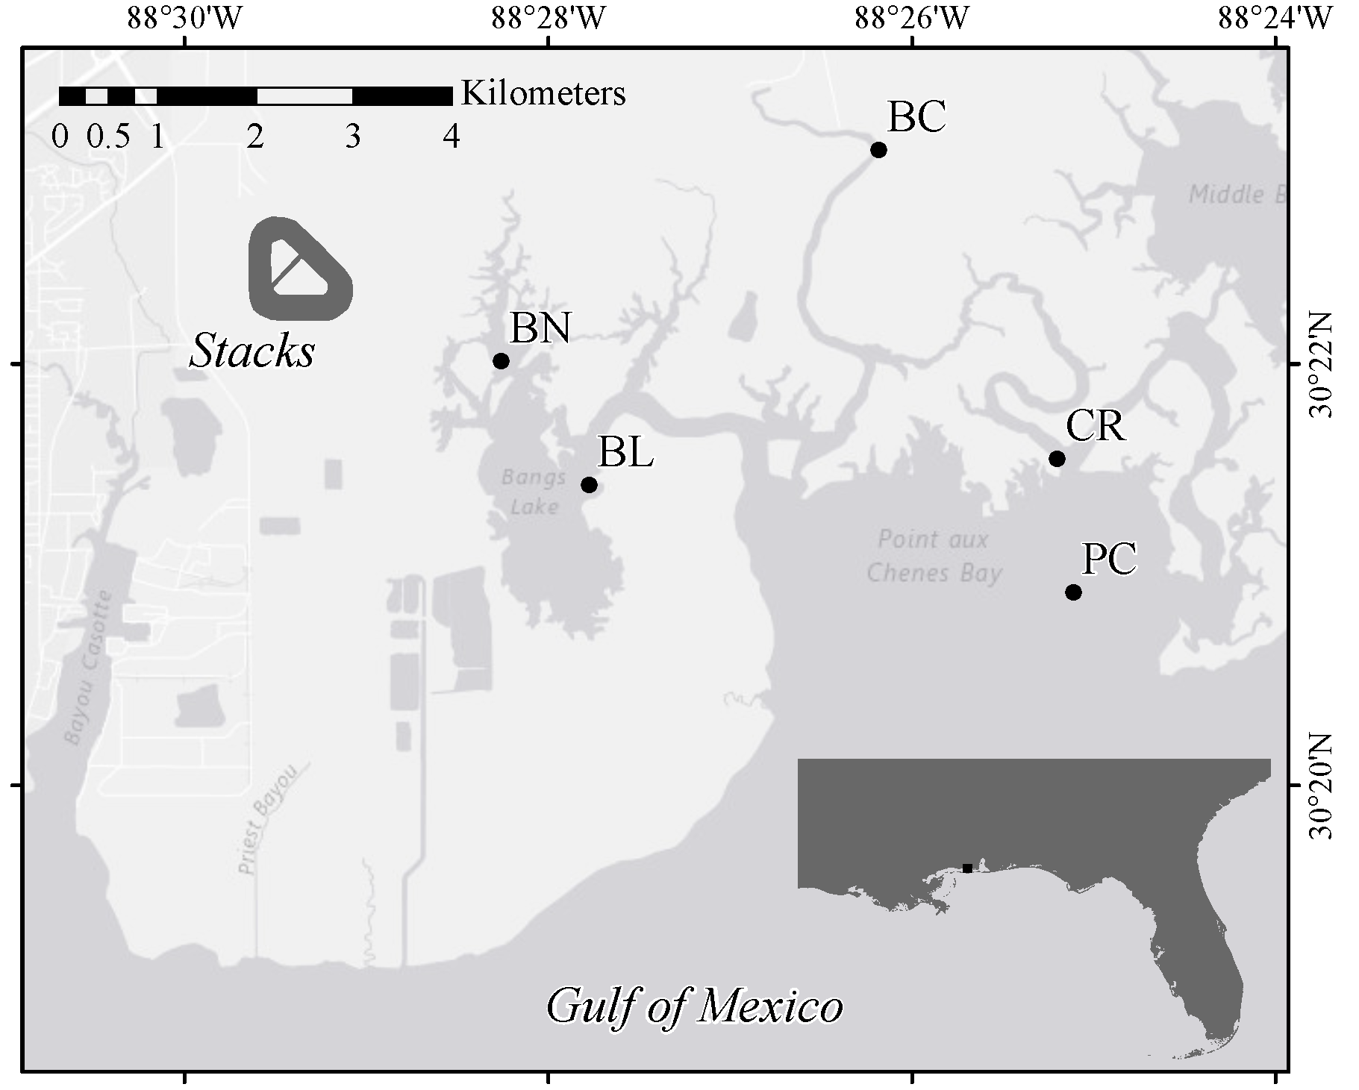
FIGURE 1
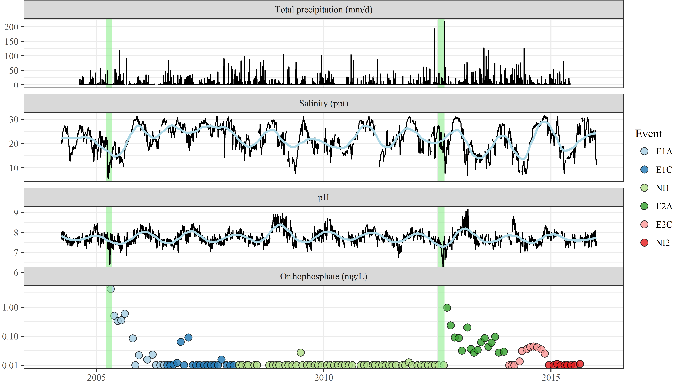
FIGURE 2
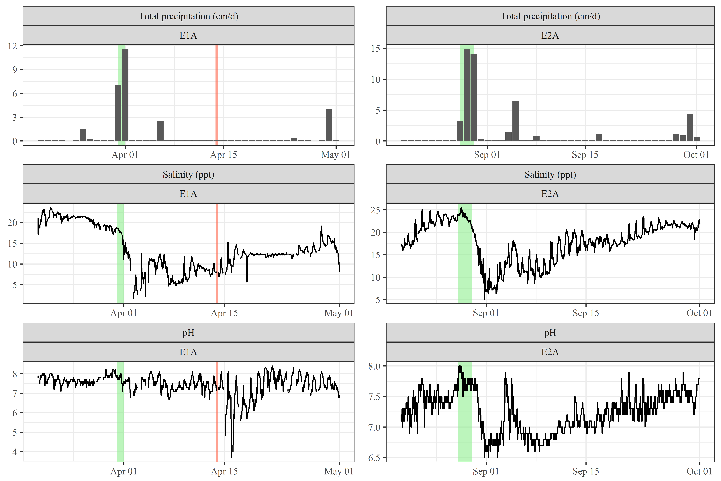
FIGURE 3
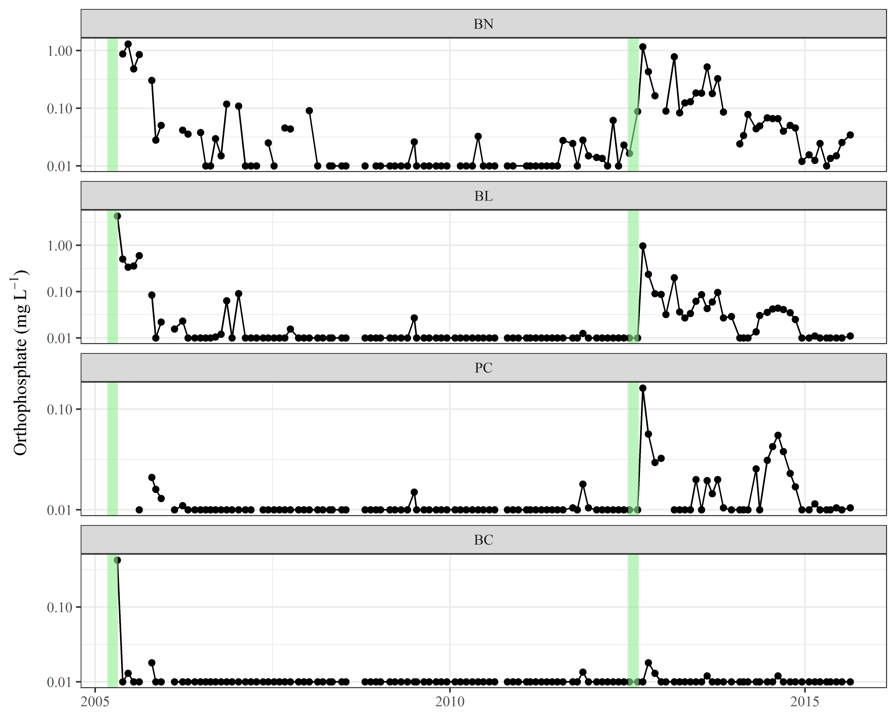
FIGURE 4
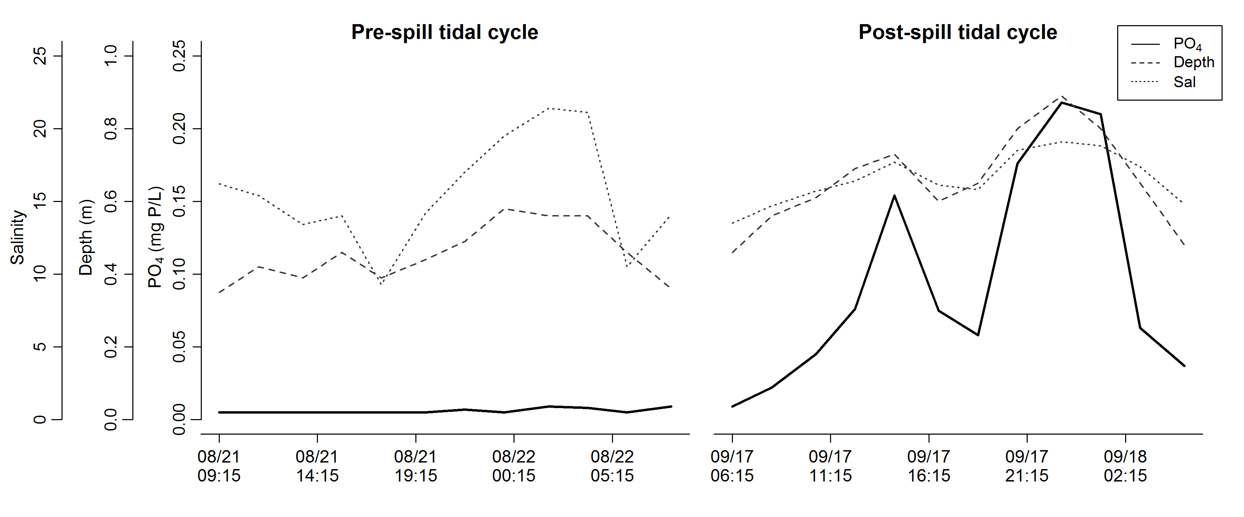
FIGURE 5.
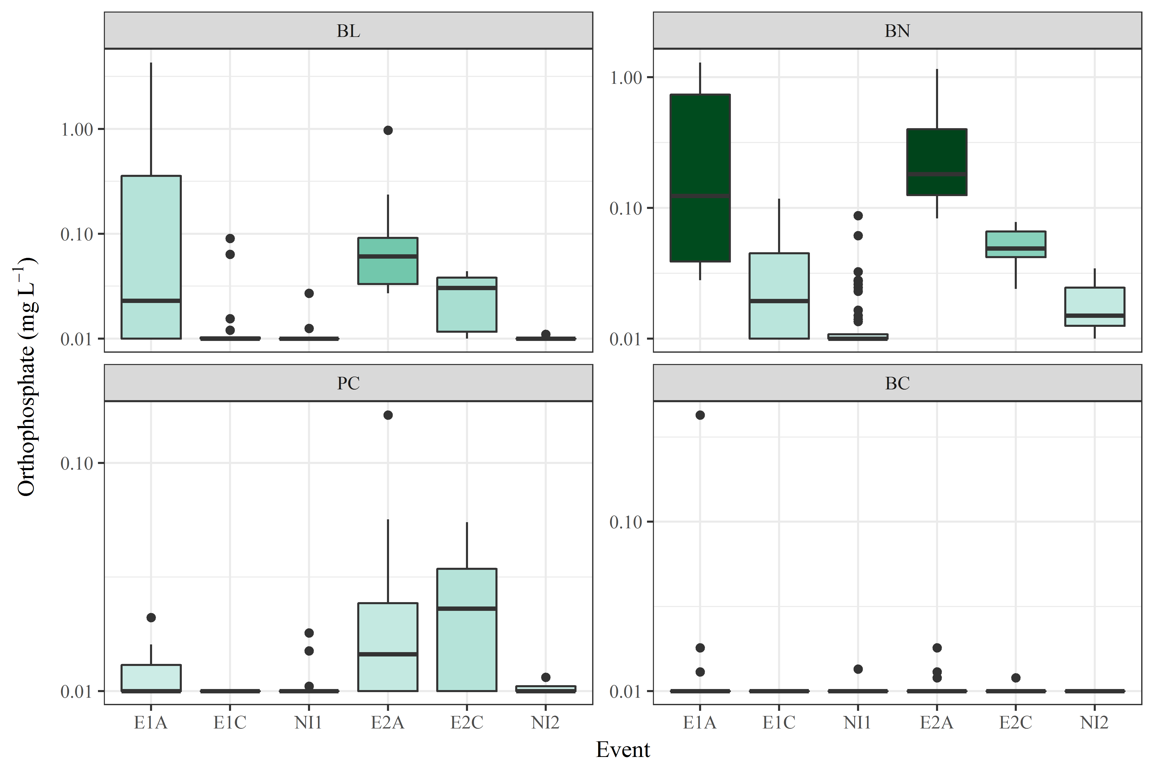
FIGURE 6
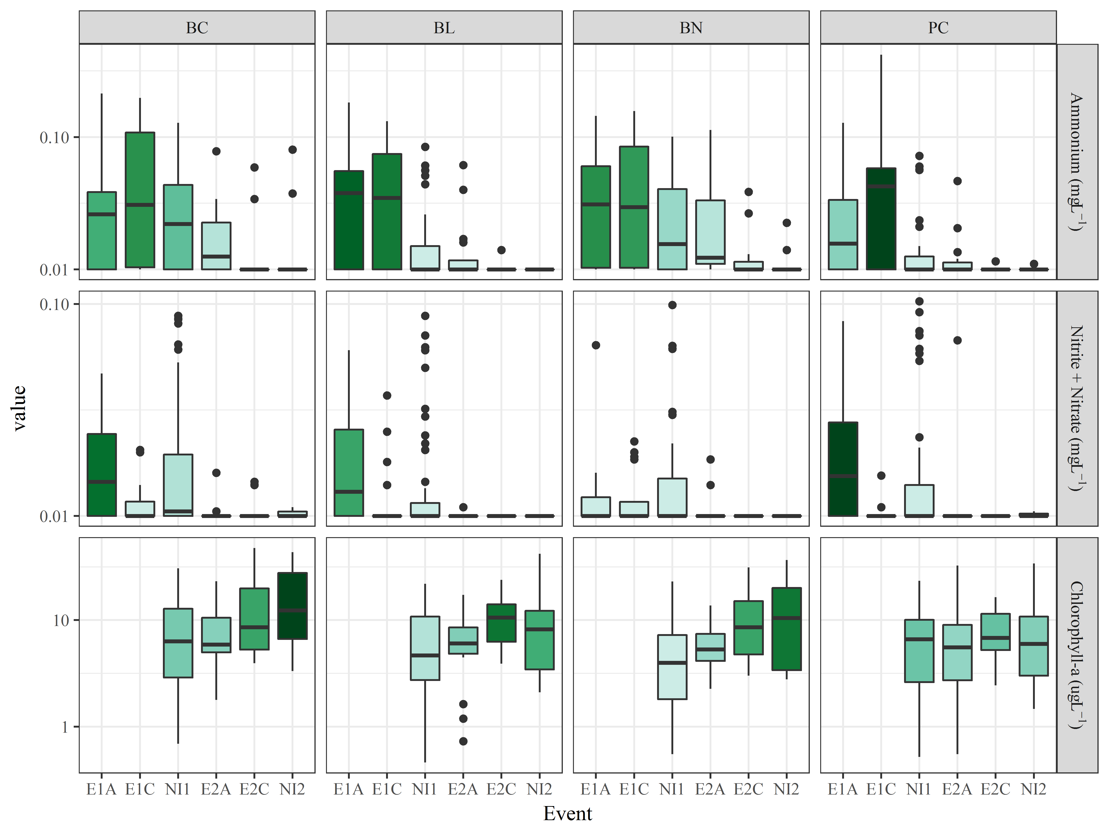
FIGURE S1

