August 31st, 2017

Mark S. Peterson

Editor-In-Chief

Gulf and Caribbean Research

I am pleased to submit our manuscript, “Water quality trends following anomalous phosphorus inputs to Grand Bay, Mississippi, USA”, to be considered as an original research article for publication in Gulf and Caribbean Research.

Grand Bay on the coast of Mississippi is a 7500-ha protected area that is part of the NOAA-funded National Estuarine Research Reserve System. A large fertilizer production facility operated adjacent to the bay from the 1960s to 2014. Storm events in 2005 and 2012 contributed to the release of wastewater effluent from the plant into the bay. This study provides an analysis of the potential impacts of the spill events using water quality data from the continuous monitoring network within the bay. In particular, very little is known regarding the long-term impacts of phosphate inputs to nitrogen-limited systems and our study provides a valuable description of the acute and chronic effects of each event. Both the questions that we address and our methods should be of broad interest to researchers in the Gulf region and to those interested in managing environmental systems.

Please feel free to contact me with any questions or concerns about our submission. We appreciate the opportunity to publish our work with Gulf and Caribbean Research.

Sincerely,

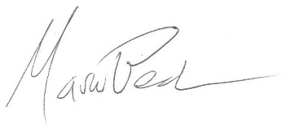

Marcus W. Beck, PhD

Post-Doctoral Research Fellow

U.S. Environmental Protection Agency

1 Sabine Island Drive

Gulf Breeze, FL 32561