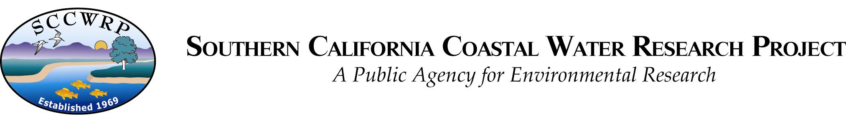

May 4th, 2018

D. Baird
Chief Editor
Estuarine, Coastal and Shelf Science

On behalf of my co-authors, I am pleased to submit our revised manuscript, “Four decades of water quality change in the upper San Francisco Estuary,” to be considered as an original research article in Estuarine, Coastal and Shelf Science.

We greatly appreciate the comments received with our review and have carefully considered our responses to best address the concerns. A complete point by point response is included with the submission. In short, we have revised to address the primary concern that our previous draft represented only a regional focus. The revised draft includes an additional section in the discussion to emphasize the novelty of our approach, particularly related to the value in using our trend analysis method to inform understanding drivers of estuarine production.

Please feel free to contact us with any questions or concerns about our submission. We appreciate the opportunity to publish our work with ECSS.

Marcus W. Beck (marcusb@sccwrp.org)
S. California Coastal Water Research Project
3535 Harbor Blvd. Suite 110
Costa Mesa, CA 92626

