May 2nd, 2017

David L. Sedlak

Editor-In-Chief

Environmental Science & Technology

I am pleased to submit our manuscript, “Four decades of water quality change in the upper San Francisco Estuary,” to be considered as an original research article for publication in Environmental Science & Technology.

The Delta region of the upper San Francisco Estuary is a complex mosaic of inflows where nutrients are received, processed, and exported to the larger bay. Routine monitoring data have been collected at several locations in the Delta for over four decades, yet a comprehensive evaluation of trends using this dataset has not been conducted. This information is timely given recent changes in the Bay that suggest past conditions may not be the future norm. We applied a new statistical method, Weighted Regressions on Time, Discharge, and Season, to describe multi-decadal trends of water quality change at several locations in the Delta. We contrast the results with common approaches for trend analysis to demonstrate the potential for imprecise and potentially wrong conclusions from simpler methods. We conclude with two specific case studies to demonstrate how the results can generate additional hypotheses for further evaluation of causal factors that influence environmental condition.

The conclusions from this work are relevant for this important ecosystem and the application of trend analyses to evaluate multi-decadal trends in aquatic environments. Please feel free to contact me with any questions or concerns about our submission. We appreciate the opportunity to publish our work with Environmental Science & Technology.

Sincerely,

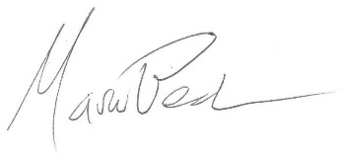

Marcus W. Beck, PhD

Post-Doctoral Research Fellow

U.S. Environmental Protection Agency

1 Sabine Island Drive

Gulf Breeze, FL 32561