March 22, 2017

Wayne S. Gardner

Charles A. “Si” Simenstad

Co-Editors-In-Chief

Estuaries and Coasts

Enclosed please find our revised manuscript, “Quantifying seagrass light requirements using an algorithm to spatially resolve depth of colonization,” to be reconsidered for publication as an original research article in Estuaries and Coasts.

We sincerely thank the reviewers for their comments on our original submission, all of which we have addressed in the attached response. To summarize, we have responded to the concerns of the first reviewer regarding clarification of our methods and novelty of the approach. In particular, we have revised the introduction, methods, and discussion accordingly, and have provided an additional analysis of trends in seagrass light requirements in Tampa Bay over twenty-five years. We believe this new analysis is a specific example of the scalability and novelty of our approach. The revisions in response to the first reviewer also address many of the concerns for the second reviewer, particularly with clarification of our methods.

We are confident that these revisions have improved the manuscript. Please feel free to contact me with any questions or concerns about our submission. I can be reached at (850) 934-2480 and [beck.marcus@epa.gov](mailto:beck.marcus@epa.gov). We appreciate the opportunity to publish our work with Estuaries and Coasts.

On behalf of my co-authors,

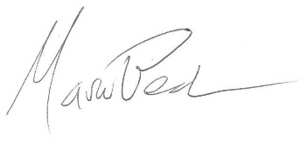

Marcus W. Beck, PhD