Hardware Model and Control Software

Design ideas

We design and build a prototype of a robot control system that uses an automatic robot to explore a walled maze with a hidden treasure inside. The robot finds the route through the maze and locate the hidden treasure. We use the camera to take pictures of the treasure and identify the type of treasure using object detection algorithm.

The robot also reports the map of the maze, the time of exploration and the pictures taken. We have make a web application that provides current and historical exploration records. And we have a database be designed to manage all information for the whole system.

This design takes the arduino mega 2560 development board as the core, controls the motor drive module through the L298N two-way DC motor, and completes the forward and turning actions of the trolley through five-way addressing and ultrasonic sensors. Through the ultrasonic ranging module at the front of the car and the motor module of the trolley, the obstacle avoidance function of the trolley is realized; Through five-way addressing, the tracking function of the trolley is realized.

The design of this paper reserves an expansion interface, which can expand the Bluetooth control module and servo module on the basis of the obstacle avoidance module, so that the car has stronger intelligence. The overall block diagram of obstacle avoidance is shown in the following figure:

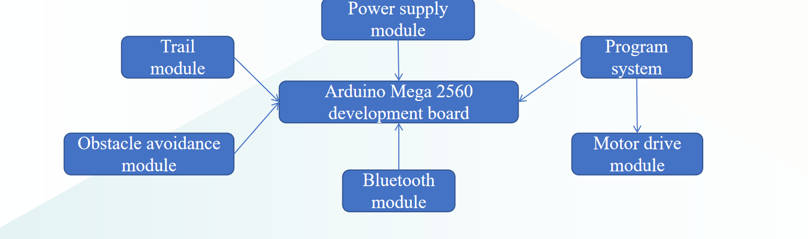

Specific function

Travel direction and turning: we use three ultrasonic sensors to control the direction of travel of the trolley, the current sensor perception distance is less than a certain value when the turn is triggered, the sensors on both sides measure the distance separately, when the left distance is greater than the right, the trolley turns left; When the right distance is greater than the left, the trolley turns right.

Identify colors: Use color sensors to identify different colors to find treasures.

Five-way tracking: Based on the infrared reflection sensor, the infrared emitting diode of the sensor continuously emits infrared rays, and when the emitted infrared rays are reflected by the object, they are collected by the infrared receiver and output analog values. The output analog value is related to the distance of the object and the color of the object. By calculating the analog value of the five outputs, the position of the trace line is judged to realize that the smart car can drive along the black line.

Bluetooth: Remote control of the trolley via Bluetooth.

WIFI: wifi controls camera photography and video, takes three photos per second and uploads data to IoT for the next step.

Technical solution and development process

First of all, we assemble the basic part of the intelligent car, and then the functions of the intelligent car are divided into motor drive module, obstacle avoidance module, tracking module and detection module. We design the software for each module individually, and finally assemble the hardware into the trolley.

We use ultrasonic sensors to realize obstacle avoidance function, when the trolley turns left, the left front and left rear wheels turn back; The two wheels of right front and right rear turn forward; When the trolley turns right, the left front and left rear wheels turn forward; The right front and right rear wheels turn back.

Object Detection Software

Purpose

To help the robot find the treasure in the maze, we build object detection software.

Design Ideas

Transmission module

Detection module

Demonstration module

Transmission module:

Using Wi-Fi to transmit photos taken by the robots in real time.

Detection module: Based on YOLOv8.

YOLOv8 is a state-of-the-art (SOTA) model for image classification, object detection and instance segmentation. It is the latest update of the YOLO series, which was open-sourced by Ultralytics in January 2023.

Demonstration module: Use Java write a GUI to demonstrate the output.

Speed:

Both YOLOv8 and YOLOv5 are fast object detection models, capable of processing images in real-time. However, YOLOv8 is faster than YOLOv5, making it a better choice for applications that require real-time object detection1.

Accuracy:

Accuracy is a critical factor to consider when choosing an object detection model. In this regard, YOLOv8 is more accurate than YOLOv5, thanks to the several improvements made in its architecture1.

Ease of use:

Both YOLOv8 and YOLOv5 are easy to use, with YOLOv5 being the easiest to use of the two1.

Anchor-free approach:

The anchor-free approach eliminates the need for predefined anchors, which makes the model more flexible and robust to object size variations

Specific FunctionDetection: Find the chosen objects (to be used as treasures)

If there is a target object in the image, it will be marked with a color block.

The higher quality the picture has, the more effective it can be.

What have we done

Train & calibrate the object detection algorithm for new, specific objects.

We found that the original model in YOLOv8 has bad performed in the detection of the chosen objects, so we retrained the model based on YOLOv8 model.

Prepare dataset

We collected 1894 images with the chosen objects (including negative samples), then labelled and divided them into training set, test set, and valid set (with proportion 3:1:1)

Train the model

We used a python script to train the model.

Evaluate the model and iteration

We tested the trained model and evaluated the performance.

Iterate several times to improve the model.

Build GUI

Handover with other group members

Database Management and Web Visualisation

Web login: Users can log in to the system by entering a name and password

Add within the web: Users can add information about the robot

Delete from web: Users can delete robot related information

Modification in the web: Users can modify the robot related information

Note: Robot related information includes robot number, name, weight, size, image.

Visual robot exploring maze records:

Robot exploration path visualization

Robot exploration time visualization

Visualization of robot taking treasure picture

This is our main page with three buttons at the top to choose from. In the middle of the page is a rotograph where we can see different types of robot models. At the bottom of the page is a surprise box that pops up ‘ welcome to robot world!!’ when users click on it.

This is our information page, in this page we can view the user's personal information and its robot information and can add, delete and modify the robot information. Each button lights up and becomes visible when clicked by the user.

This is our button popup. In different pop-ups corresponding to different buttons, users can add, delete and modify information such as the name, weight and size of the robot. And the changed information will be displayed on the web page.

This is our path page. The user can control the robot to start action with the run button, and the path displayed by the robot on the web page is its actual exploration path.

The user can control the start and end of the timing through the start and stop buttons. The robot's exploration time is then displayed below the button.