SNE-SPIMS
Special-Needs Education
Student Progress & Information Management System
Technical Design & Implementation Document
Spring Boot 3 · Thymeleaf · MyBatis · MySQL 8
Application brand: “Luna Bridge”
Version 1.0.0

Table of Contents

1. Introduction

1.1 Background
SNE-SPIMS (Special-Needs Education — Student Progress & Information Management System), branded in the interface as Luna Bridge, is a web application that helps a special-needs school handle the day-to-day record-keeping and communication around its students. Special-needs education is very individual: each child follows an Individualised Education Program (IEP), receives one or more kinds of therapy, and is supported by both teachers and parents. The information around a single child (progress notes, behaviour incidents, therapy schedules, medical alerts, messages) is sensitive, and it is shared between several people who each have a different right to see it.
The system was re-platformed from an original Java Servlet/JSP application onto Spring Boot 3, keeping the existing MyBatis data layer and the BCrypt-hashed user accounts rather than rewriting them. This document describes the resulting architecture, the design decisions behind it, and how the Spring MVC system is implemented.

1.2 Problem Statement
Paper-based or spreadsheet-based tracking of special-needs students fails on three fronts: (1) information is siloed, so a parent cannot easily see their child’s published progress; (2) there is no enforced boundary preventing one teacher or parent from seeing another family’s sensitive records; and (3) multi-step records (a report and its rubric scores, a goal and its progress history) can be left half-written when something fails mid-save. SNE-SPIMS addresses all three with role-scoped access, a clean service layer, and atomic database transactions.

1.3 Objectives
- Provide a single, role-aware system for student records, IEPs, daily reports, behaviour incidents, therapy scheduling and parent–teacher messaging.
- Enforce strict, centrally-defined access rules so each role sees only the students it is entitled to.
- Guarantee data integrity for every multi-step write through database transactions.
- Keep parents informed automatically through an in-app notification system and scheduled reminders.
- Offer a warm, accessible user interface tailored to each role.

1.4 Scope
In scope: user & account management, student profiles, teacher/parent assignment, IEP programs and measurable goals with progress history, daily progress reports with rubric scoring and parent acknowledgement, behaviour incident logging, therapy session scheduling, a unified calendar, parent–teacher messaging, role-aware dashboards and analytics, and an event-driven notification inbox.
Not implemented in the codebase: the database schema also defines tables for file attachments, attendance, medical/medication management and the IEP goal-bank, but no controller, service, DAO, or screen in the current code uses them. They are listed in the data model only because they exist in schema.sql; this document describes them as unbuilt, matching the code exactly.

1.5 Actors & Stakeholders
Actor | Description | Primary responsibilities
Admin | School administrator | Manage users, assign teachers/parents to students, publish announcements, view school-wide analytics.
Teacher | Class / subject teacher | Author daily reports, log incidents, manage IEP goals & progress, schedule therapy, message parents.
Parent | Parent or guardian | View their child’s published reports and progress, acknowledge reports, message teachers, read notifications.
Two clarifications. First, the system has exactly these three roles; there is no separate “therapist” role. A therapy session is run by a teacher (recorded as therapist_id on the session), so wherever this document says “the teacher running the session”, that is the person other systems might call a therapist. Second, the 07:00 therapy reminder is not triggered by a person but by a background timer, so it is described in the text rather than drawn as an actor.

1.6 Technology Stack
Layer | Technology
Runtime / framework | Spring Boot 3.3.5, Java 17 (LTS)
Web / view | Spring MVC, Thymeleaf + Layout Dialect, Bootstrap 5
Security | Spring Security (form login), jBCrypt ($2a$ hashes), CSRF protection
Persistence | MyBatis 3.5 (XML mappers), MySQL 8, HikariCP connection pool
Testing | JUnit 5, Mockito, AssertJ, Spring Security Test
Note: server-side PDF export is a planned feature and is not part of this build, so no PDF library is included in the stack above.

1.7 System Overview
The diagram below groups the main use cases under the three actors. Some of them (dashboard, messaging, calendar, notifications) are shared by teachers and parents, but each one is role-scoped inside, so what a teacher sees and what a parent sees are not the same. The 07:00 therapy reminder runs on a background timer rather than a person, so it is described in the text instead of being drawn as an actor.
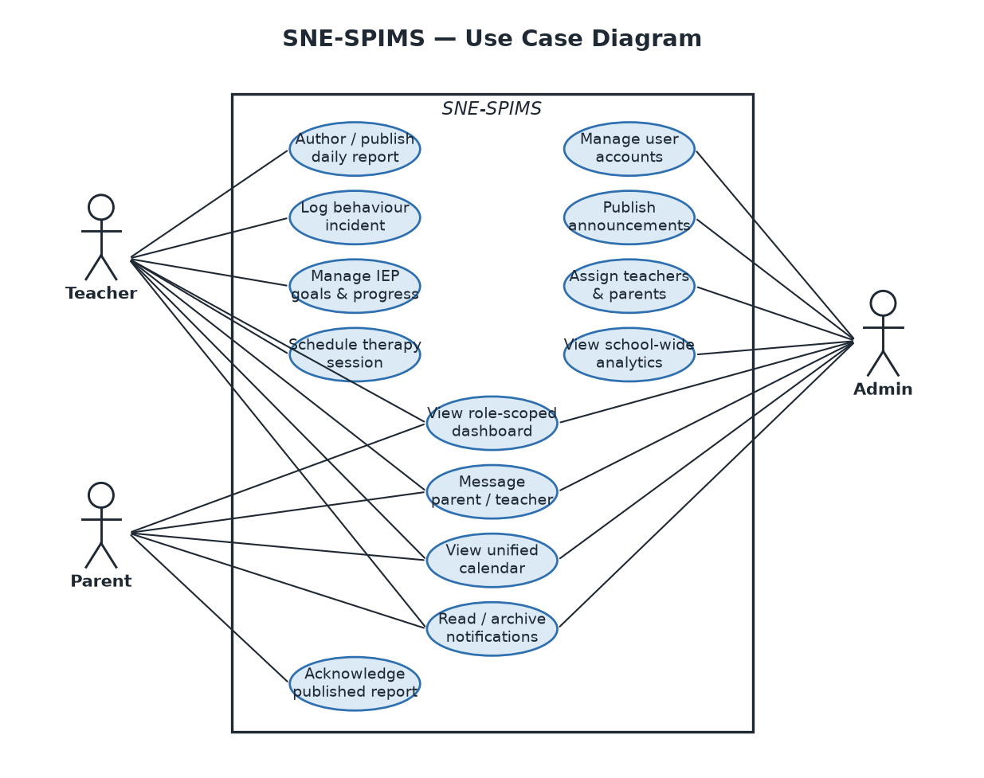
Figure 1. SNE-SPIMS use case diagram.

2. Design

2.1 Architectural Overview
SNE-SPIMS follows a classic layered architecture. A request from the browser passes through the Spring Security filter chain, is handled by a thin Spring MVC controller, delegates business rules to a service, and reaches the database only through a DAO and the shared MyBatis helper. Each layer depends only on the layer beneath it; no controller talks to a DAO directly, and no business rule leaks into a Thymeleaf template.
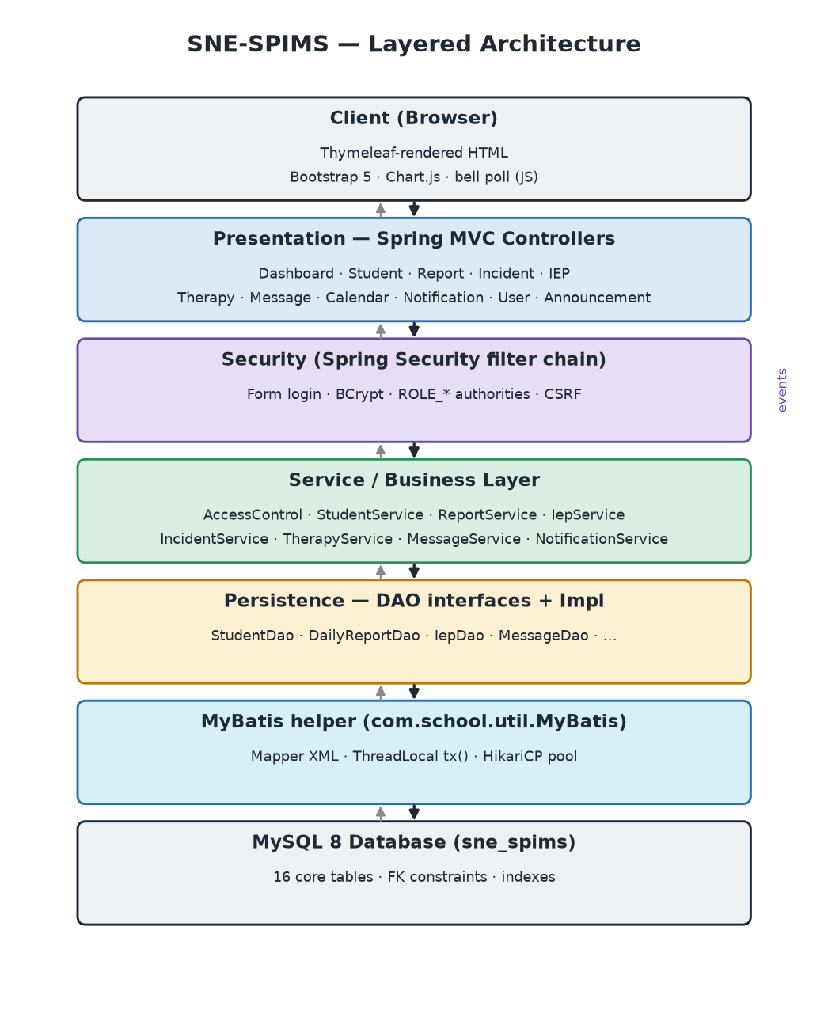
Figure 2. Layered architecture and the flow of a request.
The MyBatis bridge is worth calling out: instead of adopting Spring Data, the project keeps its existing MyBatis mapper XML and its own HikariCP pool, and exposes the hand-wired service objects to Spring as beans through a single LegacyServicesConfig configuration class. This preserved the existing data layer while gaining Spring MVC, Spring Security and dependency injection.

2.2 Layered Responsibilities
Layer | Package | Responsibility
Presentation | com.school.web | HTTP routing, form binding, role guards, flash messages, model assembly for views.
Security | com.school.security | Authentication (form login), authority mapping, URL-level authorisation, CSRF.
Service | com.school.service / notify / analytics / calendar | Business rules, validation, access-control enforcement, transactions, event publishing.
Persistence | com.school.dao(.impl) | DAO interfaces + implementations mapping to MyBatis statements.
Infrastructure | com.school.util | MyBatis helper (incl. transactions), password hashing, lookups, exceptions.
Domain | com.school.model | Plain data objects mirroring the database entities.

2.3 Package Structure
com.school
├── SneSpimsApplication (Spring Boot entry point)
├── config LegacyServicesConfig (bridge to hand-wired services)
├── web *Controller, GlobalExceptionHandler, CurrentUserAdvice
├── security SecurityConfig, AppUserDetails(Service), SecurityUtils
├── service AccessControl, *Service, Services (locator)
├── dao *Dao + dao.impl *DaoImpl
├── model User, Student, IepProgram, DailyReport, ...
├── notify NotificationService, event/*, NotificationEventListener
├── analytics AnalyticsService/Repository, DashboardData, TrendChart
├── calendar CalendarService/Repository, CalendarEvent
└── util MyBatis, Db, Passwords, Lookups, *Exception
Listing 1. Application package layout.

2.4 Domain Model
The domain model centres on two anchor entities — User and Student — joined by two assignment tables that encode the all-important access relationships: teacher_student (caseload) and parent_student (guardianship). Every other record (IEP, report, incident, therapy session, message) hangs off a student, which is why access can be decided uniformly from a single studentId.
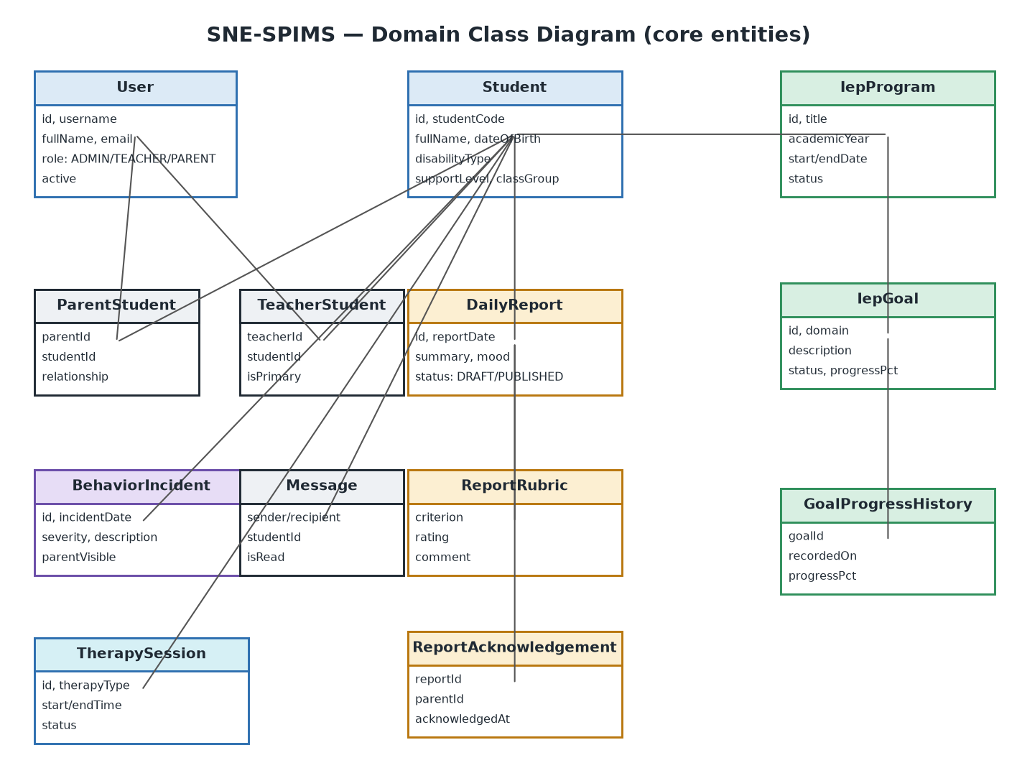
Figure 3. Core domain entities and their relationships.

2.5 Database Design
The schema comprises sixteen interrelated core tables (plus additional tables reserved for the not-yet-ported legacy features). Referential integrity is enforced with foreign keys; cascade deletes remove dependent rows when a parent record is removed, and uniqueness constraints prevent duplicates (one report per student per day, one IEP per student per academic year, one acknowledgement per parent per report).
Core tables
Table | Purpose | Key constraints
users | Accounts for all roles | unique username, unique email; role ENUM
students | Student profiles | unique student_code; disability/support ENUMs
teacher_student | Teacher caseload (M:N) | unique (teacher_id, student_id); FK cascade
parent_student | Guardianship (M:N) | unique (parent_id, student_id); relationship ENUM
iep_programs | IEP per student/year | unique (student_id, academic_year)
iep_goals | Measurable goals | FK to iep; progress_pct CHECK 0..100
iep_goal_progress_history | Progress snapshots | unique (goal_id, recorded_on)
daily_reports | Daily progress reports | unique (student_id, report_date); status ENUM
report_rubrics | Per-criterion ratings | unique (report_id, criterion); rating ENUM
report_acknowledgements | Parent read-receipts | unique (report_id, parent_id)
behavior_incidents | Behaviour logging | severity ENUM; parent_visible flag
therapy_sessions | Therapy scheduling | CHECK end_time > start_time; status ENUM
messages | Direct messaging | FK sender/recipient; optional student context
announcements | Role-targeted notices | target_role ENUM; active flag
notifications | Per-user inbox | type ENUM; is_read / is_archived flags
school_calendar | School-wide events | indexed by event_date
In the schema but not used by any code: attachments, attendance, medical_records, medications and iep_goal_templates — these tables exist in schema.sql but have no controller, service, DAO, or mapper.

2.6 Access Control Design
Access is decided by a single class, AccessControl, which answers one question: “may this user act on this student?” Because every student-scoped record carries a studentId, this one check protects reports, incidents, IEPs, therapy and messaging alike. The rule is intentionally small and centralised so it can be reasoned about and unit-tested in isolation.
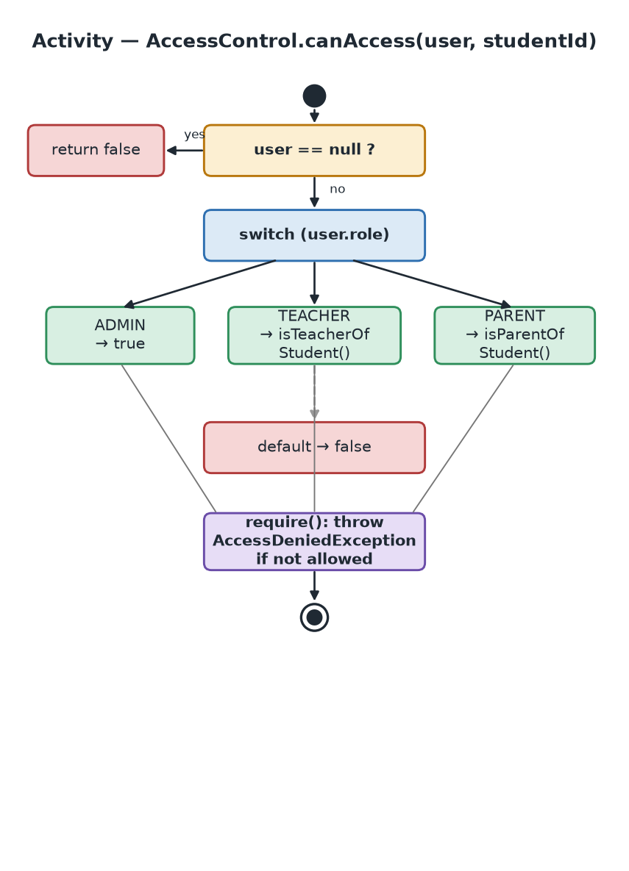
Figure 4. Access-control decision flow.
Role | Visibility rule
ADMIN | Every student (unconditional).
TEACHER | Only students in their caseload (teacher_student).
PARENT | Only their own children (parent_student).
(other / null) | Denied.
The enforcement is layered. The service layer calls access.require(user, studentId) before returning or mutating student data; the controller layer also guards by role (e.g. only staff may author reports); and the URL layer restricts admin-only areas in the Spring Security filter chain. This defence-in-depth means a single forgotten check in one layer cannot by itself expose data.

2.7 Security Design
- Authentication: Spring Security form login against the users table; passwords are verified against existing jBCrypt $2a$ hashes by BCryptPasswordEncoder.
- Authorisation: each role becomes a ROLE_<role> granted authority, used by URL matchers, controller guards and Thymeleaf sec:authorize attributes.
- CSRF: left enabled (Spring default); every Thymeleaf POST form carries the CSRF token automatically.
- Account lifecycle: deactivated accounts (active = false) are rejected at login via UserDetails.isEnabled().
- Least privilege: administrators do not use direct messaging; parents are read-only on reports/incidents; deactivated users cannot authenticate.

2.8 Transaction & Data Integrity Design
By default the MyBatis helper opens one session per call and commits immediately. Multi-step writes therefore needed an explicit transaction boundary, otherwise a failure mid-sequence could leave a half-written record (a report without its rubrics, a goal without its seed snapshot). The solution is a thread-bound transaction helper, MyBatis.tx(...): it binds a single non-auto-commit SqlSession to the current thread, every nested DAO call joins it, and the whole block commits once, or rolls back entirely if any exception escapes. Calls nest safely.
Operation | Steps made atomic
Create daily report | insert report + insert each rubric row
Update daily report | update report + delete old rubrics + re-insert rubrics
Add / update IEP goal | insert/update goal + insert progress snapshot
Notify parents | fan-out one notification per guardian (all or none)
Validation is performed before the transaction opens (e.g. rubric ratings are checked first) so that invalid input never causes even a transient write.

2.9 Notification & Event-Driven Design
Side-effects that should not block the user (notifying parents when a report is published, or when a parent-visible incident is logged) are modelled as Spring application events. The controller publishes an event; an asynchronous listener calls NotificationService, which fans out one notification per guardian inside a transaction. A scheduled job also sends therapy reminders every morning at 07:00. Notification types are limited to a fixed ENUM (DAILY_REPORT, INCIDENT, THERAPY_REMINDER, MESSAGE, GENERAL) that mirrors the database column.

2.10 Presentation & UI Design
All pages share a single Thymeleaf layout (layout/main.html) built with the Layout Dialect. A fixed icon “rail” provides role-aware navigation: links appear only for roles permitted to use them, via sec:authorize. The visual language (colour tokens, spacing and typography) is defined once in app.css and applied everywhere, with a warmer, child-centred dashboard for parents. The dashboard presents progress as cards and proportional bars rather than charts, and the notification bell polls an unread-count endpoint every 30 seconds.

2.11 Key Workflow — Daily Report Lifecycle
The daily report is the system’s most representative workflow: it touches access control, validation, transactions, the draft/publish state machine, events and notifications. A teacher creates a draft (report + rubric rows written atomically), edits it while it remains a draft, then publishes it — at which point parents can see it and are notified. Parents may acknowledge a published report, which notifies the authoring teacher.
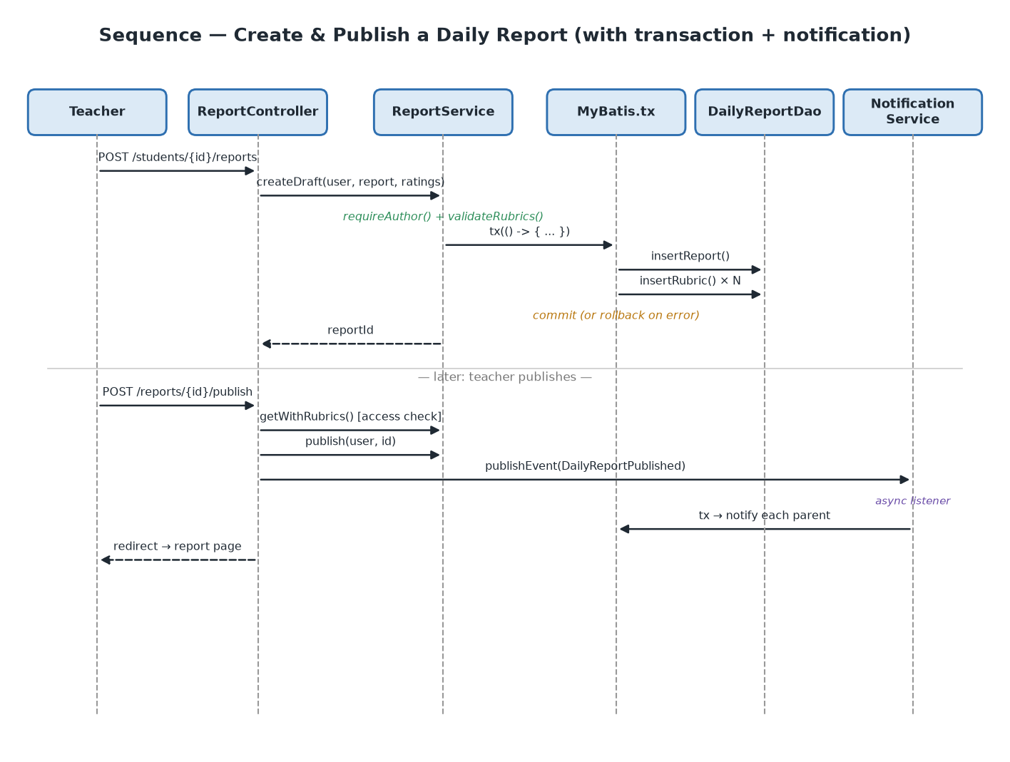
Figure 5. Sequence of creating and publishing a daily report.
The report’s permitted state transitions are summarised as a state machine. A report is born DRAFT, may be edited freely while it remains a draft, and only becomes visible to parents when PUBLISHED (which fires the notification event). Publishing is reversible via unpublish; a published report can also be acknowledged by a parent, which notifies the authoring teacher.
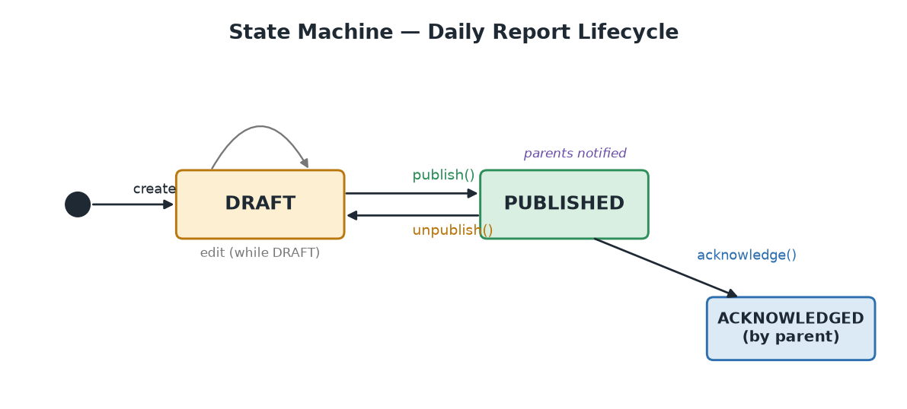
Figure 6. Daily report lifecycle state machine.

2.12 Validation & Error Handling
Business rules raise ValidationException or AccessDeniedException, which a single @ControllerAdvice (GlobalExceptionHandler) renders as friendly pages with the correct HTTP status (400 for validation, 403 for access denied). JSON endpoints such as the calendar feed return a clean 400 on malformed input rather than a 500.

2.13 Design Patterns Applied
The codebase leans on a small set of well-understood patterns rather than novel abstractions, which keeps it approachable and testable.
Pattern | Where | Purpose
Layered (n-tier) | web → service → dao → util | Separation of concerns; dependencies point downward only.
Data Access Object | *Dao / *DaoImpl | Isolate persistence behind interfaces; SQL kept in mapper XML.
Service Layer | *Service classes | Encapsulate business rules, validation and transactions.
Front Controller | Spring DispatcherServlet | Single entry point routing to @Controller handlers.
Service Locator + DI bridge | Services + LegacyServicesConfig | Reuse hand-wired services as Spring beans.
Observer / Pub-Sub | ApplicationEventPublisher + listener | Decouple side-effects (notifications) from the request.
Template Method | MyBatis.tx(...) wrapping a body | Fix the commit/rollback skeleton; vary the work.
Singleton | MyBatis SqlSessionFactory | One lazily-built, thread-safe factory per JVM.
Strategy (role) | AccessControl switch on role | Per-role visibility rule behind one interface.

2.14 Data Dictionary (selected tables)
The following catalogues give the column-level definition of the most important tables. PK = primary key, FK = foreign key, U = part of a unique constraint.

2.14.1 users
Column | Type | Notes
id | BIGINT | PK, auto-increment
username | VARCHAR(50) | U — login name
password_hash | VARCHAR(100) | BCrypt $2a$ hash
full_name | VARCHAR(120) | Display name
email | VARCHAR(120) | U
phone | VARCHAR(30) | Nullable
role | ENUM | ADMIN / TEACHER / PARENT
active | BOOLEAN | Login allowed when true
created_at | DATETIME | Defaults to now

2.14.2 students
Column | Type | Notes
id | BIGINT | PK
student_code | VARCHAR(30) | U — external code
full_name | VARCHAR(120)
date_of_birth | DATE | Drives age display
gender | ENUM | MALE / FEMALE / OTHER
disability_type | ENUM | 9 categories (AUTISM … OTHER)
support_level | ENUM | LOW / MODERATE / HIGH / INTENSIVE
enrollment_date | DATE
class_group | VARCHAR(50) | Nullable
active | BOOLEAN | Soft-delete flag

2.14.3 daily_reports
Column | Type | Notes
id | BIGINT | PK
student_id | BIGINT | FK → students; U with report_date
teacher_id | BIGINT | FK → users (author)
report_date | DATE | U with student_id (one per day)
summary | TEXT | Required written note
mood | ENUM | HAPPY / CALM / ANXIOUS / FRUSTRATED / TIRED
status | ENUM | DRAFT / PUBLISHED
published_at | DATETIME | Set on publish

2.14.4 iep_goals
Column | Type | Notes
id | BIGINT | PK
iep_id | BIGINT | FK → iep_programs (cascade)
domain | ENUM | ACADEMIC … VOCATIONAL (7)
description | VARCHAR(500) | Measurable goal
target_date | DATE | Nullable; shown on calendar
status | ENUM | NOT_STARTED … DISCONTINUED
progress_pct | INT | CHECK 0..100

2.14.5 therapy_sessions
Column | Type | Notes
id | BIGINT | PK
student_id | BIGINT | FK → students
therapist_id | BIGINT | FK → users (the teacher running the session)
therapy_type | ENUM | SPEECH / OCCUPATIONAL / PHYSICAL / BEHAVIORAL / COUNSELING
start_time / end_time | DATETIME | CHECK end > start
location | VARCHAR(120) | Room — conflict-checked
status | ENUM | SCHEDULED / COMPLETED / CANCELLED / NO_SHOW

2.14.6 behavior_incidents
Column | Type | Notes
id | BIGINT | PK
student_id | BIGINT | FK → students
reported_by | BIGINT | FK → users
incident_date | DATETIME | When it happened
description | TEXT | Required
severity | ENUM | LOW / MEDIUM / HIGH / CRITICAL
action_taken | VARCHAR(500) | Nullable
parent_visible | BOOLEAN | Auto-true for HIGH/CRITICAL

2.14.7 Relationships & cardinality
Relationship | Cardinality | On delete
users — teacher_student — students | M : N | Cascade
users — parent_student — students | M : N | Cascade
students — iep_programs | 1 : N | Cascade
iep_programs — iep_goals | 1 : N | Cascade
iep_goals — goal_progress_history | 1 : N | Cascade
students — daily_reports | 1 : N | Cascade
daily_reports — report_rubrics | 1 : N | Cascade
daily_reports — report_acknowledgements | 1 : N | Cascade
students — behavior_incidents | 1 : N | Cascade
students — therapy_sessions | 1 : N | Cascade
users — messages (sender/recipient) | 1 : N | Cascade

2.15 Non-Functional Requirements
Quality | How it is addressed
Security | BCrypt, CSRF, ROLE_-based + student-scoped authorisation, deactivated-account rejection.
Data integrity | Foreign keys + CHECK/UNIQUE constraints; atomic multi-step writes via MyBatis.tx.
Maintainability | Layered packages, thin controllers, SQL in mapper XML, single access-control authority.
Usability / accessibility | Role-aware navigation; warm, child-centred parent dashboard; consistent design tokens.
Performance | HikariCP pooling; targeted indexes for role-scoped queries; lightweight 30s bell poll.
Reliability | Centralised exception handling; validation before persistence; idempotent acknowledgement.
Testability | Pure service objects with injected DAOs; JUnit 5 + Mockito unit tests.

3. Implementation — Keycode / Screen
This section walks through the code that gives the design its teeth, then catalogues the screens that present it. Listings are taken verbatim from the source (lightly trimmed for space).

3.1 Build & Run
# build + test
mvn test
# run (requires MySQL 8 with the sne_spims schema seeded)
mvn spring-boot:run # -> http://localhost:8080
Listing 2. Build and run commands.
The application boots from SneSpimsApplication. Spring’s DataSource auto-configuration is excluded because the MyBatis layer owns its own HikariCP pool configured from db.properties.

3.2 Keycode Walkthrough

3.2.1 Transaction helper (MyBatis.tx)
The heart of the data-integrity design. A ThreadLocal carries the active session so that ordinary DAO calls automatically join an open transaction without any change to their code.
private static final ThreadLocal<SqlSession> CURRENT_TX = new ThreadLocal<>();

public static <T> T tx(Supplier<T> body) {
if (CURRENT_TX.get() != null) {
return body.get(); // already in a tx -> join it
}
SqlSession session = factory().openSession(false); // explicit commit
CURRENT_TX.set(session);
try {
T result = body.get();
session.commit();
return result;
} catch (RuntimeException e) {
session.rollback();
throw e;
} finally {
CURRENT_TX.remove();
session.close();
}
}

private static <T> T write(String statement, SessionFn<T> fn) {
SqlSession tx = CURRENT_TX.get();
if (tx != null) return fn.apply(tx); // commit deferred to tx()
try (SqlSession s = factory().openSession()) {
T result = fn.apply(s);
s.commit(); // legacy per-call commit
return result;
}
}
Listing 3. com.school.util.MyBatis — transaction support.

3.2.2 Central access control
public boolean canAccess(User user, long studentId) {
if (user == null) return false;
switch (user.getRole()) {
case "ADMIN": return true;
case "TEACHER": return assignments.isTeacherOfStudent(user.getId(), studentId);
case "PARENT": return assignments.isParentOfStudent(user.getId(), studentId);
default: return false;
}
}

/** Enforcing variant — throws when not allowed. */
public void require(User user, long studentId) {
if (!canAccess(user, studentId))
throw new AccessDeniedException("You do not have access to this student’s records.");
}
Listing 4. com.school.service.AccessControl.

3.2.3 Transactional service write with up-front validation
ReportService.createDraft shows the full pattern: authorise, validate, then perform the multi-row write inside a transaction so it is all-or-nothing.
public long createDraft(User author, DailyReport report,
Map<String,String> ratings, Map<String,String> comments) {
requireAuthor(author, report.getStudentId()); // role + student access
if (report.getReportDate() == null) throw new ValidationException("Report date is required.");
if (isBlank(report.getSummary())) throw new ValidationException("A summary is required.");
if (reportDao.dateExists(report.getStudentId(), report.getReportDate(), 0))
throw new ValidationException("A report already exists for this student on that date.");
validateRubrics(ratings); // fail BEFORE any write
report.setStatus("DRAFT");
return MyBatis.tx(() -> { // report + rubric rows: atomic
long reportId = reportDao.insertReport(report);
saveRubrics(reportId, ratings, comments);
return reportId;
});
}

private void requireAuthor(User user, long studentId) {
if (user == null || user.isParent())
throw new AccessDeniedException("Only teachers and admins can author reports.");
access.require(user, studentId);
}
Listing 5. com.school.service.ReportService — createDraft.

3.2.4 Thin controller with role guard
@PostMapping("/students/{studentId}/reports")
public String create(@PathVariable long studentId, @RequestParam ... , RedirectAttributes ra) {
User user = SecurityUtils.currentUser();
requireStaff(user); // role guard at the controller
students.get(user, studentId); // student-access check
DailyReport r = new DailyReport();
r.setStudentId(studentId); r.setTeacherId(user.getId());
r.setReportDate(reportDate); r.setSummary(summary); r.setMood(mood);
long id = reports.createDraft(user, r, toMap(criterion, rating), toMap(criterion, comment));
ra.addFlashAttribute("flashSuccess", "Report saved as draft.");
return "redirect:/reports/" + id;
}
Listing 6. com.school.web.ReportController — create handler.

3.2.5 DAO + MyBatis mapper
DAO implementations are thin: they call the shared helper with a statement id and parameters; the SQL lives in XML mapper files, keeping Java free of string SQL.
// AssignmentDaoImpl.java
public boolean isTeacherOfStudent(long teacherId, long studentId) {
return MyBatis.count("AssignmentMapper.isTeacherOfStudent",
MyBatis.args("teacherId", teacherId, "studentId", studentId)) > 0;
}
Listing 7a. DAO implementation.
<!-- AssignmentMapper.xml -->
<select id="isTeacherOfStudent" resultType="long">
SELECT COUNT(*) FROM teacher_student
WHERE teacher_id = #{teacherId} AND student_id = #{studentId}
</select>
Listing 7b. Corresponding mapper statement (parameterised — no SQL injection).

3.2.6 Security configuration
@Bean public PasswordEncoder passwordEncoder() { return new BCryptPasswordEncoder(); }

@Bean SecurityFilterChain filterChain(HttpSecurity http) throws Exception {
http.authorizeHttpRequests(auth -> auth
.requestMatchers("/css/**","/js/**","/images/**","/webjars/**","/favicon.ico","/error").permitAll()
.requestMatchers("/login").permitAll()
.requestMatchers("/users/**","/announcements/**").hasRole("ADMIN") // admin-only
.anyRequest().authenticated())
.formLogin(f -> f.loginPage("/login").defaultSuccessUrl("/dashboard", true).permitAll())
.logout(l -> l.logoutUrl("/logout").logoutSuccessUrl("/login?logout").permitAll());
return http.build();
}
Listing 8. com.school.security.SecurityConfig.

3.2.7 Event-driven notifications
// Controller publishes after a successful publish:
events.publishEvent(new DailyReportPublishedEvent(r.getStudentId(), r.getStudentName(), r.getId()));

// NotificationService fans out atomically to every guardian:
public void notifyParentsOfStudent(long studentId, String type, String title,
String message, String link) {
MyBatis.tx(() -> {
for (Assignment link2 : assignments.parentLinks(studentId))
notifyUser(link2.getUserId(), type, title, message, link, studentId);
});
}
Listing 9. Event publication and notification fan-out.

3.2.8 Role-aware Thymeleaf layout
<!-- layout/main.html : navigation links appear only for permitted roles -->
<a class="rail-btn" sec:authorize="hasAnyRole('ADMIN','TEACHER')"
th:href="@{/students}" title="Students">
<i class="bi bi-people"></i>
</a>
<a class="rail-btn" sec:authorize="hasAnyRole('TEACHER','PARENT')"
th:href="@{/messages}" title="Messages">
<i class="bi bi-chat-left-text"></i>
</a>
Listing 10. Role-aware navigation in the shared layout.

3.2.9 Therapy scheduling — three-way conflict detection
Scheduling validates the session, then rejects any clash on the student, the teacher running it, or the room. A cancelled session never blocks, and the message names exactly what conflicts.
private void checkConflicts(TherapySession s) {
long exclude = s.getId(); // 0 for a new session -> excludes nothing
if (therapyDao.hasConflict(s.getStudentId(), s.getStartTime(), s.getEndTime(), exclude))
throw new ValidationException("This student already has a session in that time slot.");
if (s.getTherapistId() > 0 &&
therapyDao.hasTherapistConflict(s.getTherapistId(), s.getStartTime(), s.getEndTime(), exclude))
throw new ValidationException("That teacher/therapist is already booked in that time slot.");
if (s.getLocation() != null && !s.getLocation().isBlank() &&
therapyDao.hasRoomConflict(s.getLocation(), s.getStartTime(), s.getEndTime(), exclude))
throw new ValidationException("Room is already booked in that time slot.");
}
Listing 11. com.school.service.TherapyService — conflict detection.

3.2.10 Current-user injection & request context
SecurityUtils reads the authenticated user from the security context; a controller advice then injects it (plus the school name and current path) into every view’s model, so templates never reach into security directly.
// SecurityUtils — usable from any layer
public static User currentUser() {
Authentication auth = SecurityContextHolder.getContext().getAuthentication();
if (auth != null && auth.getPrincipal() instanceof AppUserDetails d) return d.getUser();
return null;
}

// CurrentUserAdvice — shared model attributes for all controllers
@ControllerAdvice
public class CurrentUserAdvice {
@ModelAttribute("currentUser") public User currentUser() { return SecurityUtils.currentUser(); }
@ModelAttribute("currentPath") public String path(HttpServletRequest r) { return r.getRequestURI(); }
}
Listing 12. Authenticated-user access and model injection.

3.2.11 Scheduled therapy reminder (cron)
@Component
public class TherapyReminderJob {
@Scheduled(cron = "0 0 7 * * *") // every day at 07:00
public void run() {
int sent = notifications.sendTherapyReminders();
log.info("Therapy reminder job sent {} therapist notifications", sent);
}
}
Listing 13. com.school.notify.TherapyReminderJob.

3.2.12 Centralised exception handling
@ControllerAdvice
public class GlobalExceptionHandler {
@ExceptionHandler(AccessDeniedException.class) @ResponseStatus(HttpStatus.FORBIDDEN)
public String denied(AccessDeniedException e, Model m) {
m.addAttribute("message", e.getMessage()); return "common/denied";
}
@ExceptionHandler(ValidationException.class) @ResponseStatus(HttpStatus.BAD_REQUEST)
public String validation(ValidationException e, Model m) {
m.addAttribute("message", e.getMessage()); return "common/message";
}
}
Listing 14. com.school.web.GlobalExceptionHandler.

3.3 Testing
Automated tests focus on the security-critical and integrity-critical logic: the central access rules and the report service’s authorisation and validation ordering. The services are plain objects with injected DAOs, so they unit-test cleanly with Mockito — no database or Spring context required. The whole suite (15 tests) passes via mvn test.
@Test @DisplayName("rejects an invalid rating before writing anything")
void invalidRatingWritesNothing() {
when(assignments.isTeacherOfStudent(TEACHER_ID, STUDENT_ID)).thenReturn(true);
DailyReport r = report("DRAFT");
r.setReportDate(LocalDate.now()); r.setSummary("Good day.");
assertThatThrownBy(() -> service.createDraft(user(TEACHER_ID, "TEACHER"), r,
Map.of("Academic Engagement", "NOT_A_RATING"), Map.of()))
.isInstanceOf(ValidationException.class);
verify(reportDao, never()).insertReport(r); // no orphan draft
}
Listing 15. ReportServiceTest — validation happens before any write.
Test class | What it verifies
AccessControlTest | Null user denied; ADMIN allowed; TEACHER/PARENT allowed only for their own students; require() throws when denied.
ReportServiceTest | Parents cannot see drafts; staff can; acknowledgement rules; invalid ratings and parent authoring rejected before any write.

3.4 Screen Catalogue
The interface is organised around the icon rail. The table below maps each principal screen to its route, the roles that may reach it, and its purpose.
Screen | Route | Roles | Purpose
Login | /login | All | Form authentication.
Dashboard (staff) | /dashboard | Admin, Teacher | Analytics, sessions, incidents, reports-due, calendar strip.
Dashboard (parent) | /dashboard | Parent | Child-centred view: latest report, progress, sessions, week.
Students | /students | Admin, Teacher | Roster (role-scoped), search & filters.
Student detail | /students/{id} | Admin, Teacher | Profile, assignments, links to records.
Daily reports | /students/{id}/reports | All (scoped) | List; staff author, parents read published.
Report form | /reports/{id}/edit | Admin, Teacher | Author/edit report + rubric scoring.
IEP list / detail | /iep, /iep/{id} | All (scoped) | Programs and goals grouped by domain + progress.
Incidents | /incidents | Admin, Teacher, Parent* | Log/view incidents (parents: high-severity/shared).
Therapy | /therapy | Admin, Teacher | Schedule and manage therapy sessions.
Messages | /messages | Teacher, Parent | Per-room parent–teacher chat anchored to a student.
Calendar | /calendar | All (scoped) | Therapy + goal dates + school events feed.
Notifications | /notifications | All | Inbox + bell badge (30s poll).
Users | /users | Admin | Account CRUD, password reset, activation.
Announcements | /announcements | Admin | Role-targeted notices.
Account | /account | All | Self-service profile and password change.

3.5 Selected Screens

3.5.1 Role-aware Dashboard
The dashboard branches on role. Staff see operational widgets built entirely from live data; parents instead see a warm, child-centred layout. A child switcher supports parents with several children.
- Staff: progress-by-area cards, disability distribution, this week’s therapy sessions, recent incidents (28-day window).
- Teacher: unread-message count and a “reports due” list (caseload children with no published report in 7 days).
- Admin: teacher/parent head-counts, sessions this week, upcoming school events (14-day window).
- Parent: latest published report, progress per developmental domain, next two therapy sessions, interactive week strip.

3.5.2 Daily Report Form
The report form captures a written summary, the child’s mood, and a rating per rubric criterion. Ratings are validated against a fixed vocabulary before anything is written; the report and its rubric rows are saved together in one transaction.
- Fields: report date, summary (required), mood, and a rating + comment for each of five criteria.
- Criteria: Academic Engagement, Social Interaction, Emotional Regulation, Motor Skills, Communication.
- Ratings: EMERGING, DEVELOPING, PROFICIENT, MASTERED. Lifecycle: DRAFT → PUBLISHED (parents notified) → optionally ACKNOWLEDGED.

3.5.3 IEP Detail
An IEP program lists its measurable goals grouped by developmental domain, each with a status and a progress percentage. Updating a goal records a progress snapshot so the trend can be charted over time; goal and snapshot are written atomically.
- Domains: Academic, Communication, Social-Emotional, Motor, Behavioural, Self-care, Vocational.
- Each goal shows status (Not started → Achieved/Discontinued) and a 0–100% progress bar.

3.5.4 Behaviour Incidents
Staff log incidents with a severity; the list is role-scoped. Parents see only incidents that are explicitly shared or are HIGH/CRITICAL (which are auto-shared), and the filtering happens in the SQL query, never by fetching then hiding.

3.5.5 Messaging
Messaging is presented as chat “rooms”. A teacher sees one room per (parent, child); a parent sees one merged room per teacher across their children. Valid recipients are derived from assignment relationships, so a user can only ever message a legitimate contact about a student they share.

3.5.6 Calendar
A unified calendar merges therapy sessions, IEP goal target dates and school-wide events into one FullCalendar feed. The feed is role-scoped: the set of students whose events appear is exactly the caller’s visible roster, and an out-of-scope student id in the query is ignored rather than honoured.

3.5.7 Notifications
The inbox lists a user’s notifications (with archive/mark-read actions); a navbar bell badge polls an unread-count endpoint every 30 seconds. Notifications are created by published reports, parent-visible incidents, new messages and the 07:00 therapy-reminder job.

3.5.8 Administration (Users & Announcements)
Admin-only screens manage accounts (create, edit, reset password, activate/deactivate) and role-targeted announcements (ALL / TEACHER / PARENT) with optional publish and expiry times. Both are protected at the URL layer and again in the controller.

4. Summary
SNE-SPIMS moves a special-needs school information system onto Spring Boot 3 while keeping its MyBatis data layer and existing login credentials. What you get is a layered web application that covers student records, IEPs, daily reports, behaviour incidents, therapy scheduling, parent–teacher messaging, a unified calendar, role-aware dashboards and a notification inbox.
What the build does well:
- Centralised access control: a single AccessControl class decides student visibility for every module, enforced in depth across service, controller and URL layers.
- Data integrity: a thread-bound MyBatis.tx makes every multi-step write atomic, eliminating the half-written records that the original per-call commit allowed.
- Clean separation: thin controllers, business rules in services, SQL in mapper XML, and a shared Thymeleaf layout with role-aware navigation.
- Security by default: BCrypt verification, CSRF protection, ROLE_-based authorisation and rejection of deactivated accounts.
- Tested behaviour: the access rules and the report service’s authorisation and validation ordering are covered by JUnit 5 / Mockito tests.
Limitations & future work. Several legacy modules (file attachments, attendance recap, medical management, the IEP goal-bank) already have their database tables but are not yet ported to Spring MVC. Test coverage is solid on the security-critical paths, but the DAO and transaction layers would be better exercised end-to-end with an in-memory database. These are the obvious next steps; what ships today already works.
The application is in a working, deployable state: access is role-scoped, multi-step writes are transactional, the layers are cleanly separated, it builds with Maven, and all 15 tests pass.

